IEEE P802.15
Wireless Personal Area Networks

Project | IEEE P802.15 Working Group for Wireless Personal Area Networks (WPANs)
Title | On-Ramp Wireless Dynamic Direct Sequence Spread Spectrum (D-DSSS) Proposal for 802.15.4g
Date Submitted | 1 May 2009
Source | [David Howard, Ted Myers]  [On-Ramp Wireless]  [16885 West Bernardo Drive, San Diego, CA 92127] | Voice: [ ]  Fax: [ ]  E-mail:[david.howard@onrampwireless.com]  [ted.myers@onrampwireless.com]
Re: | Proposal for 802.15.4g
Abstract | Dynamic Direct Sequence Spread Spectrum (D-DSSS) Proposal Which Addresses Capacity and Range Limitations of Other 802.15.4 Physical Layers
Purpose | Support the preparation of proposals and initial drafting process
Notice | This document has been prepared to assist the IEEE P802.15. It is offered as a basis for discussion and is not binding on the contributing individual(s) or organization(s). The material in this document is subject to change in form and content after further study. The contributor(s) reserve(s) the right to add, amend or withdraw material contained herein.
Release | The contributor acknowledges and accepts that this contribution becomes the property of IEEE and may be made publicly available by P802.15.

1. Need for Dynamic Direct Sequence Spread Spectrum (D-DSSS) PHY 3
1.1 Link Budget 3
2 D-DSSS System Overview 5
3 Uplink Frame Structure 7
Random Phase Multiple Access (RPMA) 7
Uplink Transmit Processing 8
Uplink Frame Structure 9
Capacity Calculation 9
4 Downlink Frame Structure 10
Broadcast Channel 10
Data Channel 11
Preamble 11
5 12
7 Data Rate, Coverage, and Capacity Analysis 13
Uplink 13
Downlink 15
8 Physical Layer Timing and Synchronization 17
9 Dual Smart Utility Network (SUN)/Home Area Network (HAN Deployment 19
10 MAC Interface 21
11 Support of PAR 22

Need for Dynamic Direct Sequence Spread Spectrum (D-DSSS) PHY

The NAN (15.4g) PAR states:

“5.4 Purpose of Proposed Standard: To provide a global standard that facilitates very large scale process control applications such as the utility smart-grid network”

“5.5 Need for the Project: … Utility networking and very large scale industrial applications have requirements to keep infrastructure to a minimum, scale to millions of nodes across diverse geographical environments, and do so with carrier grade reliability. To reach every node in the network a Wireless Smart Metering Utility Network needs the capability to vary radio range while providing for high spectral reuse”

“8.1 Additional Explanatory Notes: (Item Number and Explanation)
5.5 Need for Project
… Smart Metering Utility Network requirements for complete ubiquity – communicating with all devices within a geographic territory – explicitly requires maximum range within existing local regulations.
Applications for Wireless Smart Metering Utility Network further intensify the need for maximum range as many devices are located sub-optimally. An example is Wireless Smart Metering Utility Network devices located in rural areas as at the end of electricity ‘feeders’ – where doubling range reduces cost by a factor of four as the area covered increases by the same factor.
… An example is electricity meters located in highly obstructed, high multipath locations with inflexible antenna orientation. “

Given what the PAR states (above), it would seem prudent to focus on improving
1) link budget, 2) reliability, 3) scalability/capacity in a manner that is compatible with regulations globally.

Link Budget
Rx dBm = Tx dBm + AntennaGain dB – Pathloss dB

Since regional regulations dictate maximum Tx power output and antenna gain, and range is directly related to pathloss, the only way to increase range is to lower Rx sensitivity.
Rx sensitivity can be improved by reducing bandwidth, and using lower order modulation schemes, however this results in throughput reduction. In some cases, reduction of bandwidth also requires a reduction in Tx power, and minimum bandwidth may also limited by regulation.

- D-DSSS allows a bandwidth to be chosen which fits with local regulations, while increasing receiver sensitivity by dynamically adjusting spreading factor/processing gain as needed to maintain reliable communications.

  - Reliability
There are several factors that can affect reliability. Link margin, multi-path delay spread, co/adjacent channel blocking, can all affect reliability.
D-DSSS large spreading factor/processing gain capability increases link margin, mitigates large delay spreads, and can demodulate signals that are well below the interference signals levels.

  - Scalability/Capacity
D-DSSS random phase multiple access scheme enables up multiple nodes operating at different spreading factors to be demodulated at the same time. Disadvantaged (high spreading factor) nodes don’t affect throughput or power consumption of advantaged nodes, or the aggregate throughput of the network.

(More to be added)

D-DSSS System Overview

Dynamic Direct Sequence Spread Spectrum (D-DSSS) is a proposed new physical layer that addresses range and capacity limitations of existing 802.15.4 physical layers and thus, is an ideal choice as the physical layer for the Smart Utility Network (SUN). D-DSSS achieves its range benefit by employing much larger processing gain that is typically achieved. This proposal allows for a maximum processing gain of 39 dB or 8192 chips per coding symbol which stands in contrast to the 16 chips per symbol of current 802.15.4 PHYs. This translates into a receive sensitivity of -145 dBm using a 500KHz bandwidth channel.

Note that this large amount of processing gain is not unique – GPS demodulators routinely acquire and demodulate signals that are at this level and even lower.

Although it is envisioned that some MAC changes will be required to support this physical layer, there will certainly not be any changes required to the interface between the MAC and the upper layers. Thus, any routing protocols or application software that has been developed over many years will be equally as applicable to a system incorporating this particular PHY.

The processing gain is employed only as needed based on channel conditions. A link that requires less processing gain may select a 6 dB (4 chips per symbol) processing gain and either transmit at relatively large data rates, or activate it’s radio for only a relatively small period of time to reduce the power consumption of battery powered devices.

Simultaneous to this range advantage, a dramatic capacity advantage is also achieved based on the ability of the FFDs to demodulate up to 1000 links simultaneously. Thus, even though each link data rate is dropping as more processing gain is employed; the aggregate sum of the uplink data rate remains invariant.

D-DSSS is a synchronous, half-duplex system with an uplink period of time of ~2 seconds where all many RFDs/FFDs transmits to the receiving FFD, followed by a downlink period of ~2 seconds where the FFD transmits to receiving RFDs/FFDs.

The following are more details of the system components of the D-DSSS system:

- Access Point
  - This is a Full Functioned Device (FFD) that is capable of simultaneously demodulating >1000 node’s signals each at -145 dBm receive sensitivity.
  - AP demodulates all chip timing hypothesis and spreading factor and uses 32 bit CRC to filter valid frames.
  - Access Point is typically connected to a WAN.

- Node
  - This is a Reduced Function Device (RFD) that is designed for battery powered operation.
  - Node capable of cold acquiring and demodulating at -139 dBm receive sensitivity which is -29 dB of SNR at digital baseband.

- Micro-Repeater
  - This is a Full Functioned Device (FFD) that is an integration of the Access Point PHY and Node PHY.
  - Like AP PHY, capable of demodulating >1000 node’s signals each at -145 dBm receive sensitivity.
  - Like Node PHY, capable of cold acquiring and demodulating at -139 dBm receive sensitivity which is -29 dB of SNR at digital baseband.

Uplink Frame Structure

Random Phase Multiple Access (RPMA)

RPMA is an air interface designed to support an ad-hoc, dynamic, and simultaneous multiple access at very low receive sensitivity.

For convenience of explanation, the term access point (AP) and node will be used to describe the uplink operation. The mapping of these entities into FFDs and RFDs is explained in Section 2.

The following figure depicts the operation from the point of view of the AP receiver. Each uplink transmitter generates a random number that corresponds to a fairly large range of chips to delay transmission, e.g. 0 to 8191 for the 8192 chips per frame. Each transmitter uses the same network-wide Gold code to spread the transmission. As long as no two frames arrive with 1 chip of another, that frame will generally be demodulated successfully. When a “collision” results, a negative acknowledgement will result causing another transmission. Since the randomly selected chip offset is generated each frame, it is likely that the retransmissions will not result in a “collision” the next time around.

An additional dimension to the RPMA processing (not shown in the figure below) is an outer loop processing the checks over each supported spreading factor for each possible chip offset. We propose supporting all spreading factors that are powers of 2 from 4 to 8192 (e.g. 4, 8, 16,…,4096,8192]. This feature is very important to minimize the power consumption of the node because only the minimum spreading factor is selected to close the link thus minimizing the TX time of the node. Alternatively, this feature is used for the node to opportunistically transmit at higher data rates when channel conditions permit. In other words, the node may use a smaller spreading factor and transmit in multiple sub-slots per uplink slot. See Uplink Transmit Processing section for a more details.

This “blind” processing at the AP is essential to allow the node to immediately and dynamically select the optimal (minimum) spreading factor each frame. To do this, the node accurately measures the channel via the Preamble, and uses that information to select the spreading factor. Since the system is half-duplex with the same transmit and receive frequency (unlike most cellular systems), this open loop channel estimation works quite well. Since the AP is constantly checking all chip arrival times at all supported spreading factors, the AP does not need any a priori information as to what spreading factor the node will transmit at – the AP is generally guaranteed to find it. The AP keeps track of the last spreading factor the node used for uplink communication to select the correct downlink spreading factor for downlink communication.

The suggested implementation of the AP receive functionality is to demodulate all possible chip offsets, checking for a valid CRC, and pass valid frames to the MAC. Additionally, the AP will search over all possible spreading factors in factors of 2 [8192, 4096, 2048, … 8,4] and demodulate all chip arrival hypothesis for these as well. In this manner, there need be no a priori coordination of node spreading factor to the AP.

For ease of implementation, the PHY divides frames into PHY Sub-Packets of 256 coding symbols which is around 88 bits once address and CRC are discarded. These sub-packets can then be combined to arbitrarily large frames.

Uplink Transmit Processing
The following figure shows the transmit processing for the node transmitter. The 128 bit payload includes a physical layer connection ID, the sub-packet payload, and a CRC. The data is encoded using a rate ½ convolutional code and then D-BPSK modulated. The selection of D-BPSK is very important in that it reduces the required frequency alignment between node and AP by more than an order of magnitude relative to BPSK. The signal is then spread with the appropriate Gold Code and of the appropriate length (which depends on link conditions), is upsampled, timing and frequency “compensated”, and then transmitted after the randomly selected RPMA delay.

The timing and frequency “compensation” is to cause the AP receiver to see the signal at close to 0 relative frequency and timing offset. A key requirement for this system to work is a “locked-clock” where the mixer and sample clock are derived from the same crystal/oscillator on each side of the link. In this way, the processing burden on the AP is substantially reduce by eliminating the dimensionality of finding these parameters in the case of a non-compensated node transmission.

Uplink Frame Structure
The following figure illustrates the frame structure where high, medium, and low spreading factor transmissions all co-exist on the same uplink structure. For all but the highest spreading factor, the node transmitter has a choice of which sub-slot in which to transmit. For the extreme case of the 4 chip per symbol spreading factor, the node has a selection of 2048 possible sub-slots. Additionally, a node may use multiple sub-slots in the case where the required spreading factor to close the link is less than the maximum. At the extreme, one node may transmit its PHY Sub-Packet in all 2048 sub-slots.

For this scheme to work optimally, it is important that each node power controls his transmission appropriately to combat the “near-far” problem.

Capacity Calculation

It can be shown that the uplink capacity of this system is approximately 1000 users independent of sub-slot distribution. This scenario corresponds to an interference level that is the same as the thermal noise floor which causes 3 dB degradation to the link budget.

Downlink Frame Structure

The figure below depicts the half-duplex operation of the D-DSSS system. The organization of the uplink slot is very dynamic as shown in Section 3 with countless permutations of nodes (~1000) each transmitting at the appropriate spreading factor simultaneously. The downlink frame structure is shown below:

There are 3 components to the downlink slots:

Broadcast Channel
This channel is operated at the largest spreading factor required to close the link such that there are reach to all of the nodes of the system. Since the AP functionality resides in powered devices, a larger power amplifier can be used which means that the spreading factor required to close the link is less than the power amplifier of the potentially battery powered nodes (e.g. US scenario of AP running at 1 W; node at 100 mW). Thus, the spreading factor required to close the link is the 2k spreading factor, thus, there are actually 4 Broadcast frames per downlink slot.

The Broadcast Channel is reliable and predictably present when the AP is transmitting (~50% of the time) and is leveraged for the demanding operation of initial acquisition of a node to an AP which may very well occur at the -145 dBm sensitivity condition – it is essential to have such a channel when processing gain is high. In this case, the node must learn chip timing, frame timing, and a very tight frequency alignment (~10 Hz) to the APs frequency reference.

The Broadcast Channel is also used to support the transmission of network-wide information and contains a capacity efficient ACK channel which will be described later.

Data Channel
The data channel is a un-icast (or potentially multi-cast) channel which generally uses a spreading factor less than the maximum spreading factor. Thus, over the course of a downlink slot, there will be PHY Sub-Packets at a variety of spreading factors depending upon the distribution of users that the AP is communicating with. The AP makes the determination of which spreading factor to use for a particular node based upon the noted spreading factor that the node used for the last successful uplink transmission. The AP uses a unique Gold Code typically mapped to the MAC ID of the destination node such that no other nodes are capable of receiving the PHY Sub-Packet.

Preamble
The Preamble shown is present to support various PHY specific functions. Examples of which include:
- Tracking of chip timing once initial or “cold” acquisition has occurred.
- Accurate determination of frequency offset relative to AP such that very accurate compensation of timing and frequency to AP’s reference can occur.
- Support channel power measurement at nodes so node can accurately power-control his transmitter.
- Used for selection of minimum spreading factor required to close the uplink – very important for power consumption optimization and/or to allow for higher data rate transmission.

The following figure depicts the processing performed at the AP to support its TX operation. The most efficient mapping of channel from a peak-to-average perspective is to put the Broadcast Channel/Preamble on one quadrature arm (the Q-channel as depicted below) and the Data Channel on the other quadrature arm (the I channel as depicted below). By this operation, the observed symbol appears to be a QPSK constellation, but functionally, its actually 2 distinct D-BSPK channels.

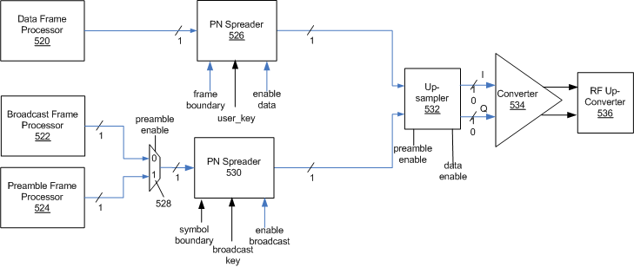

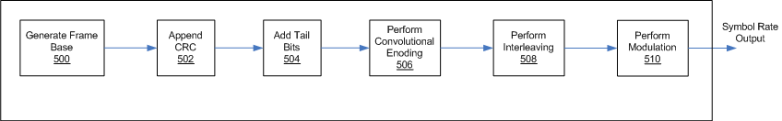

Data Rate, Coverage, and Capacity Analysis

Uplink
As described in other sections, proposed D-DSSS PHY is very dynamic in terms of spreading factor seletion. As shown below for the uplink, there is a proportional trade-off between node data rate and sensitivity. The channel bandwidth is a flexible component of the PHY. Though the table below is for the 1 MHz channel bandwidth, 3 dB more sensitivity can be achieved by reducing to near 500 kHz.

At the extreme point, the -141 dBm receive sensitivity supports around 60 bps. This may not sound link much data rate but it’s important to keep in mind 2 things:
- Even after the half-duplex and overhead is factored out – this corresponds to 9 kbytes per hour which is much more than a lot of applications require.
- The aggregate uplink data rate remains at near 19 Mbytes/per hour or equivalently 60 kbps. This 60 kbps is the number that is apples-to-apples with the PAR data rate requirement since the intent of the PAR is a capacity requirement, not a peak application data rate requirement.
The ranges here are calculated from the Okumura-Hata model using the suburban parameter. Note that for the range calculation we used a 100 mW PA that is more representative of low-power devices.

Assumptions:
- 1 MHz Bandwidth/100 mW PA/Suburban Propagation Model
- 100mW PA active

UPLINK Spreading Factor | Uplink Signal Level (dBm) | Estimated Range (mi) | Coverage Area (mi²) | Estimated Range (mi) | Coverage Area (mi²) | UPLINK Payload Data/Hr (KB/h) Per Node | UPLINK Aggregate Data Rate Access Point (KB/h)
 |  | 2.4 GHz |  | 900 MHz
16 | -114 | 1.2 | 4.9 | 2.0 | 12.3 | 4688 | 18750
32 | -117 | 1.6 | 7.7 | 2.5 | 19.4 | 2344 | 18750
64 | -120 | 1.8 | 9.7 | 3.1 | 30.8 | 1172 | 18750
128 | -123 | 2.2 | 15.4 | 3.5 | 38.8 | 586 | 18750
256 | -126 | 2.5 | 19.4 | 4.4 | 61.5 | 293 | 18750
512 | -129 | 3.1 | 30.8 | 5.0 | 77.4 | 146 | 18750
1024 | -132 | 3.9 | 48.9 | 6.3 | 122.7 | 73 | 18750
2048 | -135 | 4.4 | 61.5 | 7.9 | 194.5 | 37 | 18750
4096 | -138 | 5.6 | 97.5 | 8.8 | 244.8 | 18 | 18750
8192 | -141 | 6.3 | 122.7 | 11.1 | 388.1 | 9 | 18750

~1000 link simultaneous link demodulation allows for an aggregate uplink data rate independent of range even over 100 square miles

Downlink

The downlink capacity calculation is shown below. Unlink the uplink which can potentially leverage the 1000 Power-Amplifiers of 1000 nodes based on the simultaneous demodulation capability at the AP, the downlink uses the single Power Amplifier of the AP. Thus, the downlink is a “single-threaded” or primarily TDMA operation for unicast downlink transmission. The AP schedules transmissions in multiple subslots each at the appropriate minimum spreading factor required to close the link. Shown below is an example of aggregate downlink data rate or capacity based on an assumed distribution of nodes per spreading factor required to close the link.

Note that the sensitivity number is a bit less than the uplink numbers – this is representative of the scenario where the AP PHYs are powered and can support a 1 Watt PA which balances the link budget against the 100 mW transmit power typical of a battery powered device.

The asymmetric uplink/downlink capacity is mitigated by several factors:
- Tendency of Sensor Networking and Location Tracking Systems to be Uplink Dominated in Data Flow
- Use of Micro-Repeaters near the AP to fix the downlink bottleneck (see Section 8 for how this works).
- 1 Watt Power Amplifier on Access Point
- Use of Broadcast is inherently efficient if each node requires the same data (e.g., firmware update)
- Very Efficient 1-bit uplink Acknowledgement Scheme

Assumptions:
- 1 MHz Bandwidth/100 mW PA/Suburban Propagation Model
- 100mW PA active

DOWN LINK Spread Factor | Uplink Signal Level (dBm) | Estimated Range (mi) | Coverage Area (mi²) | Estimated Range (mi) | Coverage Area (mi²) | Example Distribution of Devices As Function of Spreading Factor | DOWNLINK Peak Node Payload Data/Hr Per Node (KB/h) | DOWNLINK Aggregate Data Rate at Access Point (KB/hr) CALCULATION
 |  | 2.4 GHz |  | 900 MHz
4 | -114 | 1.8 | 9.7 | 3.1 | 30.8 | 13.0% | 18750 | 1218.75
8 | -117 | 2.2 | 15.4 | 3.5 | 38.8 | 12.0% | 9375 | 562.50
16 | -114 | 1.8 | 9.7 | 3.1 | 30.8 | 12.0% | 4688 | 281.25
32 | -117 | 2.2 | 15.4 | 3.5 | 38.8 | 15.0% | 2344 | 175.78
64 | -120 | 2.5 | 19.4 | 4.4 | 61.5 | 15.0% | 1172 | 87.89
128 | -123 | 3.1 | 30.8 | 5.0 | 77.4 | 10.0% | 586 | 29.30
256 | -126 | 3.9 | 48.9 | 6.3 | 122.7 | 6.0% | 293 | 8.79
512 | -129 | 4.4 | 61.5 | 7.9 | 194.5 | 5.0% | 146 | 3.66
1024 | -132 | 5.6 | 97.5 | 8.8 | 244.8 | 6.0% | 73 | 2.20
2048 | -135 | 6.3 | 122.7 | 11.1 | 388.1 | 6.0% | 37 | 1.10
 |  |  |  |  |  |  | Example DOWNLINK Aggregate Payload  KB/hr | 2371

Physical Layer Timing and Synchronization

The design goal of a system using a powered Micro-Repeaters FFD configuration with D-DSSS is identical to the current notions that use the 802.15.4 PHY. The benefit of D-DSSS is an extreme range of a constituent link closing much further and more robustly than before while simultaneously maintaining both very high uplink and downlink capacity. That stands in stark contrast to existing systems that typically experience a 1/N^2 degradation in capacity where N is the maximum number of hops to the collector. A system incorporating D-DSSS experience no degradation with number of hops.

Shown below is the synchronization of FFDs with each other and battery powered RFDs. This is a synchronous system where the TX/RX behavior of each FFD alternates in a way such that concurrent communication in both upstream and downstream directions between all Micro-Repeaters can occur.

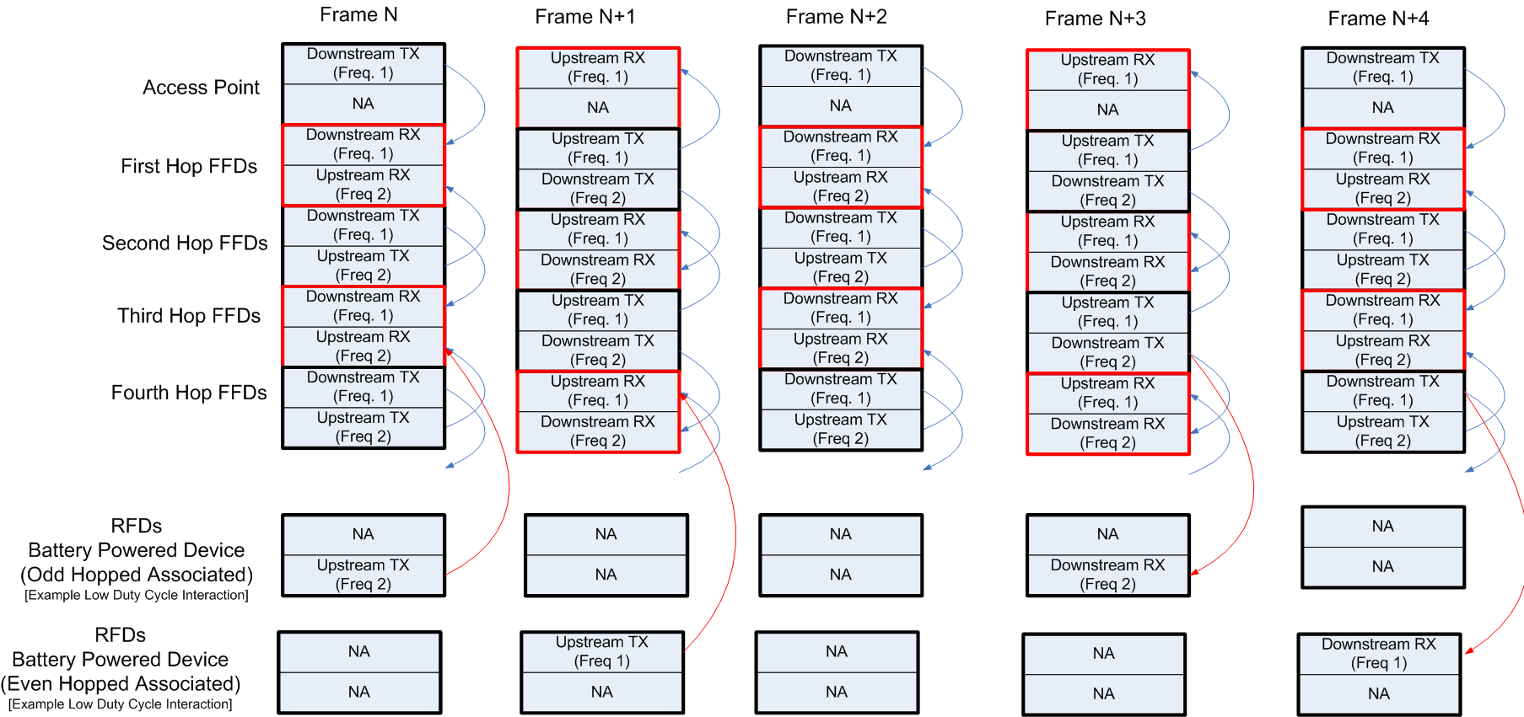

The following are more details of this synchronization scheme:

- FFDs spend half their lives simultaneously transmitting upstream and downstream data on two frequencies to RFDs and other FFDs;
- FFDs spend the other half of their lives receiving upstream and downlink data on two frequencies from RFDs and other FFDs
- The TX/RX Phase of FFDs depend on the parity of the frame number coupled with the parity of the number of hops from the Access Point
- RFDs spend most of their time sleeping, and a small fraction of their time communicating with the closest FFD.
- The multiple frequency aspect is an optional mechanism that ensures that nearby RFDs each associated with different FFDs (such that one is transmitting while the other receiving) don’t jam each other’s frequency.

Dual Smart Utility Network (SUN)/Home Area Network (HAN Deployment

The following figure depicts an envisioned deployment using the D-DSSS system. Note that both the SUN and HAN can be supported with a single system.

In this scenario, the Micro-Repeater is in each powered electric utility meter. Recall, the Micro-Repeater is functionally an integration of the node PHY and the Access Point PHY. Note that because of the nature of the processing of each of these PHYs – both PHYs can actually be made quite small. The Micro-Repeater does require power because it spends its life continuosly active, but this is typically available in the electric meter.

The system has support for battery operated devices such as gas meters by incorporating only the node PHY which has been designed to be very power efficient and extremely heavily duty-cycled in its operation.

Additionally, the HAN functionality is achieved by allowing the AP PHY component of the electric meter’s Micro-Repeater to serve as a hub in a hub-spoke topology.

The substantial benefit achieved through this type of deployment if very large reach to nearest neighbor Micro-Repeaters. In fact, as depicted in the following figure, that range is 25 x the range of existing 802.15.4 PHYs.

Uplink and downlink capacity are large enough as dictated by the PAR each for different reasons:
- Uplink capacity is always large based on the ability to demodulate many links simultaneously.
- Downlink capacity is large because by placing the collector slightly strategically, the downlink flow of data from the dedicated data channel can occur at the higher rates which are in excess of the PAR requirement. From here, data can be hopped downstream easily because only the collector is the downlink bottleneck – all other FFDs have substantially less data flowing through them.

MAC Interface

The D-DSSS PHY/MAC differs from traditional 802.15.4 PHY/MAC in several significant ways:

- D-DSSS utilizes a Random Phase Multiple Access scheme rather than Carrier Sense Multiple Access – Collision Avoidance scheme.
- A PHY data packet is made up of 1 or more sub packets
- Addressing is embedded in the PHY using a Gold code modified by the connection ID (short address).
The existing PHY and MAC service access points are maintained with minimal changes.

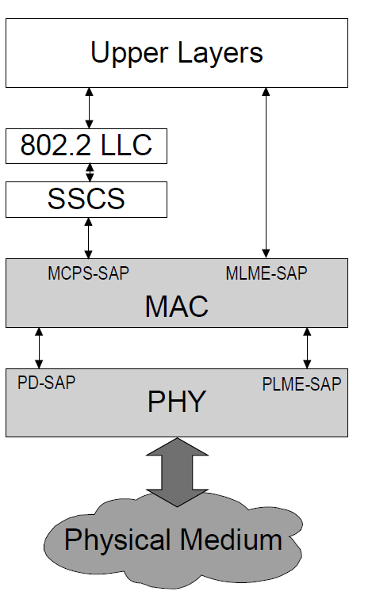
Due to high processing gains, and the ability to demodulate below the at negative SNR, Energy Detect and Clear Channel Assessment which are defined in 802.15.4 PLME-SAP to support CSMA-CA are not needed, and have limited meaning for a D-DSSS system. The underlying frame structure is similar to a beacon enabled network’s super frame structure in which CSMA is not used for beacon or GTS transmissions.

The underlying PHY data unit fixed size is transparent to the 802.15.4 PHY PD-SAP. A large PPDU is broken up into multiple PPDU sub packets (fragments) which are transported by the PHY and reassembled into a large PPDU when received.

Node addressing is not transmitted over the air by the PHY. Instead, the short address (connection ID) assigned by a coordinator when device associates is used to modify the PHY Gold code. This difference could be handled either at the PHY layer (by interpreting the MPDU, stripping the address fields, setting the appropriate Gold code, and then transmitting and vice versa, or at the MAC layer).

There will need to be some additions to the PLME-SAP to set the codes used.

Support of PAR

- Operation in any of the regionally available license exempt frequency bands, such as 700MHz to 1GHz, and the 2.4 GHz band.

D-DSSS is not specific to any particular band; however, regional regulations may impose power, PSD, LBT, or duty cycle requirements which affect overall system flexibility or use on a specific band or sub-band.

- Data rate of at least 40 kbits per second but not more than 1000 kbits per second

Aggregate throughput at the gateway is in excess of the minimum bitrate.

- Achieve the optimal energy efficient link margin given the environmental conditions encountered in Smart Metering deployments.

The ability to dynamically change spreading factor combined with Tx power control enable each node to use the minimum power necessary to communicate. Multi year battery life is achievable.

- Principally outdoor communications

High spreading factors enable robust communications in large delay spread, and dynamic outdoor environments.

- PHY frame sizes up to a minimum of 1500 octets

PPDU of > 1500 octets are supported by a PPDU sub packet transmission scheme

- Simultaneous operation for at least 3 co-located orthogonal networks

Where permitted by regional regulation, co-located networks can occupy separate channels; if limited to one channel, co-located networks can co-exist by using unique Gold codes.

- Connectivity to at least one thousand direct neighbors characteristic of dense urban deployment
Up to 1000 uplinks can be demodulated simultaneously. 64K node addressability.

