IEEE P802.15
Wireless Personal Area Networks
Project | IEEE P802.15 Task Group for Wireless Personal Area Networks (WPANs)
Title | 802.15.6 Call for Applications - Summary
Date Submitted | Revision 1: 1 July 2008  Revision 2 8 Sep 2008  Revision 3 9 Sep 2008
Source | Daniel Lewis (Editor)  NICTA  Canberra Research Laboratory  7 London Circuit  Canberra ACT 2602  Australia | Voice: +61 2 6267 6252  Fax: +61 2 6267 6220  E-mail: daniel.lewis@nicta.com.au
Re: | Responses to Call for Applications in Body Area Networks
Abstract | This document presents applications which the IEEE 802.15.6 TG requests standards proposals support. The document summarises the significant applications (those with more then a single slide of detail) presented to the IEEE 802.16.6 TG / IEEE 802.15-BAN SG / IEEE 802.15 IG. The applications are presented in the context of the categorization scheme developed by the group and originally represented in the applications matrix.
Purpose | (1) To identify applications which the IEEE 802.15.6 TG request standard proposals support  (2) To collate all significant 802.15.6 applications into a single design document.  (3) To provide a single point of reference (and application reference numbers) which can be used as a common point of reference when evaluating and comparing call for proposal responses.
Notice | This document has been prepared to assist the IEEE P802.15. It is offered as a basis for discussion and is not binding on the contributing individual(s) or organization(s). The material in this document is subject to change in form and content after further study. The contributor(s) reserve(s) the right to add, amend or withdraw material contained herein.
Release | The contributor acknowledges and accepts that this contribution becomes the property of IEEE and may be made publicly available by P802.15.

802.15.6 Proposed applications

Class A Medical applications 4
A1-1 Wearable BAN (WMTS) 5
Electroencephalogram EEG 6
Electrocardiogram ECG 7
Electromyography EMG 8
Vital signals monitoring 9
Temperature (wearable) 12
Respiration monitor (wearable) 13
Heart rate monitor (wearable) 14
Pulse oximeter SpO2 wearable 15
Blood pressure monitor (wearable) 16
pH monitor (wearable) 17
Glucose sensor (wearable) 18
Hearing aid (ear to ear communication) 19
A1-1a Disability assistance 21
Muscle tension monitor 22
Muscle tension stimulation 23
Weighing scale (wearable) 24
Fall detection (wearable) 25
A1-1b Human performance management 26
Aiding professional and amature sport training 27
Assessing emergency service personnel performance 29
Assessing soldier fatigue and battle readiness 30
Non Human (Animal) 31
A1-2a Implant BAN (MICS) 33
Glucose sensor (implant) 34
Cardiac arrhythmia monitor/recorder (implant) 36
Brain liquid pressure sensor (implant) 37
Endoscope capsule (gastrointestinal) 38
Drug delivery capsule 40
Deep brain stimulator (eg, Epilepsy, Parkinson's therrepy) 41
Cortical stimulator 42
Visual neuro-stimulator 43
Audio neuro stimulator 44
Brain-computer interface 45
A1-2b Remote control of medical devices 46
Pacemaker 47
Implantable cardioverter defibrallitor ICD 48
Implanted actuator 50
Insulin pump 51
Hearing aid (wearable and implanted) 52
Retina implants 53
A2-1 In hospital (in general) 54
A2-2 Outside Hospital 55
Class B Non-Medical applications (including entertainment) 56
B1 Real-time video streaming 57
Video streaming (among portable devices - Lower resolution) 58
Video streaming (portable device external displays - Higher resolution) 60
3D video 62
B2 Real-time audio streaming 63
Voice communication for headsets (moNo, and Lower quality) 64
Music for headsets (stereo, and Higher quality) 66
Sound track/Music - 5.1 channel (Higher bandwidth) 68
B3 Data file transfer 70
Data file transfer (Word, Excel, software programs and etc) 71
Image file transfer (digital camera, scanner and etc.) 73
Video file transfer (camcorder, multimedia player and etc.) 74
B4 Stream transfer 75
Remote control of entertainment devices 76
Body motion capture/gesture recognition, position 78
Control signal from PC peripheral devices (e.g. mouse click) 80
Forgotten things monitor 81
Emotion 83
Smart Key 85
Identification 86
Vital sign and body information based entertainment service 87
B5 Entertainment applications 88
Gaming applications using BAN 89
Social Networking using BAN 91
B6 Emergency (non-medical) 93
Emergency (non-medical) 94
Acknowledgements 95

Class A Medical applications

A1-1 Wearable BAN (WMTS)

Electroencephalogram EEG |  |  |  |  |  |  | Z001
SAR Safety | Highest | Radio range | <5m | Setup time for a new link | <3s | Cost
Regulatory - Radio | Compliant | Coexistence | Yes | Location awareness |  | Market size / region / year | Large
Topology | Star | Robustness /reliability high/med/low | High | Channel (e.g. in/out body) | On-body | Covered by Other Standards
Data link speed sym/ asymmetric | Asymmetric | Power consumption | Low | Form Factor | Small
Data rate (per link) |  | Energy scavenging possible | Yes | Privacy | High
Number of devices per piconet) | >24 | QoS - sensitive to error | Yes | Power by:  battery | Yes
Duty cycle (per device) % per time | <10% | QoS - sensitive to latency | Yes | Power by:  energy scavenging | No
Further information:
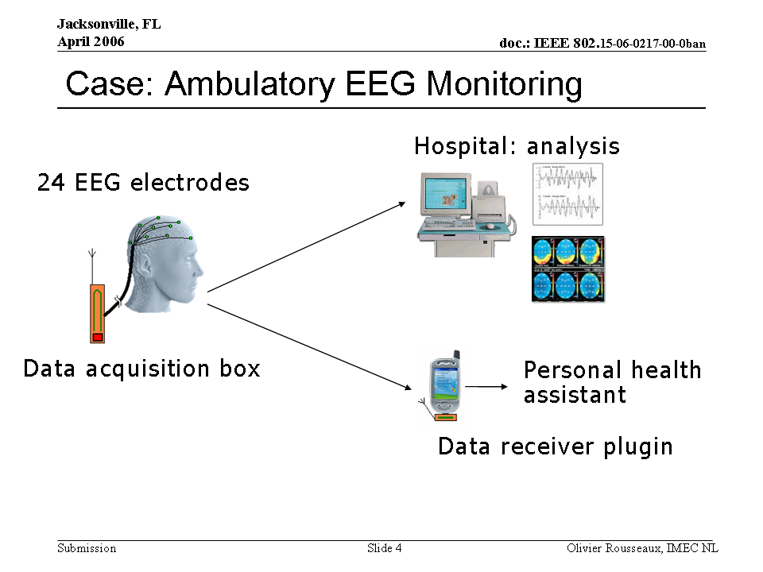 |  |  |  | 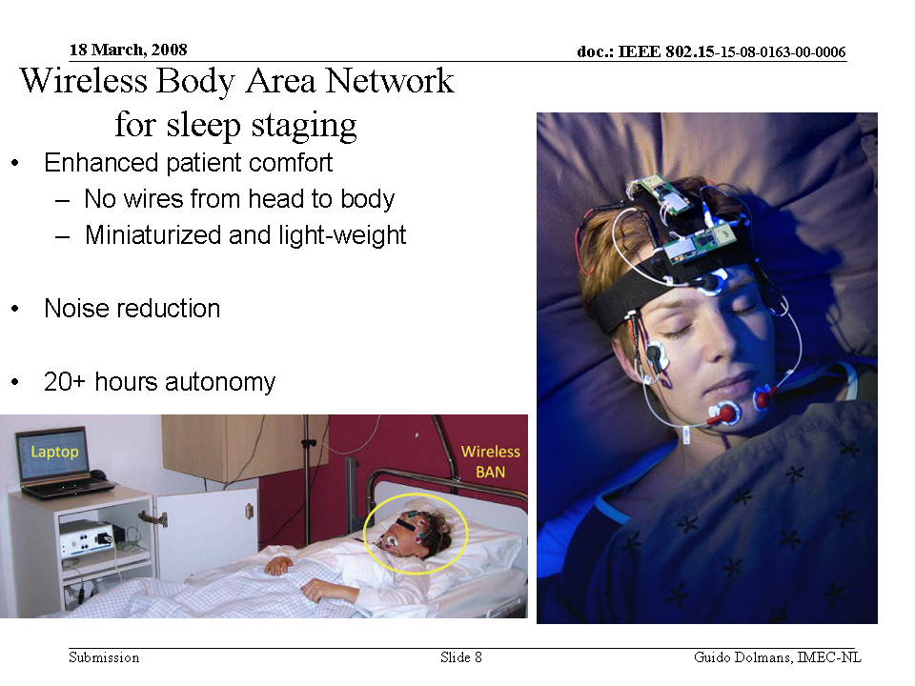

Electrocardiogram ECG |  |  |  |  |  |  | Z002
SAR Safety | High | Radio range | <5m | Setup time for a new link | <3s | Cost
Regulatory - Radio | Compliant | Coexistence | Yes | Location awareness |  | Market size / region / year | Very large
Topology | Star or point to point | Robustness /reliability high/med/low | High | Channel (e.g. in/out body) | On-body | Covered by Other Standards
Data link speed sym/ asymmetric | Asymmetric | Power consumption | Low | Form Factor | Small
Data rate (per link) | 3kbps per ECG channel | Energy scavenging possible | Yes | Privacy | High
Number of devices per piconet) | <24 | QoS - sensitive to error | Yes | Power by:  battery | Yes
Duty cycle (per device) % per time | <10% | QoS - sensitive to latency | Yes | Power by:  energy scavenging | No
Further information:

For example:
- 12 channel ECG (raw streaming):
  - 250Hz sampling rate
  - 12 bits / sample
    - 3kbps per channel
    - 36kbps total
- 12-channel ECG (compressed example. References required)
  - 250Hz sampling rate
  - 12 bits / sample
    - 2kbps total

Some applications do not require a 12 channel ECG. Fewer channels result in proportionally lower bandwidth requirements.

Other Requirements:
- Low Latency is required for certain care scenarios.

Electromyography EMG |  |  |  |  |  |  | Z003
SAR Safety | High | Radio range | <5m | Setup time for a new link | <3s | Cost
Regulatory - Radio | Compliant | Coexistence | Yes | Location awareness |  | Market size / region / year | Small
Topology | Star | Robustness /reliability high/med/low | High | Channel (e.g. in/out body) | On-body | Covered by Other Standards
Data link speed sym/ asymmetric | Asymmetric | Power consumption | Low | Form Factor | Small
Data rate (per link) |  | Energy scavenging possible | Yes | Privacy | High
Number of devices per piconet) | <12 | QoS - sensitive to error | Yes | Power by:  battery | Yes
Duty cycle (per device) % per time | <10% | QoS - sensitive to latency | Yes | Power by:  energy scavenging | No
Further information:

Vital signals monitoring |  |  |  |  |  |  | Z004
SAR Safety | High | Radio range | <5m | Setup time for a new link | <3s | Cost
Regulatory - Radio | Compliant | Coexistence | Yes | Location awareness |  | Market size / region / year | Very large
Topology | Star | Robustness /reliability high/med/low | High | Channel (e.g. in/out body) | On-body | Covered by Other Standards
Data link speed sym/ asymmetric | Asymmetric | Power consumption | Low | Form Factor | Small
Data rate (per link) |  | Energy scavenging possible | Yes | Privacy | High
Number of devices per piconet) | <12 | QoS - sensitive to error | Yes | Power by:  battery | Yes
Duty cycle (per device) % per time | <1% | QoS - sensitive to latency |  | Power by:  energy scavenging | No
Further information:
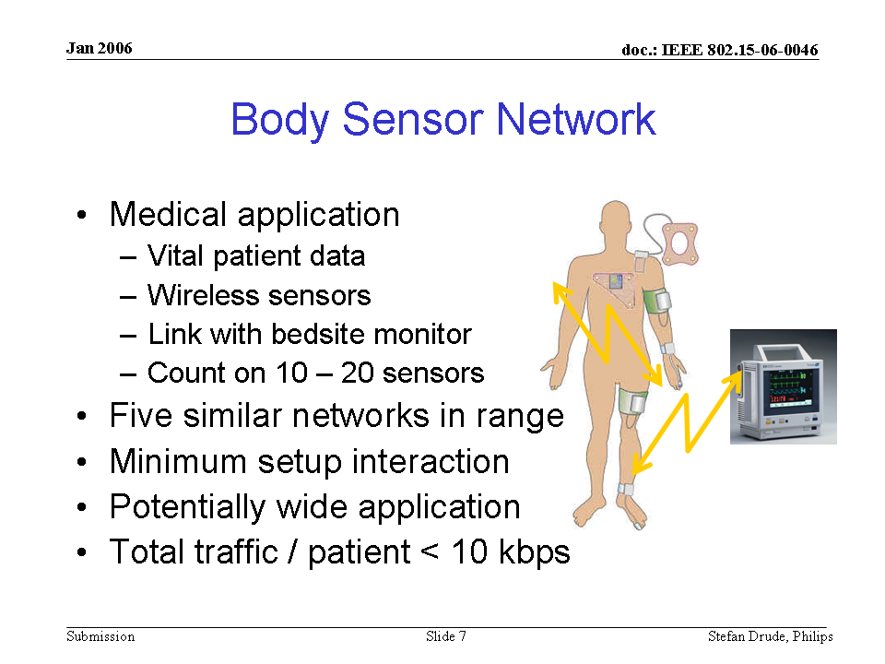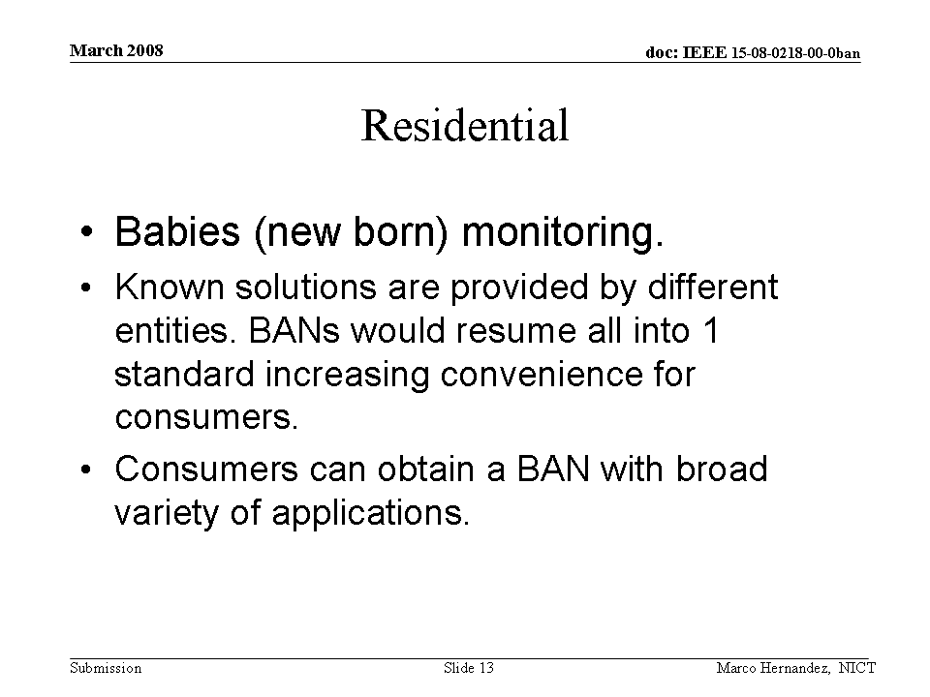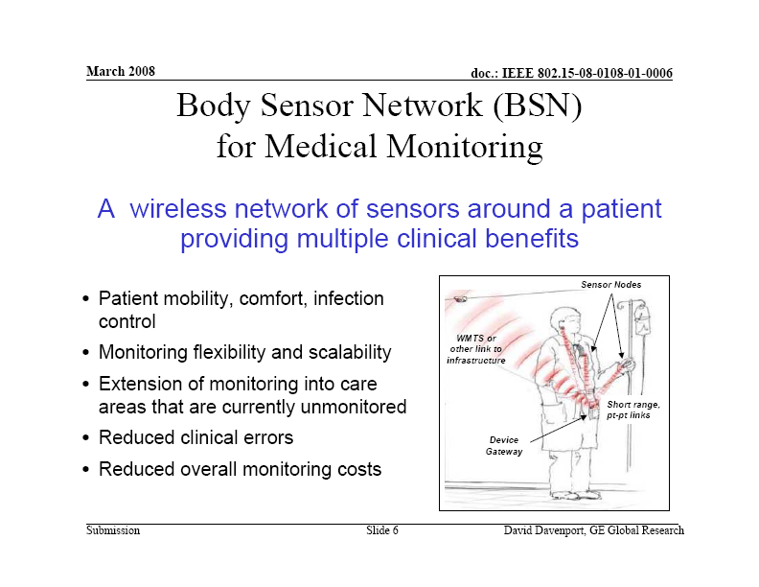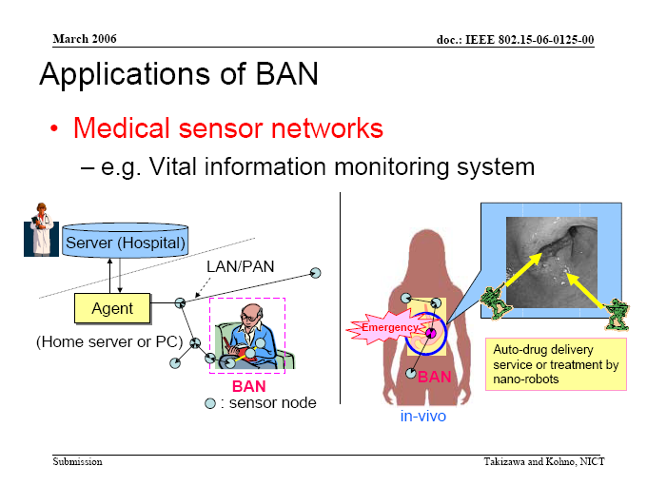 |  |  |  | 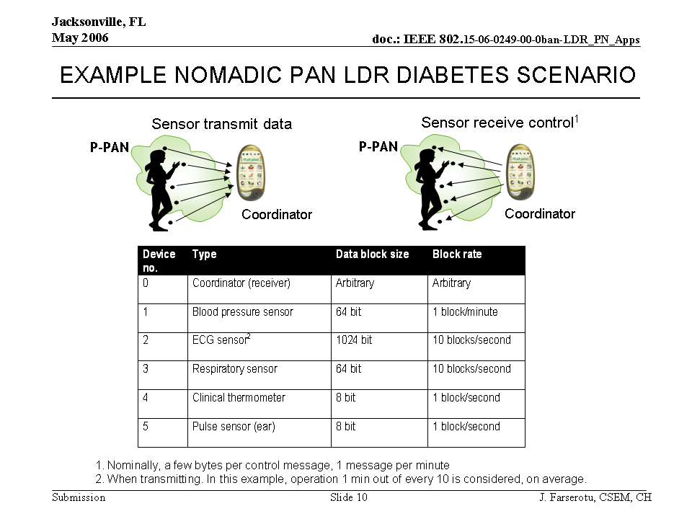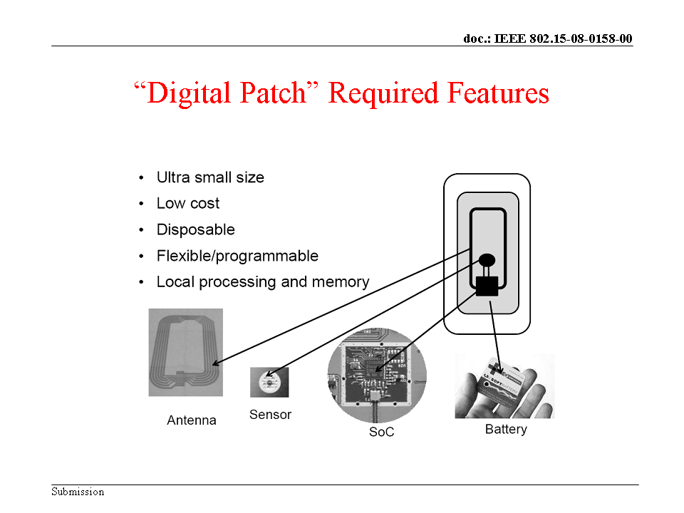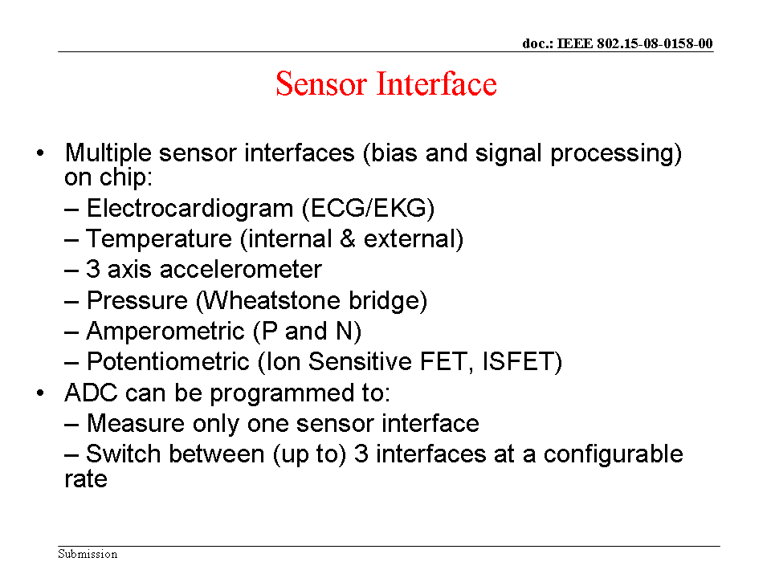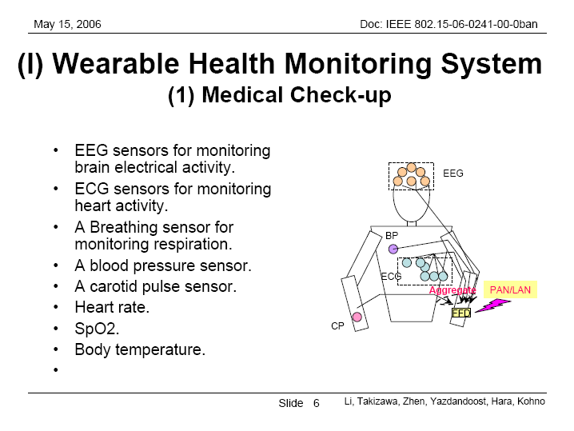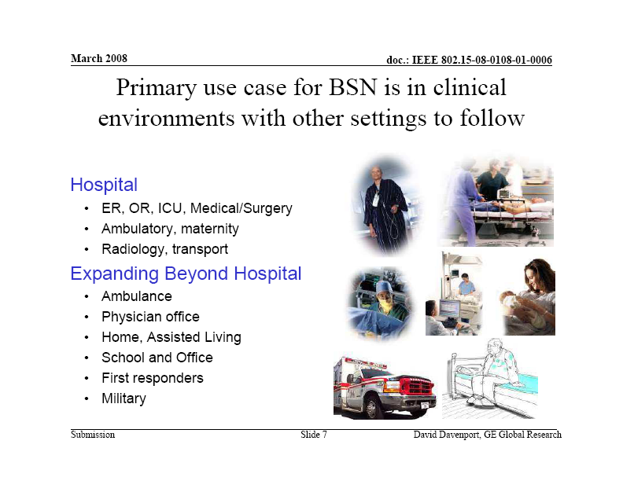

Temperature (wearable) |  |  |  |  |  |  | Z005
SAR Safety | High | Radio range | <5m | Setup time for a new link | <3s | Cost
Regulatory - Radio | Compliant | Coexistence | Yes | Location awareness |  | Market size / region / year | Very large
Topology | Star or point to point | Robustness /reliability high/med/low | High | Channel (e.g. in/out body) | On-body | Covered by Other Standards
Data link speed sym/ asymmetric | Asymmetric | Power consumption | Low | Form Factor | Small
Data rate (per link) | < 16bps | Energy scavenging possible | Yes | Privacy | High
Number of devices per piconet) | <12 | QoS - sensitive to error | Yes | Power by:  battery | Yes
Duty cycle (per device) % per time | <1% | QoS - sensitive to latency |  | Power by:  energy scavenging | Yes
Further information:

Two example scenarios:
- Continuous
  - For example Sports/performance monitoring multiple times per minute.
- Occasional
  - For example recording temperature during illness several times per day.

Typical payload need only be two bytes per sample. Maximum sampling rate: 1Hz ➔ 16bps
Sensor power consumption can be of the order of microwatts

Respiration monitor (wearable) |  |  |  |  |  |  | Z006
SAR Safety | High | Radio range | <5m | Setup time for a new link | <3s | Cost
Regulatory - Radio | Compliant | Coexistence | Yes | Location awareness |  | Market size / region / year | Very large
Topology | Star | Robustness /reliability high/med/low | High | Channel (e.g. in/out body) | On-body | Covered by Other Standards
Data link speed sym/ asymmetric | Asymmetric | Power consumption | Low | Form Factor | Small
Data rate (per link) |  | Energy scavenging possible | Yes | Privacy | High
Number of devices per piconet) | <12 | QoS - sensitive to error | Yes | Power by:  battery | Yes
Duty cycle (per device) % per time | <1% | QoS - sensitive to latency |  | Power by:  energy scavenging
Further information:

Heart rate monitor (wearable) |  |  |  |  |  |  | Z007
SAR Safety | High | Radio range | <5m | Setup time for a new link | <3s | Cost
Regulatory - Radio | Compliant | Coexistence | Yes | Location awareness |  | Market size / region / year | Large
Topology | Star/tree | Robustness /reliability high/med/low | High | Channel (e.g. in/out body) | On-body | Covered by Other Standards
Data link speed sym/ asymmetric | Asymmetric | Power consumption | Low | Form Factor | Small
Data rate (per link) |  | Energy scavenging possible | Yes | Privacy | High
Number of devices per piconet) | <12 | QoS - sensitive to error | Yes | Power by:  battery | Yes
Duty cycle (per device) % per time | <1% | QoS - sensitive to latency |  | Power by:  energy scavenging | No
Further information:

Pulse oximeter SpO2 wearable |  |  |  |  |  |  | Z008
SAR Safety | High | Radio range | <5m | Setup time for a new link | <3s | Cost
Regulatory - Radio | Compliant | Coexistence | Yes | Location awareness |  | Market size / region / year | Large
Topology | Star/tree/point to point | Robustness /reliability high/med/low | High | Channel (e.g. in/out body) | On-body | Covered by Other Standards
Data link speed sym/ asymmetric | Asymmetric | Power consumption | Low | Form Factor | Small
Data rate (per link) | 32 kbps | Energy scavenging possible | Yes | Privacy | High
Number of devices per piconet) | <12 | QoS - sensitive to error | Yes | Power by:  battery | Yes
Duty cycle (per device) % per time | <1% | QoS - sensitive to latency |  | Power by:  energy scavenging | If possible
Further information:

Payload of approximately 4 bytes per reading
      - Pulse rate (1 byte)
      - Perfusion (2 bytes)
      - Blood Oxygenation (1 byte)
Data sent up to once per second
Typical use cases:
- Monitoring for 20 minutes per day
- During a workout
- Acute illness
Power less than 50mW typically

Blood pressure monitor (wearable) |  |  |  |  |  |  | Z009
SAR Safety | High | Radio range | <5m | Setup time for a new link | <3s | Cost
Regulatory - Radio | Compliant | Coexistence | Yes | Location awareness |  | Market size / region / year | Large
Topology | Star/tree | Robustness /reliability high/med/low | High | Channel (e.g. in/out body) | On-body | Covered by Other Standards
Data link speed sym/ asymmetric | Asymmetric | Power consumption | High | Form Factor | Medium
Data rate (per link) | < 10 bps | Energy scavenging possible | No | Privacy | High
Number of devices per piconet) | <12 | QoS - sensitive to error | Yes | Power by:  battery | No
Duty cycle (per device) % per time | <1% | QoS - sensitive to latency |  | Power by:  energy scavenging | If possible
Further information:

Based on a typical cuff-type blood pressure monitor

▪ One reading taken at most, two to three times per day
▪ 3 bytes per reading
▪ Not time critical
▪ Assuming a cuff based blood pressure sensor, these devices are high power, e.g. 1.5W during pumping to inflate cuff

pH monitor (wearable) |  |  |  |  |  |  | Z010
SAR Safety | High | Radio range | <5m | Setup time for a new link | <3s | Cost
Regulatory - Radio | Compliant | Coexistence | Yes | Location awareness |  | Market size / region / year | Large
Topology | Star/tree | Robustness /reliability high/med/low | High | Channel (e.g. in/out body) | On-body | Covered by Other Standards
Data link speed sym/ asymmetric | Asymmetric | Power consumption | Low | Form Factor | Small
Data rate (per link) |  | Energy scavenging possible | Yes | Privacy | High
Number of devices per piconet) | <12 | QoS - sensitive to error | Yes | Power by:  battery | Yes
Duty cycle (per device) % per time | <1% | QoS - sensitive to latency |  | Power by:  energy scavenging | If possible
Further information:

Glucose sensor (wearable) |  |  |  |  |  |  | Z011
SAR Safety | High | Radio range | <5m | Setup time for a new link | <3s | Cost
Regulatory - Radio | Compliant | Coexistence | Yes | Location awareness |  | Market size / region / year | Large
Topology | Star/tree | Robustness /reliability high/med/low | High | Channel (e.g. in/out body) | On-body | Covered by Other Standards
Data link speed sym/ asymmetric | Asymmetric | Power consumption | Low | Form Factor | Small
Data rate (per link) |  | Energy scavenging possible | Yes | Privacy | High
Number of devices per piconet) | <12 | QoS - sensitive to error | Yes | Power by:  battery | Yes
Duty cycle (per device) % per time | <1% | QoS - sensitive to latency |  | Power by:  energy scavenging | If possible
Further information:
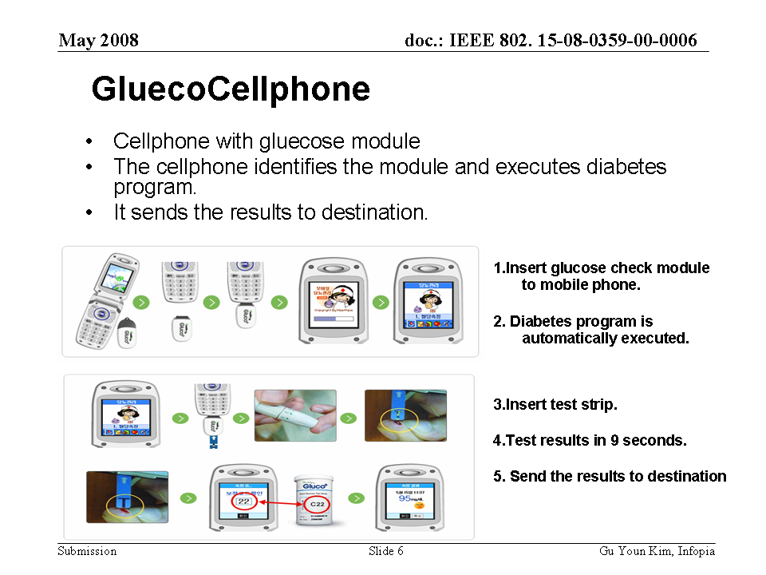

Hearing aid (ear to ear communication) |  |  |  |  |  |  | Z012
SAR Safety |  | Radio range |  | Setup time for a new link |  | Cost
Regulatory - Radio |  | Coexistence |  | Location awareness |  | Market size / region / year
Topology |  | Robustness /reliability high/med/low |  | Channel (e.g. in/out body) |  | Covered by Other Standards
Data link speed sym/ asymmetric |  | Power consumption |  | Form Factor
Data rate (per link) |  | Energy scavenging possible |  | Privacy
Number of devices per piconet) |  | QoS - sensitive to error |  | Power by:  battery
Duty cycle (per device) % per time |  | QoS - sensitive to latency |  | Power by:  energy scavenging | If possible
Further information:
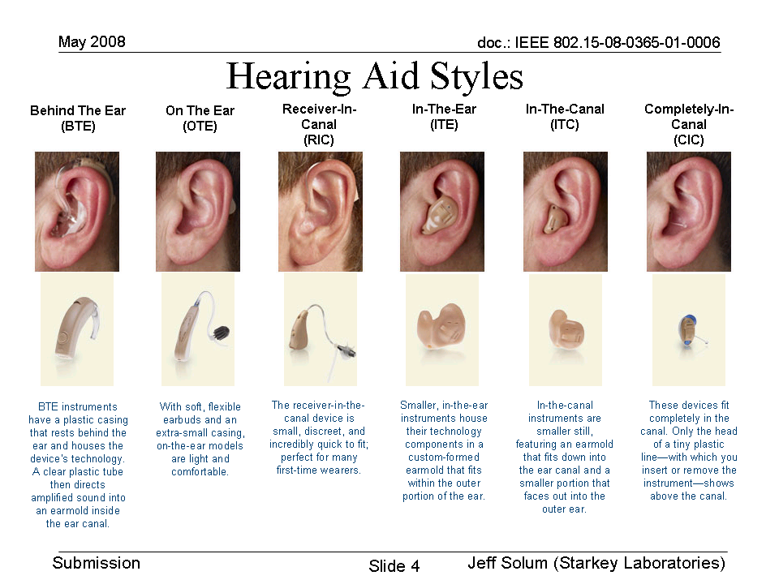 |  |  |  | 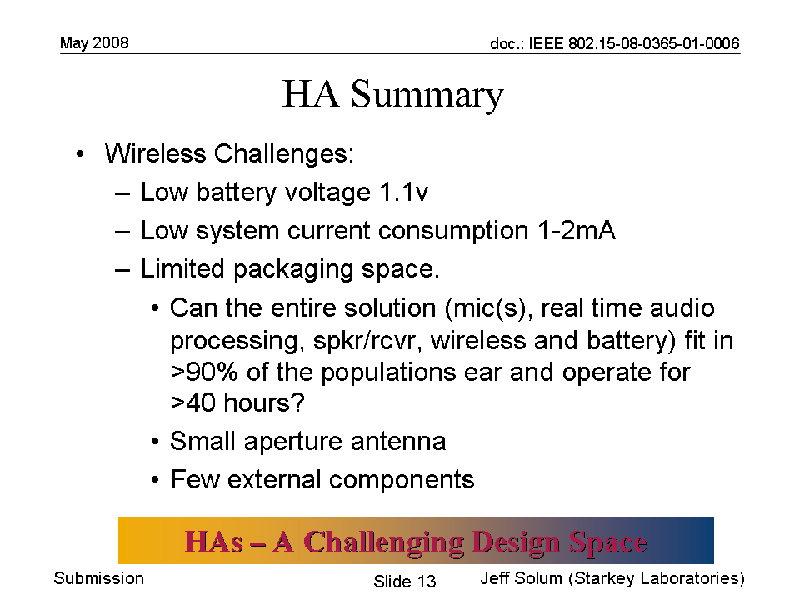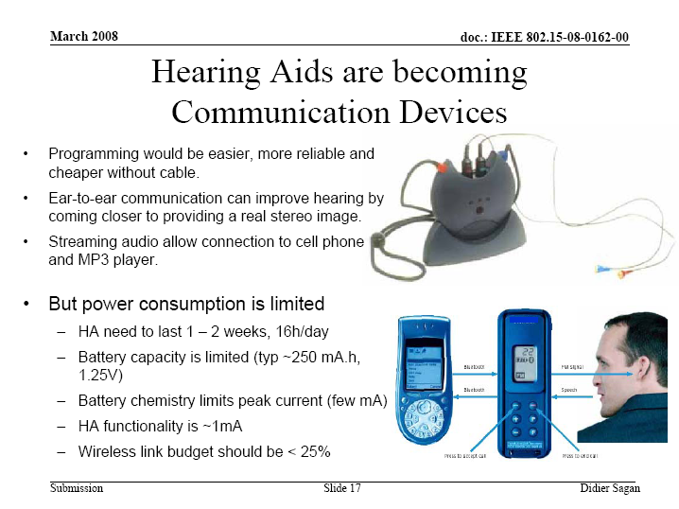

A1-1a Disability assistance

Muscle tension monitor |  |  |  |  |  |  | Z013
SAR Safety |  | Radio range | <5m | Setup time for a new link | <3s | Cost
Regulatory - Radio |  | Coexistence | Yes | Location awareness |  | Market size / region / year
Topology | Star/tree | Robustness /reliability high/med/low | High | Channel (e.g. in/out body) | On-body | Covered by Other Standards
Data link speed sym/ asymmetric | Asymmetric | Power consumption | Low | Form Factor | Small
Data rate (per link) |  | Energy scavenging possible | Yes | Privacy | High
Number of devices per piconet) | <12 | QoS - sensitive to error | Yes | Power by:  battery | Yes
Duty cycle (per device) % per time | <1% | QoS - sensitive to latency |  | Power by:  energy scavenging | No
Further information:

Muscle tension stimulation |  |  |  |  |  |  | Z014
SAR Safety |  | Radio range | <5m | Setup time for a new link | <3s | Cost
Regulatory - Radio |  | Coexistence | Yes | Location awareness |  | Market size / region / year
Topology | Star/tree | Robustness /reliability high/med/low | High | Channel (e.g. in/out body) | On-body | Covered by Other Standards
Data link speed sym/ asymmetric | Asymmetric | Power consumption | Low | Form Factor | Small
Data rate (per link) |  | Energy scavenging possible | Yes | Privacy | High
Number of devices per piconet) | <12 | QoS - sensitive to error | Yes | Power by:  battery | Yes
Duty cycle (per device) % per time | <1% | QoS - sensitive to latency |  | Power by:  energy scavenging | No
Further information:

Weighing scale (wearable) |  |  |  |  |  |  | Z015
SAR Safety | Medium | Radio range | <5m | Setup time for a new link | <3s | Cost
Regulatory - Radio |  | Coexistence | Yes | Location awareness |  | Market size / region / year
Topology | Star/tree/point-to-point | Robustness /reliability high/med/low | High | Channel (e.g. in/out body) | On-body | Covered by Other Standards
Data link speed sym/ asymmetric | Asymmetric | Power consumption | Low | Form Factor | Small
Data rate (per link) | <10 bps | Energy scavenging possible | Yes | Privacy | High
Number of devices per piconet) | <12 | QoS - sensitive to error | Yes | Power by:  battery | Yes
Duty cycle (per device) % per time | <1% | QoS - sensitive to latency |  | Power by:  energy scavenging | If possible
Further information:

- Approximately 2 bytes per reading
- Low power sensor of the order of a few 10s of mW if not less

Fall detection (wearable) |  |  |  |  |  |  | Z016
SAR Safety |  | Radio range | <5m | Setup time for a new link | <3s | Cost
Regulatory - Radio |  | Coexistence | Yes | Location awareness |  | Market size / region / year
Topology | Star/tree | Robustness /reliability high/med/low | High | Channel (e.g. in/out body) | On-body | Covered by Other Standards
Data link speed sym/ asymmetric | Asymmetric | Power consumption | Low | Form Factor | Small
Data rate (per link) |  | Energy scavenging possible | Yes | Privacy | High
Number of devices per piconet) | <12 | QoS - sensitive to error | Yes | Power by:  battery | Yes
Duty cycle (per device) % per time | <1% | QoS - sensitive to latency |  | Power by:  energy scavenging | No
Further information:
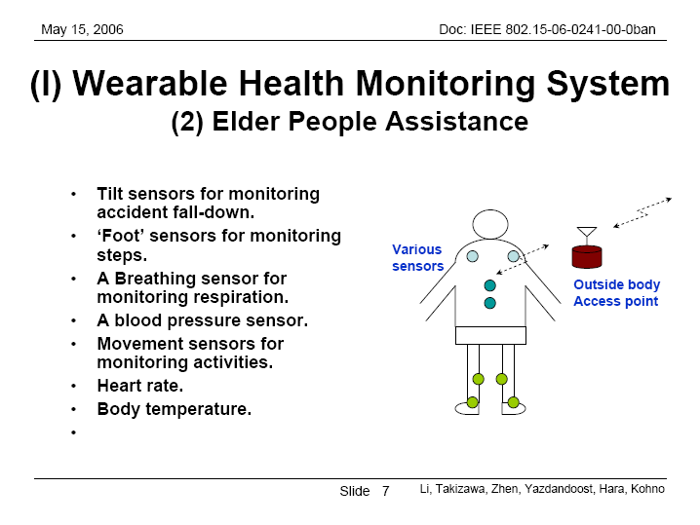 |  |  |  | 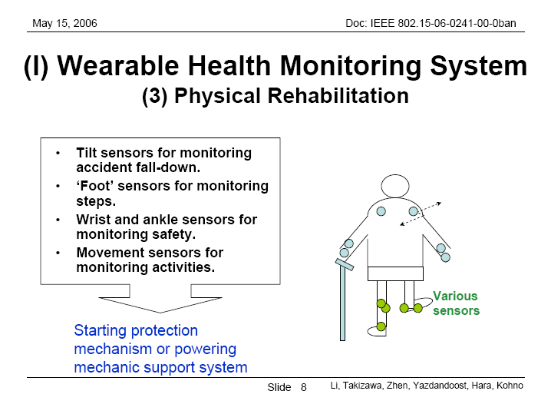

A1-1b Human performance management

Aiding professional and amature sport training |  |  |  |  |  |  | Z014
SAR Safety |  | Radio range | <5m | Setup time for a new link | <3s | Cost
Regulatory - Radio |  | Coexistence | Yes | Location awareness |  | Market size / region / year
Topology | Star/tree/point-to-point | Robustness /reliability high/med/low | High | Channel (e.g. in/out body) | On-body | Covered by Other Standards
Data link speed sym/ asymmetric | Asymmetric | Power consumption | Low | Form Factor | Small
Data rate (per link) | Varies per sensor type | Energy scavenging possible | Yes | Privacy | High
Number of devices per piconet) | <12 | QoS - sensitive to error | Yes | Power by:  battery | Yes
Duty cycle (per device) % per time | <10% | QoS - sensitive to latency | Yes | Power by:  energy scavenging | No
Further information:

▪ Time synchronization between multiple motion sensors may be required in order to correlate data.
▪ Both raw and compressed data can be sent over the link depending on the specific application. For example: node sends step rate or raw acceleration data.
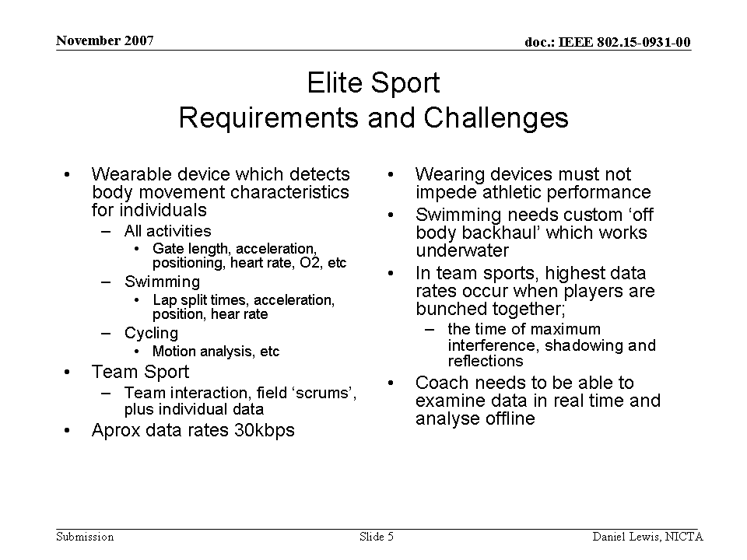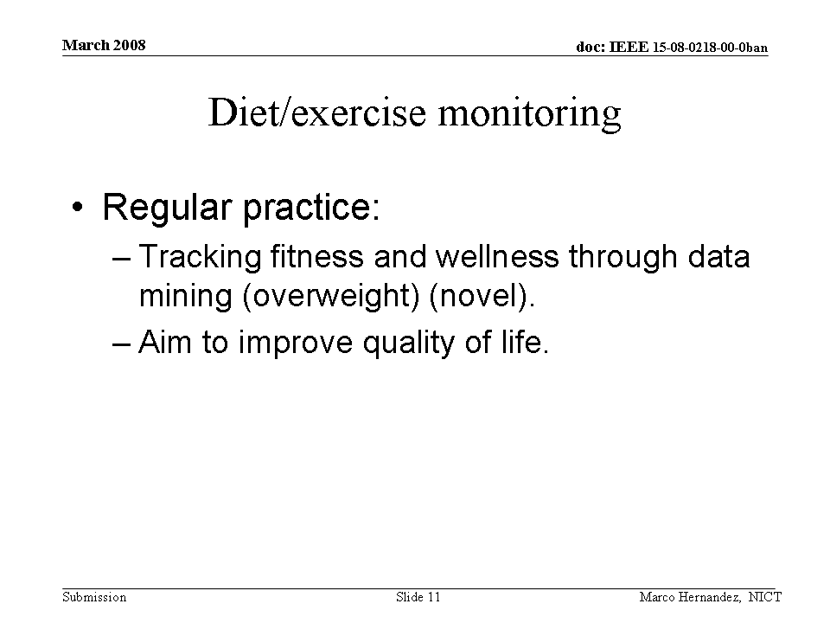 |  |  |  | 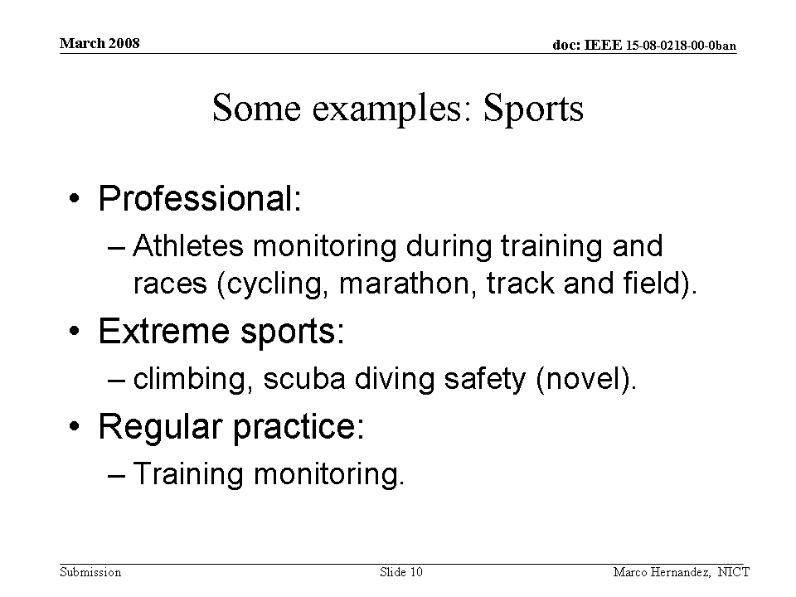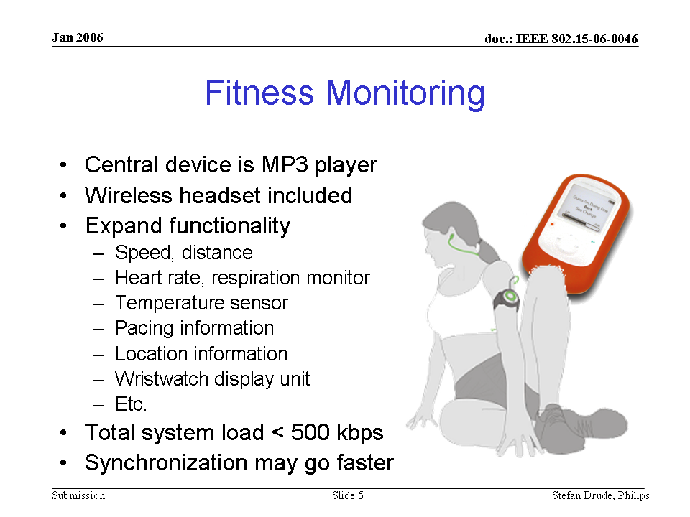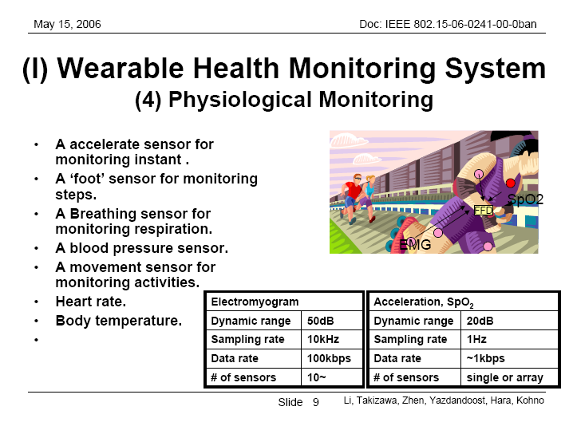

Assessing emergency service personnel performance |  |  |  |  |  |  | Z015
SAR Safety |  | Radio range | <5m | Setup time for a new link | <3s | Cost
Regulatory - Radio |  | Coexistence | Yes | Location awareness |  | Market size / region / year
Topology | Star/tree | Robustness /reliability high/med/low | High | Channel (e.g. in/out body) | On-body | Covered by Other Standards
Data link speed sym/ asymmetric | Asymmetric | Power consumption | Low | Form Factor | Small
Data rate (per link) |  | Energy scavenging possible | Yes | Privacy | High
Number of devices per piconet) | <13 | QoS - sensitive to error | Yes | Power by:  battery | Yes
Duty cycle (per device) % per time | <10% | QoS - sensitive to latency |  | Power by:  energy scavenging | No
Further information:
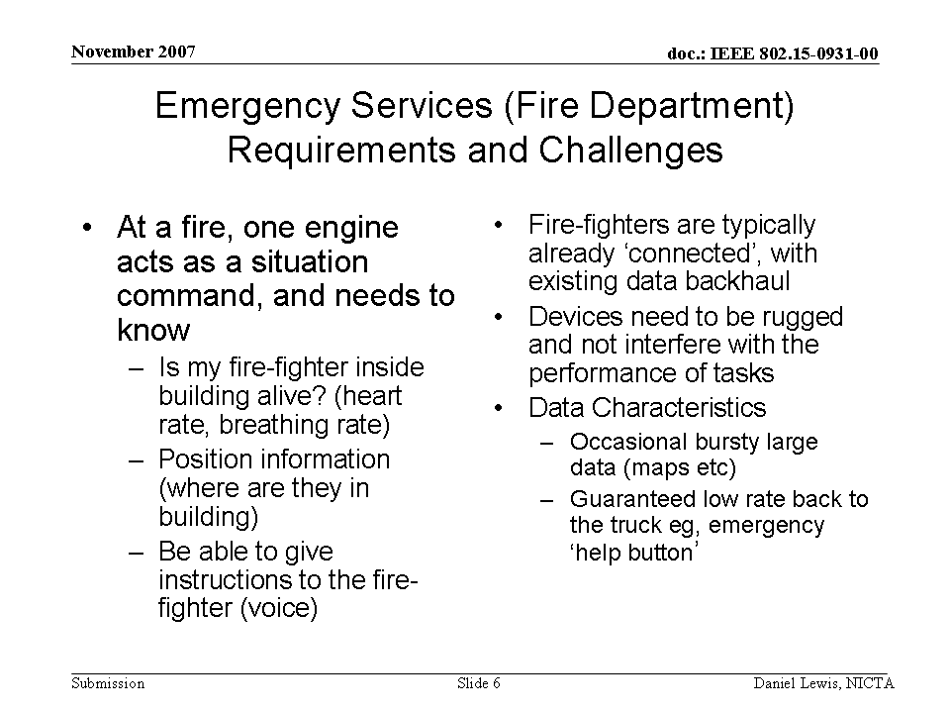

Assessing soldier fatigue and battle readiness |  |  |  |  |  |  | Z016
SAR Safety |  | Radio range | <5m | Setup time for a new link | <3s | Cost
Regulatory - Radio |  | Coexistence | Yes | Location awareness |  | Market size / region / year
Topology | Star/tree | Robustness /reliability high/med/low | High | Channel (e.g. in/out body) | On-body | Covered by Other Standards
Data link speed sym/ asymmetric | Asymmetric | Power consumption | Low | Form Factor | Small
Data rate (per link) |  | Energy scavenging possible | Yes | Privacy | High
Number of devices per piconet) | <14 | QoS - sensitive to error | Yes | Power by:  battery | Yes
Duty cycle (per device) % per time | <10% | QoS - sensitive to latency |  | Power by:  energy scavenging | No
Further information:
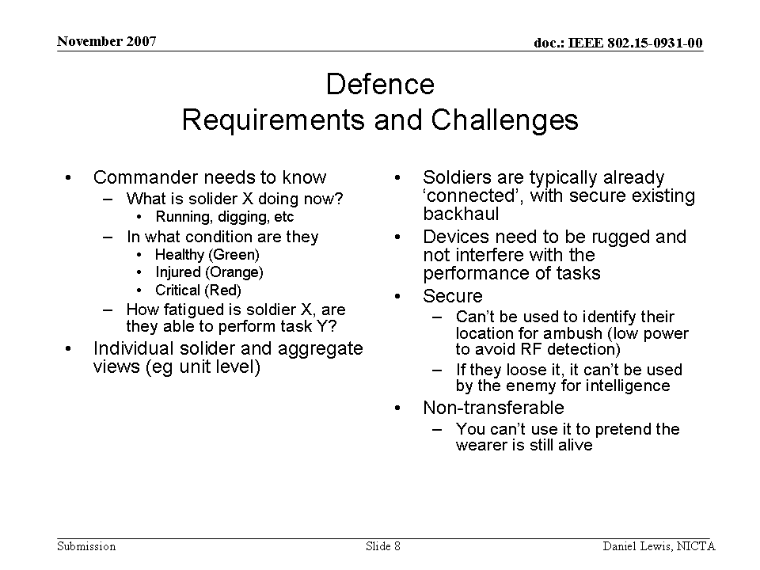

Non Human (Animal) |  |  |  |  |  |  | Z012
SAR Safety |  | Radio range |  | Setup time for a new link |  | Cost
Regulatory - Radio |  | Coexistence |  | Location awareness |  | Market size / region / year
Topology |  | Robustness /reliability high/med/low |  | Channel (e.g. in/out body) |  | Covered by Other Standards
Data link speed sym/ asymmetric |  | Power consumption |  | Form Factor
Data rate (per link) |  | Energy scavenging possible |  | Privacy
Number of devices per piconet) |  | QoS - sensitive to error |  | Power by:  battery
Duty cycle (per device) % per time |  | QoS - sensitive to latency |  | Power by:  energy scavenging | If possible
Further information:
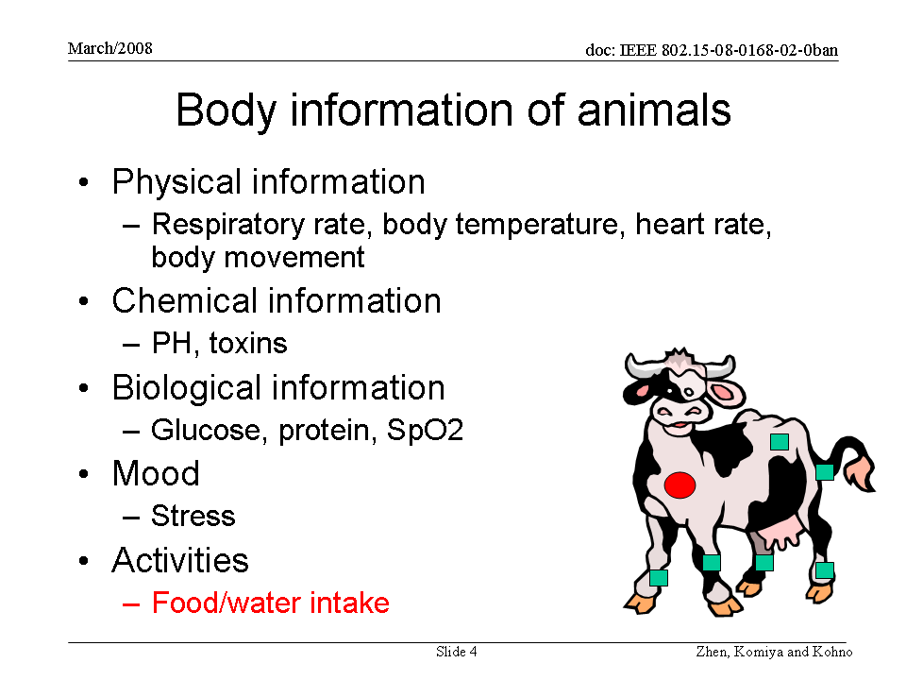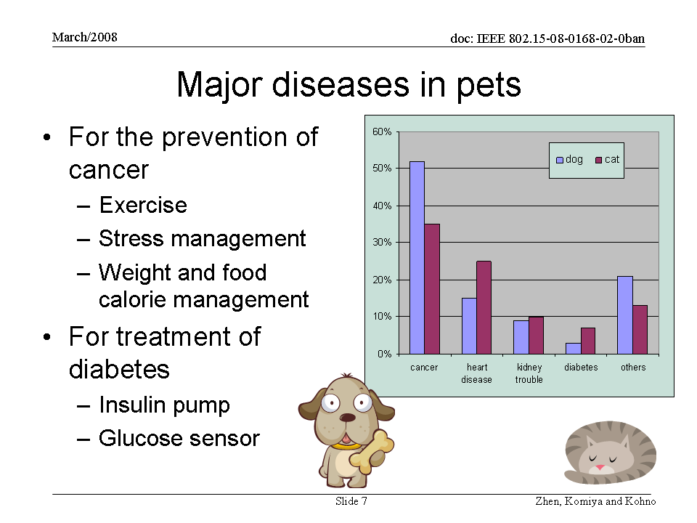 |  |  |  | 

A1-2a Implant BAN (MICS)

Glucose sensor (implant) |  |  |  |  |  |  | Z017
SAR Safety | High | Radio range | <3m | Setup time for a new link | <3s | Cost
Regulatory - Radio | Compliant | Coexistence | Yes | Location awareness |  | Market size / region / year | Very large
Topology | Star | Robustness /reliability high/med/low | High | Channel (e.g. in/out body) | In-body | Covered by Other Standards
Data link speed sym/ asymmetric | Asymmetric | Power consumption | Extremely Low | Form Factor | Small
Data rate (per link) |  | Energy scavenging possible | Yes | Privacy | High
Number of devices per piconet) | <12 | QoS - sensitive to error | Yes | Power by:  battery | Yes
Duty cycle (per device) % per time | <1% | QoS - sensitive to latency |  | Power by:  energy scavenging | If possible
Further information:
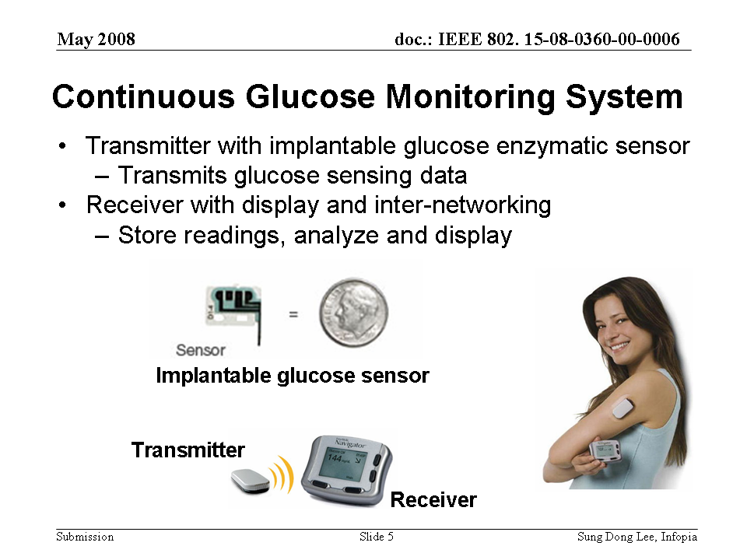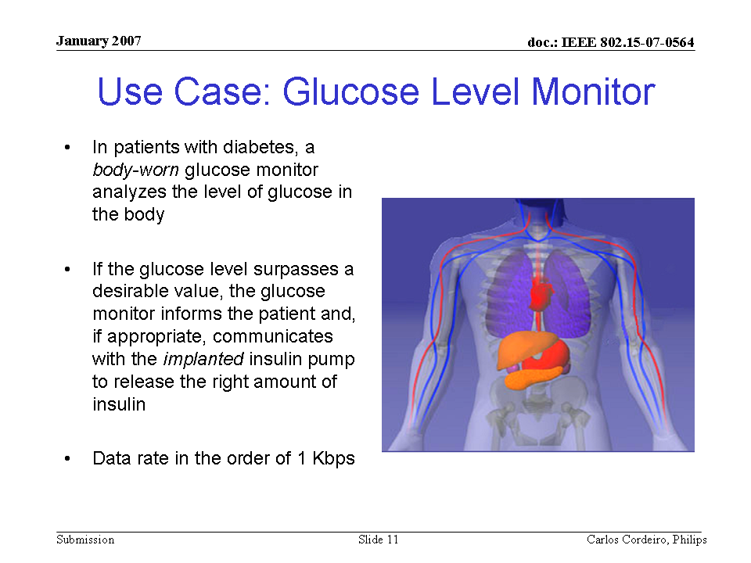 |  |  |  | 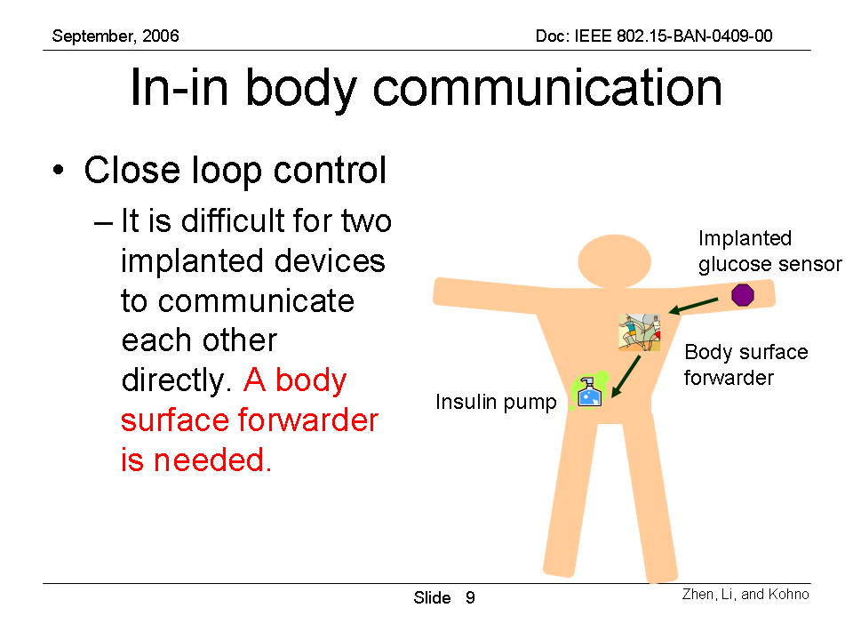

Cardiac arrhythmia monitor/recorder (implant) |  |  |  |  |  |  | Z018
SAR Safety | High | Radio range | <3m | Setup time for a new link | <3s | Cost
Regulatory - Radio | Compliant | Coexistence | Yes | Location awareness |  | Market size / region / year | Very large
Topology | Star/tree | Robustness /reliability high/med/low | High | Channel (e.g. in/out body) | In-body | Covered by Other Standards
Data link speed sym/ asymmetric | Asymmetric | Power consumption | Extremely Low | Form Factor | Small
Data rate (per link) |  | Energy scavenging possible | Yes | Privacy | High
Number of devices per piconet) | <12 | QoS - sensitive to error | Yes | Power by:  battery | Yes
Duty cycle (per device) % per time | <1% | QoS - sensitive to latency |  | Power by:  energy scavenging | If possible
Further information:
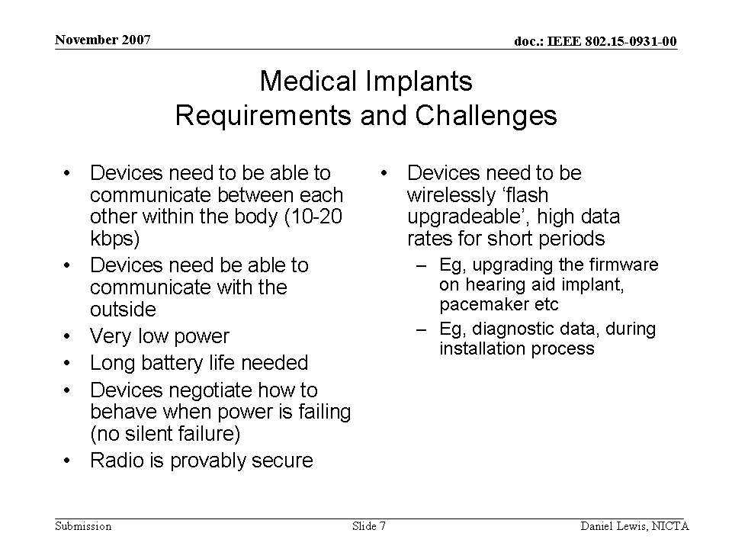

Brain liquid pressure sensor (implant) |  |  |  |  |  |  | Z019
SAR Safety | High | Radio range | <3m | Setup time for a new link | <3s | Cost
Regulatory - Radio | Compliant | Coexistence | Yes | Location awareness |  | Market size / region / year | Large
Topology | Star | Robustness /reliability high/med/low | High | Channel (e.g. in/out body) | In-body | Covered by Other Standards
Data link speed sym/ asymmetric | Asymmetric | Power consumption | Extremely Low | Form Factor | Small
Data rate (per link) |  | Energy scavenging possible | Yes | Privacy | High
Number of devices per piconet) | <12 | QoS - sensitive to error | Yes | Power by:  battery | Yes
Duty cycle (per device) % per time | <1% | QoS - sensitive to latency |  | Power by:  energy scavenging | If possible
Further information:

Endoscope capsule (gastrointestinal) |  |  |  |  |  |  | Z020
SAR Safety | High | Radio range | <3m | Setup time for a new link | <3s | Cost
Regulatory - Radio | Compliant | Coexistence | Yes | Location awareness | If possible | Market size / region / year | Large
Topology | Star | Robustness /reliability high/med/low | High | Channel (e.g. in/out body) | In-body to out-body | Covered by Other Standards
Data link speed sym/ asymmetric | Asymmetric | Power consumption | Low | Form Factor | SwalLowable
Data rate (per link) | > 2Mbps | Energy scavenging possible |  | Privacy | Medium
Number of devices per piconet) | <6 | QoS - sensitive to error | Yes | Power by:  battery | Yes
Duty cycle (per device) % per time | <50% | QoS - sensitive to latency | Yes | Power by:  energy scavenging | If possible
Further information:
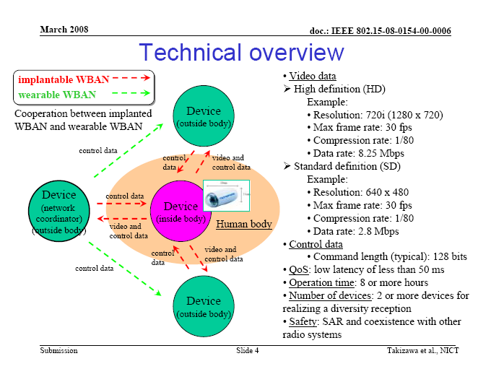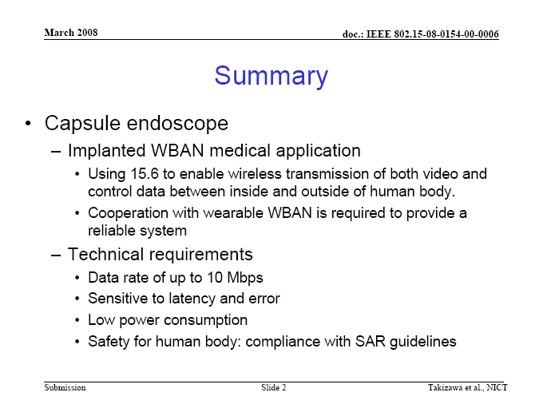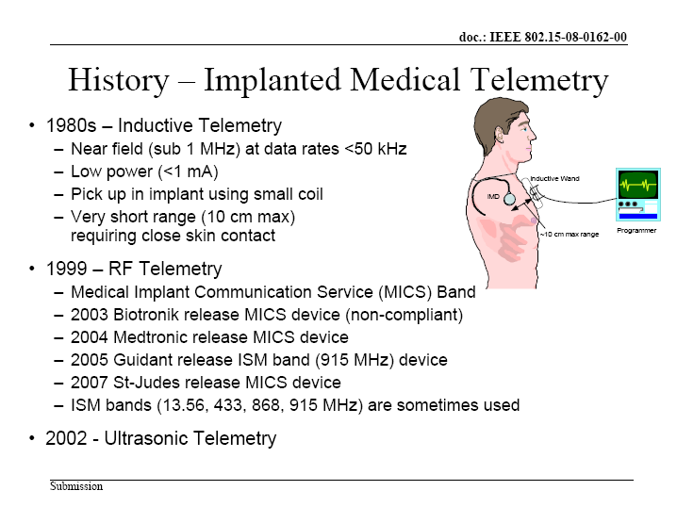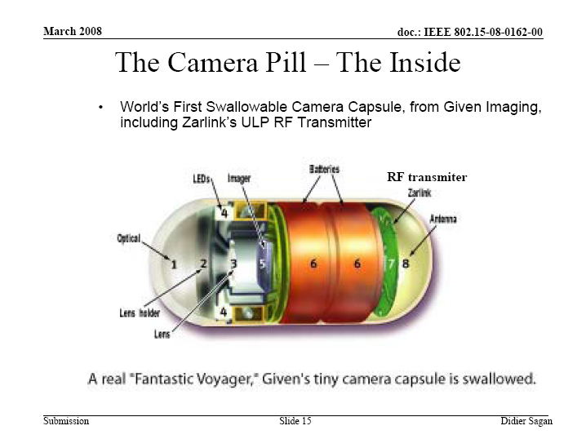 |  |  |  | 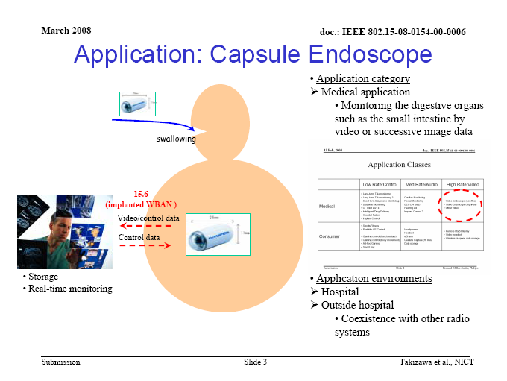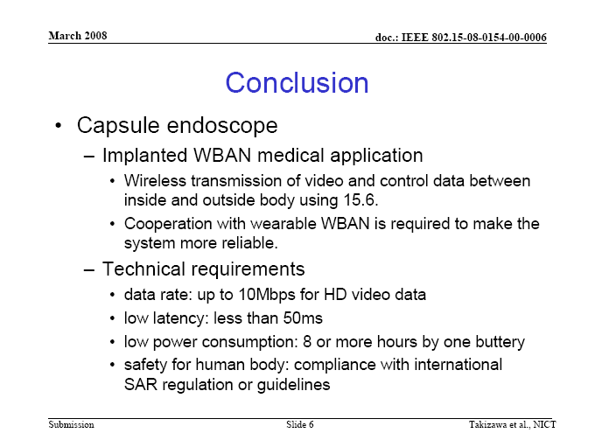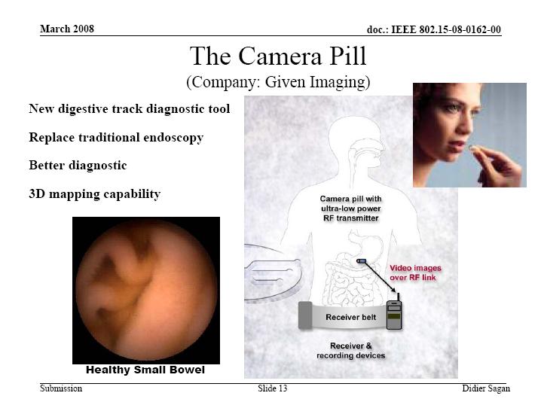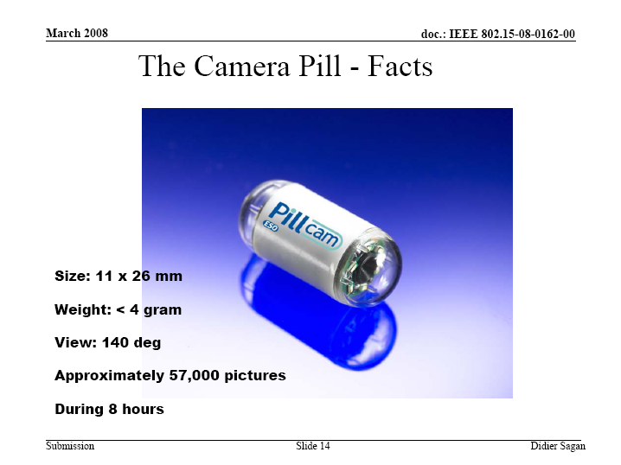

Drug delivery capsule |  |  |  |  |  |  | Z021
SAR Safety |  | Radio range | <3m | Setup time for a new link | <3s | Cost
Regulatory - Radio | Compliant | Coexistence | Yes | Location awareness |  | Market size / region / year
Topology | Star | Robustness /reliability high/med/low | High | Channel (e.g. in/out body) | In-body | Covered by Other Standards
Data link speed sym/ asymmetric | Asymmetric | Power consumption | Low | Form Factor | Small
Data rate (per link) |  | Energy scavenging possible | Yes | Privacy | High
Number of devices per piconet) | <12 | QoS - sensitive to error | Yes | Power by:  battery | Yes
Duty cycle (per device) % per time | 1% | QoS - sensitive to latency |  | Power by:  energy scavenging | If possible
Further information:
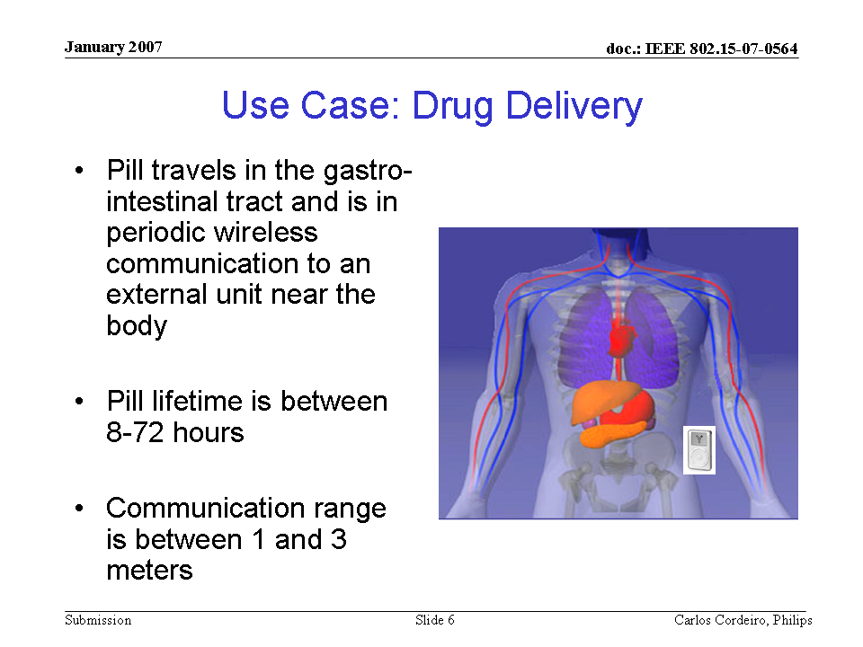 |  |  |  | 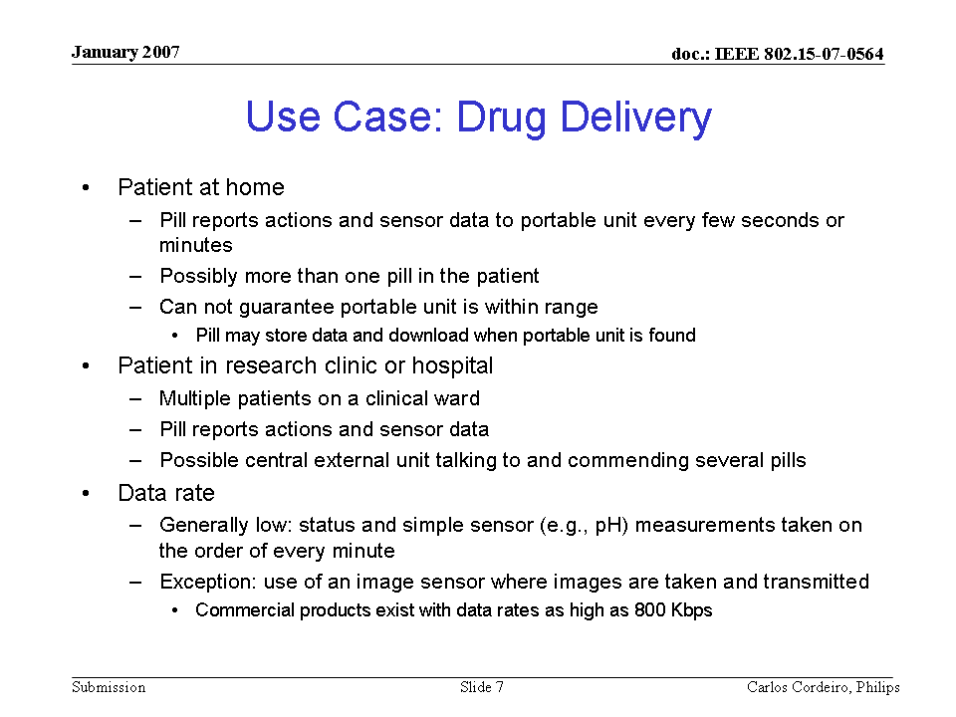

Deep brain stimulator (eg, Epilepsy, Parkinson's therrepy) |  |  |  |  |  |  | Z022
SAR Safety |  | Radio range | <3m | Setup time for a new link | <1s | Cost
Regulatory - Radio | Compliant | Coexistence | Yes | Location awareness |  | Market size / region / year
Topology | Star | Robustness /reliability high/med/low | Medium | Channel (e.g. in/out body) | In-body | Covered by Other Standards
Data link speed sym/ asymmetric | Asymmetric | Power consumption | Extremely Low | Form Factor | Small
Data rate (per link) |  | Energy scavenging possible | Yes | Privacy | High
Number of devices per piconet) | >24 | QoS - sensitive to error | Yes | Power by:  battery | Yes
Duty cycle (per device) % per time | <50% | QoS - sensitive to latency | Yes | Power by:  energy scavenging | If possible
Further information:
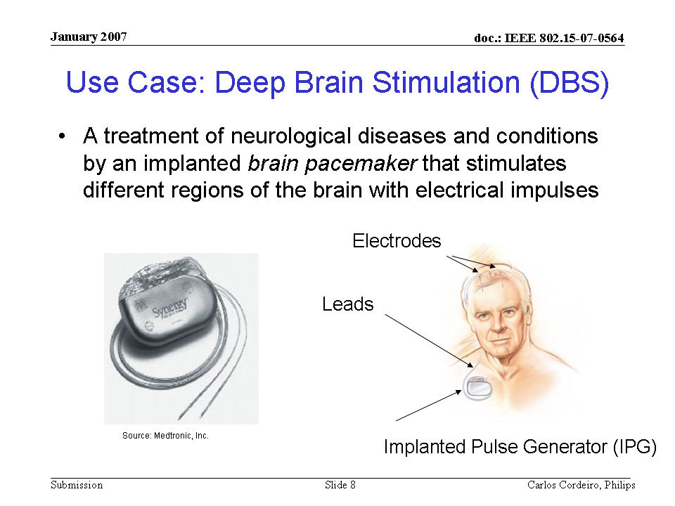 |  |  |  | 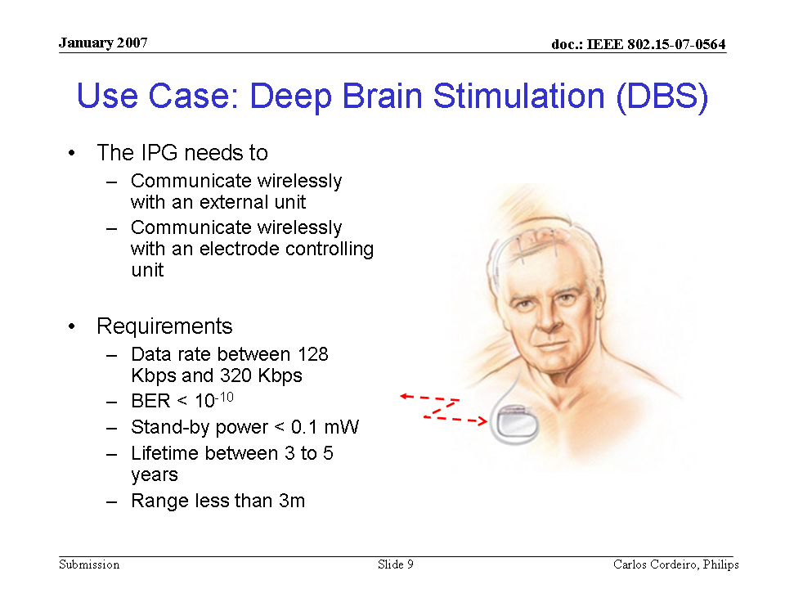

Cortical stimulator |  |  |  |  |  |  | Z023
SAR Safety |  | Radio range | <3m | Setup time for a new link | <1s | Cost
Regulatory - Radio | Compliant | Coexistence | Yes | Location awareness |  | Market size / region / year
Topology | Star | Robustness /reliability high/med/low | Medium | Channel (e.g. in/out body) | In-body | Covered by Other Standards
Data link speed sym/ asymmetric | Asymmetric | Power consumption | Extremely Low | Form Factor | Small
Data rate (per link) |  | Energy scavenging possible | Yes | Privacy | High
Number of devices per piconet) | >24 | QoS - sensitive to error | Yes | Power by:  battery | Yes
Duty cycle (per device) % per time | <50% | QoS - sensitive to latency | Yes | Power by:  energy scavenging | If possible
Further information:

Visual neuro-stimulator |  |  |  |  |  |  | Z024
SAR Safety |  | Radio range | <3m | Setup time for a new link | <1s | Cost
Regulatory - Radio | Compliant | Coexistence | Yes | Location awareness |  | Market size / region / year
Topology | Star | Robustness /reliability high/med/low | Medium | Channel (e.g. in/out body) | In-body | Covered by Other Standards
Data link speed sym/ asymmetric | Asymmetric | Power consumption | Extremely Low | Form Factor | Small
Data rate (per link) |  | Energy scavenging possible | Yes | Privacy | High
Number of devices per piconet) | >24 | QoS - sensitive to error | Yes | Power by:  battery | Yes
Duty cycle (per device) % per time | <50% | QoS - sensitive to latency | Yes | Power by:  energy scavenging | If possible
Further information:

Audio neuro stimulator |  |  |  |  |  |  | Z025
SAR Safety |  | Radio range | <3m | Setup time for a new link | <1s | Cost
Regulatory - Radio | Compliant | Coexistence | Yes | Location awareness |  | Market size / region / year
Topology | Star | Robustness /reliability high/med/low | Medium | Channel (e.g. in/out body) | In-body | Covered by Other Standards
Data link speed sym/ asymmetric | Asymmetric | Power consumption | Extremely Low | Form Factor | Small
Data rate (per link) |  | Energy scavenging possible | Yes | Privacy | High
Number of devices per piconet) | >24 | QoS - sensitive to error | Yes | Power by:  battery | Yes
Duty cycle (per device) % per time | <50% | QoS - sensitive to latency | Yes | Power by:  energy scavenging | If possible
Further information:

Brain-computer interface |  |  |  |  |  |  | Z026
SAR Safety |  | Radio range | <3m | Setup time for a new link | <1s | Cost
Regulatory - Radio | Compliant | Coexistence | Yes | Location awareness |  | Market size / region / year
Topology | Star | Robustness /reliability high/med/low | Medium | Channel (e.g. in/out body) | In-body | Covered by Other Standards
Data link speed sym/ asymmetric | Asymmetric | Power consumption | Extremely Low | Form Factor | Small
Data rate (per link) |  | Energy scavenging possible | Yes | Privacy | High
Number of devices per piconet) | >24 | QoS - sensitive to error | Yes | Power by:  battery | Yes
Duty cycle (per device) % per time | <50% | QoS - sensitive to latency | Yes | Power by:  energy scavenging | If possible
Further information:
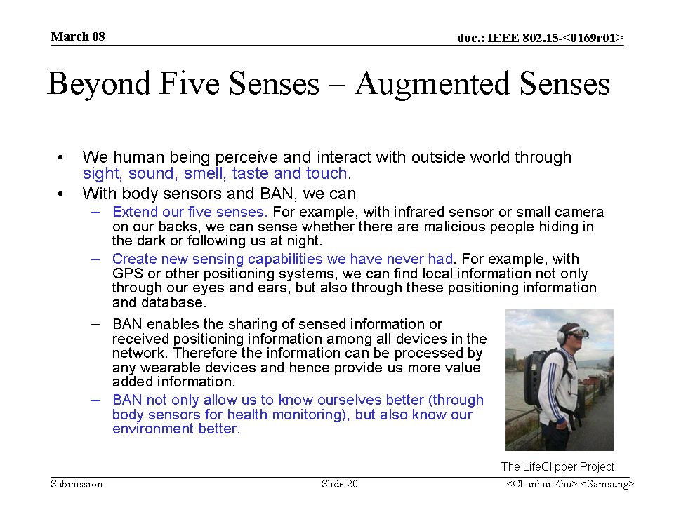

A1-2b Remote control of medical devices

Pacemaker |  |  |  |  |  |  | Z027
SAR Safety |  | Radio range | <3m | Setup time for a new link | <3s | Cost
Regulatory - Radio | Compliant | Coexistence | Yes | Location awareness |  | Market size / region / year
Topology | Star | Robustness /reliability high/med/low | High | Channel (e.g. in/out body) | In/On-body & On/In-body | Covered by Other Standards
Data link speed sym/ asymmetric | Asymmetric | Power consumption | Low | Form Factor
Data rate (per link) |  | Energy scavenging possible | Yes | Privacy | High
Number of devices per piconet) | <12 | QoS - sensitive to error | Yes | Power by:  battery | Yes
Duty cycle (per device) % per time | <1% | QoS - sensitive to latency |  | Power by:  energy scavenging | If possible
Further information:

Implantable cardioverter defibrallitor ICD |  |  |  |  |  |  | Z028
SAR Safety |  | Radio range | <3m | Setup time for a new link | <3s | Cost
Regulatory - Radio | Compliant | Coexistence | Yes | Location awareness |  | Market size / region / year
Topology | Star | Robustness /reliability high/med/low | High | Channel (e.g. in/out body) | In/On & On/In | Covered by Other Standards
Data link speed sym/ asymmetric | Asymmetric | Power consumption | Low | Form Factor
Data rate (per link) |  | Energy scavenging possible | Yes | Privacy | High
Number of devices per piconet) | <12 | QoS - sensitive to error | Yes | Power by:  battery | Yes
Duty cycle (per device) % per time | <1% | QoS - sensitive to latency |  | Power by:  energy scavenging | If possible
Further information:
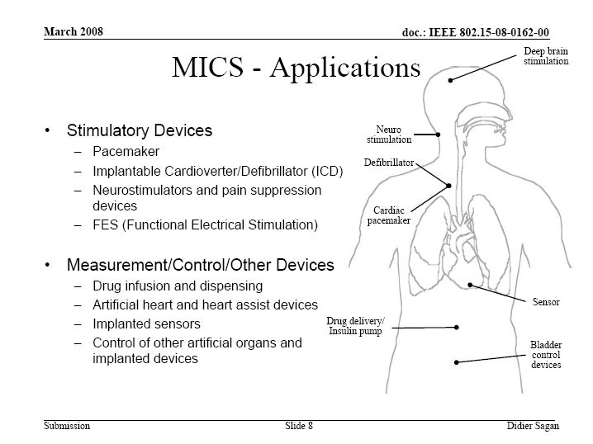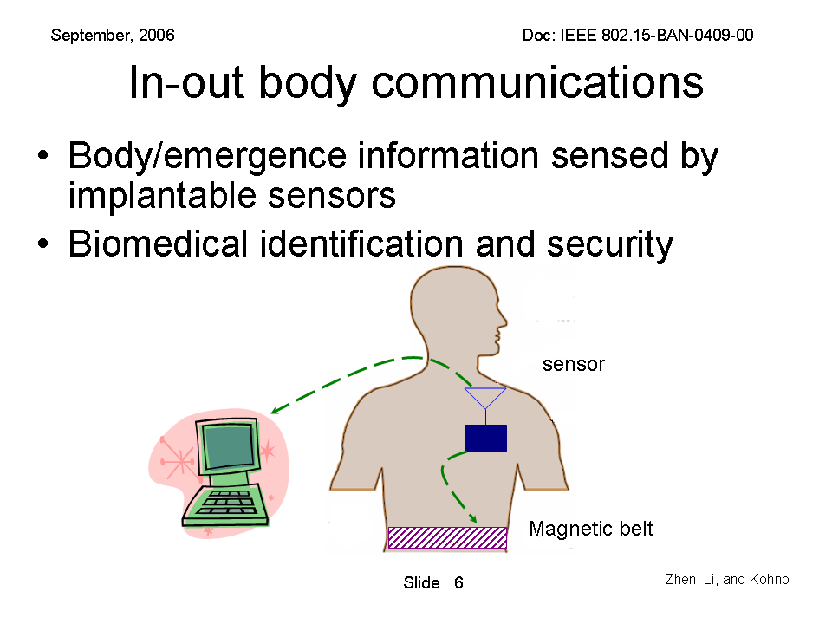 |  |  |  | 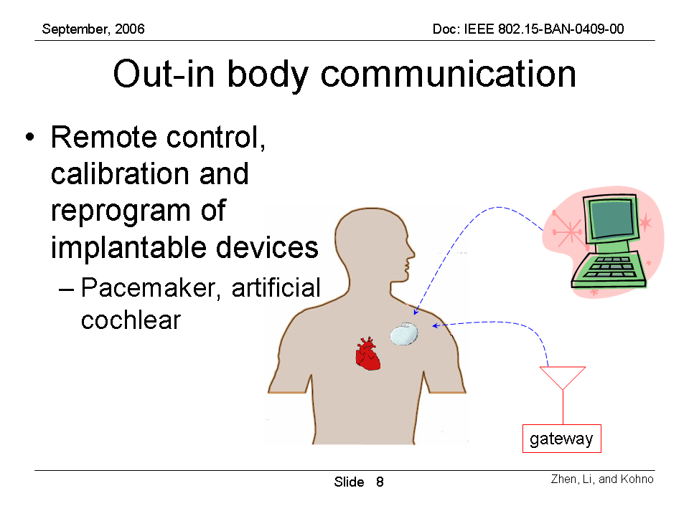

Implanted actuator |  |  |  |  |  |  | Z029
SAR Safety |  | Radio range | <3m | Setup time for a new link | <3s | Cost
Regulatory - Radio | Compliant | Coexistence | Yes | Location awareness |  | Market size / region / year
Topology | Star | Robustness /reliability high/med/low | High | Channel (e.g. in/out body) |  | Covered by Other Standards
Data link speed sym/ asymmetric | Asymmetric | Power consumption | Low | Form Factor
Data rate (per link) |  | Energy scavenging possible | Yes | Privacy | High
Number of devices per piconet) | <12 | QoS - sensitive to error | Yes | Power by:  battery | Yes
Duty cycle (per device) % per time | <1% | QoS - sensitive to latency |  | Power by:  energy scavenging | If possible
Further information:
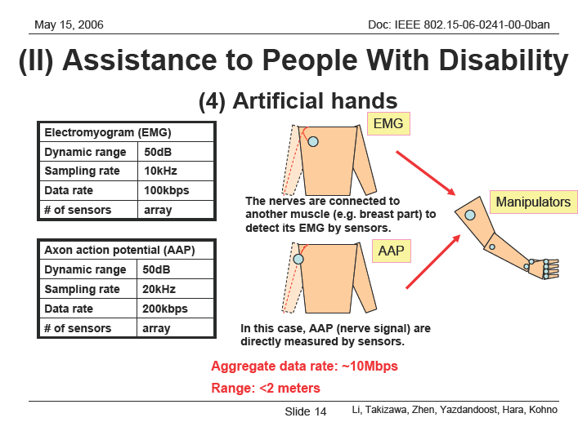

Insulin pump |  |  |  |  |  |  | Z030
SAR Safety |  | Radio range | <3m | Setup time for a new link | <3s | Cost
Regulatory - Radio | Compliant | Coexistence | Yes | Location awareness |  | Market size / region / year
Topology | Star | Robustness /reliability high/med/low | High | Channel (e.g. in/out body) | In/On & On/In | Covered by Other Standards
Data link speed sym/ asymmetric | Asymmetric | Power consumption | Low | Form Factor
Data rate (per link) |  | Energy scavenging possible | Yes | Privacy | High
Number of devices per piconet) | <12 | QoS - sensitive to error | Yes | Power by:  battery | Yes
Duty cycle (per device) % per time | <1% | QoS - sensitive to latency |  | Power by:  energy scavenging | If possible
Further information:
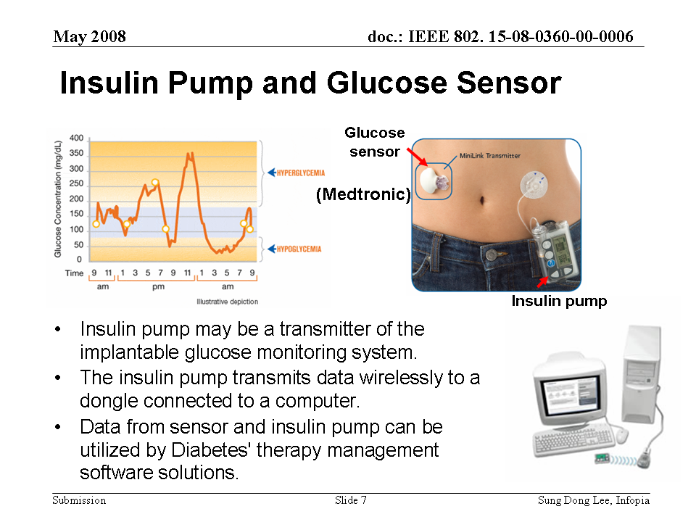

Hearing aid (wearable and implanted) |  |  |  |  |  |  | Z031
SAR Safety |  | Radio range | <3m | Setup time for a new link | <3s | Cost
Regulatory - Radio | Compliant | Coexistence | Yes | Location awareness |  | Market size / region / year
Topology | Star | Robustness /reliability high/med/low | High | Channel (e.g. in/out body) | On & In Body | Covered by Other Standards
Data link speed sym/ asymmetric | Asymmetric | Power consumption | Low | Form Factor
Data rate (per link) |  | Energy scavenging possible | Yes | Privacy | High
Number of devices per piconet) | <12 | QoS - sensitive to error | Yes | Power by:  battery | Yes
Duty cycle (per device) % per time | <1% | QoS - sensitive to latency |  | Power by:  energy scavenging | If possible
Further information:

Retina implants |  |  |  |  |  |  | Z032
SAR Safety |  | Radio range | <3m | Setup time for a new link | <3s | Cost
Regulatory - Radio | Compliant | Coexistence | Yes | Location awareness |  | Market size / region / year
Topology | Star | Robustness /reliability high/med/low | High | Channel (e.g. in/out body) | In Body | Covered by Other Standards
Data link speed sym/ asymmetric | Asymmetric | Power consumption | Extremely Low | Form Factor
Data rate (per link) |  | Energy scavenging possible | Yes | Privacy | High
Number of devices per piconet) | <12 | QoS - sensitive to error | Yes | Power by:  battery | Yes
Duty cycle (per device) % per time | <1% | QoS - sensitive to latency |  | Power by:  energy scavenging | If possible
Further information:

A2-1 In hospital (in general)

A2-2 Outside Hospital

Class B Non-Medical applications (including entertainment)

B1 Real-time video streaming

Video streaming (among portable devices - Lower resolution) |  |  |  |  |  |  | Z033
SAR Safety |  | Radio range | <3m | Setup time for a new link | <1s | Cost
Regulatory - Radio |  | Coexistence | Yes | Location awareness |  | Market size / region / year
Topology | Star | Robustness /reliability high/med/low | Medium | Channel (e.g. in/out body) | On-body | Covered by Other Standards
Data link speed sym/ asymmetric | Asymmetric | Power consumption | Relatively high | Form Factor
Data rate (per link) | 10Mbps | Energy scavenging possible | Yes | Privacy | Low
Number of devices per piconet) | <12 | QoS - sensitive to error |  | Power by:  battery | Yes
Duty cycle (per device) % per time | High | QoS - sensitive to latency | Yes | Power by:  energy scavenging | No
Further information:
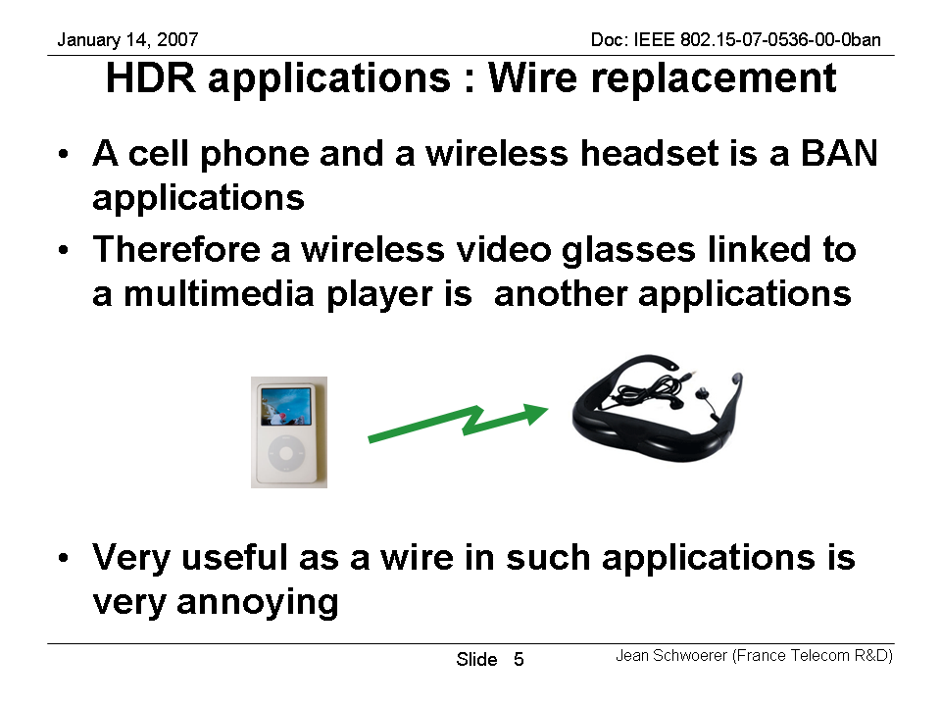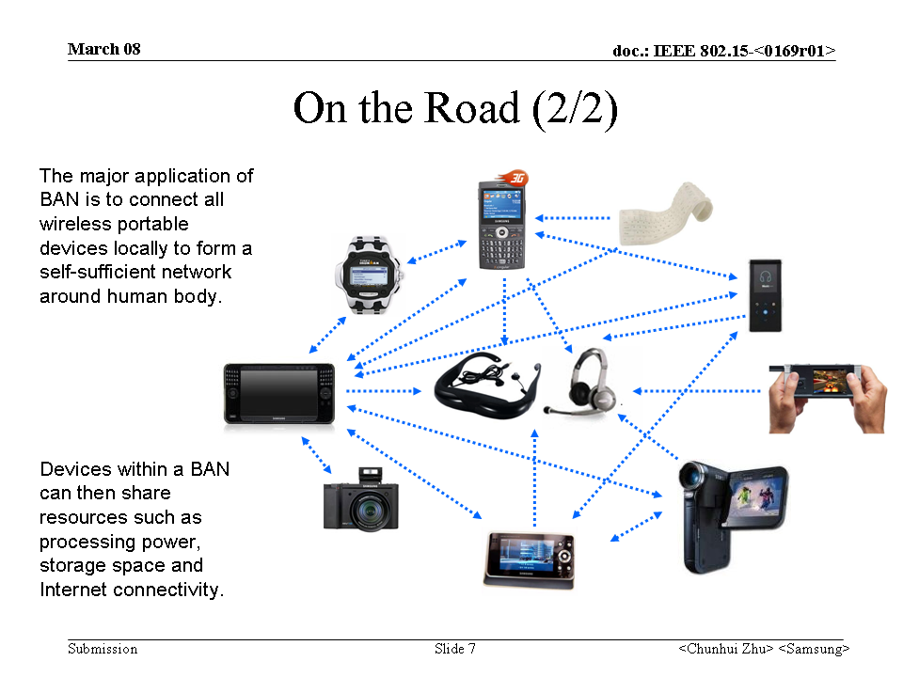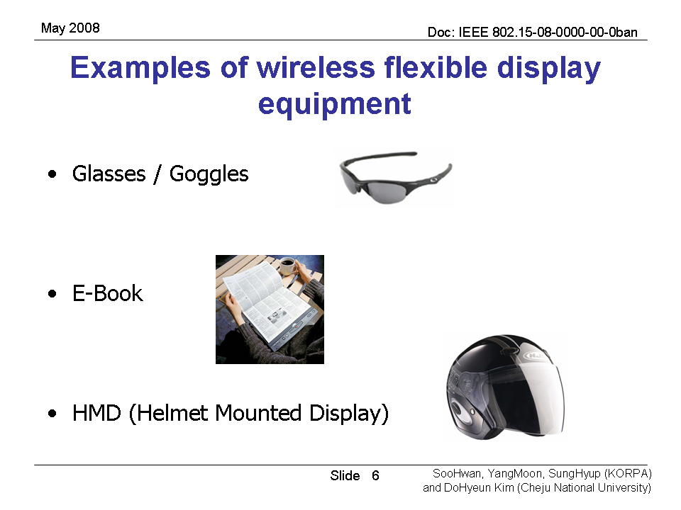 |  |  |  | 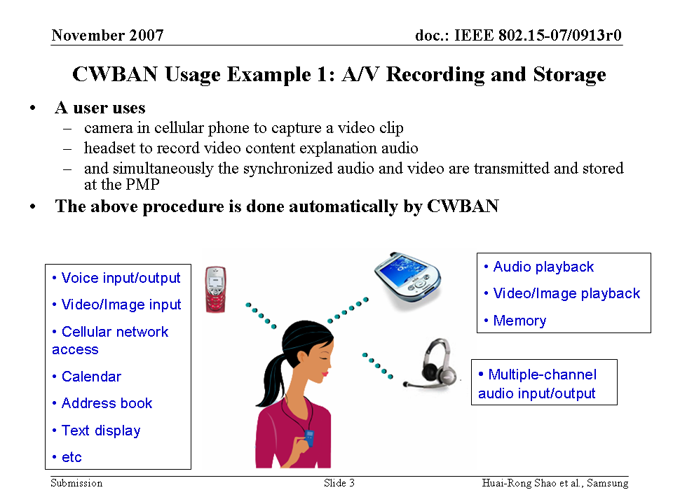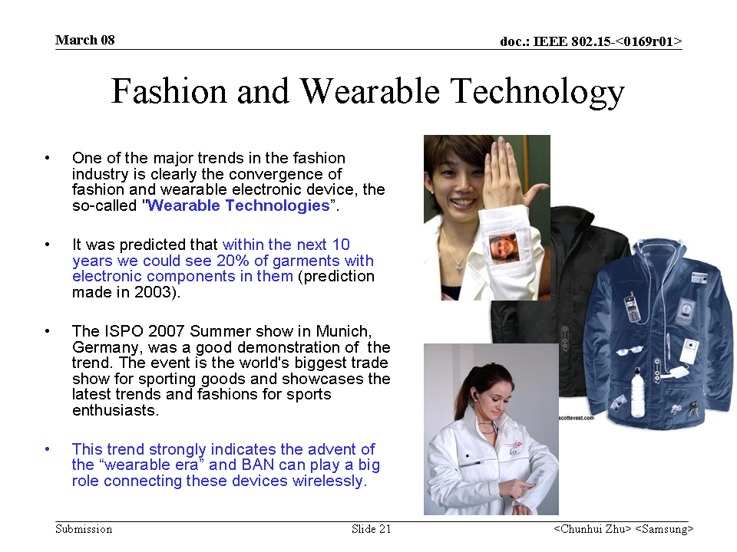

Video streaming (portable device external displays - Higher resolution) |  |  |  |  |  |  | Z034
SAR Safety |  | Radio range | <3m | Setup time for a new link | <1s | Cost
Regulatory - Radio |  | Coexistence | Yes | Location awareness |  | Market size / region / year
Topology | Star | Robustness /reliability high/med/low | Medium | Channel (e.g. in/out body) | On-body | Covered by Other Standards
Data link speed sym/ asymmetric | Asymmetric | Power consumption | Relatively high | Form Factor
Data rate (per link) | 10~20Mbps? | Energy scavenging possible | Yes | Privacy | Low
Number of devices per piconet) | <12 | QoS - sensitive to error |  | Power by:  battery | Yes
Duty cycle (per device) % per time | High | QoS - sensitive to latency | Yes | Power by:  energy scavenging | No
Further information:
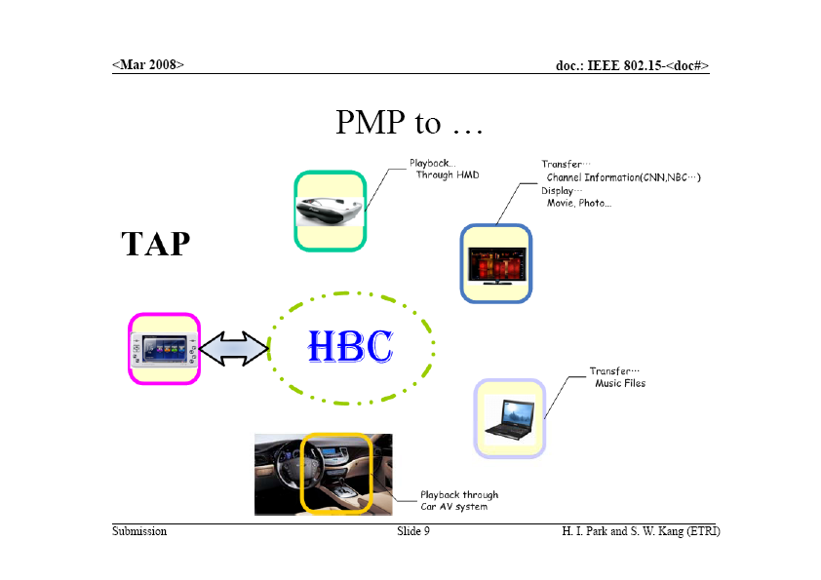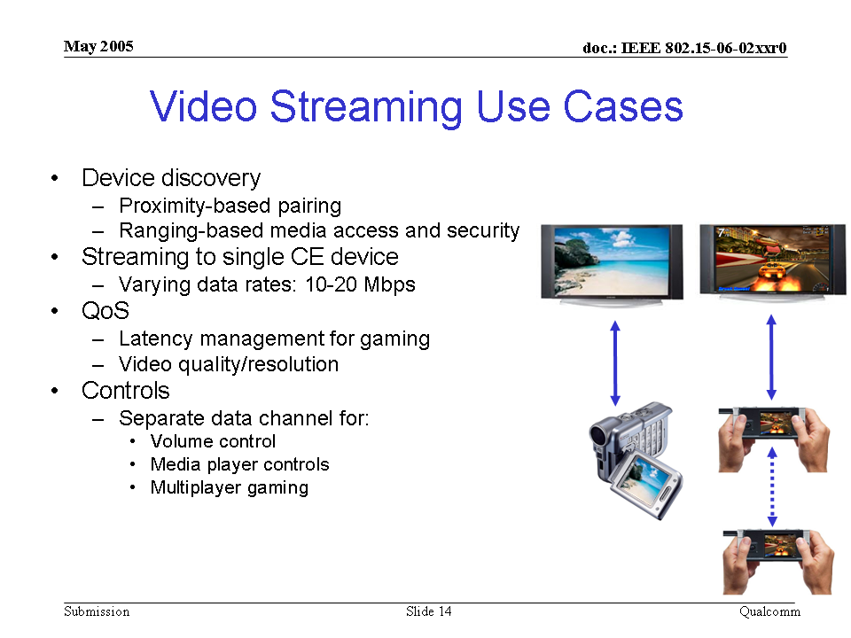 |  |  |  | 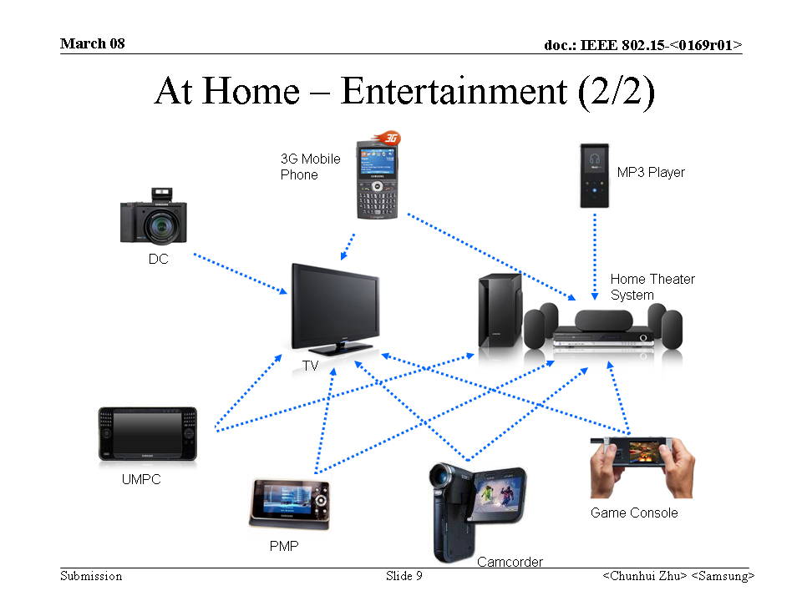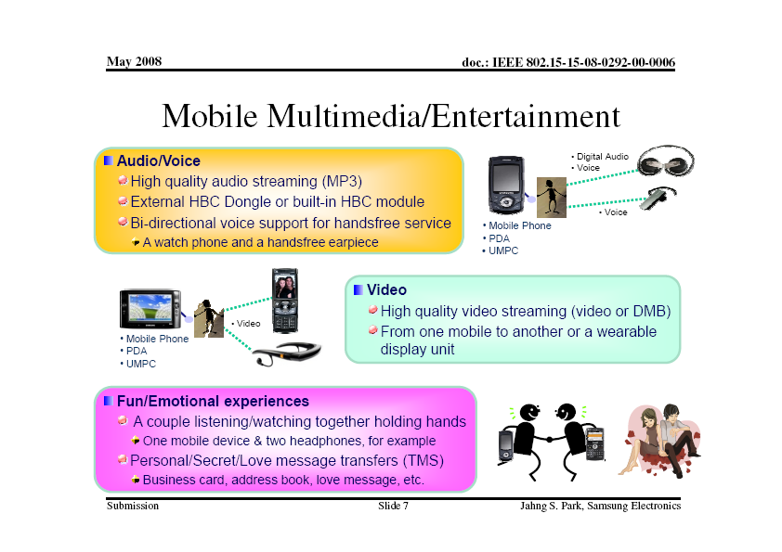

3D video |  |  |  |  |  |  | Z035
SAR Safety |  | Radio range | <3m | Setup time for a new link | <1s | Cost
Regulatory - Radio |  | Coexistence | Yes | Location awareness |  | Market size / region / year
Topology | Star | Robustness /reliability high/med/low | Medium | Channel (e.g. in/out body) | On-body | Covered by Other Standards
Data link speed sym/ asymmetric | Asymmetric | Power consumption | Relatively high | Form Factor
Data rate (per link) | 100Mbps? | Energy scavenging possible | Yes | Privacy | Low
Number of devices per piconet) | <12 | QoS - sensitive to error |  | Power by:  battery | Yes
Duty cycle (per device) % per time | High | QoS - sensitive to latency | Yes | Power by:  energy scavenging | No
Further information:

B2 Real-time audio streaming

Voice communication for headsets (moNo, and Lower quality) |  |  |  |  |  |  | Z36
SAR Safety |  | Radio range | <3m | Setup time for a new link | <3s | Cost
Regulatory - Radio |  | Coexistence | Yes | Location awareness |  | Market size / region / year
Topology | Star | Robustness /reliability high/med/low | Medium | Channel (e.g. in/out body) | On-body | Covered by Other Standards
Data link speed sym/ asymmetric | Asymmetric | Power consumption | Relatively high | Form Factor
Data rate (per link) | 256kbps | Energy scavenging possible | Yes | Privacy | Low
Number of devices per piconet) | <12 | QoS - sensitive to error |  | Power by:  battery | Yes
Duty cycle (per device) % per time | High | QoS - sensitive to latency | Yes | Power by:  energy scavenging | No
Further information:
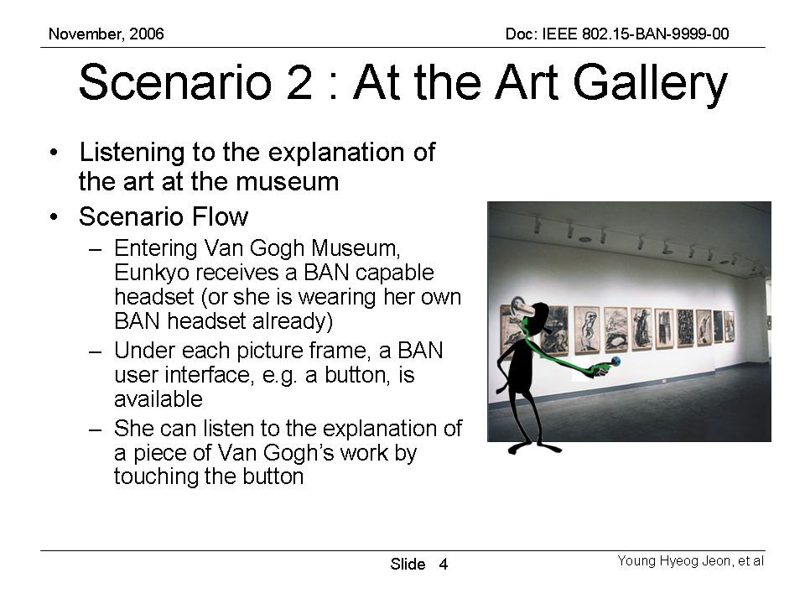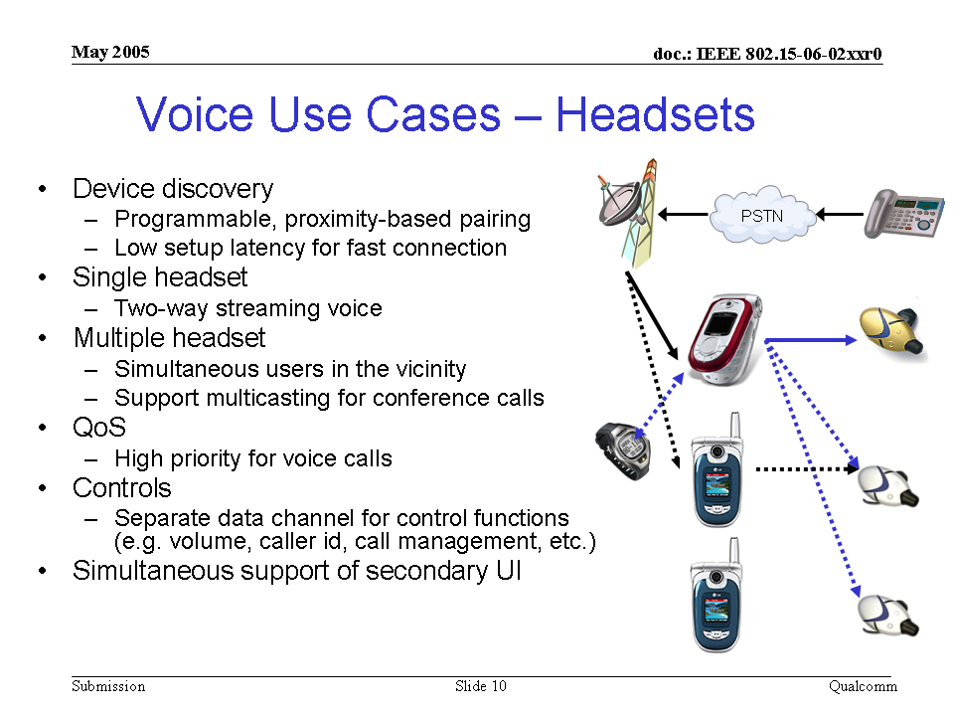 |  |  |  | 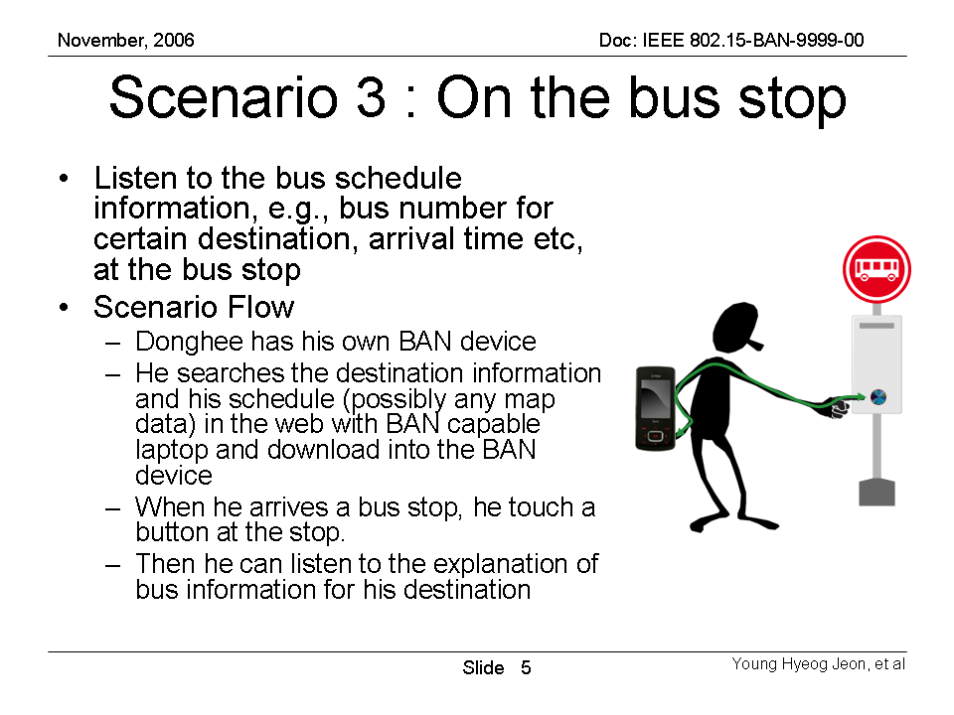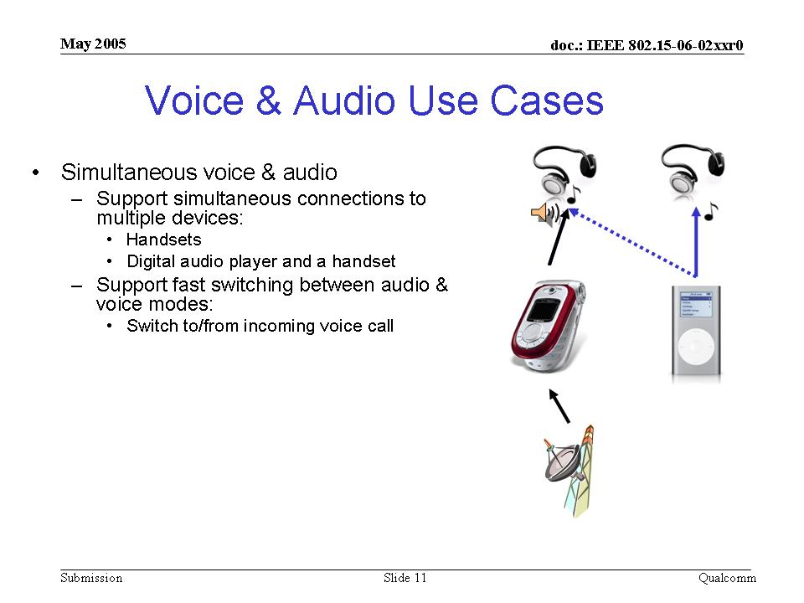

Music for headsets (stereo, and Higher quality) |  |  |  |  |  |  | Z37
SAR Safety |  | Radio range | <3m | Setup time for a new link | <3s | Cost
Regulatory - Radio |  | Coexistence | Yes | Location awareness |  | Market size / region / year
Topology | Star | Robustness /reliability high/med/low | Medium | Channel (e.g. in/out body) | On-body | Covered by Other Standards
Data link speed sym/ asymmetric | Asymmetric | Power consumption | Relatively high | Form Factor
Data rate (per link) | 1Mbps | Energy scavenging possible | Yes | Privacy | Low
Number of devices per piconet) | <12 | QoS - sensitive to error |  | Power by:  battery | Yes
Duty cycle (per device) % per time | High | QoS - sensitive to latency | Yes | Power by:  energy scavenging | No
Further information:
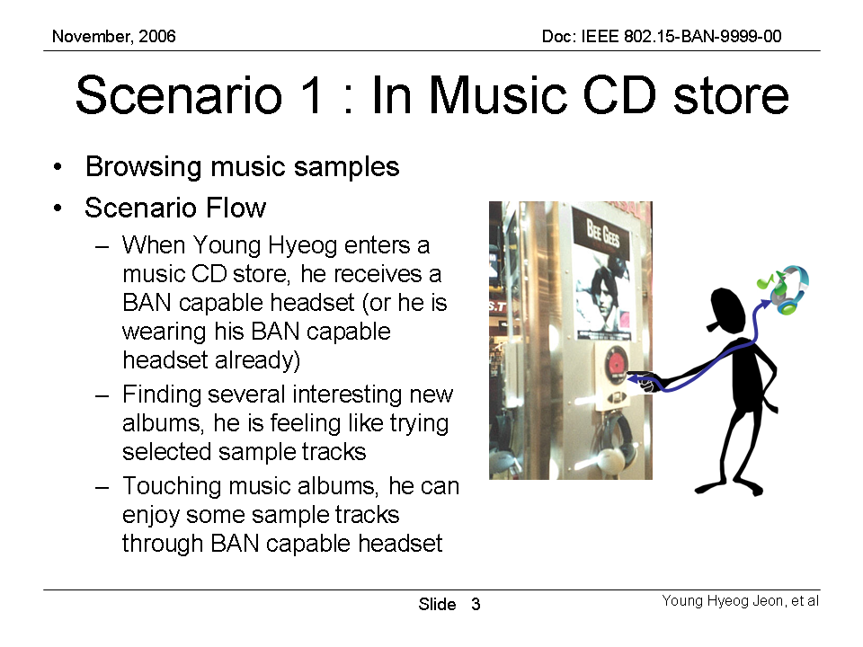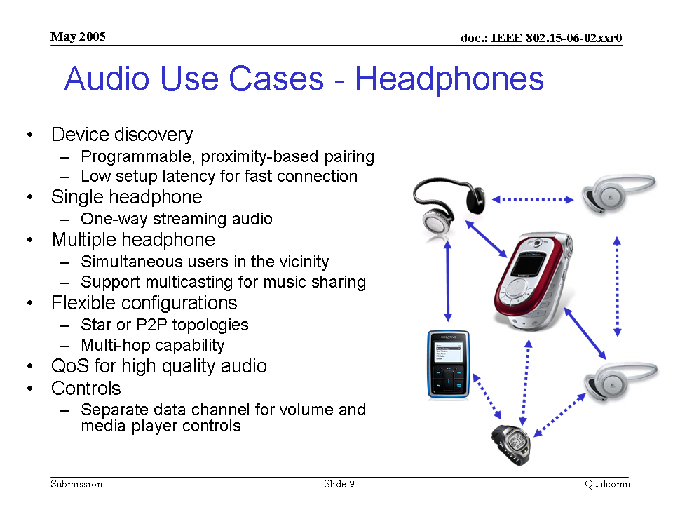 |  |  |  | 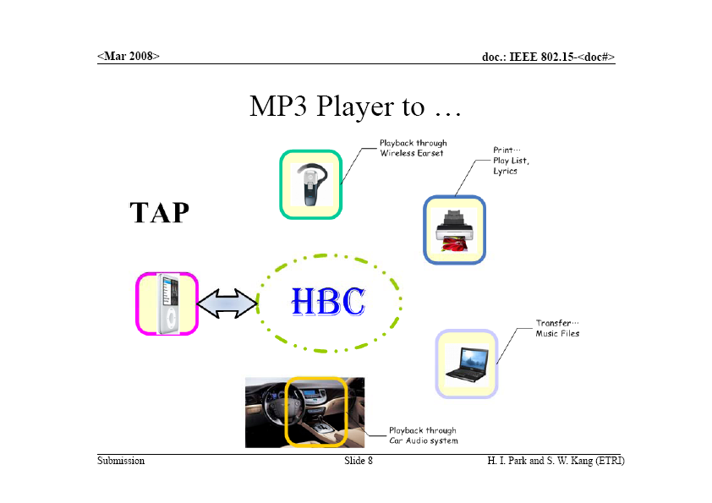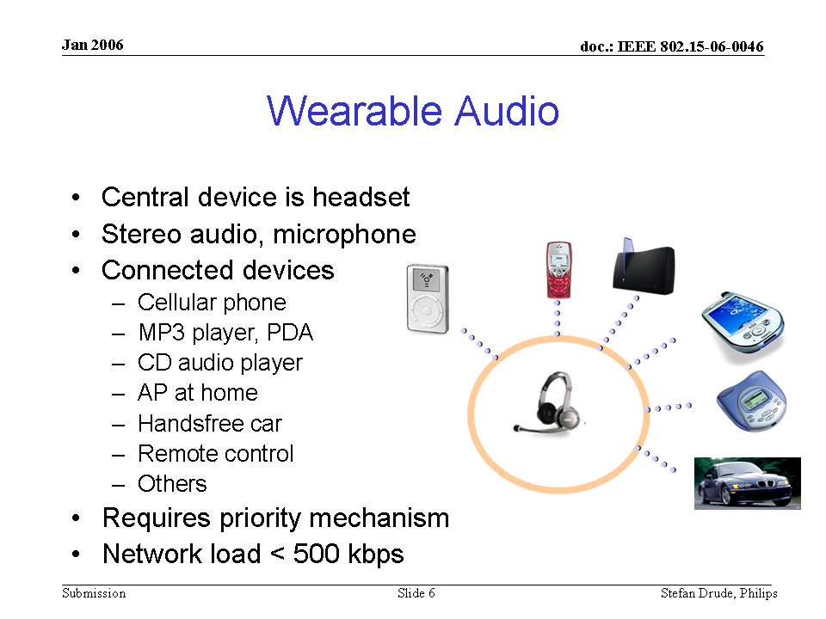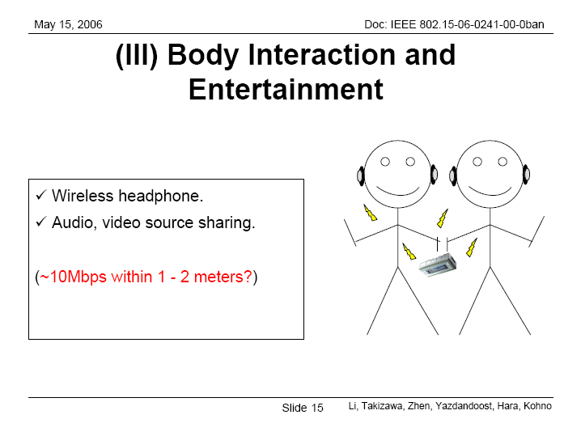

Sound track/Music - 5.1 channel (Higher bandwidth) |  |  |  |  |  |  | Z38
SAR Safety |  | Radio range | <5m | Setup time for a new link | <3s | Cost
Regulatory - Radio |  | Coexistence | Yes | Location awareness |  | Market size / region / year
Topology | Star | Robustness /reliability high/med/low | Medium | Channel (e.g. in/out body) | On-body | Covered by Other Standards
Data link speed sym/ asymmetric | Asymmetric | Power consumption | Relatively high | Form Factor
Data rate (per link) | 5Mbps | Energy scavenging possible | Yes | Privacy | Low
Number of devices per piconet) | <12 | QoS - sensitive to error |  | Power by:  battery | Yes
Duty cycle (per device) % per time | High | QoS - sensitive to latency | Yes | Power by:  energy scavenging | No
Further information:
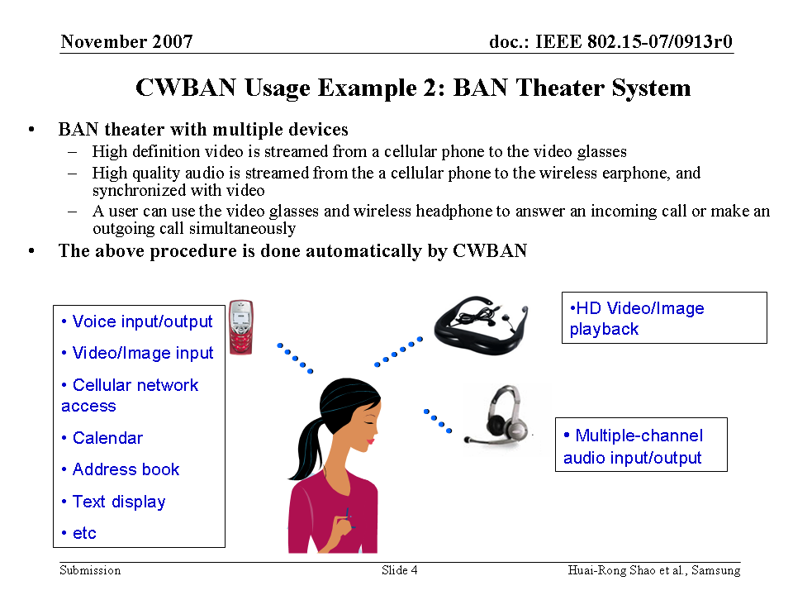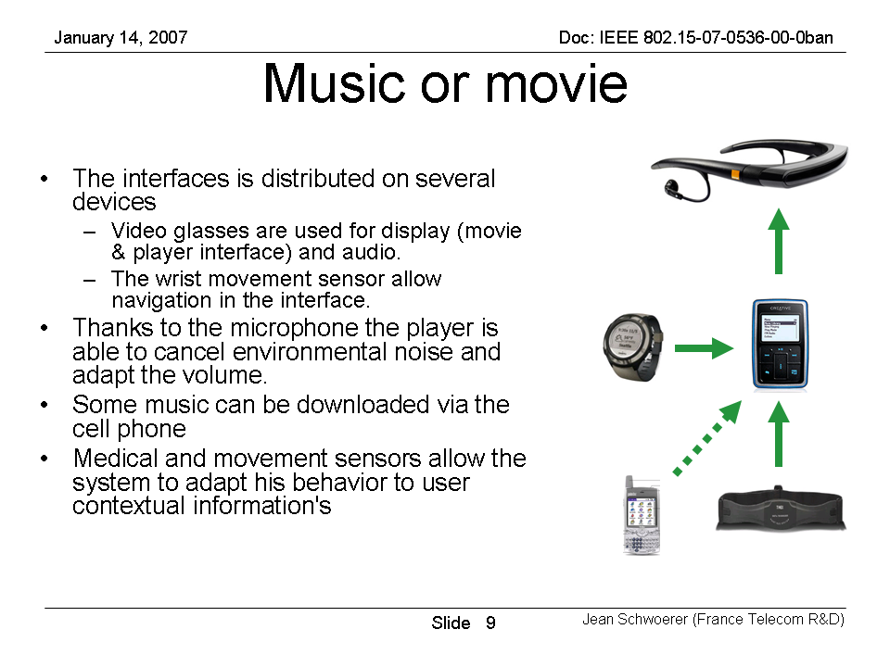 |  |  |  | 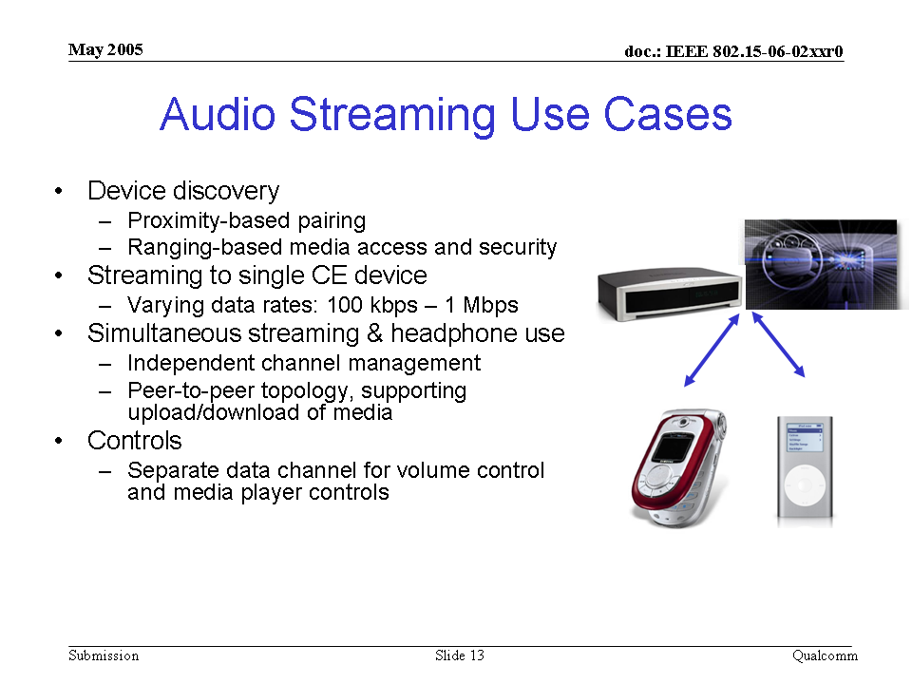

B3 Data file transfer

Data file transfer (Word, Excel, software programs and etc) |  |  |  |  |  |  | Z39
SAR Safety |  | Radio range | <3m | Setup time for a new link | <3s | Cost
Regulatory - Radio |  | Coexistence | Yes | Location awareness |  | Market size / region / year
Topology | Star | Robustness /reliability high/med/low | High | Channel (e.g. in/out body) | On-body | Covered by Other Standards
Data link speed sym/ asymmetric | Asymmetric | Power consumption | Med | Form Factor
Data rate (per link) | 10Mbps | Energy scavenging possible | Yes | Privacy | High
Number of devices per piconet) | <12 | QoS - sensitive to error | Yes | Power by:  battery | Yes
Duty cycle (per device) % per time | High | QoS - sensitive to latency |  | Power by:  energy scavenging | No
Further information:
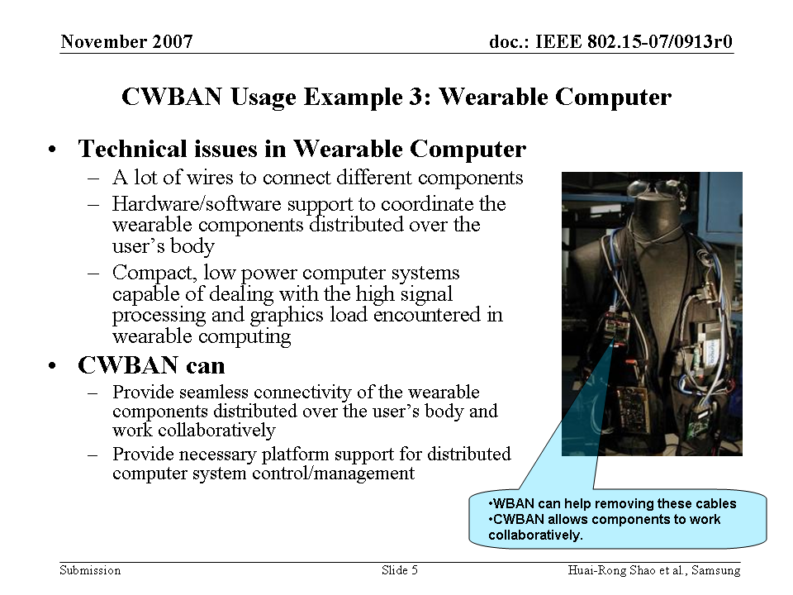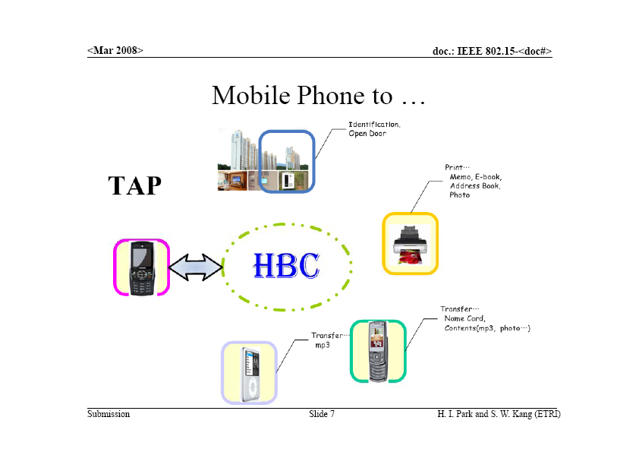 |  |  |  | 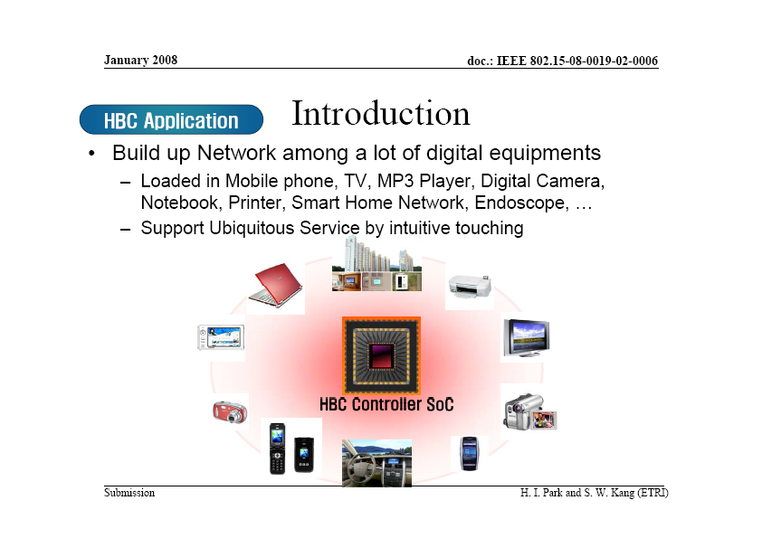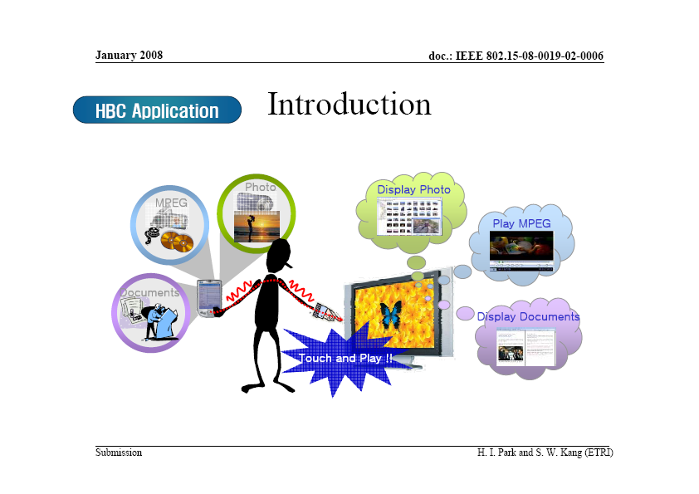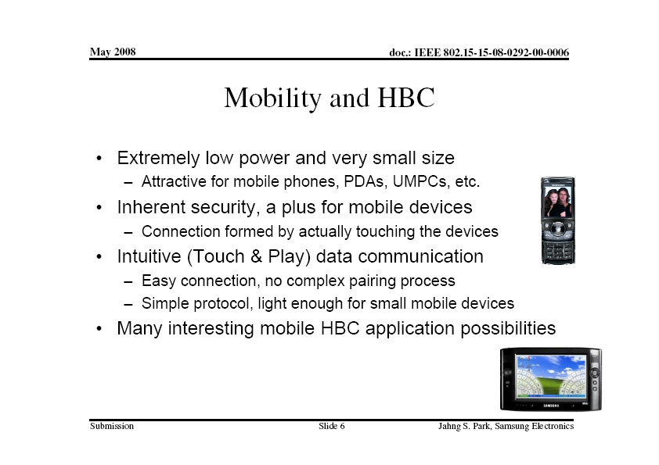

Image file transfer (digital camera, scanner and etc.) |  |  |  |  |  |  | Z40
SAR Safety |  | Radio range | <3m | Setup time for a new link | <3s | Cost
Regulatory - Radio |  | Coexistence | Yes | Location awareness |  | Market size / region / year
Topology | Star | Robustness /reliability high/med/low | High | Channel (e.g. in/out body) | On-body | Covered by Other Standards
Data link speed sym/ asymmetric | Asymmetric | Power consumption | Relatively high | Form Factor
Data rate (per link) | 10Mbps | Energy scavenging possible | Yes | Privacy | High
Number of devices per piconet) | <12 | QoS - sensitive to error | Yes | Power by:  battery | Yes
Duty cycle (per device) % per time | High | QoS - sensitive to latency |  | Power by:  energy scavenging | No
Further information:

Video file transfer (camcorder, multimedia player and etc.) |  |  |  |  |  |  | Z41
SAR Safety |  | Radio range | <3m | Setup time for a new link | <3s | Cost
Regulatory - Radio |  | Coexistence | Yes | Location awareness |  | Market size / region / year
Topology | Star | Robustness /reliability high/med/low | High | Channel (e.g. in/out body) | On-body | Covered by Other Standards
Data link speed sym/ asymmetric | Asymmetric | Power consumption | Relatively high | Form Factor
Data rate (per link) | 10Mbps | Energy scavenging possible | Yes | Privacy | High
Number of devices per piconet) | <12 | QoS - sensitive to error | Yes | Power by:  battery | Yes
Duty cycle (per device) % per time | High | QoS - sensitive to latency |  | Power by:  energy scavenging
Further information:
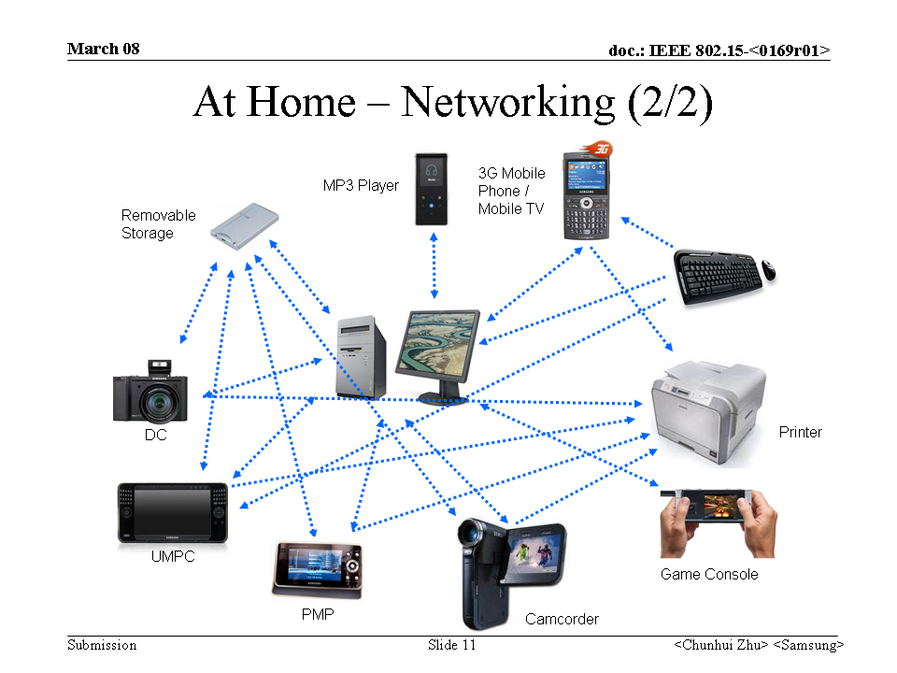 |  |  |  | 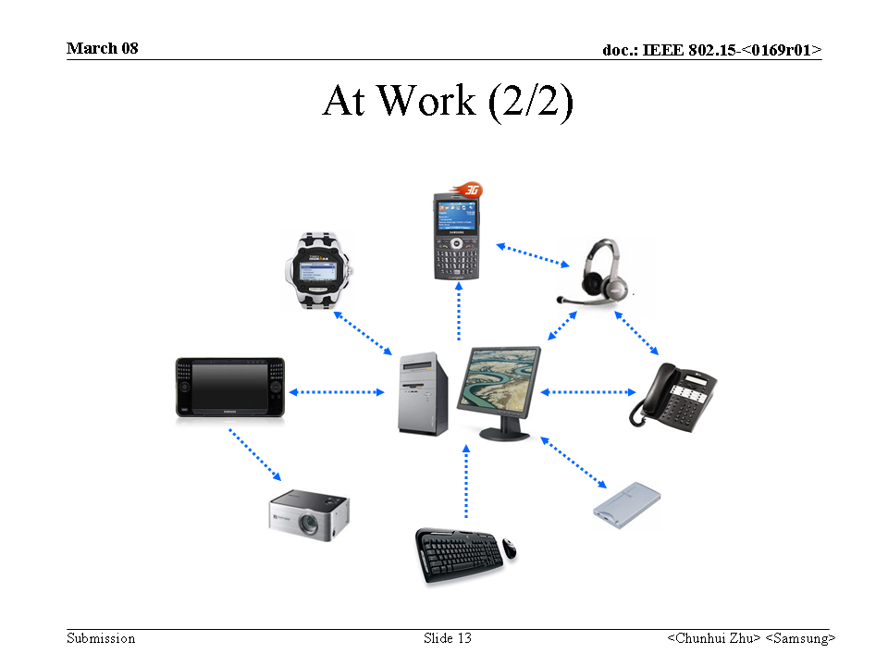

B4 Stream transfer

Remote control of entertainment devices |  |  |  |  |  |  | Z42
SAR Safety |  | Radio range | <5m | Setup time for a new link | <3s | Cost
Regulatory - Radio |  | Coexistence | Yes | Location awareness |  | Market size / region / year
Topology | Star | Robustness /reliability high/med/low | High | Channel (e.g. in/out body) | On-body | Covered by Other Standards
Data link speed sym/ asymmetric | Asymmetric | Power consumption | Low | Form Factor
Data rate (per link) | 256kbps | Energy scavenging possible | Yes | Privacy | High
Number of devices per piconet) | <12 | QoS - sensitive to error | Yes | Power by:  battery
Duty cycle (per device) % per time | Low | QoS - sensitive to latency | Yes | Power by:  energy scavenging
Further information:
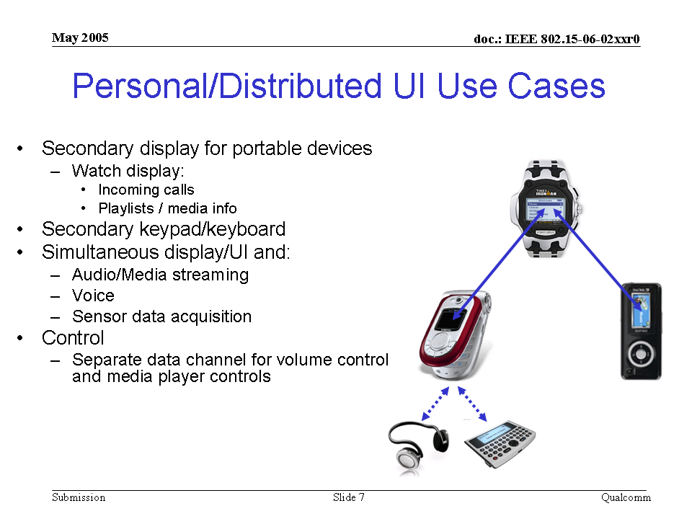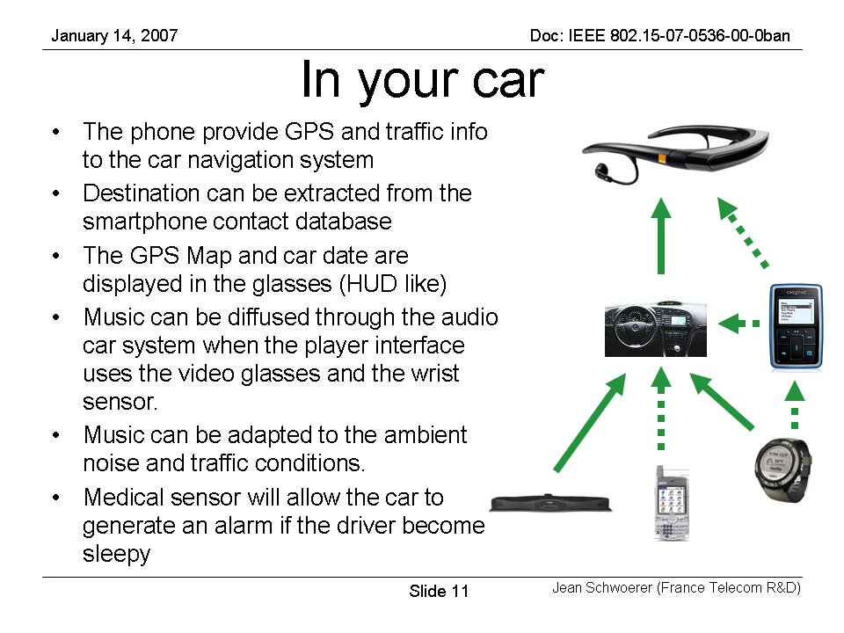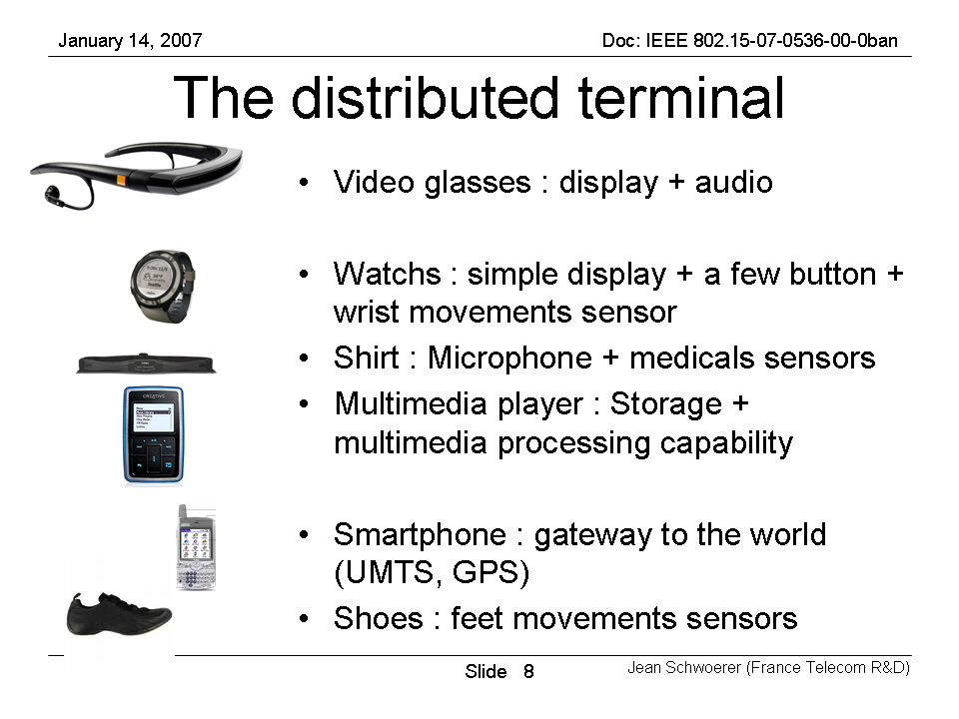 |  |  |  | 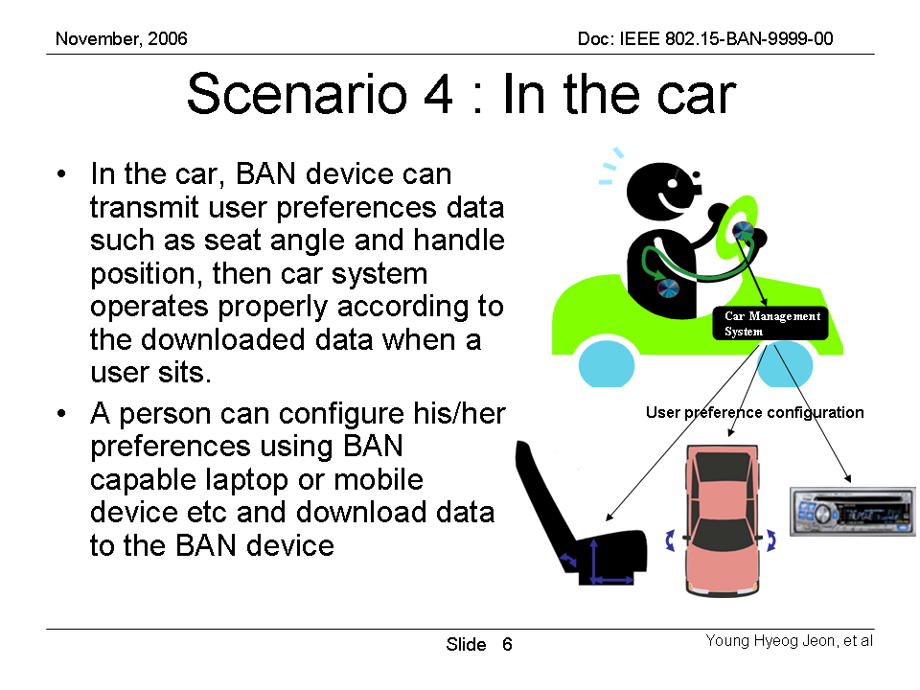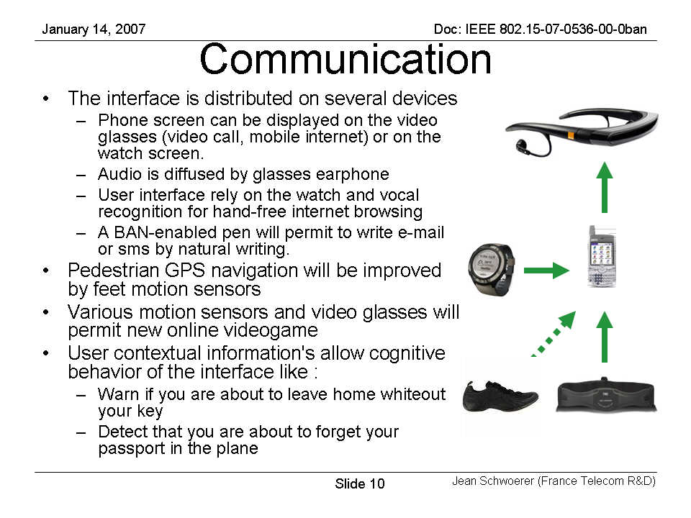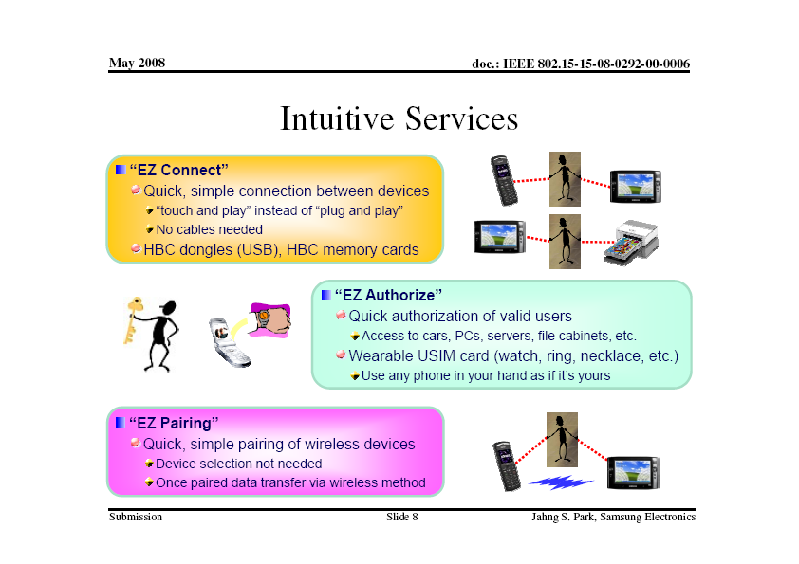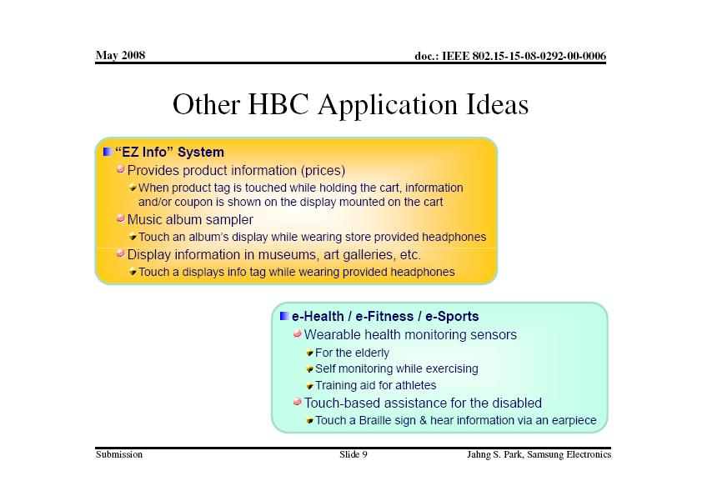

Body motion capture/gesture recognition, position |  |  |  |  |  |  | Z43
SAR Safety |  | Radio range | <5m | Setup time for a new link | <3s | Cost
Regulatory - Radio |  | Coexistence | Yes | Location awareness |  | Market size / region / year
Topology | Star | Robustness /reliability high/med/low | High | Channel (e.g. in/out body) | On-body | Covered by Other Standards
Data link speed sym/ asymmetric | Asymmetric | Power consumption | Low | Form Factor
Data rate (per link) | 256kbps | Energy scavenging possible | Yes | Privacy | Med
Number of devices per piconet) | <12 | QoS - sensitive to error | Yes | Power by:  battery | Yes
Duty cycle (per device) % per time | Med | QoS - sensitive to latency | Yes | Power by:  energy scavenging | No
Further information:
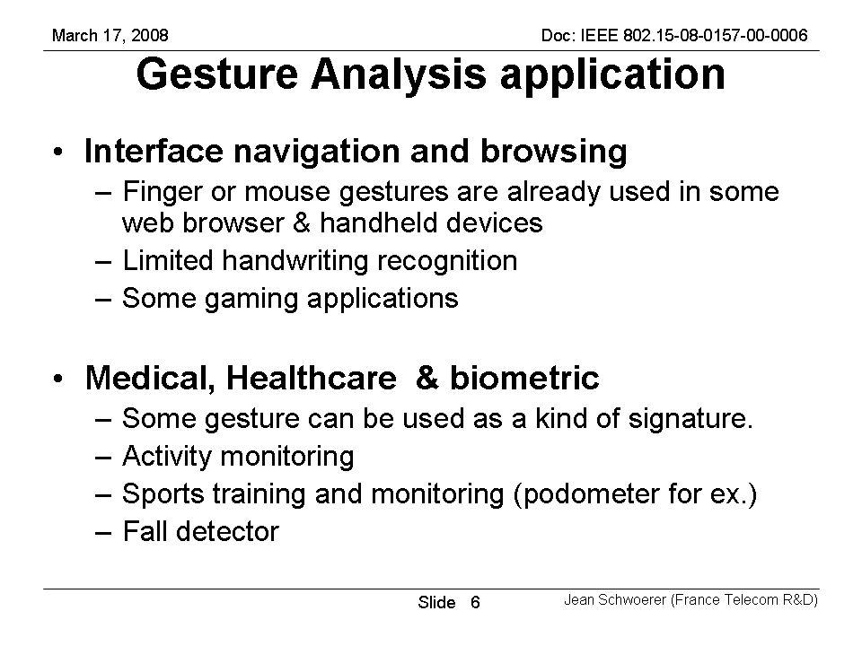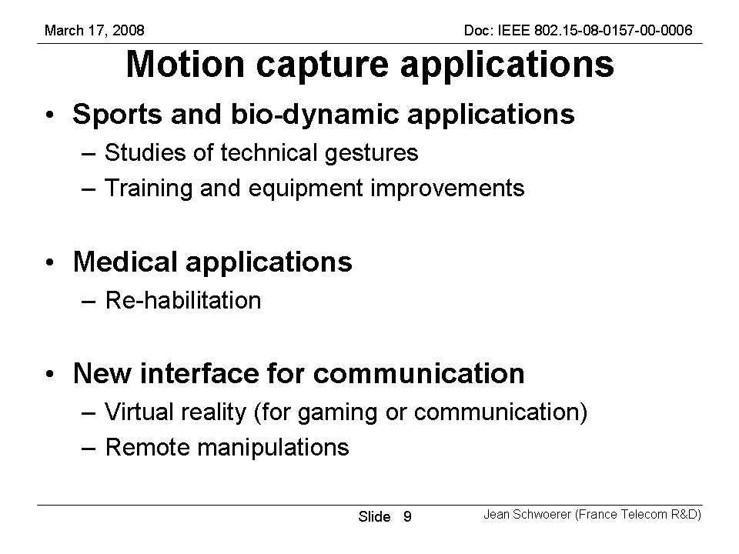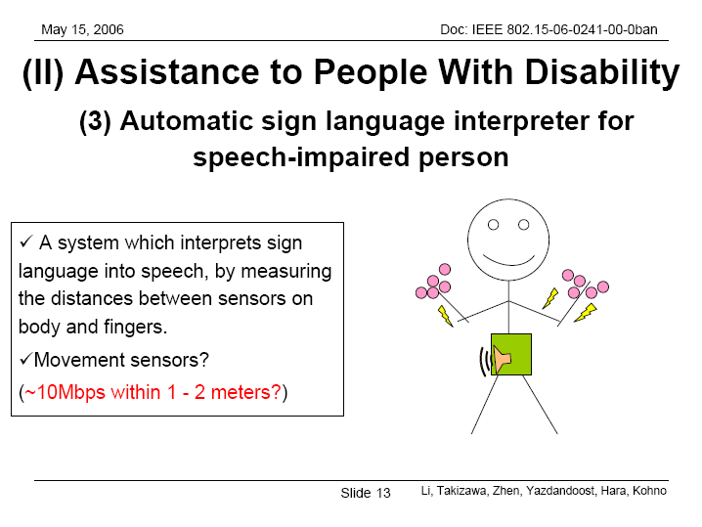 |  |  |  | 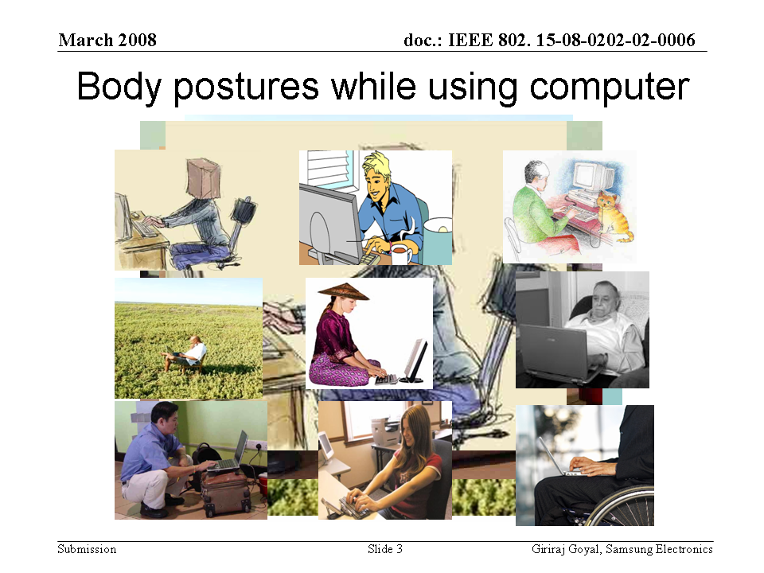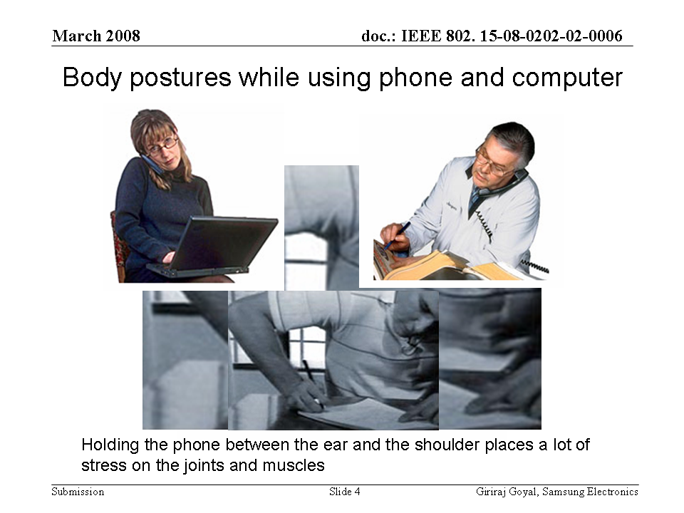

Control signal from PC peripheral devices (e.g. mouse click) |  |  |  |  |  |  | Z44
SAR Safety |  | Radio range | <5m | Setup time for a new link | <3s | Cost
Regulatory - Radio |  | Coexistence | Yes | Location awareness |  | Market size / region / year
Topology | Star | Robustness /reliability high/med/low | High | Channel (e.g. in/out body) | On-body | Covered by Other Standards
Data link speed sym/ asymmetric | Asymmetric | Power consumption | Low | Form Factor | Small
Data rate (per link) | 256kbps | Energy scavenging possible | Yes | Privacy | High
Number of devices per piconet) | <12 | QoS - sensitive to error | Yes | Power by:  battery | Yes
Duty cycle (per device) % per time | Low | QoS - sensitive to latency |  | Power by:  energy scavenging
Further information:
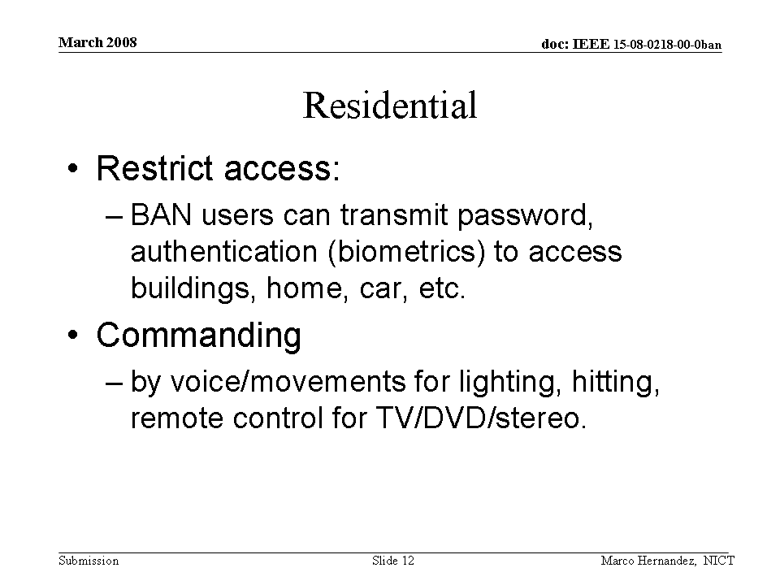

Forgotten things monitor |  |  |  |  |  |  | Z45
SAR Safety |  | Radio range | <5m | Setup time for a new link | <3s | Cost
Regulatory - Radio |  | Coexistence | Yes | Location awareness |  | Market size / region / year
Topology | Star/tree | Robustness /reliability high/med/low | High | Channel (e.g. in/out body) | On-body | Covered by Other Standards
Data link speed sym/ asymmetric | Symmetric | Power consumption | Low | Form Factor
Data rate (per link) | 256kbps | Energy scavenging possible | Yes | Privacy | Low
Number of devices per piconet) | >24 | QoS - sensitive to error | Yes | Power by:  battery | Yes
Duty cycle (per device) % per time | Med | QoS - sensitive to latency |  | Power by:  energy scavenging | No
Further information:
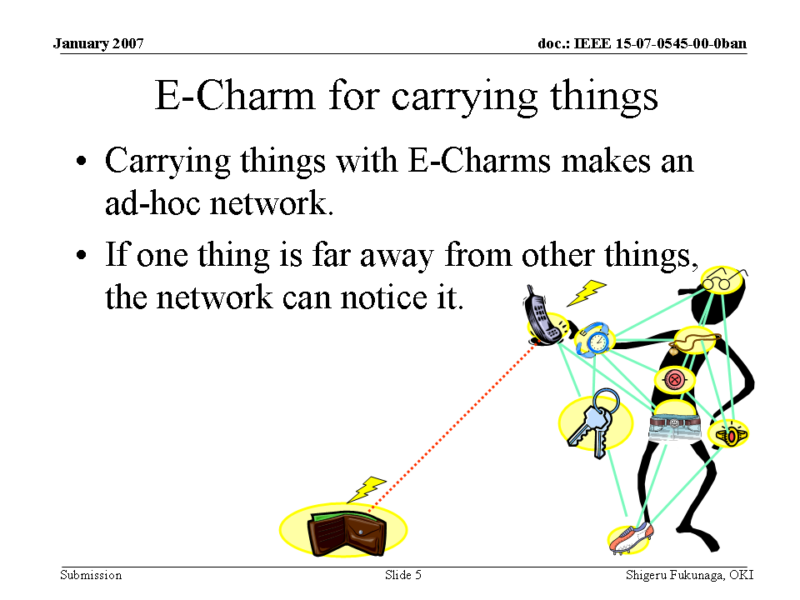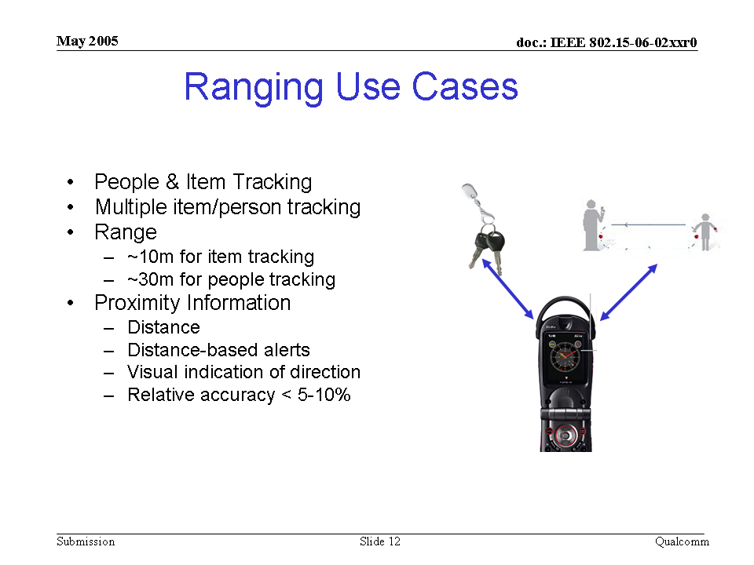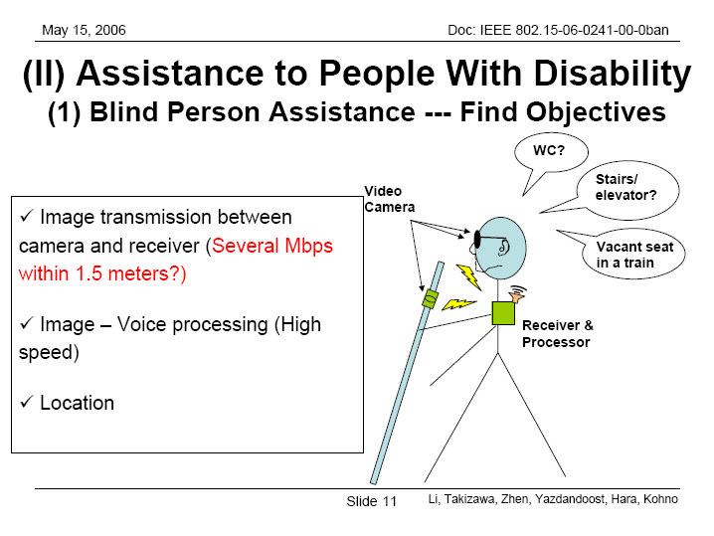 |  |  |  | 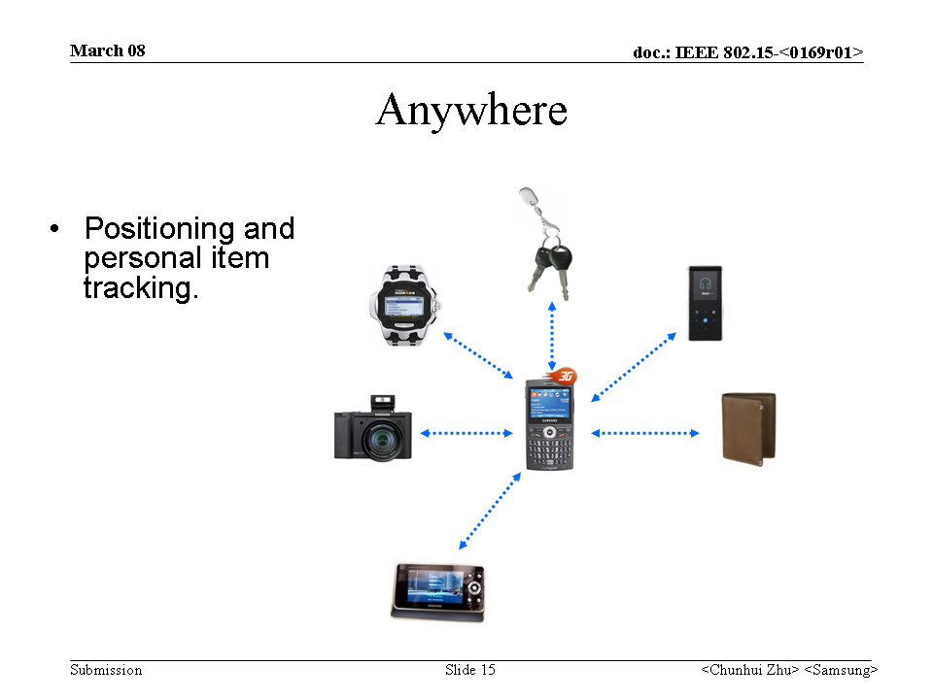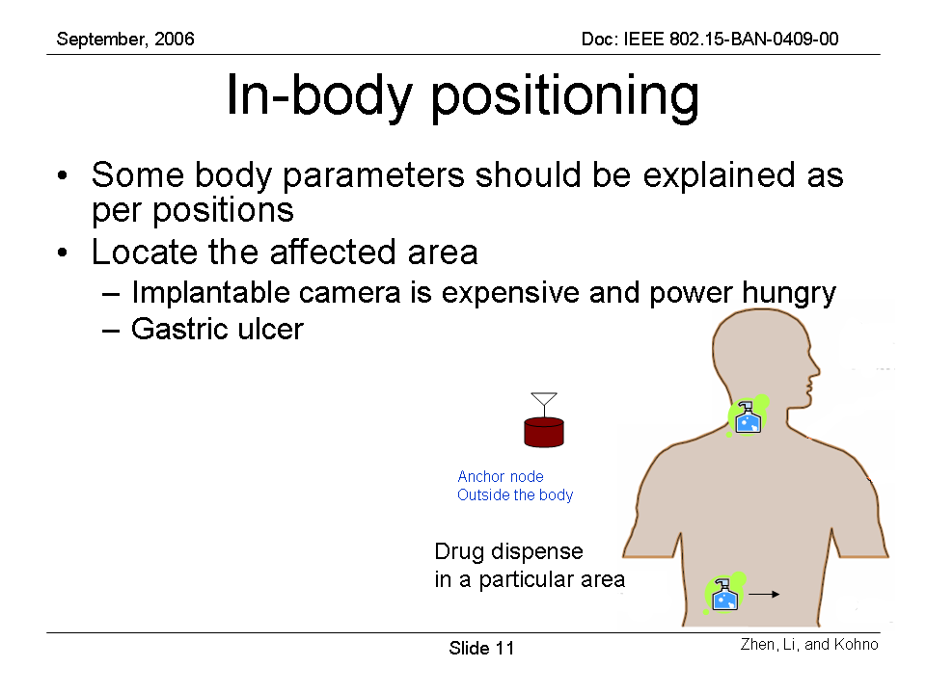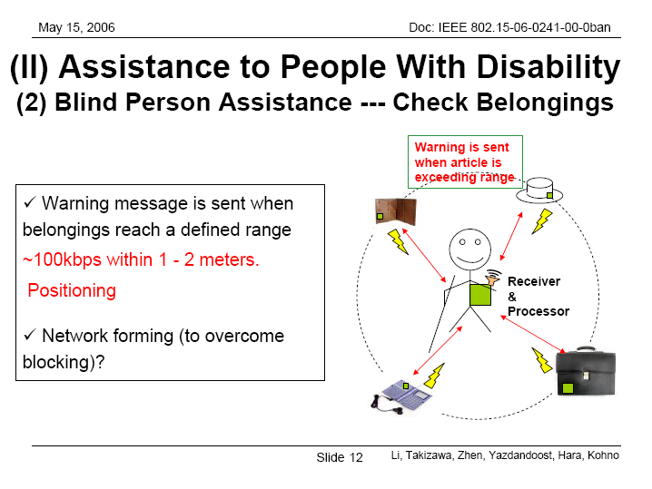

Emotion |  |  |  |  |  |  | Z46
SAR Safety |  | Radio range | <5m | Setup time for a new link | <3s | Cost
Regulatory - Radio |  | Coexistence | Yes | Location awareness |  | Market size / region / year
Topology | Star | Robustness /reliability high/med/low | High | Channel (e.g. in/out body) | On-body | Covered by Other Standards
Data link speed sym/ asymmetric | Asymmetric | Power consumption | Low | Form Factor
Data rate (per link) | 256kbps | Energy scavenging possible | Yes | Privacy | Low
Number of devices per piconet) | <12 | QoS - sensitive to error | Yes | Power by:  battery | Yes
Duty cycle (per device) % per time | Low | QoS - sensitive to latency |  | Power by:  energy scavenging
Further information:
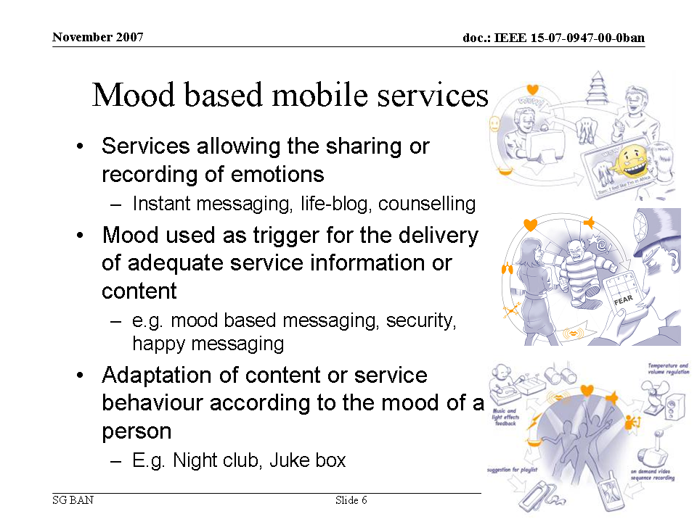 |  |  |  | 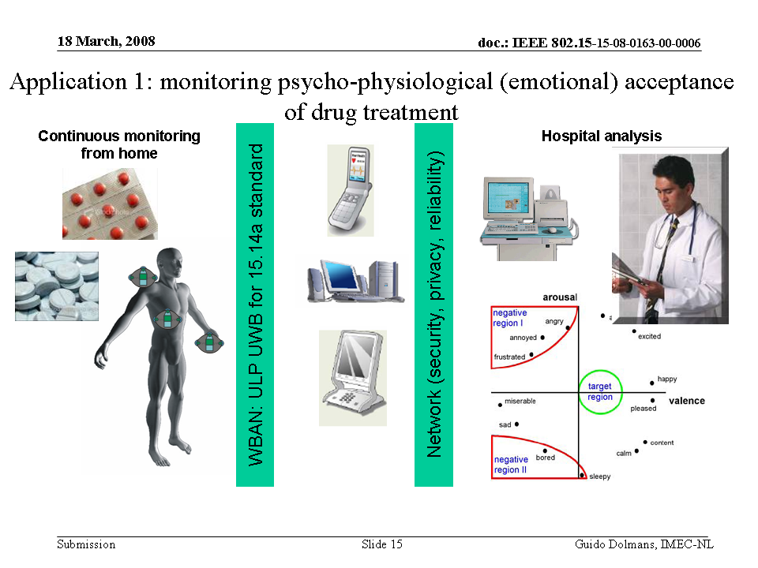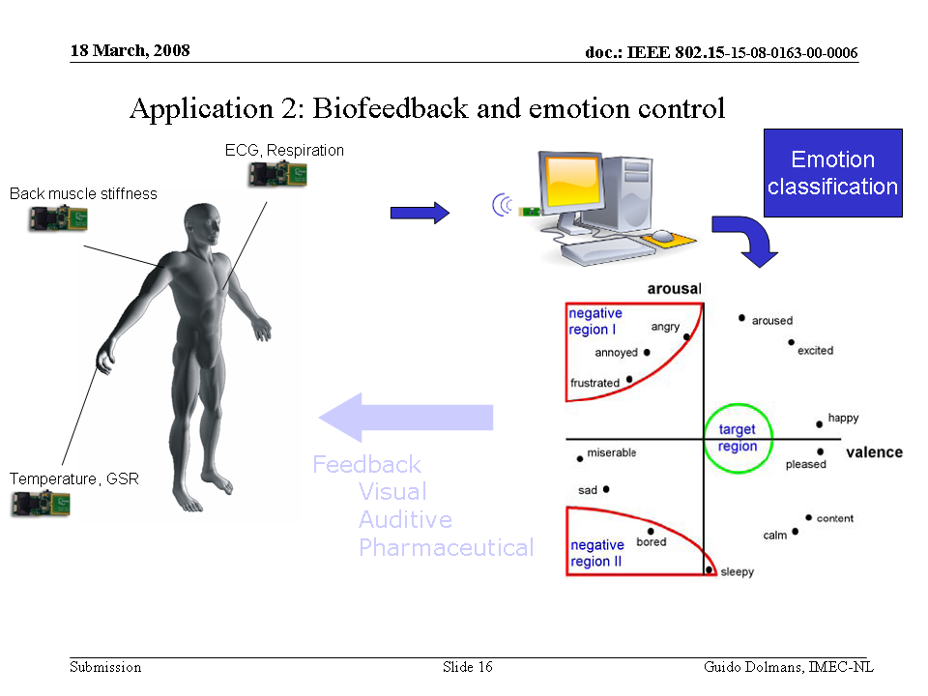

Smart Key |  |  |  |  |  |  | Z47
SAR Safety |  | Radio range |  | Setup time for a new link |  | Cost
Regulatory - Radio |  | Coexistence |  | Location awareness |  | Market size / region / year
Topology |  | Robustness /reliability high/med/low |  | Channel (e.g. in/out body) |  | Covered by Other Standards
Data link speed sym/ asymmetric |  | Power consumption |  | Form Factor
Data rate (per link) |  | Energy scavenging possible |  | Privacy
Number of devices per piconet) |  | QoS - sensitive to error |  | Power by:  battery
Duty cycle (per device) % per time |  | QoS - sensitive to latency |  | Power by:  energy scavenging
Further information:

Identification |  |  |  |  |  |  | Z48
SAR Safety |  | Radio range |  | Setup time for a new link |  | Cost
Regulatory - Radio |  | Coexistence |  | Location awareness |  | Market size / region / year
Topology |  | Robustness /reliability high/med/low |  | Channel (e.g. in/out body) |  | Covered by Other Standards
Data link speed sym/ asymmetric |  | Power consumption |  | Form Factor
Data rate (per link) |  | Energy scavenging possible |  | Privacy
Number of devices per piconet) |  | QoS - sensitive to error |  | Power by:  battery
Duty cycle (per device) % per time |  | QoS - sensitive to latency |  | Power by:  energy scavenging
Further information:
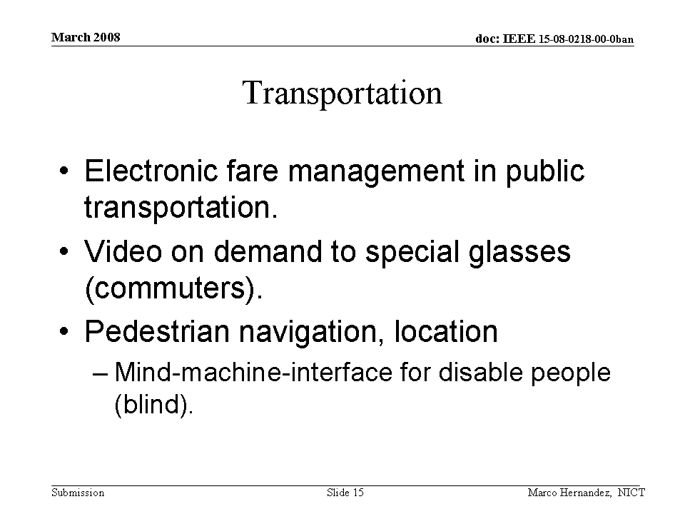 |  |  |  | 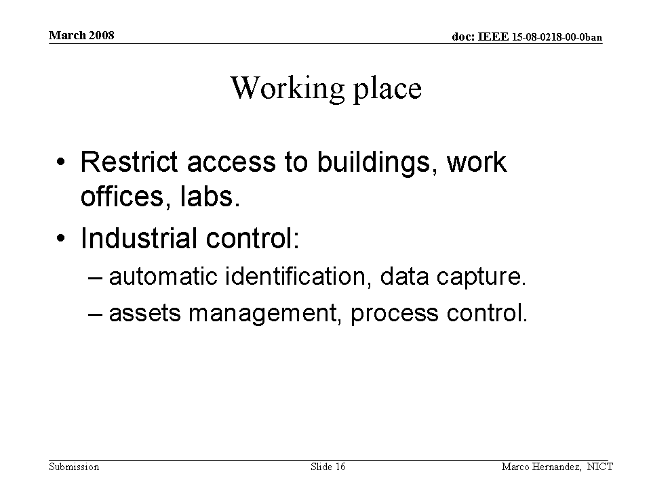

Vital sign and body information based entertainment service |  |  |  |  |  |  | Z49
SAR Safety |  | Radio range |  | Setup time for a new link |  | Cost
Regulatory - Radio |  | Coexistence |  | Location awareness |  | Market size / region / year
Topology |  | Robustness /reliability high/med/low |  | Channel (e.g. in/out body) |  | Covered by Other Standards
Data link speed sym/ asymmetric |  | Power consumption |  | Form Factor
Data rate (per link) |  | Energy scavenging possible |  | Privacy
Number of devices per piconet) |  | QoS - sensitive to error |  | Power by:  battery
Duty cycle (per device) % per time |  | QoS - sensitive to latency |  | Power by:  energy scavenging
Further information:
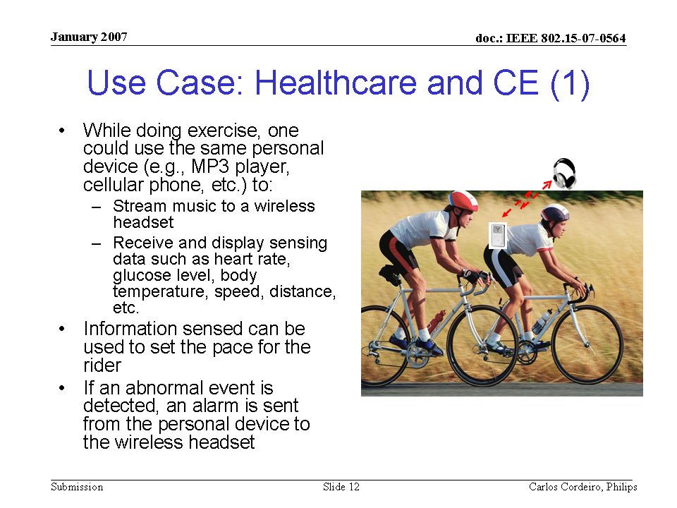 |  |  |  | 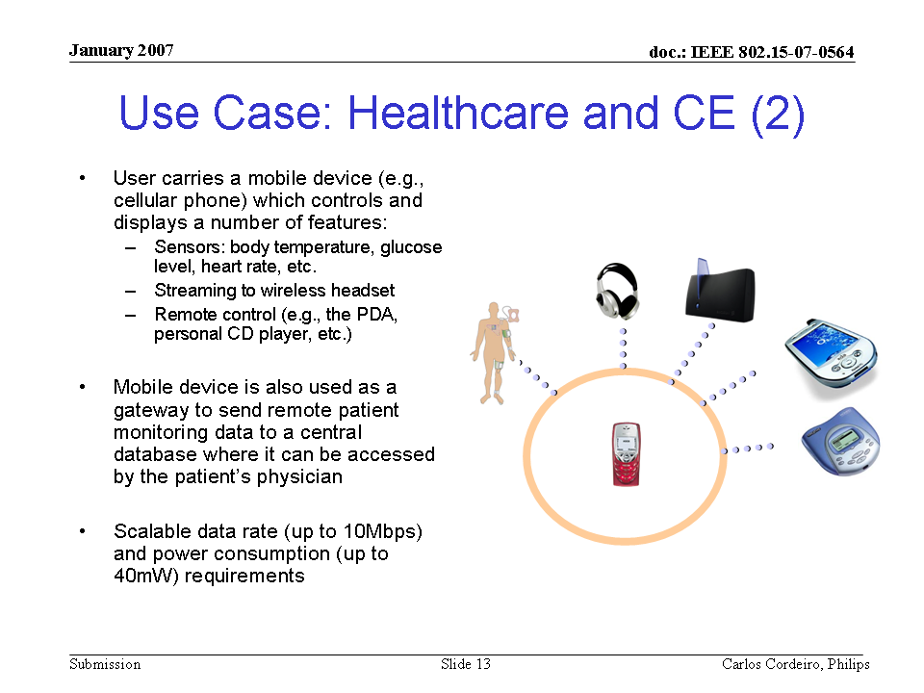

B5 Entertainment applications

Gaming applications using BAN |  |  |  |  |  |  | Z50
SAR Safety | Medium | Radio range | <5m | Setup time for a new link | <1s | Cost | Low
Regulatory - Radio | Compliant | Coexistence | Yes | Location awareness | Yes | Market size / region / year | Very large
Topology | Star, P2P | Robustness /reliability high/med/low | Medium | Channel (e.g. in/out body) | In-air to On-Body, On-body to In-air, On-body to On-body | Covered by Other Standards | Bluetooth
Data link speed sym/ asymmetric | Asymmetric | Power consumption | Low | Form Factor | Small
Data rate (per link) | 200kbps ~2Mbps | Energy scavenging possible | Yes If possible | Privacy | Medium
Number of devices per piconet) | 12 to 24 | QoS - sensitive to error | Medium | Power by:  battery | Yes
Duty cycle (per device) % per time | <30% | QoS - sensitive to latency | High | Power by:  energy scavenging | If possible
Further information:
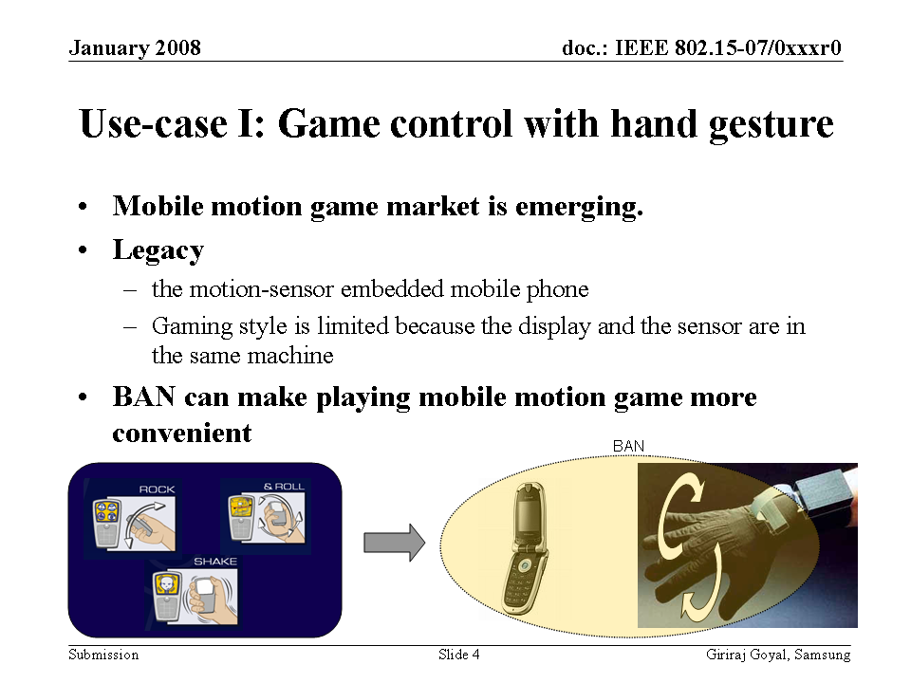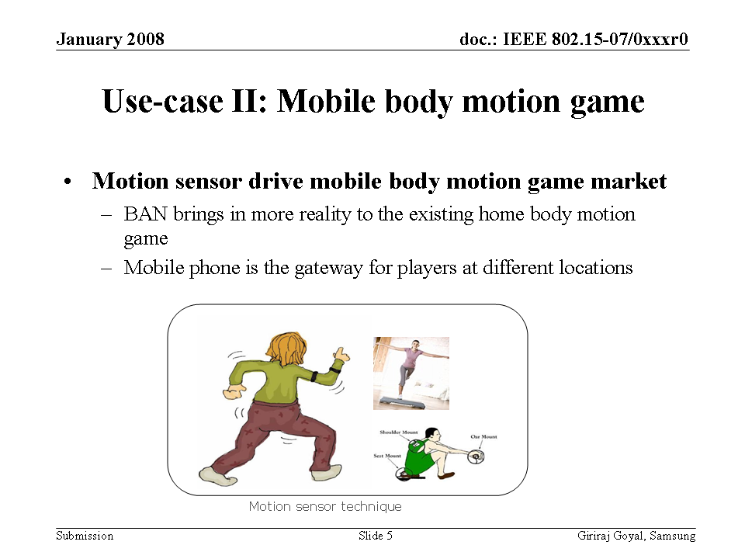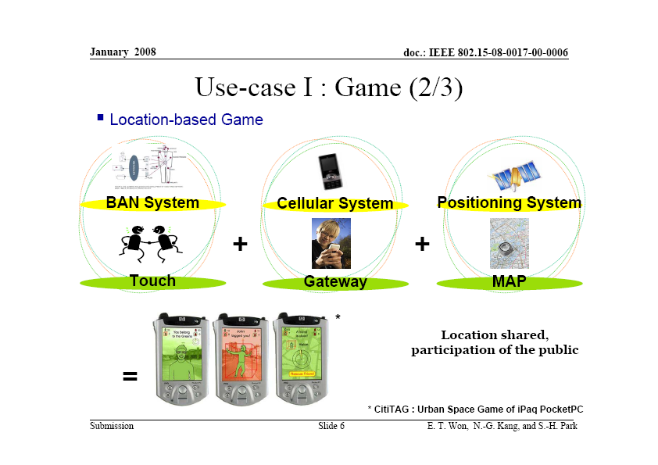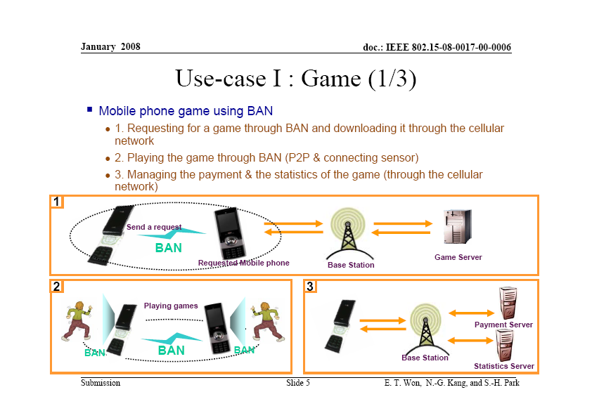 |  |  |  | 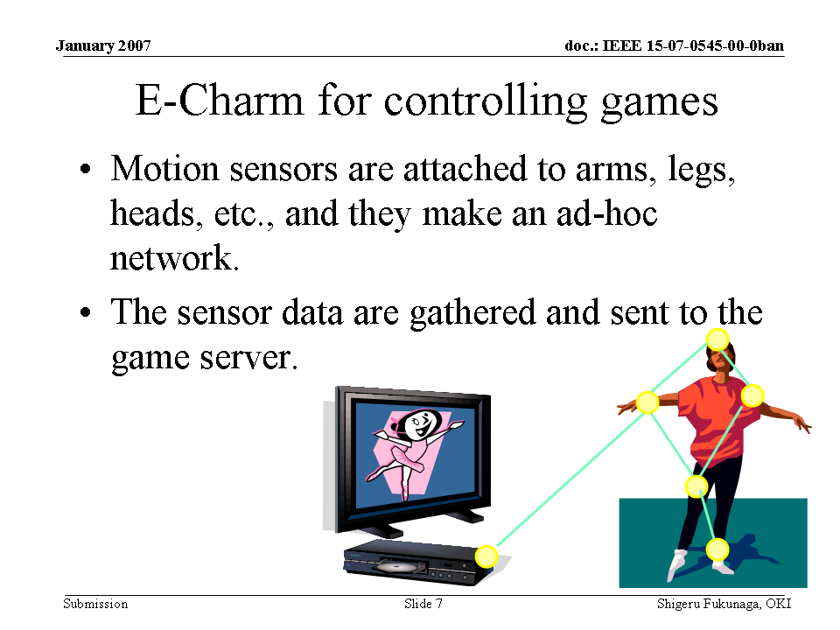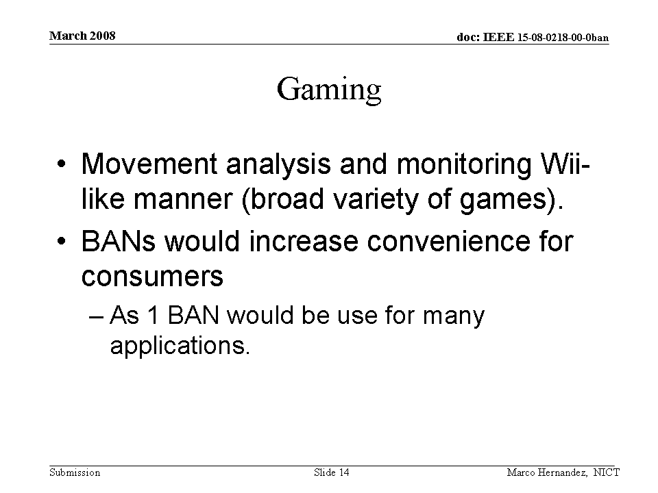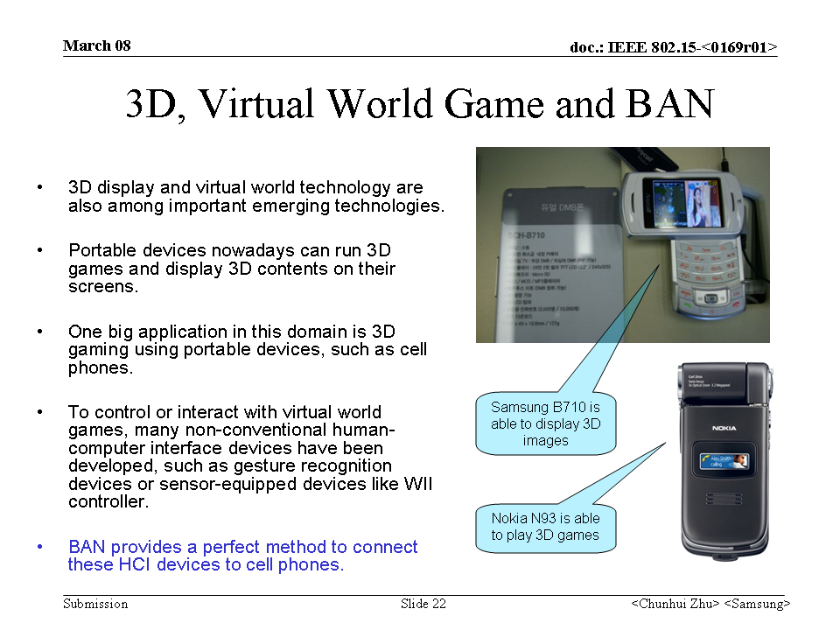

Social Networking using BAN |  |  |  |  |  |  | Z51
SAR Safety | Medium | Radio range | <1.5m | Setup time for a new link | <1s | Cost | Low
Regulatory - Radio | Compliant | Coexistence | Yes | Location awareness | No | Market size / region / year | Very large
Topology | P2P | Robustness /reliability high/med/low | Low | Channel (e.g. in/out body) | In-air to In-air | Covered by Other Standards | Bluetooth
Data link speed sym/ asymmetric | Symmetric | Power consumption | Low | Form Factor | Small
Data rate (per link) | <200Kbps | Energy scavenging possible | No | Privacy | High
Number of devices per piconet) | 2 | QoS - sensitive to error | Low | Power by:  battery | Yes
Duty cycle (per device) % per time | <1% | QoS - sensitive to latency | Low | Power by:  energy scavenging | No
Further information:
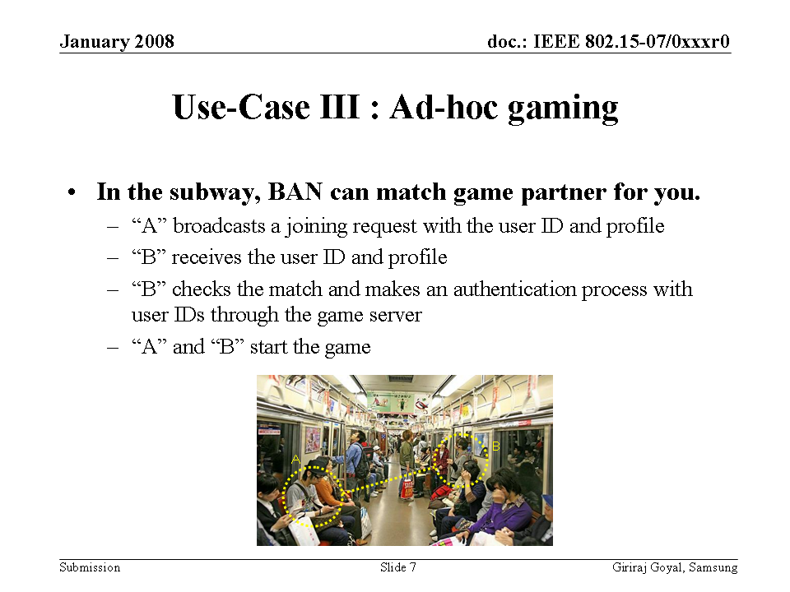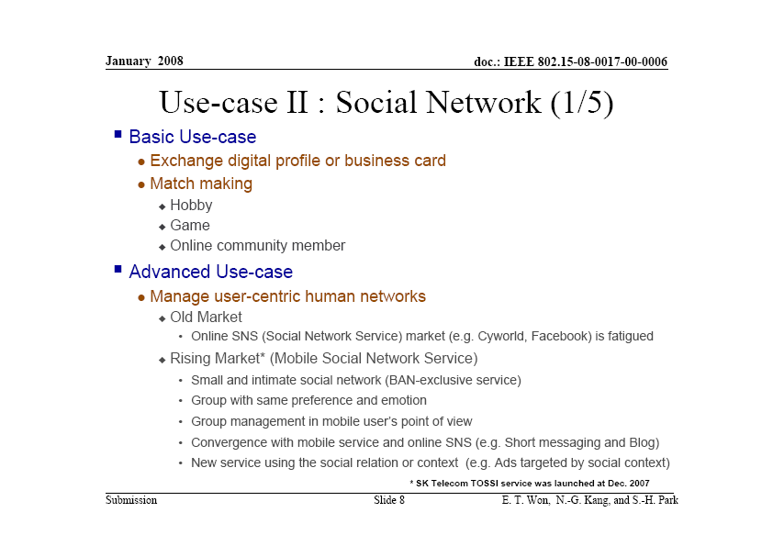 |  |  |  | 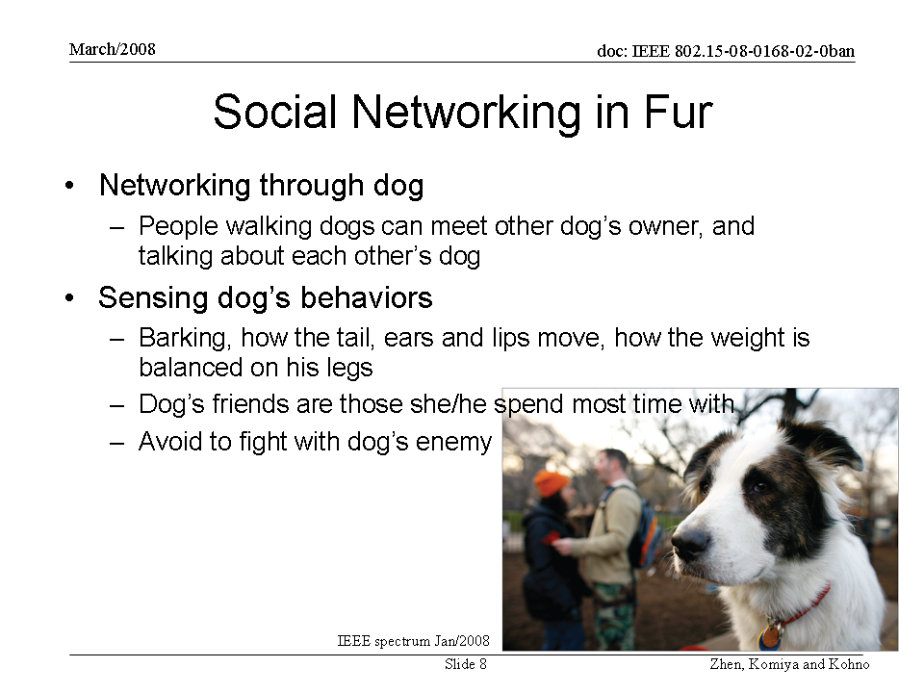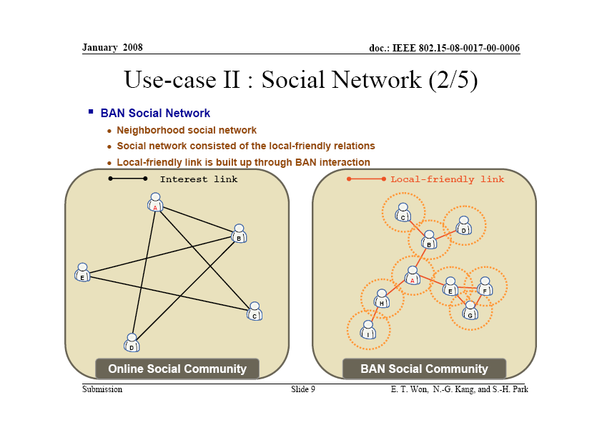

B6 Emergency (non-medical)

Emergency (non-medical) |  |  |  |  |  |  | Z52
SAR Safety | High | Radio range | <5m | Setup time for a new link | <1s | Cost
Regulatory - Radio | Compliant | Coexistence | Yes | Location awareness |  | Market size / region / year
Topology | Star, Point-to Point | Robustness /reliability high/med/low | High | Channel (e.g. in/out body) | On-body | Covered by Other Standards
Data link speed sym/ asymmetric | Asymmetric | Power consumption | Low | Form Factor | Small
Data rate (per link) | < 10 kbps | Energy scavenging possible | Yes | Privacy | High
Number of devices per piconet) | 2 | QoS - sensitive to error | Yes | Power by:  battery | Yes
Duty cycle (per device) % per time | <1% | QoS - sensitive to latency | Yes | Power by:  energy scavenging | Yes
Further information:

Example (1), Notification of a Fire in the home
Example (2), Notification of flammable Gas, or poisonous gas in the home
Example (3), Notification of an home intruder in the house

Sensors off the body, (eg built into the house) may detect a non-medical emergency event and need to urgently communicate this event to body worn devices, in order to notify the wearer of the emergency situation.

Notes:

“Energy scavaing possible” refers to whether the power level of the sensor is low enough to be powered by energy scavaging technologies. “power by energy scavenging” indicates whether a power scavenging approach would be appropriate in this applications context .

Acknowledgements
This document was compiled from the following presentations presented at the IEEE 802.16.6 TG / IEEE 802.15-BAN SG / IEEE 802.15-BAN IG.
Any omissions from this list is unintentional

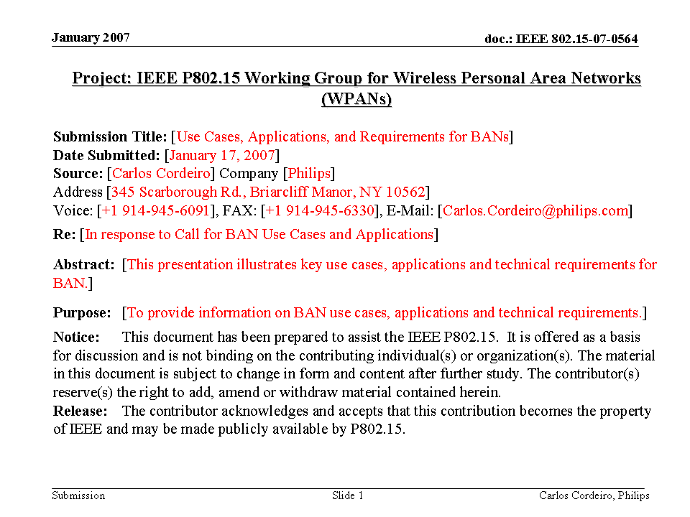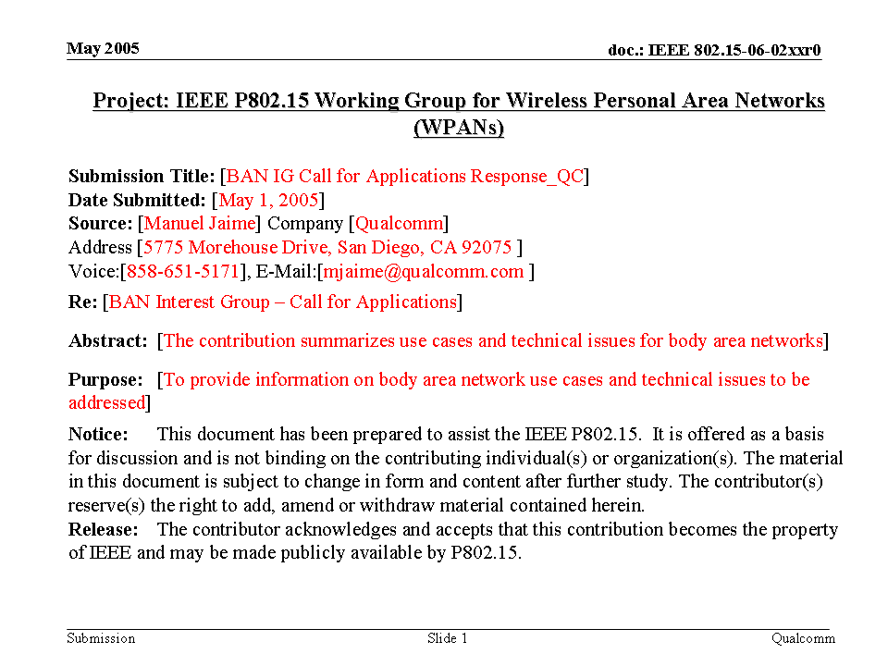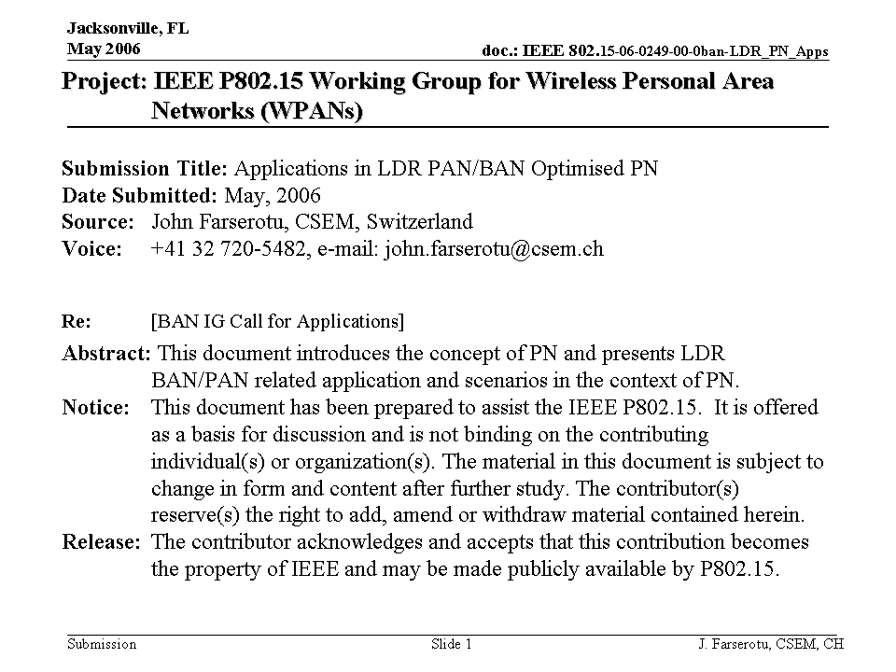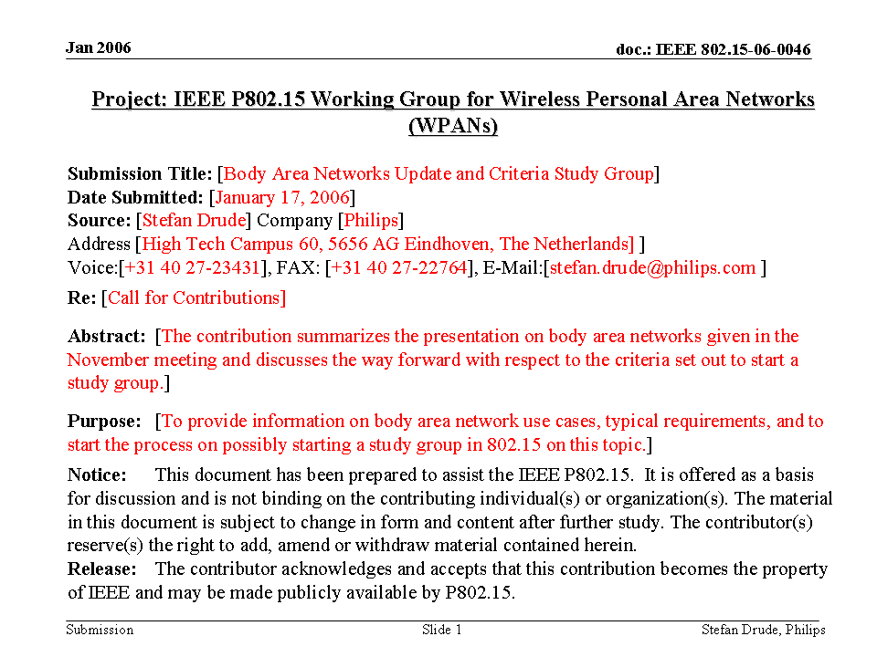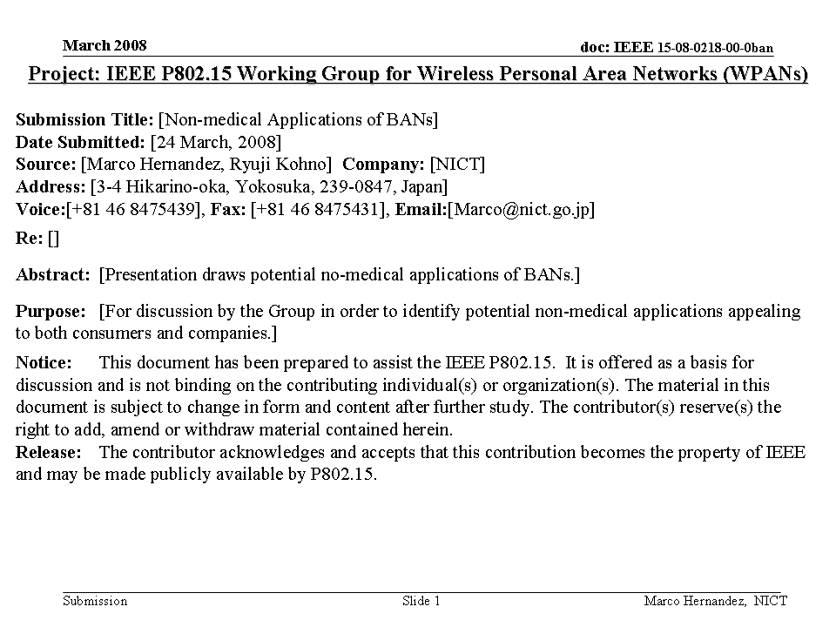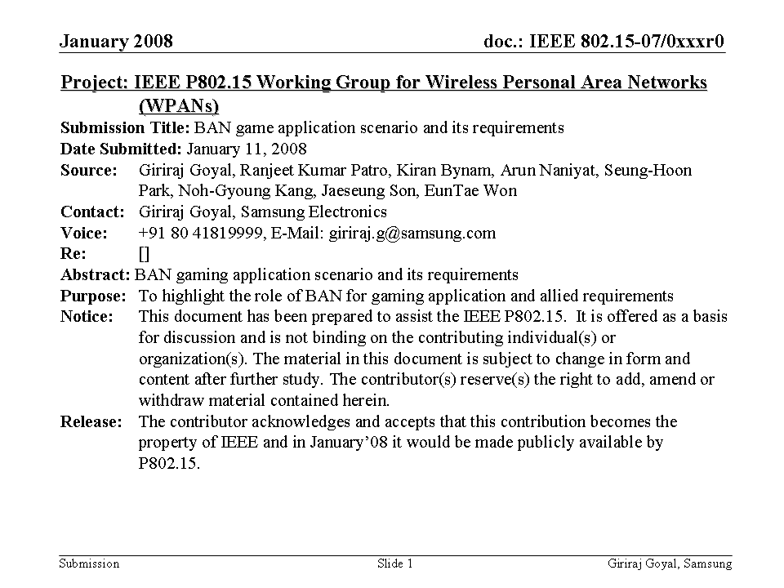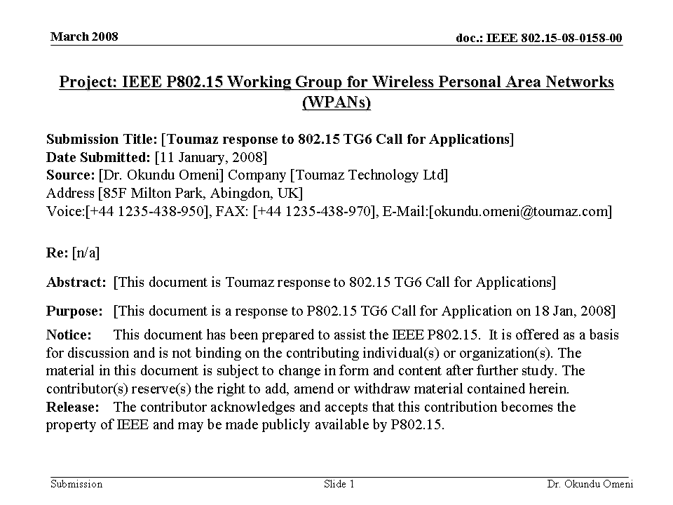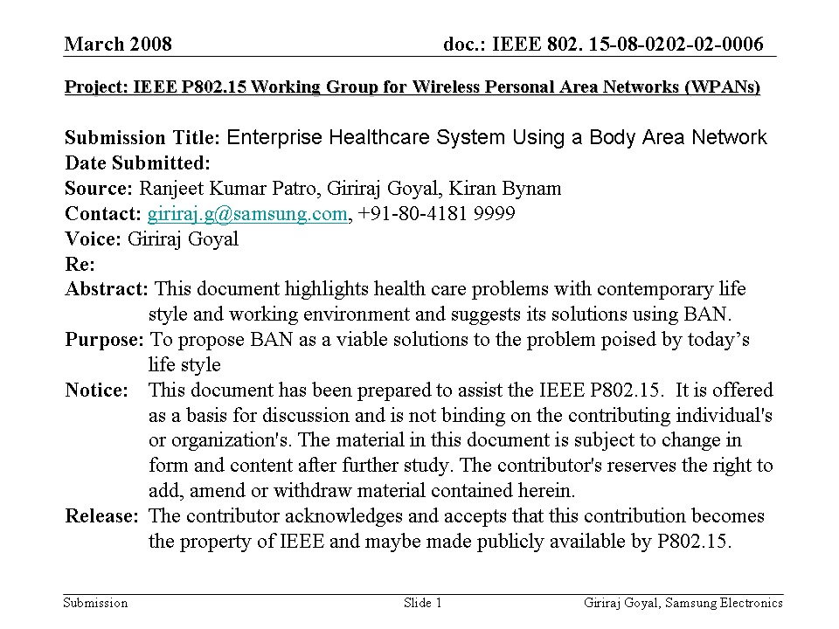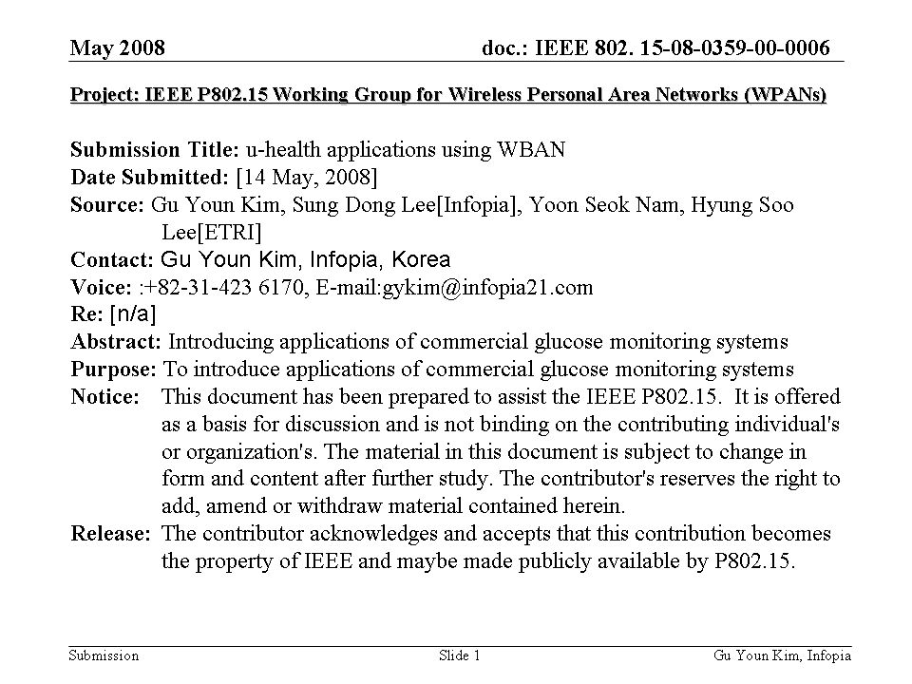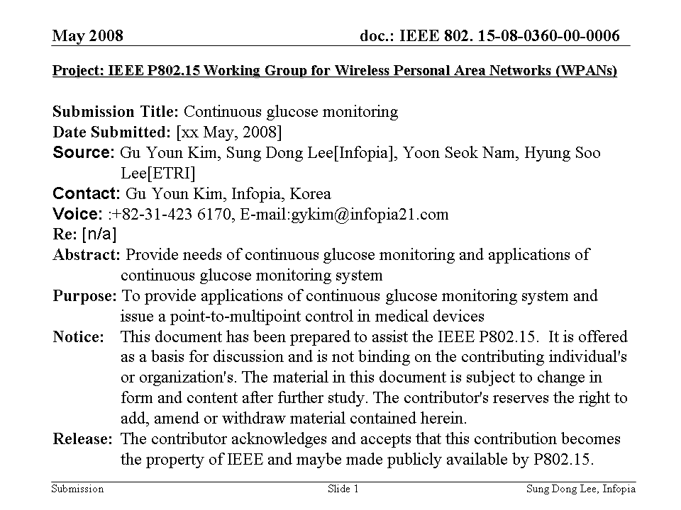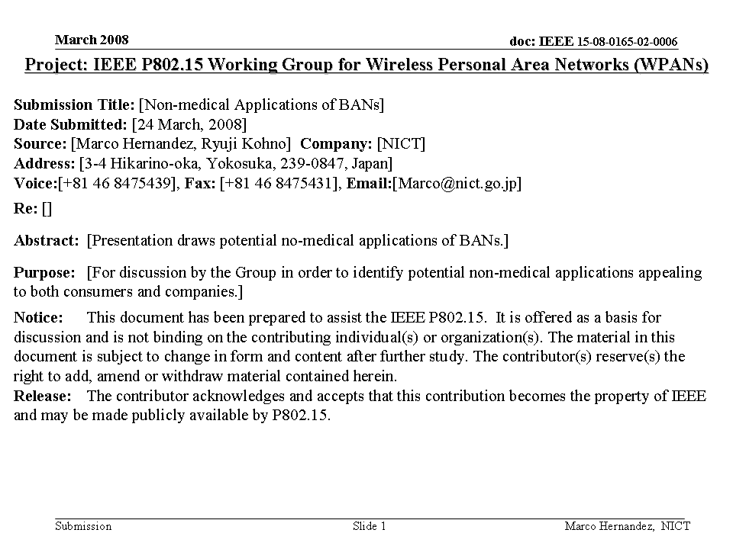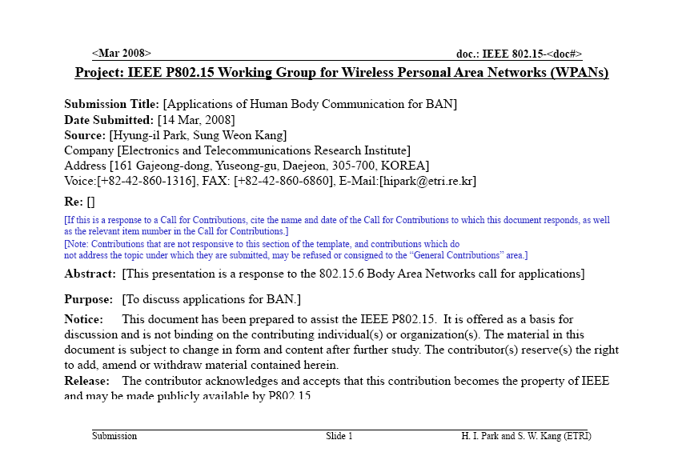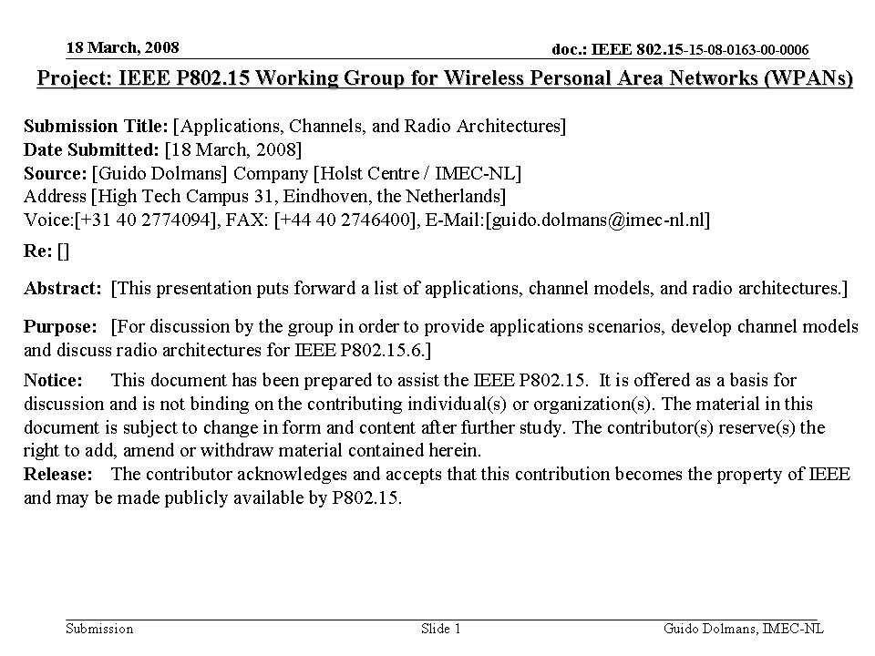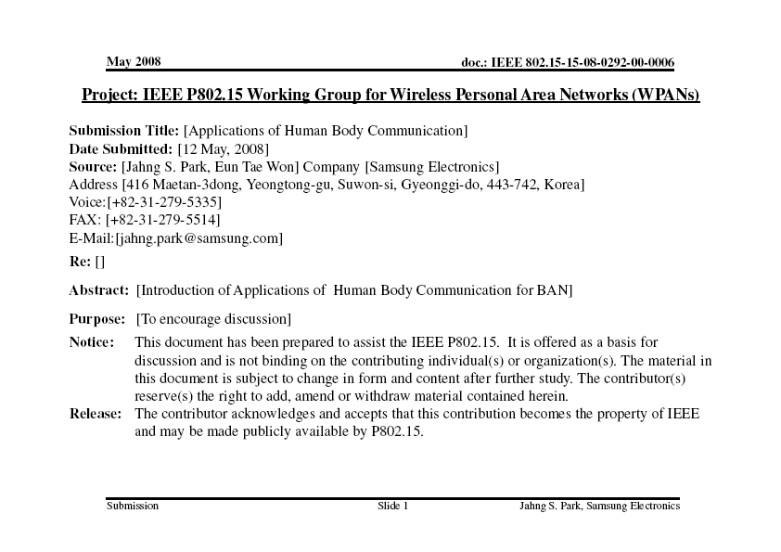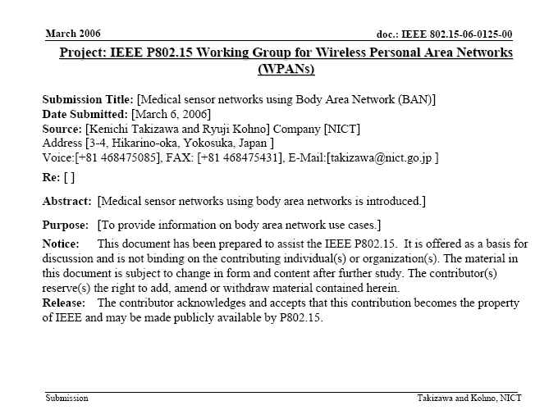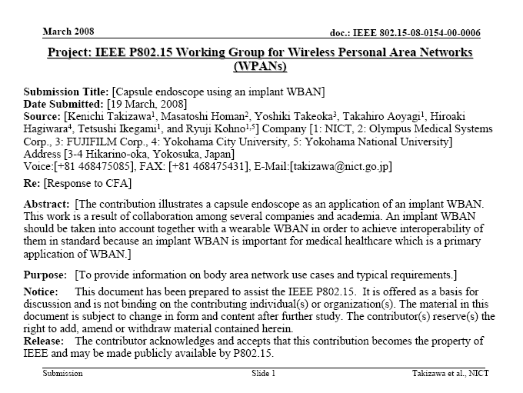 | 

