IEEE P802.15
Wireless Personal Area Networks

Project | IEEE P802.15 Working Group for Wireless Personal Area Networks (WPANs)
Title | Ranging Subcommittee Final Report
Date Submitted | 8 November 2004
Source | Rick Roberts, Harris Corporation | Voice: 321-729-3018  Fax: [ ]  E-mail: rrober14@harris.com
Re: | Ranging Subcommittee of TG4a
Abstract
Purpose | Provided in support of the activities of TG4a concerning location / ranging.
Notice | This document has been prepared to assist the IEEE P802.15. It is offered as a basis for discussion and is not binding on the contributing individual(s) or organization(s). The material in this document is subject to change in form and content after further study. The contributor(s) reserve(s) the right to add, amend or withdraw material contained herein.
Release | The contributor acknowledges and accepts that this contribution becomes the property of IEEE and may be made publicly available by P802.15.
Table of Contents
1. Introduction 2
2. TOA Ranging 3
3. TDOA Ranging 6
4. SSR Ranging 9
5. NFER Ranging 11
6. AOA Localization 13
7. MAC and PHY Interfaces 16
8. Interface Comments 18
9. PHY Sublayer 22
10. MAC Sublayer 24
11. References 35

Introduction

The ranging subcommittee identified 5 different ranging algorithms:

- Time-of-Arrival (TOA)
- Time-Difference-of-Arrival (TDOA)
- Signal Strength Ranging (SSR)
- Near-Field EM Ranging (NFER)
- Angle-of-Arrival (AOA)

This report opens with a brief discussion of each type of ranging and then suggests text to describe the interfaces associated with each of these ranging techniques. We do not make any recommendations as to a preferred ranging methodology since ranging algorithms themselves are anticipated to run at the application layer. In fact, it is likely that hybrid ranging algorithms will emerge that use a combination of ranging techniques so as to have multiple degrees of freedom in an attempt to improve the calculated range estimate.

TOA Ranging

TOA ranging is discussed in references [2], [3], [9], [12], [13], [15], [18].

Classical ranging transactions (namely the Two Way Ranging -TWR- and the One Way Ranging -OWR- schemes), and the corresponding synchronization requirements, are highly dependant on the communication protocol and the network topology.

The first technique enabling the measure of the signal round-trip Time-Of-Flight (TOF) between two asynchronous transceivers consists in using a classical two-way remote synchronization technique.

Device A
Device B
Two equations in two unknowns yield:
* US Naval Observatory, Telstar Satellite, circa 1962
http://www.boulder.nist.gov/timefreq/time/twoway.htm
Unmatched detect-delays in the two devices may require one-time offset calibration.
Unknown propagation delay
Unknown clock offset
Message 1
Message 2
Multiple measurements of t_{p} and t_{o} yield finer precision & accuracy, and allow frequency offset correction.
Figure 1 Two-Way Time Transfer Model

A pair of terminals are time-multiplexed with half-duplex packet exchanges. This procedure relies on a typical mechanism for fused location and communication: a requestor sends packets to a responder which replies after synchronizing with packets containing synchronous timing information. The reception of this response allows the requestor to determine the round-trip TOF information (Figure 2). This solution seems to be particularly adapted for distributed networks (a fortiori in the lack of coordination) .
A
B
TOF
TOF
Channel
Acquisition
Synchro H
Communication Payload
Preamble Acquisition Header
Tround
Response Delay
Elapsed times measured by the system

Transmitted packets

Received packets

Figure 2: Two Way Ranging (TWR) transaction enabling to estimate the round-trip Time-OF-Flight between two asynchronous terminals (feeding TOA-based positioning algorithms)

Now, if two terminals are synchronized to a common clock (i.e. sharing the same time reference and time base), it is clear that the TOF information can be directly obtained from a simple OWR transaction (not detailed here).

The two previous transactions provide so-called TOA location metrics corresponding to the relative distance between terminals. For the considered scenarios (TOA/TWR and TOA/OWR), slot lengths and procedures, fixed by a pre-existing communication standard, represent drastic constraints for the maximum and minimum (blind distances) relative measurable distances and the ranging accuracy.

A straightforward approach to calculate the position of a mobile terminal based upon TOA uses a geometric interpretation to calculate the intersection of circles for TOA-based algorithms. Indeed, if three TOA are measured between a mobile terminal and three (or more) distinct anchors (note that anchors should be considered as nodes doted with a prior knowledge of their relative positions), the mobile position can be easily computed in the 2-D plane. These solutions (geometrical solutions or solutions based on optimization procedures) correspond to popular radiolocation methods.

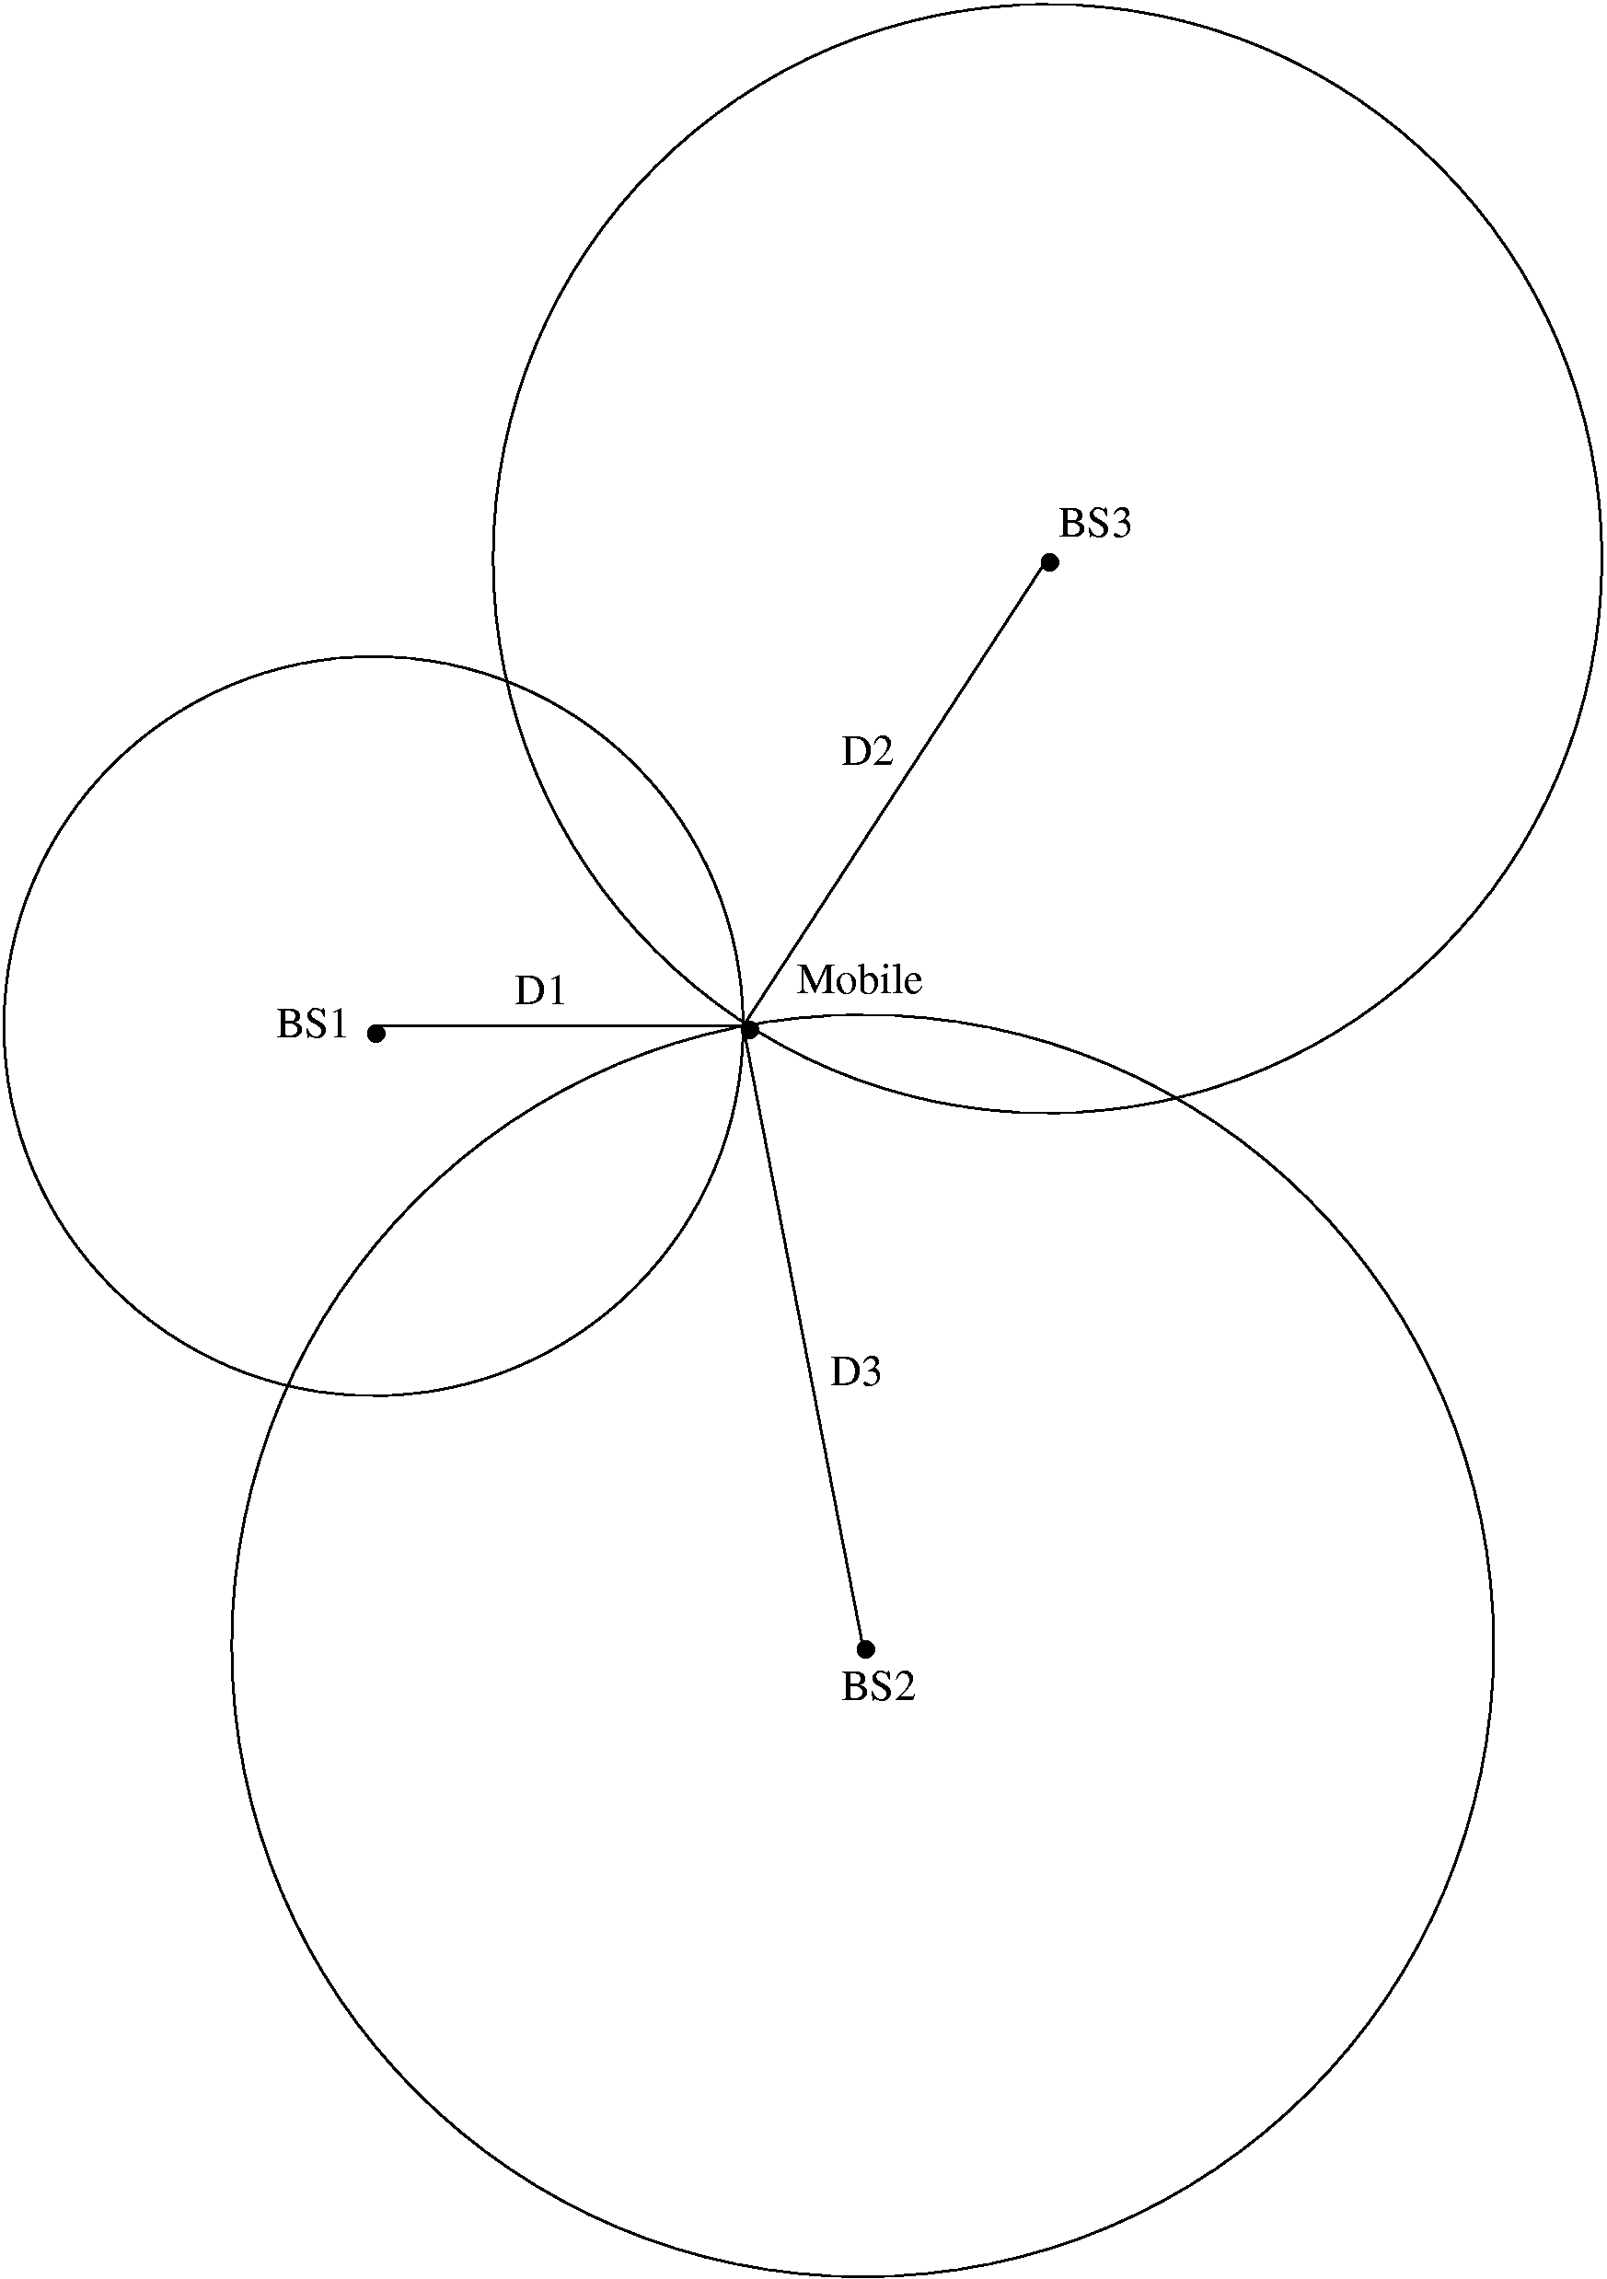
Mobile (x_{m},y_{m})
Anchor 2 (x_{A2},y_{A2})
Anchor 3 (x_{A3},y_{A3})
Anchor 1 (x_{A1},y_{A1})
Positioning from TOA
3 anchors with known positions (at least) are required to retrieve a 2D-position from 3 TOAs
Measurements
Estimated Position
Specific Positioning Algorithms
Figure 3 – Positioning from TOA

2.1 Double Token Exchange TOA (sometimes called DTOA)

A variant of TOA discussed in [15] is the token exchange method which is intended to accomplish ranging without synchronization of the local clocks. This method only requires that a ranging token be exchanged twice between two units in the following manner:

1) DEV A sends a ranging token to DEV B
2) DEV B holds onto the token for a time τ and then sends the token back to DEV A
3) Next DEV A sends a second ranging token to DEV B
4) DEV B holds onto the token for a time 2τ and then sends the token back to DEV A
5) DEV A calculates the ranging information as discussed above

Figure 4 illustrates the message sequence involved when requesting a range measurement. The ranging command initiates the precise exchange of a ranging token between the source DEV and the destination DEV as shown in the message sequence chart below.

Figure 4— MSC for ranging token exchange

The time of flight between the two devices is then calculated as

T_{flight} = {T¹(3)- T¹(0)} - [{T²(3)- T²(0)}/2]

where the time epochs are defined in Figure 4.

TDOA Ranging

TDOA ranging is discussed in references [2], [3], [8].

TDOA is related to TOA inasmuch as the time difference between synchronized reference anchor terminals is calculated and used for the localization calculations. The TDOA is traditionally obtained through OWR transactions (Figure 5). In this scheme, a pair of isochronous terminals, viewed as anchors, preliminary detect the TOA associated with packets emitted by the mobile. The TOAs are estimated relative to a common reference time (shared among references) but independent on the actual transmission time.

Time Difference Of Arrival (TDOA) & One Way Ranging (OWR)
T_{o}
Mobile TX
Anchor 1 RX
T_{OF,1}
T₁
Anchor 2 RX
T_{OF,2}
T₂
Anchor 3 RX
T_{OF,3}
T₃
Anchor 1
Anchor 2
Anchor 3
Mobile
Isochronous
Info T₂
Info T₃
Info T₂
Info T₃
TOA Estimation
TDOA Estimation
TDOA Estimation
Passive Location
TOA Estimation
Isochronous
Figure 5 – TDOA and OWR

Anchors have to be re-synchronized with an external clock or by a beacon signal periodically broadcasting packets to all the fixed references. This beacon signal may come from a coordinator or a dedicated terminal. Note that “synchronization” means “absolute synchronization” here, and implies that anchors know their relative distance to the beacon provider.

Reference Time

A
Mobile Terminal

TOF(A-B)

B

Isochronous Terminals
Transmitted packets
TOA_{B}

C
Received packets
Elapsed times measured by the system
TOF(A-C)
TOA_{C}

Figure 6: One Way Ranging (OWR) Protocol allowing to estimate differential Time of Arrival at a couple of two isochronous terminals (feeding TDOA-based positioning algorithms)

Finally, the approach taken to calculate the position of a mobile terminal for TDOA location metrics involves making two or more TDOA measurements. A straightforward approach uses a geometric interpretation to calculate the intersection of two or more hyperbolas for TDOA-based algorithms. If two or more TDOA measurements can be formed at a set of three or more distinct anchors, the mobile position can be easily computed in the 2-D plane.

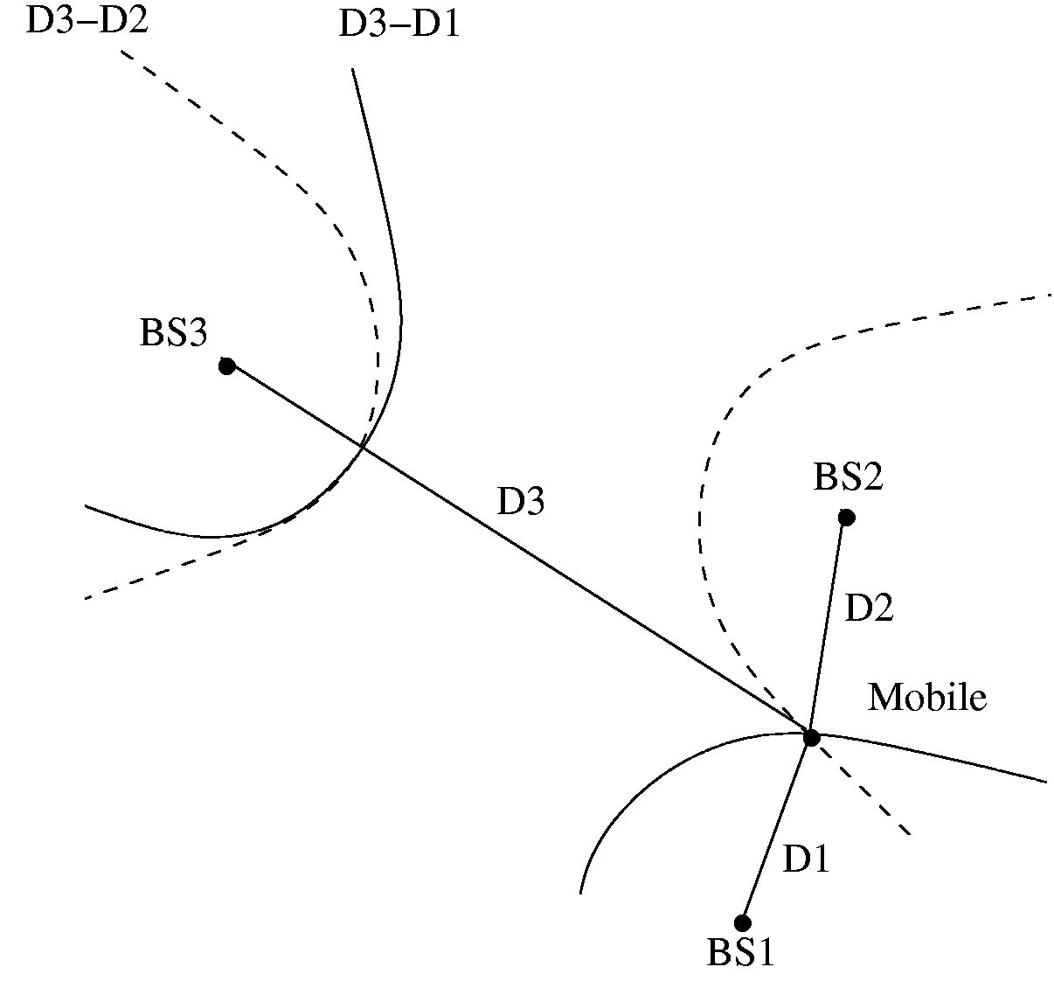
Mobile (x_{m},y_{m})
Anchor 1 (x_{A1},y_{A1})
Anchor 2 (x_{A2},y_{A2})
Anchor 3 (x_{A3},y_{A3})
Positioning from TDOA
3 anchors with known positions (at least) are required to find a 2D-position from a couple of TDOAs
Measurements
Estimated Position
Specific Positioning Algorithms

Figure 7 – Positioning from TDOA

Note that the basis for TDOA is one-way ranging (OWR). The implementation of OWR can be done in one of two forms; that is, either active OWR where the unknown station is transmitting or passive where the unknown stations is receiving. The primary implication is where the TDOA hyperbolas are collected for processing.

TDOA can operate in one of two modes …

Mode 1 – The station of interest (SOI) receives multiple reference pulses and calculates the TDOA
LORAN-C type operation and the processing burden is on the receiver to run the hyperbolic location algorithms

Mode 2 – The station of interest transmits a reference pulse which is received by multiple fixed nodes
The fixed nodes must forward the TDOA information to a workstation which then runs the hyperbolic location algorithms²
Key:
Sync Pulse
Location Pulse
Position Report
Mode 1 - Passive
Key:
Sync Pulse
Location Pulse
TDOA backhaul
Mode 2 - Active
controller
controller
reference node
reference node
SOI
SOI
Note: The sync pulse accuracy determines the TDOA accuracy and hence the sync pulse requires a wideband transmission
Figure 8 – Passive and Active TDOA OWR

SSR Ranging

SSR ranging is discussed in references [7], [17].

SSR ranging is already supported by the 802.15.4 standard because it runs off the RSSI. SSR ranging is simple and does not require the synchronization needed for TOA and TDOA based ranging; however, there are issues with attenuation variance due to multipath, etc, which require multiple measurements and measurement averaging.

We start our analysis by considering the case of free space propagation. In free space propagation, the received power, as a function of distance, is given as $P_{r}(d)=P_{t}G_{t}G_{r}{\left(\frac{λ}{4πd}\right)}^{2}\text{ Watts}$. In free space, the “large-scale” energy attenuation obeys an inverse square law relationship $L\left(d\right)=\text{10}\text{log}\text{10}\left(\frac{\text{Pr}}{\text{Pt}}\right)=\text{10}\text{log}\text{10}\left(\frac{(4πd)^{2}}{G_{t}G_{r}λ^{2}}\right)$. In practice, the far field received power is reference to a distance d₀ as $P_{r}(d)=P_{r}(d_{0}){\left(\frac{d_{0}}{d}\right)}^{2}$. In terrestrial settings, additional mechanisms such as reflection, diffraction and scattering affect wave propagation and causing “small-scale” slow and fast fading components. For ranging we’d like to extract the large-scale attenuation from the combined large and small scale attenuation.

Figure 9 – Large-scale Fading

With wideband signals the mean received power can be calculated by summing the powers of the multipath in the power delay profile. With narrowband signals, received power experiences large fluctuations over a local area and averaging must be used to estimate the mean received power. Range can be estimated via $\hat{d}=d_{0}{\text{10}}^{\frac{p_{0}−\hat{p}(d)}{\text{10}n}}=d{\text{10}}^{\frac{X_{σ}}{\text{10}n}}$. The range estimation distribution variance decreases with decreasing distance.

Devices calculate ranges to their neighbors

Location is jointly estimated using collective information

Benefits
Location Accuracy/Range Extension
Architectural Blueprint
d
z₉
d
d
d
d
d
d
d
d
d
d
d
d
d
d
d
data
link
central
computer
‘Blind’
NeuRFons
‘Reference’

Figure 10 – Relative Location

NFER Ranging

NFER ranging is discussed in references [4], [10], [14].

Most RF systems operate in the “far-field” with distances between transmitters and receivers typically many wavelengths. The detailed behavior of RF signals in the “near-field” region, within about a half wavelength (0.50 λ) of an antenna is usually ignored, because the subtleties of near-field behavior do not affect most RF systems. Dr. Hans Schantz has discovered that this often overlooked domain of RF science can be used to make simple, high precision distance measurements.

RF or radio signals are electromagnetic waves which are a combination of an electric (E-field) wave and a magnetic (H-field) wave. Close to a transmit antenna, the electric and magnetic waves are in “phase quadrature,” approximately 90º out of phase with each other. By the time these waves have traveled about a half wavelength (0.50 λ) from an antenna, however, the electric and magnetic waves are nearly synchronous, i.e. 0º phase difference. The phase quadrature between the electric and magnetic fields gradually vanishes as the waves move away from the transmit antenna.
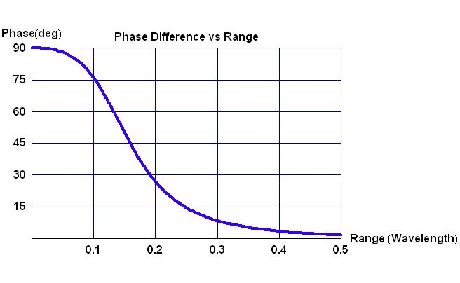
Figure 11 – Phase Difference vs. Range

By tracking this phase quadrature, precise distance measurements may be made from about 0.05 λ to 0.50 λ with best performance between about 0.08 λ to 0.30 λ. The effective range for a NFER™ system depends on the operating frequency (i.e. the lower the frequency, the longer the range).

In practice, a near field tag or beacon transmitter emits an unmodulated RF tone. A near field locator receiver compares the phase of the electric and magnetic fields to determine the range.

Figure 12 – Near-Field TX Beacon and RX Locator

The implications of the low frequency Near-Field ranging approach are numerous. The wavelengths of a near field system are long compared to the propagation environment; hence, the ranging results are basically unaffected by multipath. In addition, the low frequencies have superior propagation penetration properties with regards to buildings, etc. Phase offsets can be introduced by gross features such as the building frame and the building wiring or plumbing. However, these phase offsets are relatively gradual and may be dealt with by calibration.

AOA Localization

AOA ranging is discussed in reference [6].

AOA, by itself, is a localization technique as opposed to a ranging technique; however, AOA does not require the precise synchronization needed for TOA and TDOA methods. When combined with a viable ranging technique, AOA allows vector ranging which opens up interesting possibilities.

The angle of arrival is the direction to the source of an incoming wave field as measured by an array of antenna elements. The planar wave front models the incoming wave far field by measuring the phase (time) difference of the wave front at different array elements.

Y
(x,y)
Source
X
R
Range
θ
Azimuth
2D model
Array
Elements
X
R
φ
θ
(x,y,z)
Z
Y
Azimuth
Elevation
Range
Source
Array Elements
3D model
Figure 13 – 3D and 2D Localization

A phased array antenna system consists of any number of antenna elements distributed in a particular geometrical pattern, with the output of all the antenna elements vectorially added to synthesize a particular antenna pattern in the direction of the incoming source fields.

Figure 14 – Phased Array Antenna

As long as the spatial sampling requirement is met, larger arrays generally provide better resolution of the source field, but with increasing size and cost. In the case of UWB, the maturity of UWB antenna array technology must be taken into consideration.

Special consideration is needed for multipath environments and for multi-source cases since sources can be closely spaced. In non-line-of-sight environments, the measured AOA might not correspond to the direct path component of the incoming wave field which can lead to large positioning errors.

Two dimensional positioning requires measurement of the AOA by at least two antenna array systems. In practice, measurement errors arise due to: imperfect array phase and gain calibration, improper modeling of the mutual coupling between elements, and error due to the presence of a strong indirect path.

True line of position
Measurement error
DEV-A
DEV-B
DEV-C
Figure 15 – Two Dimensional Positioning

At the PHY sub-layer, the PHY would notify the MAC protocol of the signal reception information (for example, AOA and reception power) and the higher layers would make the complex decisions and range bearing calculations. The MAC would assign time slots to be used for AOA measurements and the total number of measurement periods required to make one position estimate would depend on the accuracy requirement of the application.

At the MAC sub-layer, each device could maintain a cache table to keep the AOA, reception time, reception power, etc. of the last signal from each neighboring device. In practice, each device may update the AOA and reception time that corresponds to a neighboring device even when overhearing any signal, regardless of whether the signal is sent to that device. ACK frames may be used as measurement frames to conserve power and MAC resources.

MAC and PHY Interfaces (Quick Review)

7.1 MAC sublayer service specification

The MAC sublayer provides an interface between the SSCS and the PHY. The MAC sublayer conceptually includes a management entity called the MLME. This entity provides the service interfaces through which layer management functions may be invoked. The MLME is also responsible for maintaining a database of managed objects pertaining to the MAC sublayer. This database is referred to as the MAC sublayer PIB.
Figure 16 depicts the components and interfaces of the MAC sublayer.
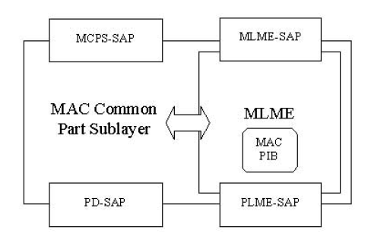
Figure 16—The MAC sublayer reference model

The MAC sublayer provides two services, accessed through two SAPs:
- The MAC data service, accessed through the MAC common part sublayer (MCPS) data SAP (MCPS-SAP)
- The MAC management service, accessed through the MLME-SAP.

These two services provide the interface between the SSCS and the PHY, via the PD-SAP and PLME-SAP interfaces. In addition to these external interfaces, an implicit interface also exists between the MLME and the MCPS that allows the MLME to use the MAC data service.

7.2 PHY service specifications

The PHY provides an interface between the MAC sublayer and the physical radio channel, via the RF firmware and RF hardware. The PHY conceptually includes a management entity called the PLME. This entity provides the layer management service interfaces through which layer management functions may be invoked. The PLME is also responsible for maintaining a database of managed objects pertaining to the PHY. This database is referred to as the PHY PAN information base (PIB). Figure 17 depicts the components and interfaces of the PHY.
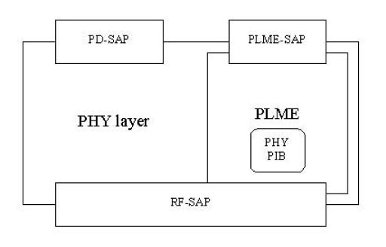
Figure 17 – The PHY reference model

The PHY provides two services, accessed through two SAPs: the PHY data service, accessed through the PHY data SAP (PD-SAP), and the PHY management service, accessed through the PLME’s SAP (PLMESAP).

7.2 Device Management Entity (DME)

(The following paragraph was extracted from reference [20])

In order to provide correct MAC operation, a device management entity (DME) should be present within each DEV. The DME is a layer-independent entity that may be viewed as residing in a separate management plane or as residing “off to the side.” The exact functionality of the DME is not specified in this standard, but in general this entity may be viewed as being responsible for such functions as the gathering of layer-dependent
status from the various layer management entities, and similarly setting the value of layer-specific parameters. The DME typically performs such functions on behalf of the general system management entities and implements standard management protocols.

Figure 18 – stacked reference models with DME interface

Interface Comments

8.1 TOA and TDOA

TOA Two Way Ranging - single packet exchange
- DME entry point into MAC is MLME-SAP
- MAC peer-to-peer commands
- ranging request, ranging ack response
- TX & RX synchronize PHY clocks (seems hard to do)
- ranging token sent, ranging token received
- MAC/PHY communications via PD-SAP
- MAC constructs ranging packet
- TX PHY emits / RX PHY measures time of arrival
- RX PHY stores timer count in PHY PIB
- RX DME retrieves count from PHY PIB and calculates range

TOA Two Way Ranging - double packet exchange
- DME entry point into MAC is MLME-SAP
- MAC peer-to-peer commands
- ranging request, ranging ack response
- 1st ranging token sent, ranging token received, held τ and returned
- 2nd ranging token sent, ranging token received, held 2τ and returned
- MAC/PHY communications via PD-SAP
- MAC constructs 1st ranging packet
- Sender PHY emits
- RX measures 1st time of arrival, holds for τ seconds, sends back
- sender measure 1st time of return
- RX measures 2nd time of arrival, holds for 2τ seconds, sends back
- sender measures 2nd time of return
- Sender PHY stores all timer count in PHY PIB
- Sender DME retrieves count from PHY PIB and calculates range

TOA One Way Ranging - Active
- DME entry point into MAC is MLME-SAP
- MAC peer-to-peer commands
- ranging request, ranging ack response
- RX anchors synchronize PHY clocks (via out of channel network)
- ranging token sent, ranging token received
- MAC/PHY communications via PD-SAP
- MAC constructs ranging packet
- TX PHY emits / RX PHY measures time of arrival
- RX PHY stores timer count in PHY PIB
- RX DME retrieves count from PHY PIB
- DME then forwards count to calculator station for processing

TOA One Way Ranging - Passive
- DME entry point into MAC is MLME-SAP
- MAC peer-to-peer commands
- ranging request, ranging ack response (do each anchor serially)
- TX anchors synchronize PHY clocks (via out of channel network)
- ranging token sent, ranging token received
- MAC/PHY communications via PD-SAP
- MAC constructs ranging packet
- TX PHY emits / RX PHY measures time of arrival
- RX PHY stores all timer counts in PHY PIB (one for each TX anchor)
- RX DME retrieves counts from PHY PIB and calculates range

8.2 SSR (signal strength ranging)

SSR (signal strength ranging)
- DME/MAC identifies unit being received
- RX measure RSSI (receive signal strength)
- Store results in PHY PIB (May need to add explicit RSSI PHY PIB)
- DME retrieve RSSI reading from PHY PIB

8.3 AOA
(notes from Marilynn Green’s presentation [6])

- MAC will have to adapt to different capabilities of the local and remote devices.
  - For example: One type of device may be fully equipped with GPS, a compass, and an antenna array to measure AOA…but another device may only be able to measure AOA.
- In the simplest case, the PHY passes AOA results to the MAC and the MAC leaves more complex decisions to higher layers, like…
  - Need for repeated measurements.
  - Calculation of position.
- MAC can reserve the time needed to make the AOA measurements.
- Guaranteed time slots may be required for:
  - ARQ: Initiator’s AOA request.
  - ACK: Responder’s acknowledgement.
  - AM: Responder’s AOA measurement frame.
  - AMR: Responder’s AOA measurement report.
- MAC may need to have pre-programmed constants to correct for device-specific measurement errors (ex.: drift in the phase and gain of the antenna elements).
- Power efficiency:
  - Power control to conserve battery power during device idle periods.
  - Reply frame with measurement results can be sent in the same frame as the request so that the device does not have to store measurement reports for a long time and can more quickly return to idle mode.
  - In some cases, ACK frame may be used to obtain the AOA measurements.
- MAC measurement report to higher layers may contain:
  - AOA.
  - Success or failure.
  - Quality of measurement.
- Number of measurement periods required to satisfy accuracy requirements can be decided by higher layers.

AOA
- DME/MAC identifies unit being received
- PHY measures AOA during normal packet traffic (can this be done?)
(Marilynn Green indicated we may need special measure frames)
- Store results in PHY PIB
- DME retrieves AOA reading from PHY PIB
- DME applies calibration parameters, calculates AOA

8.4 Near-Field Ranging

NFER (Q-Track)
Overall, I believe it is possible to incorporate the NFER approach into the IEEE802 protocol stack. One suggestion, provided by the editor of this document, is as follows (but we’ll have to wait until proposal presentations to see what is actually proposed):

Figure 19 – Dual RF Partitioning

PHY Sublayer

9.1 High Rate Clock Option for Time of Arrival (TOA/TDOA) Support

A PHY that supports either TOA or TDOA shall have a high rate clock located at the PHY layer.
High Rate Clock

Counter
start
stop
count
PHY SAP - START CLOCK COMMAND
PHY Correlator
Vthresh
Local PHY Trigger Mechanism (TBD)
Figure 20 – High Rate PHY Clock

The two parameters that shall be reported to the PHY PIB are the count value and the frequency of the high rate clock.

9.4 PHY constants and PIB attributes
This subclause specifies the constants and attributes required by the PHY.

9.4.1 PHY PIB ranging attributes
The PHY PIB comprises the attributes required to manage the PHY of a device. Each of these attributes can be read or written using the PLME-GET.request and PLME-SET.request primitives, respectively. The attributes contained in the PHY PIB are presented in Table 3.

Table 3—PHY PIB ranging attributes
Attribute | Identifier | Type | Range | Description
phyRangeClockFreq | 0x04 | Integer | 0-10000 | High Rate Ranging Clock Frequency (MHz)
phyRangeCount | 0x05 | Integer | 0-99999 | Ranging Counter Count Value
phyRSSI | 0x06 | Integer | 0-999 | Received Signal Strength  (Needed?  If so, units?)
phyAOA | 0x07 | Integer | 0-359 | Angle of Arrival (degrees)
phyNferFreq | 0x08 | Integer | 0-999999 | NFER Operating Frequency (KHz)
phyNferAngle | 0x09 | Integer | 0-99999 | E-H field angle, tenths of degrees  (what is the required resolution?)

MAC Sublayer

10.1 MAC management service – Ranging

Table 4 - Additional MLME

Name | Request | Indication | Response | Confirm
MLME-RANGE | 10.1.1 | 10.1.2 | 10.1.3 | 10.1.4

This mechanism supports range determination between two DEVs. This one primitive supports all ranging options via a rich set of primitives. The primitive's parameters are defined in Table 5.

Table 5— MLME-RANGE primitive parameters

Name | Type | Valid Range | Description
SrcID | Integer | Any valid DEVID as defined in TBD | The device ID of the source
DestID | Integer | Any valid DEVID as defined in TBD | The device ID of the destination
Timeout | Integer | As defined in TBD | The time limit for completion of the ranging packet exchange.
Reason Code | Integer | 2 octets:  - first two bits indicate if requrested RangeType is supported  (10.1.4.2)  - next 11 bits indicate supported RangeTypes  (0=not supported, 1=supported) | b0,1=enumerated  (as per 10.1.4.2)  b2= TWR TOA  b3= TWR TOA DOUBLE  b4= OWR TOA-A  b5= OWR TOA-P  b6= TWR TDOA  b7= TWR TDOA DOUBLE  b8= OWR TDOA-A  b9= OWR TDOA-P  b10= SSR  b11= AOA  b12= NFER  b13=reserved  b14=reserved  b15=reserved
RangeType | Integer | 0 to 10  (4 bits from octet) | 0=TWR TOA  1=TWR TOA DOUBLE  2=OWR TOA-A  3=OWR TOA-P  4=TWR TDOA  5=TWR TDOA DOUBLE  6=OWR TDOA-A  7=OWR TDOA-P  8=SSR  9=AOA  10=NFER  11 to 255=reserved
Note:
TWR=two way ranging
OWR=one way ranging
TOA=time of arrival
TDOA=time difference of arrival
DOUBLE=double packet exchange, differential TOA
SSR=signal strength ranging
AOA=angle of arrival
NFER=near field electromagnetic ranging
A=active TOA/TDOA
P=passive TOA/TDOA

10.1.1 MLME-RANGE.request
This primitive is used to request that the range between two devices be measured. The semantics of the primitive are as follows:
MLME-RANGE.request (DestID, SrcID, Timeout, RangeType)
The parameters are defined in Table 5.
10.1.1.1 When generated
This primitive is generated by the source DME to request a range measurement.
10.1.1.2 Effect of receipt
When a DEV MLME receives this primitive from its DME, it will generate a RANGE command, which it will send to the Destination PNID. The Destination PNID, upon receiving the RANGE command, will generate an MLME-RANGE.indication.
(Editor question … does this exchange need to happen for all ranging options, or just for TOA/TDOA? It won’t hurt to do it for all ranging options but it could cause excessive overhead when it is not needed. Actually, we don’t have to answer this question until after the down selection.)
10.1.2 MLME-RANGE.indication
This primitive is used to indicate a received RANGE command. The semantics of the primitive are as follows:
MLME-RANGE.indication (DestID, SrcID, Timeout, RangeType)
The parameters are defined in Table 5.
10.1.2.1 When generated
This primitive is sent by the non-initiating MLME to its DME upon receiving a RANGE command.
10.1. 2.2 Effect upon receipt
When the Destination DME receives this primitive, it will determine whether to accept or reject the source DEV request for the requested range type measurement. In addition, the Destination DME will append the ReasonCode bit map field to indicate which ranging types are supported. The Destination DME will then send a MLME-RANGE.response with appropriate parameter values to its MLME via the MLME-SAP.
10.1.3 MLME-RANGE.response
This primitive is used to initiate a response to an MLME-RANGE.indication. The semantics of the primitive are as follows:
MLME-RANGE.response (DestID, SrcID, ReasonCode)
The parameters are defined in Table 5.
10.1.3.1 When generated
This primitive is generated by the Destination DME upon receiving an MLME-RANGE.indication.
10.1.3.2 Effect upon receipt
When the destination MLME receives this primitive from its DME, it will either initialize the ranging state machine in anticipation of exchanging ranging tokens or it will reject the ranging request with a ReasonCode indicating the reason for the request being denied.
10.1.4 MLME-RANGE.confirm
This primitive is used to inform the initiating source DME whether the requested ranging token exchange will commence or was the ranging request rejected. The semantics of the primitive are as follows:
MLME-RANGE.confirm (DestID, SrcID, ReasonCode)
The parameters are defined in Table 5.
10.1.4.1 When generated
The initiating source MLME sends this primitive to its DME to confirm whether a ranging token exchange is pending.
10.1.4.2 Effect upon receipt
When the initiating source MLME receives a ReasonCode[0,1] = ExchangeTokens (00) it shall initiate the ranging token exchange as per clause TBD. When the ReasonCode = DoNotExchangeTokens (01) the source MLME shall terminate the ranging token exchange procedure and perhaps attempt ranging later. When the ReasonCode = RangeTypeNotSupported (10) the source MLME shall terminate the ranging token exchange and shall not initiate another range measurement of that type with that particular destination DEV. (Note that the following 11 bit field will indicate which RangeTypes are supported). If the ranging is not complete within the time specified by parameter "Timeout" then the ReasonCode shall be set to ReasonCode=TimeoutFailure (11).

10.2 MAC MLME MSC Ranging Descriptions
This clause shows the MSC (message sequence charts) for each of the ranging token exchange options.
10.2.1 TWR TOA and TWR TDOA MSC Description
Figure 20 illustrates the message sequence involved when requesting a TWR TOA or TWR TDOA measurement. The ranging command initiates the precise exchange of a ranging token between the source DEV and the destination DEV as shown in the message sequence chart below.
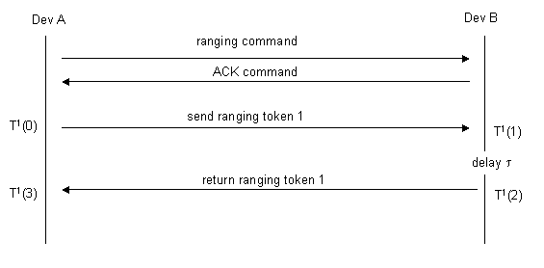
Figure 21— MSC for TWR TOA/TDOA token exchange
Device A must receive the return token from device B within the amount of time indicated in the command Timeout field. The ranging token itself is PHY dependent and is described in clause TBD. The time of flight between the two devices is then calculated as
T_{flight} = {T¹(3) - T¹(0) - τ}/2

where the time epochs are defined in Figure 1. The calculated range is then stored as PHY Management object phyRangeCount (clause 9.4.1).

10.2.2 TWR TOA DOUBLE and TWR TDOA DOUBLE MSC Description
Figure 21 illustrates the message sequence involved when requesting a TWR TOA DOUBLE or TWR TDOA DOUBLE measurement. The ranging command initiates the precise exchange of a ranging token between the source DEV and the destination DEV as shown in the message sequence chart below.
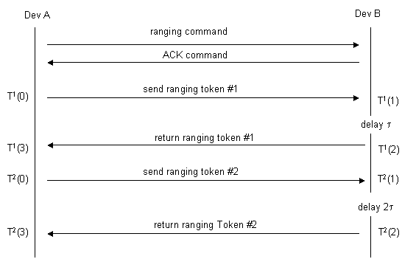

Figure 22— MSC for TWR TOA/TDOA DOUBLE token exchange
Device A must receive the second token from device B within the amount of time indicated in the command Timeout field. The ranging token itself is PHY dependent and is described in clause TBD. The time of flight between the two devices is then calculated as
T_{flight} = {T¹(3)- T¹(0)} - [{T²(3)- T²(0)}/2]

where the time epochs are defined in Figure 1. The calculated range is then stored as PHY Management object phyRangeCount (clause 9.4.1).

10.2.3 OWR TOA-A and OWR TDOA-A MSC Description
Figure 22 illustrates the message sequence involved when requesting an OWR TOA-A or OWR TDOA-A measurement. The ranging command initiates the precise exchange of a ranging token between the source DEV and the destination DEV as shown in the message sequence chart below.
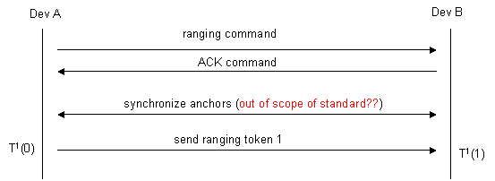
Figure 23— MSC for OWR TOA-A/TDOA-A token exchange
Device B must receive the token from device A within the amount of time indicated in the command Timeout field. The ranging token itself is PHY dependent and is described in clause TBD. The time of flight between the two devices is then calculated as
T_{flight} = {T¹(0) - T¹(1)}/2

where the time epochs are defined in Figure 1. The calculated range is then stored as PHY Management object phyRangeCount (clause 9.4.1).

10.2.4 OWR TOA-P and OWR TDOA-P MSC Description
Figure 23 illustrates the message sequence involved when requesting an OWR TOA-A or OWR TDOA-A measurement. The ranging command initiates the precise exchange of a ranging token between the source DEV and the destination DEV as shown in the message sequence chart below.
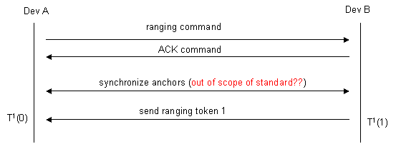
Figure 24— MSC for OWR TOA-P/TDOA-P token exchange
Device A must receive the token from device B within the amount of time indicated in the command Timeout field. The ranging token itself is PHY dependent and is described in clause TBD. The time of flight between the two devices is then calculated as
T_{flight} = {T¹(1) - T¹(0)}/2

where the time epochs are defined in Figure 1. The calculated range is then stored as PHY Management object phyRangeCount (clause 9.4.1).
10.2.5 SSR MSC Description
Figure 24 illustrates the message sequence involved when requesting a Signal Strength measurement. The ranging command initiates the exchange of a ranging packet between the source DEV and the destination DEV as shown in the message sequence chart below. (Editor: it seems we’d want to pre-arrange measuring the RSSI to ensure the device of interest is “on the air” … comments?).
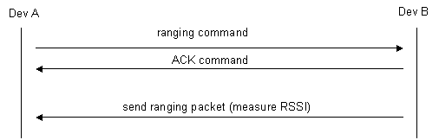
Figure 25— MSC for Signal Strength Based Ranging

Device A must receive the RSSI ranging packet from device B within the amount of time indicated in the command Timeout field. The RSSI ranging packet itself is PHY dependent and is described in clause TBD. The signal strength RSSI reading is then stored as PHY Management object phyRSSI (clause 9.4.1).
10.2.6 AOA MSC Description
Figure 25 illustrates the message sequence involved when requesting an AOA measurement. The ranging command initiates the exchange of a ranging packet between the source DEV and the destination DEV as shown in the message sequence chart below. (Editor: it seems we’d want to pre-arrange measuring the angle of arrival to ensure the device of interest is “on the air” … comments?).
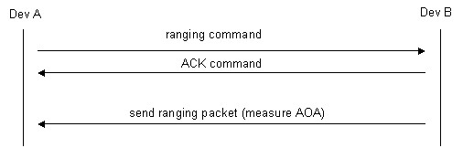
Figure 26— MSC for AOA Based Ranging

Device A must receive the AOA ranging packet from device B within the amount of time indicated in the command Timeout field. The RSSI ranging packet itself is PHY dependent and is described in clause TBD. The AOA reading is then stored as PHY Management object phyAOA (clause 9.4.1).
10.2.6 NFER MSC Description
Figure 26 illustrates the message sequence involved when requesting an NFER angle measurement. The ranging command initiates the exchange of a ranging packet between the source DEV and the destination DEV as shown in the message sequence chart below. (Editor: it seems we’d want to pre-arrange measuring the NFER angle to ensure the device of interest is “on the air” … comments?).
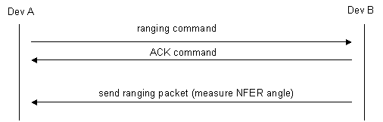
Figure 27— MSC for NFER Based Ranging

Device A must receive the NFER ranging packet from device B within the amount of time indicated in the command Timeout field. The NFER ranging packet itself is PHY dependent and is described in clause TBD. The NFER angle reading is then stored as PHY Management object phyNferAngle (clause 9.4.1).

References

[1] Cumulative Minutes TG4a Ranging Subcommittee, Colin Lanzl, Vern Brethour, Patrick Houghton, doc 15-04-0411-xx-004a

[2] UWB Localization Techniques, Benoit Denis, STMicroelectronics, doc 15-04-0418-00-004a

[3] Ranging Protocols and Network Organization, Benoit Denis, STMicroelectronics, doc 15-04-0427-00-004a

[4] Near Field Ranging Algorithm, Hans Schantz, Q-Track Corporation, doc 15-04-0438-00-004a

[5] Berlin Ranging Subcommittee Report, Rick Roberts, Harris Corporation, doc 15-04-0477-01-004a

[6] Sample MAC Requirements for Angle of Arrival Based Ranging, Marilynn P. Green, Nokia, doc 15-04-0563-00-004a

[7] Signal Strength Based Ranging, Neiyer Correal, Motorola, doc 15-04-0564-00-004a

[8] TDOA Localization Techniques, Rick Roberts, Harris Corporation, doc 15-04-0572-00-004a

[9] Two Way Time Transfer Based Ranging, Joes Decuir, MCCI, doc 15-04-0573-00-004a

[10] Technical Introduction to Near Field Electromagnetic Ranging, Hans Schantz, Q-Track Corporation, www.Q-Track.com

[11] P802.15.4a Alt Phy Selection Criteria, doc 15-04-0232-12-004a

[12] Ranging, RF Signature and Adaptability, Rick Roberts, Harris Corporation, doc 15-04-0300-00-004a

[13] The Effect of AWGN on the Accuracy of Time of Arrival Detection, Rick Enns, doc 15-04-0335-00-004a

[14] Near Field Electromagnetic Ranging, Kai Siwiak, Time Derivative, doc 15-04-0360-00-004a

[15] Technical Editor Contribution of IEEE Formatted Draft Text for MB-OFDM Proposal, Rick Roberts, Harris Corporation, doc 15-03-0541-01-003a

[16] Introduction to Chirp Spread Spectrum (CSS) Technology, John Lampe, Nanotron Technologies, doc 15-04-0353-00-004a

[17] IEEE802.15.4 Relative Location, Neiyer Correal and Fred Martin, Motorola, doc 15-04-0228-01-004a

[18] Intel CFP Presentation for a UWB PHY, Foerster, et al, Intel Corporation, doc 03109r1P802-15-3a

[19] Wireless Medium Access Control (MAC) and Physical Layer (PHY) Specifications for Low-Rate Wireless Personal Area Networks (LR-WPANs), IEEE802.15.4, 2003

[20] Wireless Medium Access Control (MAC) and Physical Layer (PHY) Specifications for High-Rate Wireless Personal Area Networks (HR-WPANs), IEEE802.15.3, 2003

The term NFER is a trademark of the Q-Track corporation
A variation of this packet exchange technique, mentioned in [15], uses dual packet exchanges and measures the difference of TOA in an attempt to calibrate out the clock drift from the other cooperating device. In principle, this technique does not require precise clock calibration between the two ranging devices. This technique has been called Differential-Time-of-Arrival (DTOA), but in general we reframe from this nomenclature to avoid confusion with TDOA (Time-Difference-of-Arrival). Instead we’ll call it the “double token exchange” method and it is covered in section 2.1.
The source device calculates the ranging information. If the destination device wants range information it will have to send a ranging command in the reverse direction.
It is similar to SSR (signal strength ranging) in this sense.
Whether or not the far-field planar wave approximation holds well will depend on the array aperture and the minimum wavelength of the source signal. In the near field, the phase (time) difference at different array elements becomes a non-linear function of the source’s position.
There is a spatial sampling requirement that limits the inter-element spacing of antenna elements to be ≤½ minimum source wavelength.

