IEEE P802.11
Wireless LANs
Minutes of the IEEE P802.11 Full Working Group
Date: 2007-02-01
Author(s):
Name | Company | Address | Phone | email
R. R. Miller (Recording for Tim Godfrey) | AT&T | 180 Park Avenue, Florham  Park, NJ 07932 | +1 (973) 236-6920 | rrm@att.com
Abstract
This document constitutes the draft minutes of the 802.11 full working group for the January, 2007 session at London, UK.
Notice: This document has been prepared to assist IEEE 802.11. It is offered as a basis for discussion and is not binding on the contributing individual(s) or organization(s). The material in this document is subject to change in form and content after further study. The contributor(s) reserve(s) the right to add, amend or withdraw material contained herein.

Release: The contributor grants a free, irrevocable license to the IEEE to incorporate material contained in this contribution, and any modifications thereof, in the creation of an IEEE Standards publication; to copyright in the IEEE’s name any IEEE Standards publication even though it may include portions of this contribution; and at the IEEE’s sole discretion to permit others to reproduce in whole or in part the resulting IEEE Standards publication. The contributor also acknowledges and accepts that this contribution may be made public by IEEE 802.11.

Patent Policy and Procedures: The contributor is familiar with the IEEE 802 Patent Policy and Procedures <http:// ieee802.org/guides/bylaws/sb-bylaws.pdf>, including the statement "IEEE standards may include the known use of patent(s), including patent applications, provided the IEEE receives assurance from the patent holder or applicant with respect to patents essential for compliance with both mandatory and optional portions of the standard." Early disclosure to the Working Group of patent information that might be relevant to the standard is essential to reduce the possibility for delays in the development process and increase the likelihood that the draft publication will be approved for publication. Please notify the Chair <stuart@ok-brit.com> as early as possible, in written or electronic form, if patented technology (or technology under patent application) might be incorporated into a draft standard being developed within the IEEE 802.11 Working Group. If you have questions, contact the IEEE Patent Committee Administrator at <patcom@ieee.org>.
Opening Plenary: Monday, January 15, 2007
- Introduction
  - The joint meeting 11, 15, 18, 19, 20, 21, and 22 is called to order by Stuart J. Kerry at 0810 hours.
  - The agenda of 802.11 is in doc: IEEE 01-06-1881r3.
- APPROVE OR MODIFY 802.11 MEETING AGENDA
  - Changes from previous revision
    - The agenda looks the same as the previous one except for the addition of the joint meeting items.
  - Stuart reviews the agenda.
  - Request for modifications to agenda from table or floor. None.
  - The agenda is moved and approved by unanimous consent.

- REVIEW AND APPROVE THE 802.11 MINUTES OF Melbourne (September 2006) JOINT SESSION
  - Stuart asks if there are any matters arising from the minutes.
  - Clint Chaplin asks if the minutes include the minutes of the individual task groups
  - Stuart defers the question until the minutes of Dallas meeting are discussed.
  - The minutes are moved and approved by unanimous consent
- Announcements
  - Please switch off handsets
  - Stuart reads anti-trust announcement

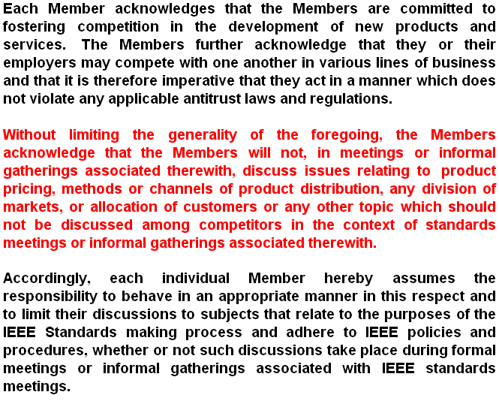

  - Stuart advises that the group is on notice that it is operating under these rules.
  - Straw poll of individuals attending meetings for first time: 26
  - Rick Alfvin notes 207 attendees at this session (raised to 237 at ~0930 to account for latecomers).
- Treasury Report
  - John Barr provides financial report document 15-07-537r0:

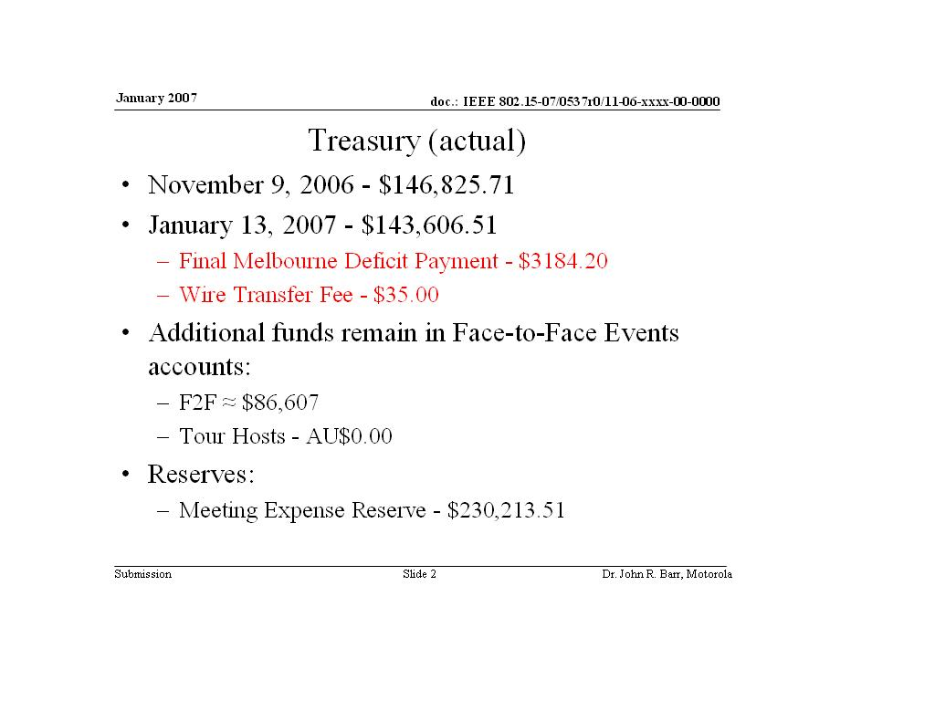

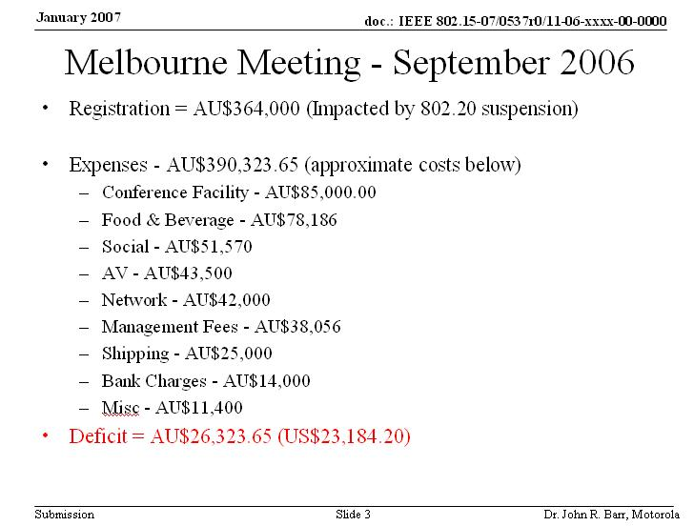

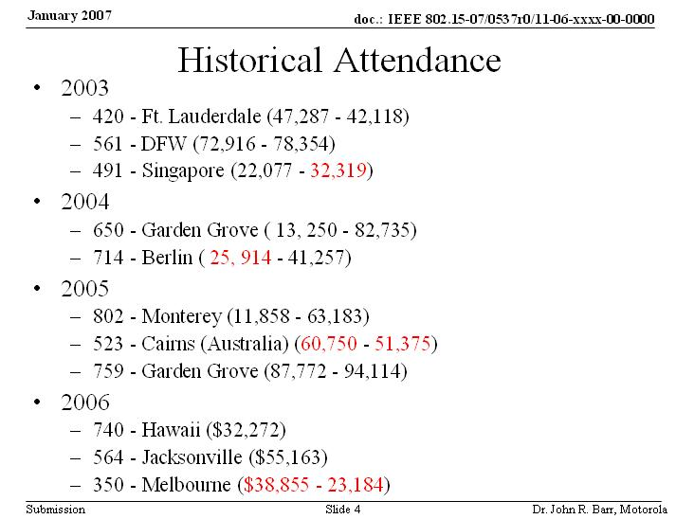

  - Attendance declined in Melbourne due to 802.20 not meeting
- Review of IEEE 802 Policies and Procedures
  - Al Petrick not present, so Stuart handling.
  - Stuart reads patent policy (March 2003, Revised February 2006)

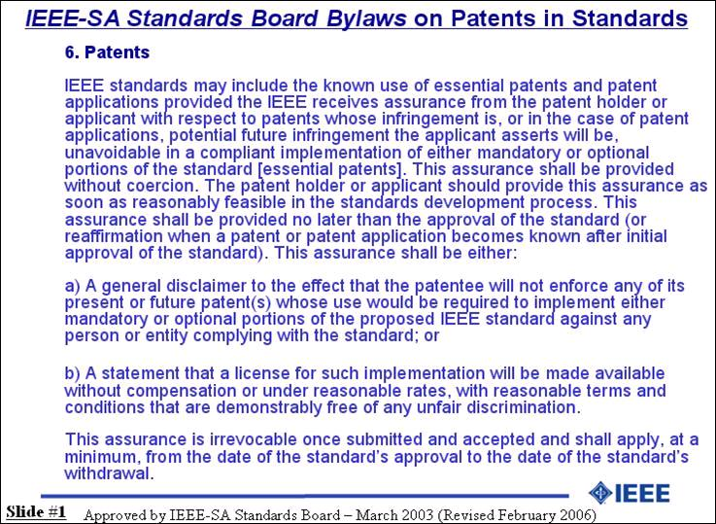

  - Stuart reads Inappropriate Topics for IEEE WG Meetings

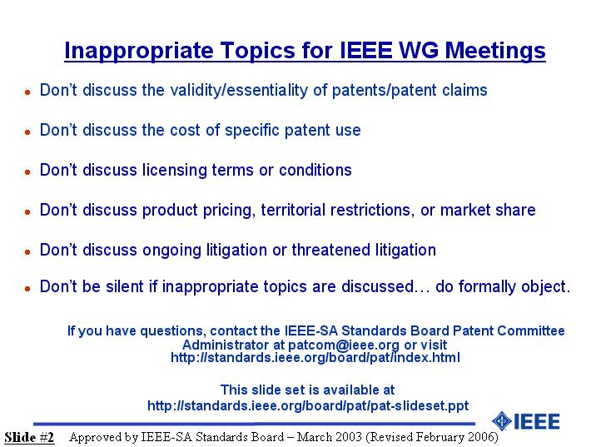

  - If there are any questions, send them to the PATCOM secretary at http://www.patcom.ieee.org
  - Does everyone understand the patent policy? Are there any questions on the patent policy? None. This session is running under these rules. Are there any letters of assurance that the chairs of the Working Groups need to be aware of? None.
  - Are there any announcements from the table? No.
  - Are there any announcements from the floor? No.
  - Stuart advises caution with leaving computers and other personal items unattended.
- Discussion of Future Venues
  - Bob Heile reviews 2007 venues
  - May 13-18 Montreal
  - September 16-21 Waikoloa
  - For 2008, Singapore considered, but under new management and possibly cost-prohibitive
  - New property in Taipei considered, but may be too small
  - Auckland, NZ, Australia also possible
  - Floor point: Australia attendance was poor. Suggest Europe or US as Far East locations seem difficult for most to attend.
  - Heile: Hopeful Singapore can be renegotiated
- EXCOM Activities and Plans including PARs
  - No plans or tutorials this meeting
- Network Capability Review
  - Rick Alfvin indicates network up and running. There have been packet losses to western US. There is a help desk adjacent to registration.
- Review of Working Group TAG Activities and agenda approval
  - 802.11 agenda version r2 posted
    - There are joint meetings on Tuesday and Thursday with 802.21
  - Any changes to the 802.11 agenda? None.
  - The agenda is moved and approved by unanimous consent
  - Approval of Dallas minutes
  - John Rosdahl: Do these minutes include the task group minutes?
  - Stuart: Yes, this is assumed because Tim has been kind enough to include them.
  - John: The task groups also approve the minutes?
  - Stuart: Not all of them, but they should.
  - John: The task groups that I attend do this, but why is this not a rule for all?
  - Stuart: All minutes should be approved by TG members. I dictate this as WG chair. Tim combined the minutes for the membership as a matter of courtesy.
  - Charles: When the minutes are approved here, are the minutes of task groups included?
  - Stuart: Robert’s Rules indicate the task groups should approve their minutes as part of their work process. I just made the edict that task groups should do this as part of their adherence to parliamentary procedure.
  - Lee Armstrong: Our TG has been doing this, but…
  - Stuart: I said that it was a possibility that some task groups had not approved their minutes. From this point on, task groups will formally approve minutes of each meeting. We are approving working group meeting minutes only this session. Bob Miller, please note in the minutes that we are approving only the WG minutes, not the TG minutes that Tim inserted. OK.
  - Stuart: Any objection to approving the 802.11 minutes by unanimous consent?
  - John Barr: What is the document number?
  - Harry: I have to look it up, and it will take time.
  - Stuart: Approval of minutes tabled until Wednesday.
- 802.11 Voter Summary Review
  - Voters 325, Potential 11, Nearly 35, Aspirant 184, Lost 26
  - Harry: Announcement on voting. Our voting membership was 403 at November, now 325 due to people not voting on ballots or not meeting attendance criteria.
  - Stuart: Harry, can you discuss your work associated with letter ballots and why the results were late?
  - Harry: It took about 5 weeks to get the last batch of letter ballots out. Each must have valid voters list because of attendees gaining voting rights. With 3-5 letter ballots resulting from a meeting and 3 days to prepare each, by the time I got the tallies done it took about 5 weeks. The work is significantly complicated when people ask to have their voting rights restored. 50-100 people saying, “I forgot to sign up” induces much delay (about 1/3 longer). In the meetings we are required to have a voters list in case a roll call ballot is taken. Restoration of voting rights is another issue.
  - Stuart: In discussion with Harry, you are advised that the policy will be that if attendance not signed, the record cannot be changed. You have two hours with 5 minutes extra at beginning and end. After the session is finished the record is set. If you have lost voting rights due to failure to answer a ballot, we will consider each case, but exceptions will be very limited.
  - John Rosdahl: There were 3 ballots. Each had a different voter count.
  - Harry: The ballot pools are the same. It was a mistake on the site, which is being fixed.
  - Keith: Are we going to get the attendance server fixed?
  - Harry: Yes, underway now.
  - Stuart: All policy changes become effective at 1201 Friday.
  - Bob O’Hara: Can you make available open time slots on the meeting schedule? Yes.
- 802.11 Ballot Review for Letter Ballots 92, 93, and 94
  - Ballot 92, TGp: Voters 347, Approved 166, 66% Approval Ratio, 90% Return Ratio. The ballot failed.
  - Ballot 93, TGs: Voters 347, Approved 128, 48% Approval Ratio, 88% Return Ratio. The ballot failed.
  - Ballot 94, TGy: Voters 347, Approved 182, 74.9% Approval Ratio, 90% Return Ratio. The ballot passes.
  - Bob O’Hara: I contest that ballot 94 has passed. IEEE requires 75%, not 74.9% for a technical ballot to pass. Please state your rationale.
  - Stuart: If you look at IEEE ballot, it shows a decimal place. I have seen other cases where round-up of the decimal has been done. I shall take this off line and report to the group on Wednesday.
  - John Rosdahl: The number of people who voted on TGp is 312 and that was 90% return ratio. For TGs 305 is 88%. For TGy, 305 produced 90%. These appear to show different return ratio percentages for the same data. One of the calculations seems incorrect.
  - Stuart: Harry, please double-check this.
- Meeting Attendance Review
  - Harry: Document 1736r2 will be the document on the server showing attendance procedures. There are 18 official meetings, or 5.6% per meeting. Evening meetings on Monday and Tuesday are extra credit, as are Policies and Procedures meetings. Log in for attendance via 172.16.0.10 or http://newton.events.ieee.org. You must sign in to get onto the list for claiming attendance. You select the task group you are claiming credit for. Documents may be found on http://802server.events.ieee.org
  - Darwin: Please put explicit URL on screen for attendance. Harry shows on screen.
  - Floor: There is a problem with the attendance server, when will it be fixed.
  - Harry: Working on it now.
- Policies and Procedures
  - Stuart: Al Petrick not here, will delay to next session. Any questions on P&P, see Harry or me. Publicity will be handled by me. John Rosdahl will handle timeline updates.
- Reports
  - WG Technical Editor Status
    - Stuart: Terry Cole and Simon Barber are not at this session. Harry Worstell to stand in for the editor’s meeting on Tuesday at 0800.
  - Wireless Next Generation Study Group
    - Stuart: T. K. Tan is not here. I have asked Steve McCann to chair the WNG this week. Will the chairs please come up?
    - Steve McCann: WNG Agenda in doc 07-0037r1. Meeting tomorrow at 0800 to begin to discuss WMM 11e PAR, Emergency Services, and Video over WLAN.
  - TGk Radio Resource Measurement Task Group
    - Richard Paine: TGk agenda in doc 07-0085. Hoping to go to letter ballot this week.
  - TGma/ANA
    - Bob O’Hara: Number assignments for ANA with motions. If you have a ballot that is nearly at its last sponsor recirc you should replace the “TBA” with real numbers for both at TG and WG approval. TGma has been finished final circulation, now forwarded to REVCOM. Now on agenda for early consideration. The standards board should approve as 802.11-2006 replacing the lettered amendments. Remember, all of the amendment numbers will disappear, so plan accordingly. 11ma will finish work at this session with a PAR for continuing maintenance work. Draft is doc in 07-0029r0. No 5-criteria are required on ma PARs.
  - TGn
    - Bruce Kraemer: In comment resolutions from Letter Ballot #1. Resolutions prepared for about 200 of 500. Majority are in “co-existence”. We anticipate completing these and expect to go to LB2.
  - TGp
    - Lee Armstrong: Letter ballot failed. Working on comment resolution.
  - TGr
    - Clint: Chaplin: Comments from last meeting will be finished. Expect to go to new letter ballot. The session plan for TGr shows incorrect information.
  - TGs
    - Donald Eastlake: See document doc 06/1106r1. As the letter ballot did not pass, TGs will work on comment resolutions.
  - TGT
    - Stuart: Charles can no longer be chair of TGT. Stuart thanks Charles for his service. Anticipate switching chairs in March.
    - Charles: Finished internal review, and working on proposals. Expect to wrap up draft, and proceed to letter ballot.
  - TGu
    - Steve McCann: Agenda in doc 0027r2. Will continue liaisons, and work forward.
  - TGv
    - Pat Calhoun: Agenda in doc 07-0067r0. Internal 446 comments in 07draft. Heading to letter ballot.
  - TGw
    - Jesse Walker: Agenda in document 1169r0. Resolving comments from letter ballot 88. Please contact me if you plan to attend ad-hoc.
  - TGy
    - Peter Ecclesine: Continuing with comment resolution Question: Results of letter ballot. Will cover Wednesday including questions.
  - DLSSG
    - Stuart: Harry serving as chair pro-tem of study group. Will look for chair out of study group. Agenda in doc 06-1881.
- 802.15 Announcements and Summaries
  - Bob Heile, Chair of 802.15: Shows attendance and document URL for 802.15, http://newton.events.ieee.org
  - 802.15 voting stats: Voters 127, Nearly 29, Aspirants 106
  - Rick Alfvin: Summarizes attendance and document access procedures for 802.15 and other WGs. Select working group on left side. Log in using USERID for the event, with password. Login will take you to attendance. Your group will be listed. Select group and submit. Document access on right side of “Newton” entry page.
  - [Secretarial note: the acoustics and sub-standard PA system, coupled with low presenter volume made hearing difficult. Some information from some presenters may have been lost]
  - Task Group Reviews
    - Task Group 3C, mm-Wave: Working on 4 system documents: system refinements, criteria, usage model, and channel model. When finished we shall issue a call for proposals.
    - 4C Study Group, Alternate PHY 15.4 China: Will solicit input from 15.4 members and harmonize to produce China standards with IEEE standards and work on PAR.
    - 4E TG Alternate 15.4 Physical Layer for Japan: No document from regulatory authority yet. Develop timeline and one presentation scheduled.
    - TG5 Mesh Networking: Working on changes to current draft.
    - Study Group on Body Area Networking (Art) [inaudible]: Several contributions and body channel model.
    - Wireless Next Generation Standing Committee: Presentations
    - 4A TG: Competed recirculation ballot after Dallas, will wrap up.
  - 802.18 Radio Regulatory TAG Summary
    - Mike Lynch: 19 Voters, 0 Nearly, 2 Aspirants
    - Considered ATC, 2.4 band use, and NPRM on TV whitespace. Joint meeting with 802.19.
  - 802.19 Coexistence TAG Activities and Plans
    - Steve Shellhammer; List of officers presented. Liaison list review with 17 voting members. Produced 11n concerns document. Dynamic frequency selection, frequency selection scenarios. Demonstration of SEAMCAT tool using WiMAX.
  - 802.20 Mobile Broadband Wireless Access Activities and Plans
    - Arnie Greenspan: No actual voter count yet. Schedule review. There will be a schedule change due to the joint meeting session this AM. Plan to discuss and vote on new work plan for 802.20. Then discussion/resolution remaining comments on LB2. Presentation by Motorola, regarding new proposal. Discussion of predecessor document leading to LB2.
  - 802.21 Media Independent Handover Activities and Plans
    - Vivek Gupta: 31 Voters, 8 Nearly. [inaudible] Presentations of spectrum reuse and several joint meetings with other task groups.
  - 802.22 Wireless Regional Area Networks and Activities
    - Carl Stevenson: 57 Voters, 12 Nearly, 43 Aspirants. Confirmation of task groups and ad-hocs, comment resolution tutorial. TG1 hoping to go to ballot coming out of March.
- Return to 802.11 Agenda
  - Stuart: No items have been added to the agenda. Is there any other business? Yes. John Barr: Have we reached quorum? Stuart: In 802.11 we will be checking AM and PM. 802.11 is very close to quorum. I will inform when quorum is reached. Other WGs polled, with reply: “unknown or probably not, but will watch AM/PM and Tuesday and inform”.
  - Floor: If no quorum, do we operate as ad-hoc?
  - Stuart: The chair is responsible to determine whether possibility of quorum.
  - Vice chair of 802.16: 200 members registered
- Closing
  - Stuart: Any other business? No. It is 0944. No other business. Session recessed.

Mid-Week Plenary: Wednesday, January 17, 2007
- Introduction
  - The mid-week plenary is called to order by Stuart J. Kerry at 1032 hours.
  - This session will run from 1030-1230
  - The agenda of 802.11 is in doc: IEEE 01-06-1881r4.
  - The attendance is 184 individuals.
  - Items missed Monday
- Modifications to Agenda
  - Stuart: Any modifications to agenda? No. Any objection to accepting the agenda unanimously? No. Unanimous approval.
- Patent Issues
  - Stuart: The chair needs to be aware of any patent issues/letters of assurance. Is everyone familiar with patent policy, are there any questions? No. You are under notice we are operating under these rules
- Attendance
  - Harry Worstell: Attendance system has been running well except for first hour Monday. Stuart has inaugurated a “no forgiveness” policy, so attendees are cautioned to make sure to log onto the server for each session.
- Other Announcements
  - Charles is stepping down as TGT chair, and I am seeking replacement nominations. One volunteer has already come forward.
- Liaisons
  - 802.18
    - Second call for 802.11-802.18 Liaison No Nominations.
  - 802.19
    - Chair (Steve Shellhammer) is stepping down. Eldad Perchia presented the report. Group has had discussions with other groups and has been working on SEAMCAT coexistence tools.
  - 802.21
    - David Hunter presented document 11-07/0151r0 covers progress in handover to other networks. 802.21 now close to practice. The architectural diagram shows interaction of control elements. The architecture assumes certain services are available. Many variables are handled via an elaborate information element structure. Timeline began letter ballot Mar 06, now on 3rd ballot. Sponsor ballot anticipated mid-2007. 405 comments received on latest ballot, with 300 resolutions expected this week. 72 voters. All of the 21 area is available to 802.11 members via same credentials as 802.11. A joint ad-hoc meeting will occur before the March Plenary. 802.21 currently interfacing with EU commissions and their networks, helping operators develop interfaces. This activity is not complete. Chair of 802.21 will give a review presentation at the next meeting (March).
  - Wi-Fi Alliance
    - Andrew Myles presented Document 07/0141r0. 2006 saw Alliance do many press releases, but a “new way” might be needed for continuing success (acceleration of products). Wi-Fi alliance is now certifying Wi-Fi Protected Setup to ease setup complexity. Setup is a simplified method for setting up secure services. Difficulty with 802.11u liaison with 802.11/Wi-Fi Alliance document sharing. Why does 802.11 protect drafts? The Wi-Fi Alliance is soliciting new members.
    - Stephen McCann: On behalf of 11u, the liaison was probably short-sighted. We sent a liaison into an impossible situation. If we think about “r”, it asked for an “expert review”. We should be asking for a similar approval.
    - Stuart: Regarding Slide 3, I agree process must be speeded. I think we must resolve issues between organizations. The documentation for “u” is available through IEEE rules. The issue about sharing documentation is copyrighting. I want to see if Wi-Fi and 802.11 can share documents bi-directionally. Regarding the slow process, let’s identify holes, and fix them. With respect to PR: Excellent job promoting 802.11, but pre-N certification was troubling. We should closely work together on marketing down the road.
    - Jim Carlo: There is a process for making drafts available at slight charge. It is really up to the working group to allow the IEEE to do that.
    - Stuart: Perhaps you (TGu) can explore that with the Wi-Fi Alliance. Other organizations could also explore this.
  - IETF
    - Dorothy Stanley presented document 07/0142r1. 3 items were covered: Radius extension and RADEXT WG documents (shown with documents-access URLs), Updating IETF ECRIT Charter (undergoing review, planning review response in March), and continuation of previous SDO Emergency Services work. Two groups are holding ad-hocs incl. CAPWAP. Updates on various projects.
    - Stuart: Questions? None
    - Dorothy: I have a motion prepared…
    - Motion
“Move to approve liaison document 11-07-1949r0 and request the 802.11 WG chair to forward it to IETF RADEXT as the response to the request for review comments on the radext-wlan-03 internet draft.”
Moved: Dorothy Stanley
Seconded: Jesse Walker
Stuart: Is there any discussion on the motion? None.
For 96, Against 0, Abstain 9. The motion passes.
  - JTC1 SC6
    - Jesse Walker summarizes progress with JTC1 SC6 liaison. The next meeting is in Xian, China. The national bodies have reviewed the document, and IEEE has responded as well. At the Xian meeting these will be discussed. Chuck Thomson and Jesse will attend the meeting.
  - 3GPP
    - Stuart: Third call for 3GPP liaison volunteers. None. Position closed.
  - TIA
    - Ariel Sharon presented document 07/0150. TIA considering safety service matters. Broadband Task Force covering this topic. Joint meeting with TGy studying coexistence in 4.9 band. The group is trying to decide the appropriate home for this work. Existence of two non-complementary protocols could degrade communications. No further action at this time recommended, but it is likely that there will be incompatibility between 802.11 and the other one.
- Old Business (Monday) Review
  - Approve Dallas Minutes
    - Stuart: The minutes are in document 06/07r0. We wish to approve the minutes and matters arising from these minutes. Is there any discussion? No. Is there any objection to approving the minutes unanimously. None. Minutes are approved unanimously.
  - Letter Ballot 92, 93, and 94 Investigation Results
    - Stuart: The chair requested Harry to review ballot results, responding to questions posed Monday. The process of record is that the ballot results are shared with the chair, then the task group chairs, and then a post-ballot audit is conducted. The results of the audit are shown on the slide.

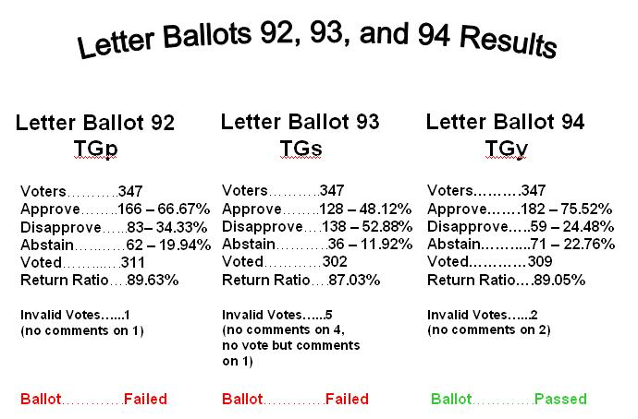

- Announcements
  - TGn Schedule Revision
    - Bruce Kraemer: TGn is nearing the end of its work. The MAC sub-team is still working to complete comment resolutions. There is a change to the PM1 schedule. The session will be combined to support Coexistence and 1-1/2 hours for MAC. I wanted to announce the change to the larger group.
    - Stuart: Are there any issues with the reallocation of time? The change applied only to today, not Thursday. No objections.
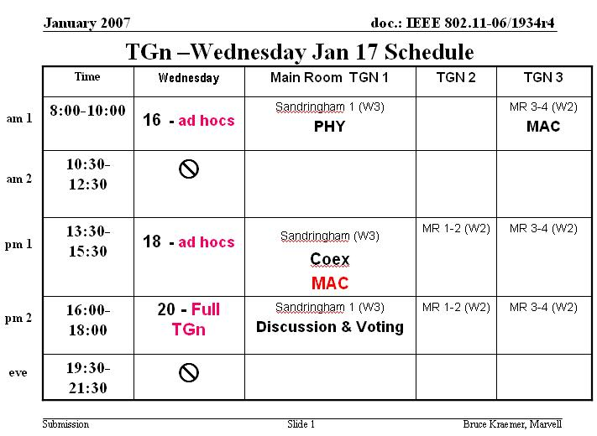

- Other Business
  - TGr Session Added
    - Clint Chaplin: I have requested another session for TGr. I request to modify the TGr agenda/meeting schedule. TGma has finished and left AM1 on Thursday open, and I have replaced the slot with TGr. The meeting room will be MR 5-6.
    - Stuart: Is there any objection to modifying the agenda to replace TGma with TGr? None. The change is approved unanimously.
  - TGT Change Inquiry
    - Stuart: Charles, are there any changes on TGT? No.
  - Other business Inquiry
    - Stuart: Is there any other business in the mid-week Plenary? No.
- Announcement
  - Appeals Panel
    - Stuart: After we recess, we shall go to an appeals panel regarding the TGr appeal at the Dallas Session. The panel members were selected as Steve McCann, Bruce Kraemer, and Richard Paine. The Appellee is Clint Chaplin, and Appellant is Dan Harkins.
- Close
  - The Midweek Plenary is recessed at 1122 hours.

Closing Plenary: Friday, January 19, 2007
- Introduction
  - The closing plenary is called to order by Stuart J. Kerry at 0807 hours.
  - Shows agenda 06/1881r5
  - Cellphones to mute or vibrate
- Agenda
  - Steve McCann is ill, Harry Worstell to substitute
  - Have added a column on right of agenda with motion intentions.
  - P802.11e Wi-Fi WMM item has been added
  - Any other changes to agenda from table? No.
  - Any from floor? No.
  - Approve? Objections? None. Unanimously approved.
- Patent Policy
  - Stuart reiterates patent policy.
  - Stuart: This meeting is operating under these rules.
  - Stuart: Chairs should watch CAC tag for report dates.
  - PatCalhoun: Heathrow Airport status shows some flights late/cancelled. Heathrow Express up, Heathrow Connect down.
  - Stuart: Any volunteers for DLS-SG Chair? None. I appoint Suman Sharma, who previously volunteered.
  - Any 802.18 Liaison volunteers? Rich Kennedy. I appoint Rich Kennedy.
  - Any 802.19 Liaison volunteers? No. Eldad Pershia appointed per previous volunteering.
  - Any volunteers for TGT chair? For next meeting Charles will handle, but will need replacement after that. Chair volunteers Sharma, who volunteered.
  - Harry: IEEE IT group working on document software for us. Available soon. Will take a week to check out, after which “wireless world” may be retired. Attendance server went down yesterday, but back up after one session at 2:45. Rooms were notified.
- P&P Stuart: Al Petrick is not here, so will defer
- Publicity Stuart: No report
- Timeline Stuart: Timeline chart update is on website
- Technical Editor Update: No update. Harry: (covers meeting this venue) The editors had a good meeting. TGma draft will take 4-6 months to get through IEEE editors, but large document.
  - Rev ma will not be available, so I have 9.0 draft to be made available for a fee.
- Location Straw poll. Majority affirmed London as good venue.
- Reports
  - 802.18 Liaison Report - Peter Murray Shown in document 802.16 07/0008r0 and 802.11 07/199r0. Weather radar could pose problems, however these locations are known. Global regulatory information on 802.11n 40 MHz channels in 2.4 and 5 GHz covered. Questions? None.
  - WNGSC Closing Report – Harry, on behalf of Stephen McCann. Presentations. One vote not completed. See doc 11-07-189r0.
  - TGk – Richard Paine. See doc 07/0197r0 – Completed LB90 comment resolutions in prep for last letter ballot. 100% comments resolved. Recirc out of this meeting. Accomplishments since Nov reviewed. Produced Draft 7.0. March Plans: Recirc Sponsor ballot. May plans: sponsor ballot comment resolution, and recirc ballot. Weekly teleconferences. 1 motion for recirculation LB and request for numbers.
  - TGma/ANA – Bob O’Hara. See doc 07/0094r0. Interpretation request and response for comment #1. Motion on this. Setting continuing maintenance authorization in place. See docs 0095 for interpretation and 0097 for continuing maintenance. Questions? None. ANA: No requests yet, but anticipates one from TGk Questions Yes.
  - Floor: Will the new standard be called 802.11 – 2006 or 2007?
  - BobO: Will be called 802.11 – 2007.
  - TGn – Bruce Kraemer See doc 07/0193r0 – Reviewed letter ballot #1 12,000 comments, 3000 of which technical, with balance editorial. Entered London with 500 comments to process, some pre-prepared responses. Were able to resolve all 500. Output docs are spreadsheets of ad-hocs, doc numbers shown for comments. Have motion for WG request for letter ballot which still must be prepared. No teleconferences, ad-hoc chairs will convene in Orlando prior to March meeting. No ad-hoc required in Orlando. Anticipate need for ad-hoc in April (pending) will ask WG to help plan this event. Anticipate time needed in Montreal prior to May meeting. Timeline adjusted, with publication date moved out about 6 months. Questions? None.
  - Stuart: An investigation for location and motion. Why are you bringing a motion for this? In the past, when we are planning, we have notified the WG.
  - John Rosdahl: It is required for the meeting notice to allow 30 day lead time.
  - Attendance count: 57 left side of room. 70 right. 127 whole room.
  - TGp - Lee Armstrong See doc 0194r0. LB92 failed with 1060 comments. TG met 4 times. Draft 2.0 accepted as new working draft.
  - TGr - Clint Chaplin See doc 07/0199r0. 621 comments from LB92, with 288 comments now resolved. Presentation on chair ruling issue. Announced ad-hocs for Feb 21-23 and April 24-26. Comment resolutions are in doc 06/1895-16. Plan for March: Recirculation ballot resolutions will be prepared.
  - Stuart: With regard to the disputed chair ruling. The Appeals Panel has 30 days to render an opinion. Then a 30 day window opens for re-hearing petition.
  - TGs - Donald Eastlake See doc 07/0192r1. There were 5703 comments, 192 from non-voters. Some comments were added at this meeting; total now 5713. Motion passed to change PAR as it was based on access point mentality. Scheduled teleconferences. Requested ad-hoc in Hillsboro, OR in February. Questions/Comments? Yes.
  - Harry: Comments from non-qualified voters are generally processed like others.
  - TGT - Charles Wright See doc 07/0064r1. Processing comments, now down to 30 deferred, decided those to be declined. Discussion of what is required for letter ballot. Editor to produce new draft. Plans for March meeting: teleconferences, first on Feb 8. Questions? None.
  - Stuart: Adds an objective for next meeting for a new TGT chair.
  - TGu – Harry Worstell for Stephen McCann See doc 07/200r0. Four technical submissions, one presentation postponed due to joint meeting postponement. Request two teleconferences and ad-hoc January 20-22 in San Jose, CA. Joint meeting between 802.21 and TGu. D0.03 produced. Questions? No.
  - TGv – Pat Calhoun See doc 07/0196r1 – Internal review resulted in 446 comments, now down to 9 open issues with tentative resolutions. Timeline pushed out 6 months: IEEE to publish in Oct ‘09. Closed 239 comments this week with normative text. Updated objectives, new comment spreadsheet, etc. Pushed out due to new submission requests. Questions? None.
  - TGw – Jesse Walker See doc 07/191r0. Comment resolution for LB88. TGw is having an ad-hoc in Santa Clara January 29-31. Resolved 267 total technical comments, 208 unresolved. 728 editorial comments resolved total, 0 unresolved. Editor completed draft 0.01. Two conference calls scheduled. Goals for March: Complete comment resolution, prepare for LB. Questions? None.
  - TGy – Peter Ecclesine See doc 07/0098r3. Discussed goals of TGy. LB94 closed, results announced. 11-07/0008r1 has spreadsheet with comments. Adjusted schedule with same end date. Doc 07/0121r0 contains London minutes. Goals for March: comment resolution, recirculate after March. Questions? None.
  - DLS-SG – Harry Worstell See doc 07/0201r0. Reviewed process, IP rules. Reviewed PAR and 5-Criteria needs. Selected a recommendation to the WG chair for SG Chair. Discussed study group process. Planned two telecons: Feb 13 and March 6. March Plan: Begin development of PAR and 5 criteria.
  - Stuart: Harry can you assist the new Chair? Yes.
- Old Business
  - Harry Worstell: I’d like to offer a motion…
  - Move to empower the following TG(s)SG(s)Ad-Hoc(s) to hold teleconference calls beginning no sooner than February, 2007 through 15 days past the end of the March 2007 Plenary Session.
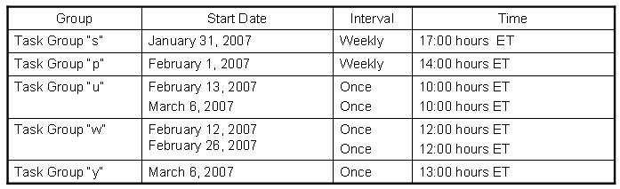
  - Move: Harry Worstell (on behalf of group)
  - Second: Charles Wright
  - Stuart: I’d like to ask if the group will approve by unanimous consent. Approved by unanimous consent.
  - Richard Paine:
  - WG Motion for Recirculation LB
  - Believing that comment responses in 06/1739r18 and the draft mentioned below satisfy WG 802.11 rules for letter ballot recirculation,
Authorize a 15 day LB recirculation of 802.11k draft 7.0
  - Movers in TGk
  - TGk Ganesh/Kwak Result 5-0-0
  - Move: Richard Paine
  - Moved on behalf of task group
  - For 87, Against 3, Abstain 5 The motion passes.
  - Richard: Motion for Numbers
  - On behalf of the TG, move to request the IEEE 802.11 Assigned Number Authority (ANA) to allocate numbers for the following Element IDs: Measurement Pilot Transmission information, BSS Available Admission Capacity, and BSS AC Access Delay.
  - Approved by unanimous consent.
  - Bob O’Hara: On behalf of the working group, I wish to move...
  - Moved: to accept document 07/0095r0 as the response to the interpretation request #1.
  - Moved: Bob O’Hara
  - For 74, Against 1, Abstain 8. The motion passes.
  - Bob O’Hara: Moved on behalf of task group…
  - Moved: to forward document 07/0070r0 for approval by the 802 Executive Committee, to be placed on the ExCom March 2007 agenda.
  - Move: Bob O’Hara
  - For 76, Against 0, Abstain 8. The motion passes.
  - Stuart: (In response to a question from floor) The availability of quorum is a very close call. Final determination will be made in March.
  - TGn has two motions.
- Move to incorporate all of the comment resolutions approved during the TGn January 2007 session into Draft P802.11n D1.09 to create draft 1.10.
- Approve a 15-day working group letter ballot asking the procedural question “Should the 802.11n Draft 1.10 be forwarded to Working Group Letter Ballot as Draft 2.0?”
- if successful, begin as soon as possible a 30 day Working Group Letter Ballot asking the technical question “Should 802.11n Draft 2.0 be forwarded to Sponsor Ballot?”
  - Move: Bruce Kraemer (on behalf of group)
  - For 100, Against 0, Abstain 5. The motion passes.
  - Bruce Kraemer: A second motion:
- Request authorization for TGn to investigate an acceptable location during mid-April 2007 at which it could conduct an ad hoc meeting for the purpose of comment resolution following the close of letter ballot 2.0
- pending final review/approval to be held during the March plenary meeting in Orlando.
  - Stuart: Will the group approve unanimously? Unanimous approval.
  - TGr motion.
  - Clint Chaplin (On behalf of TGr)
  - MOTION: Move to authorize an IEEE 802.11 TGr ad-hoc meeting on April 24th through April 26th, 2007
By (TGr): Rajneesh Kumar
Second (TGr): Dorothy Stanley
TGr Result: Yes - 11; No - 0; Abstain - 0.
  - Stuart: Will the group approve unanimously? Unanimous consent.
  - Donald Eastlake: I wish to move (on behalf of the group)…
  - Moved to approve the amendment in 11-07/149r5 to the P802.11s PAR and forward this PAR amendment to the 802 Executive Committee for their approval and further transmission.
  - In TGs:
Moved: Suman Sharma Seconded: Jan Kruys
Yes: 21 No: 0 Abstain: 2
  - Stuart: Discussion on the motion? Yes.
  - Andrew Myles: It was decided to do a mesh AP. What has changed?
  - Donald: When the PAR was written replacement of wired infrastructure was the issue. New applications and usage cases have mandated reconsideration (e.g. relay boxes to extend coverage, first responder walkie-talkies, etc.). Technical developments such as radio aware routing, etc. are necessary for mesh but not necessarily aligned with APs.
  - Stuart: Further discussion?
  - Dave Bagby: I speak against this. This is a distribution system, and an architectural solution that would seem to be AP based.
  - Moved: Donald Eastlake (on behalf of group)
  - Stuart: I would like a tally count of all voting members.
  - Rest for 3 minutes.
  - There are 115 voting members. Not a quorum.
  - For 53, Against 18, Abstain 26.
  - Stuart: The percentage is 74.647%. The motion fails.
  - Donald: I would also like to move (on behalf of the group)…
  - Moved to approve a TGs ad hoc meeting to resolve Letter Ballot comments 11-13 April 2007 in Eindhoven, Netherlands.
In TGs:
Moved: Juan Carlos Zuniga Seconded: Dee Denteener
Adopted by unanimous consent
  - Stuart: Will the group approve this motion unanimously? Unanimously approved.
  - Stuart: If there is no objection, we shall skip the break to keep moving. Is there any objection? None. Approved.
  - Stuart: TGu has a motion? Yes.
  - Move to schedule a TGu ad hoc meeting on February 20-22, 2007, which includes a joint TGu/802.21 1-day ad hoc meeting in San Jose California,
  - Move: Harry Worstell
  - Second: Eleanor Edwards
  - Stuart: Will the group approve this motion unanimously? Unanimously approved.
  - Stuart: Anything from DSS – SG?
  - Harry Worstell: No.
  - Stuart: There is no more old business.
- New Business
  - 802.11e/Wi-Fi WMM
  - Bob O’Hara presented document 07/116r2. This was previously presented in WNG, but ran out of time. Some changes to the PAR were made as a result of that WNG discussion. Purpose for WNG presentation was to encourage aligning 802.11e with WMM, thus recognizing a market reality. Two apparently similar, but not compatible, specifications will cause problems in the market. This PAR would have a limited scope using the WMM specification and the 802.11e amendment. All of the equipment available today is compliant with WMM. There are elements of operation discovered at Wi-Fi that are incorrect and do not operate as intended. Going forward in Wi-Fi Alliance for pre-certification of 802.11n devices depending on WMM specification, rather than 802.11e. We should transition to WMM, incorporating changes and corrections developed to make the trademark compliant with QoS. [Shows what changed from WNG presentation] Shows scope of PAR. Not in proposed scope: Deprecation of HCCA, Burst ACK, DLS or anything else not specifically addressed in WMM specification. Aim is two sponsor ballots before the end of this year. Aim at sponsor ballot out of November meeting.
  - Document 07/0079r3 shows PAR with changes highlighted in yellow.
  - Scope is limited to WMM 1.1.
  - Motion
  - Move that the IEEE 802.11 WG forward a PAR, in 11-07-0029-03, proposing to align 802.11ma (802.11e) with WMM, to the 802 Executive Committee for approval at the March 2007 session.
  - Mark Hamilton: I see a schedule that seems to indicate rubber-stamping an existing Wi-Fi document.
  - Bob O’Hara: This does not intend to rubber stamp existing work.
  - Mark: WMM spec 1.1 is a living document just like ours. If the document moves, it will complicate the process.
  - Bob: The intent is that only approved versions would be used. If a new version is approved, the task group can either approve or disapprove of moving forward with those changes.
  - Adrian Matthews: I’d like to understand impacts on TGn, which is built on TGe. Concern that mechanisms used in “n” could change. Will the WMM draft be made available to 802.11 members? These changes should not impact 802.11n work in progress. We would continue to work on “n”.
  - Secretarial Note: Affirm that Bob O’Hara said liaison to WFA shook his head affirmative on availability of document.
  - Dave Bagby: 802.11 creates standards documents. Historically WFA was set up for certification. In several instances, WFA has chosen to make its specification different from the 802.11 standard: 802.11e and 802.11i. The beginning of the presentation has multiple authors. The companies listed would seem to indicate that if WFA has one document and IEEE has another, certification requires action backwards. The root of the conflict is that certification is already proceeding on TGn ahead of the completion of the 802.11n standard. Do we continue to set up WFA as an arbiter of standards? In the end, this would jeopardize the comment process for 802.11 and devolve to a smaller group of companies making the standard.
  - [minutes taken by Rosdahl] Bob Miller: 2 points, first, form follows function. So a testing process should follow the specification... number 2, many companies are working to the spec and as this is a relatively new spec, it would be detrimental to the companies to change the spec as it would influence the market product landscape.
  - Guido Hertz: This body should decide what the standards are. I am against the motion. It would reverse the process.
  - Bruce Kraemer: I believe that converging versions of QoS is important, but I suggest it might be handled by a maintenance function (if the objective is simply to fix problems). If it was just to fix problems and would not generate problems, that would be OK. However not being sure what the implications of changes are would be more problematic. I suggest beginning a study group to cover these issues.
  - Dorothy Stanley: Every draft published contains a notation that says this is a draft, not for publication. The situation we have here, with good intention, is that the WFA took an early version of 802.11e, worked on it, and now is coming back with changes, picking up additional features, etc. If the issue is that WFA sees technical issues, then the process should be to make the technical corrections as a maintenance action in 802.11. They should bring the comments forward in “ma”. What are the technical issues or capabilities that are lacking treatment? I speak against the motion.
  - [Unknown]: I too speak against. WFA had an opportunity to act on some of the issues in the 802.11e process, but did not participate in the process. Instead it chose to select options of its own. The situation would be that some other group could change the work of a working group here.
  - Stuart: I’d like someone to speak in favour.
  - Thomas Kneuhel: I speak for the motion. In 802.11 development we make standards without technical implementations to confirm proper operation. Certain features did not work in the 802.11e specification, and they are proposing that these cases be fixed. Updating the standard as a result of this gained knowledge would be valuable. 802.11n uses the same mechanisms as 802.11e, so it would be good to make sure things are working correctly.
  - Clint Chaplin: I speak against the motion. IEEE 802.11 is a registered, accredited standards organization with copyrighted standards. WFA is none of those. They do not develop standards, only specifications. For them to proceed this way would seem to deprecate our ability as a standards organization to act in an open and balanced process.
  - Steven Palm: WFA did not bring this motion. Individuals in IEEE brought this motion. This is actually very positive, not negative as some have viewed it. There are a lot of different ways of doing this, different rules, etc. At the end of the day, we should fix the document. How we got the information is irrelevant. We ought to correct the area.
  - Darwin Engwer: This demonstrates again the disadvantage of Wi-Fi jumping the gun rather than working with us. There is very little 802.11e client product available. It should be certified for new applications that are coming along, and would cause harm if changed. There was an e-mail on the reflector on this topic by a member (John Kowalski) who was active in 802.11e. I suggest people read this.
  - [Unknown]: I am neither for nor against. We had a scheduled break at 10. I’d like a break.
  - Rosdahl: We had a motion on this earlier? Yes.
  - Stuart: Any more for the queue? Yes. What is the will of the body Raise hands for break now.
  - Balanced vote.
  - Stuart: I will make the call. We carry on.
  - Industry is not a slave to what we do. We should reconcile what WFA (industry) is doing with standards. I would advocate a study group to collaborate on this. The goal should be to reconcile the spec with what equipment is out there.
  - Stuart: We are in debate. It was my call to continue, for the record.
  - Andrew Myles: Members are here to represent their employers. I speak for the motion. In an ideal world, standards bodies would produce perfection. In a real world. The market decided on what devices are needed. It is very important that what WFA does to align with the standards. We should use our normal processes to make this an international standard.
  - Eric Schrylander: I speak against the motion. If 802.IIe was broken, that was studied in the group
  - Chris Hanson: I call the question
  - Stuart: Objections? Yes. Bagby. The motion requires a seconder.
  - Stuart: Is there a second on the motion? Jim Provonovich
  - Those members in favor of calling the question, please rise.
  - Stuart: This requires 2/3 vote. The result is For 47, Against 24, Abstain 18. The votes for constitute 66.2%. The question is not called.
  - Stuart: Next on the queue…
  - Bob O’Hara: I would like to address the points of debate that I have heard. A member has guessed what might happen (e.g. 802.11 might lose its status if work is brought in from outside). I would challenge 10 members to say “I am building fully compliant equipment today”. Then this work would not be needed. I would also challenge them to say “I am not implementing WMM”. We are building WMM products, not 802.11e products. The standard is based upon research, simulations, and arguments. The WFA took the draft, and with communication back and forth (membership in both organizations) information flowed back and forth). Companies eventually had to change what we standardized. What was brought back to 802.11e was not adopted. We now have to standardize what we build, not necessarily build what we standardize. 802.11e is a plan for operation, but not a test plan. We would be aligning to specifications. There was also a point that we should not act today, but start a study group to move ahead. I can’t see how the PAR would be materially different should the process be today or 10 years from now. A study group will only delay the work. In the front of a draft standard there is a disclaimer that one should not build equipment before it is final. It would be good to make sure the process was more concurrent. Comments that suggest this as an ma activity. I sent a request, but comments arrived too late in the recirculation process. The attempt was made, however. Dealing with this as a maintenance process means that the process might also be delayed. If you want to align with what the market is buying today, we should act now. WRT the “rubber stamp” premise, the precedent is 802.15 which brought in work from outside. It is much better to have a standards organization act as a clearing house for such things. I want this to be conducted in to openness of IEEE.
  - Johnny Zwieg: Motion Personal Privilege
  - The queue length and acrimony would seem to beg a break.
  - Stuart: Any objection to making the break shorter to 15 minutes? I am not now recognizing the motion. We are recessed until 1055 hours.
  - Recess at 1040
  - Reconvene at 1056 hours
  - Stuart: We resume the queue…
  - Bob O’Hara has left for the airport, the motion remains on the table, Andrew Myles (also on document) will substitute for Bob.
  - David Hunter: My company is doing WMM-SA. I would like the liaison to request the WMM-SA Wi-Fi specification.
  - Stuart: The WFA Liaison has confirmed that the WMM version 1.1 is available to anyone for $25.
  - David: WMM-SA?
  - Myles: This motion is only for version 1.1. Bob mentioned that this might change. In the case of WMM-SA which may provide other features might be imported. There is not a spec available for this.
  - David: We have nothing, then, so this would be a problem. HCCA is part of 802.11e.
  - Dave Stevenson: I call the question
  - Objection: Clint and Ivan.
  - Second: Ivan Reede
  - Those wishing to call the question please rise.
  - For 53, Against 18, Abstain 11. The motion passes. The question is called.
  - Motion
  - Move that the IEEE 802.11 WG forward a PAR, in 11-07-0029-03, proposing to align 802.11ma (802.11e) with WMM, to the 802 Executive Committee for approval at their March 2007 session.
  - Move: Bob O’Hara
  - Second: Thomas Kuehnel
  - Stuart: Members in favor please rise…
  - For 26, Against 4, Abstain 46. The motion fails.
  - Stuart: We shall return to the agenda
  - Charles Wright: Point of information. Please repeat vote tally. Done.
  - TGu motion (on behalf of working group)
  - “Move to approve document 11-07-0195-00-0000 and request that the IEEE 802.11 Working Group Chair forward the liaison letter to the IEEE 802.21Chair”
  - Move: Eleanor Hepworth
  - Second: Dave Stephenson
  - For 60, Against 0, Abstain 4. The motion passes.
  - DLS-SG Motion
  - A teleconference was left off for “u”
  - Harry presents 0200r0 again requesting addition of TGu to the teleconference list previously approved.
  - Motion
  - Move to have 2 DLS SG Teleconferences
February 13th 2007: 1000 ET 1 hour
March 6th 2007 1000 ET 1 hour
  - Move: Harry Worstell
  - Second: Clint Chaplin
  - Stuart: Is there any objection to approving this motion unanimously? None. Approved Unanimously
  - Darwin Engwer presented document 07/0202r1 – Introduction to IMT – Advanced. There has been a proposal to start a study group. That request failed during the week of the last meeting, but was subsequently passed later during a teleconference. The presenter attended the meeting. A presentation has been prepared for ExCom in March, indicating what was to be done. This is an overview, to allow quick action. This will be an 802.18 document. I cut and pasted it into this 802.11 document. IMT = International Mobile Telephony: A new global unified wireless architecture. Mobile class (100 Mbps/high-mobility) and nomadic/local area class (1 Gbps/low-mobility) in licensed and maybe unlicensed bands. ITU-R response via .18 due by May 2007, IEEE 802 possibilities exist. The work entertained so far is comments to ITU-R and new radio interface requirements. This looks like an opportunity for 802.11 to work a next-gen PHY beyond “n”. This may take 5-6 years, so we should start now. 802 already working on multiple access technologies, individual WGs could address different aspects of the IMT-Advanced vision, and IEEE 802 should provide a harmonized view. Several architectural vision slides were shown, along with a capability chart with rate/mobility axes and field of uses.
  - Stuart: Discussion? Yes.
  - Charles Wright: Useful data rate. Where are we in 11n?
  - Darwin: We can get about 600 Mbps with everything turned on.
  - Charles: This goes to group in May, what is really needed?
  - Stuart: I think we need to form ad-hoc group to make a response for May, but 802 action will depend on ExCom direction. We could work by e-mail.
  - Darwin: Wanted to gauge interest in group.
  - Charles: What hypothetically, would we do? A framework, and later fill in a PAR? This doesn’t have to represent any similarity to final result?
  - Ivan Reede: I am in 802.18 as well. Voice over Wi-Fi. Video over cellphones. IMT is negotiating with all regulatory bodies worldwide. 802 may want to act in this “spectrum hunting”.
  - Lee Armstrong: Regarding the field of use diagram. We are dealing with the lower-left area. The middle area is also being pursued. There is also a lot of activity regarding dual mode phones.
  - Bruce Kraemer: We need some on-going discussions with 802 on this beginning in March. I am confused regarding legitimate opportunities for 802.11. There is homework required to determine if, how, and by what plan we would contribute. We need something organized to lie on the table, including deadlines and work estimate. At least one phone call should be scheduled.
  - Stuart: It would be toward 802.11, or should this be 802?
  - Bruce: There should be an 802.11 steering group for this. The EC needs to think about this too. We need an 802.11, though.
  - Mark: I been attending and this seems to have a flavor of spectrum investigation. I believe we should be involved.
  - Bagby: You can think about EC tutorials in March. There is not enough time for a TG. This would require a special chairman’s committee to develop a response in this time frame.
  - Peter: I came with a motion for ITU-R in which 802.11 a/b/g are already there. We are already in there; we are not starting from scratch. 802.16m is further ahead, but there are continuing meetings for a few years. We just have to go ahead with explaining the extensions.
  - Andrew: I request the chair to make a decision on behalf of the working group.
  - Stuart: Any more discussion?
  - Straw poll: Who is interested in this. Yes, lots, No, few.
  - Stuart: Darwin, are you interested in leading an ad-hoc group?
  - Darwin: I would be willing to look into it and report in March.
  - Stuart: Might we have a joint lead? Bruce volunteers.
  - Stuart: So we have a joint ad-hoc team: Bruce and Darwin
  - Stuart: No other business in groups? No. New business? No.
  - Andrew Myles; We should start a study group on 116r2 to get the ball rolling in March.
  - Moved: Darwin (motion being prepared)
  - Is there a second? Yes. Bruce Kraemer seconds.
  - Start: Password for private area 0900 ET on Monday password will be changed.
  - Motion:
  - Move to start a study group to consider the matters raised in 116r2 in relation to the alignment of WMM to IEEE 802.11
  - Moved: Andrew Myles
  - Seconded: Bruce Kraemer
  - Stuart: Discussion?
  - Bruce: A comment was made about errors in 802.11e and it would be good to get those considered for “n”
  - Dave Bagby: When you have two documents that differ there is an opportunity to change both documents. I would like to see the WMM change, or at least seek consistency.
  - Stuart: This will be re-affirmed at the Orlando meeting.
  - Andrew Myles: I call the question.
  - Second: Jim Petranovich
  - Stuart: Objections? None.
  - For 37, Against 11, Abstain 14. The motion passes.
  - Point of information:
  - Charles: Does this allow the adoption of the PAR?
  - Stuart: No. This will be re-affirmed at the Orlando meeting. Is there any other New Business?
  - Adrian: e-mail reflector question. Regarding 15 day rule, we may not complete the ballot before the next meeting. We should not be struggling to do this. This is likely to be the route people will take, so is there any way we can streamline this process via a rule change. I’d like to see if we should start a group to look at what changes are possible.
  - Stuart: Should we start an activity to investigate methods that could be used to speed the process?
  - Harry: Policies and procedures come from 802. The comments that you receive prior to the end of the vote can still be used at the next meeting. That is already permitted.
  - Stuart: The LMSC rules are different from the 802 rules.
  - Straw Poll:
  - Are we happy with the status quo or should we should change the rules?
  - Yes, we are happy. No, we are not happy.
  - 2/3 not happy.
  - Stuart: This problem is higher in the chain.
  - Adrian: Who will do what to whom?
  - Stuart: We need to push upward. Adrian and I should pursue.
  - Can I have an agenda item for this at the next meeting?
  - Yes. Noted.
  - For information: During the break I spoke to a WFA representative to talk to us to get a formal relationship going to streamline the process together.
  - Any other business?
  - Johnny Zwieg: I would like to propose a change to 802.11 policies regarding exposure to atmospheric irritants. The P&P clearly spells this out.
  - Stuart: Very well. Seeing no other business, I show the agenda 07-0075r0. The graphic is fixed. Please book your hotel now.
- Closing
  - Stuart: It is 1200. We are adjourned.

