IEEE P802.11
Wireless LANs
LB289 CR for DSSS/CCK transmit spectrum mask
Date: 2025-10-10
Author(s):
Name | Affiliation | Address | Phone | Email
Rui Cao | NXP | 350 Holger Way, San Jose, CA |  | rui.cao_2@nxp.com
Hongyuan Zhang | NXP | 350 Holger Way, San Jose, CA |  | Hongyuan.zhang@nxp.com
Youhan Kim | Qualcomm |  |  | youhank@qti.qualcomm.com
Juan Fang | Intel |  |  | juan.fang@intel.com
Sigurd Schelstraete | MaxLinear |  |  | sschelstraete@maxlinear.com

Abstract
This submission proposes resolution for the CID 165 of LB289 on DSSS/CCK transmit spectrum mask. All resolutions are based on REVmf D1.0.

Revisons:
- r0: initial version
CID | Clause | Page.Line | Comment | Proposed Change | Resolution
165 | 15.4.5.5 | 3629.10 | The transmit spectrum mask of DSSS PHY is specified based on 11MHz chip rate, differently from OFDM PHY. In practical deployment, DSSS PHY is used in the same 20MHz channel as OFDM PHY, and the DSSS spectrum mask can also meet 20MHz OFDM PHY specification. To simplify the spectrum mask definition and testing, it is suggested to unify the spectrum mask definition. | To update the DSSS PHY transmit spectrum mask definition to be the same as 20MHz OFDM PHY defined in subclause 17.3.9.3 (Transmit spectrum mask) as in Figure 17-13. | Revised  Agreed with the commenter in principle. It is beneficial to unify the mask definition for DSSS/CCK. Considering the legacy devices, to define the transmit requirement as either DSSS/CCK mask or OFDM mask been met.  TGmf Editor: please make the changes as in 11-25/1813r0.

Discussions:
Historically, different transmit spectrum mask is defined for DSSS/CCK PHY and 20MHz OFDM PHY.
However, the state-of-art devices that are compliant with 802.11 standards support both the DSSS/CCK PHY (e.g. Clause 15) and the 20MHz OFDM PHY (e.g. Clause 17). Both the waveforms are transmitted in the same 20MHz channel with the same transmit RF front-end. It is reasonable to unify the spectrum mask definition, which allows better transmitter optimization and can also simplify the testing procedure.
Note that, by comparing the two spectrum masks, the existing devices on the market that meets the DSSS/CCK transmit spectrum mask should automatically satisfy the 20MHz OFDM PHY transmit mask. We expect no impact to legacy devices.
To be on the safe side, considering all existing off-the-shelf devices supporting DSSS/CCK, the standards can leave both transmit spectruam mask definition and allow STAs to pass transmit mask requirement if either transmit mask is satisfied.
For REVmf, we suggest adding the transmit spectrum mask definition for the 20MHz OFDM PHY as one option for DSSS/CCK PHY, and keep the transmit spectrum mask definition for DSSS/CCK as the fall-back mode.

Background:

15.4.5.5 Transmit spectrum mask
…
The interim transmit spectrum mask shall be 0 dBr (decibel relative to the SINx/x peak) for fc – 11 MHz < f
< fc +11 MHz, –30 dBr for fc – 22 MHz < f < fc –11 MHz and fc +11 MHz < f < fc + 22 MHz, –50 dBr for
f < fc –22 MHz and f > fc + 22 MHz, where fc is the channel center frequency. The transmit spectrum mask
shall not exceed the maximum of the interim transmit spectrum mask and –53 dBm/MHz at any frequency
offset in the 2.4 GHz band. The transmit spectrum mask when the –50 dBr spectrum level is above –53
dBm/MHz is shown in Figure 15-10 (Transmit spectrum mask). The measurements shall be made using 100
kHz resolution bandwidth and a 30 kHz video bandwidth.

17.3.9.3 Transmit spectrum mask
…
For operation using 20 MHz channel spacing, the transmitted spectrum shall have a 0 dBr (dB relative to the
maximum spectral density of the signal) bandwidth not exceeding 18 MHz, –20 dBr at 11 MHz frequency
offset, –28 dBr at 20 MHz frequency offset, and the maximum of –40 dBr and –39 dBm/MHz at 30 MHz
frequency offset and above. The transmitted spectral density of the transmitted signal shall fall within the
spectral mask, as shown in Figure 17-13 (Transmit spectrum mask for 20 MHz transmission). The
measurements shall be made using a 100 kHz resolution bandwidth and a 30 kHz video bandwidth.
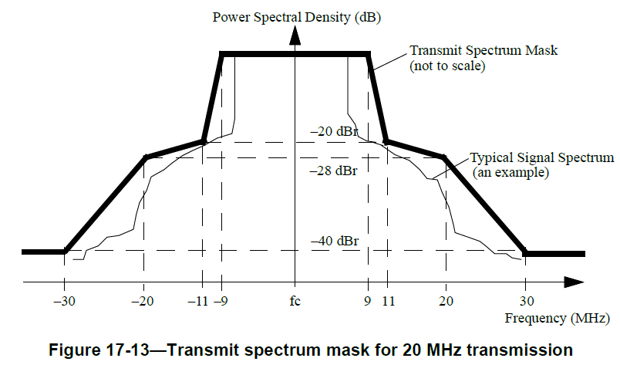

TGmf Editor: Please make the following change in subclause 15.4.5.5, 16.3.7.4 and 18.4.7.3 of D1.0.

15.4.5.5 Transmit spectrum mask

The overall transmit spectral mask is constructed using two components. First, an interim spectrum mask is
constructed. The overall transmit
spectrum mask is then constructed by taking the higher of the interim transmit spectrum mask and -53 dBm/MHz at each frequency offset.
Two interim spectrum masks are defined. The transmitted spectral density of the transmitted signal shall fall within the transmit spectral mask using either one of the interim mask definitions.

NOTE – If the transmitted spectral density of the transmitted signal from a STA that is compliant using one interim spectrum mask definition but not compliant using the other definition, then the STA is considered to be compliant with the transmit spectrum mask requirement.

The first interim spectrum mask is defined the same as the transmit spectrum mask defined for 20 MHz channel spacing in 17.3.9.3 (Transmit spectrum mask) and shown in Figure 17-13 (Transmit spectrum mask for 20 MHz transmission).

The second interim spectrum mask is defined relative to the SINx/x peak of the signal.
The interim transmit spectrum maskshall be 0 dBr (decibel relative to the SINx/x peak) for fc – 11 MHz < f < fc +11 MHz, –30 dBr for fc – 22 MHz < f < fc –11 MHz and fc +11 MHz < f < fc + 22 MHz, –50 dBr for f < fc –22 MHz and f > fc + 22 MHz, where fc is the channel center frequency. The transmit spectrum mask shall not exceed the maximum of the interim transmit spectrum mask and –53 dBm/MHz at any frequency offset in the 2.4 GHz band. The transmit spectrum mask when the –50 dBr spectrum level is above –53dBm/MHz is shown in Figure 15-10 (Transmit spectrum mask). The measurements for comparison against the interim transmit spectral mask shall be made using a 100 kHz resolution bandwidth and a 30 kHz video bandwidth. Measurements for comparison against –53 dBm/MHz shall be made using a 1 MHz resolution bandwidth and a 30 kHz video bandwidth.
NOTE – If a measurement made using 100 kHz resolution bandwidth is lower than –63 dBm/100 kHz, then the measurement can be considered to be lower than –53 dBm/MHz. However, if a measurement made using 100 kHz resolution bandwidth is higher than –63 dBm/100 kHz, then the measurement cannot be considered to be higher than –53 dBm/MHz.

Figure 15-10—Transmit spectrum mask

16.3.7.4 Transmit spectrum mask
The overall transmit spectral mask is constructed using two components. First, an interim spectrum mask is constructed. The overall transmit spectrum mask is then constructed by taking the higher of the interim transmit spectrum mask and -53 dBm/MHz at each frequency offset. Two interim spectrum masks are defined. The transmitted spectral density of the transmitted signal shall fall within the transmit spectral mask using either one of the interim mask definitions.

NOTE – If the transmitted spectral density of the transmitted signal from a STA that is compliant using one interim spectrum mask definition but not compliant using the other definition, then the STA is considered to be compliant with the transmit spectrum mask requirement.

The first interim spectrum mask is defined the same as the transmit spectrum mask defined for 20 MHz channel spacing in 17.3.9.3 (Transmit spectrum mask) and shown in Figure 17-13 (Transmit spectrum mask for 20 MHz transmission).

The second interim spectrum mask is defined relative to the SINx/x peak of the signal.
The interim transmit spectrum mask shall be 0 dBr (decibel relative to the SINx/x peak) for fc - 11 MHz < f < fc +11 MHz, -30 dBr for fc-22 MHz < f < fc-11 MHz and fc + 11 MHz < f < fc + 22 MHz, and -50 dBr for f < fc–22MHz and f > fc + 22 MHz, where fc is the channel center frequency.
The transmit spectrum mask shall not exceed the maximum of the interim transmit spectrum mask and -53dBm/MHz at any frequency offset in the 2.4 GHz band. The transmit spectrum mask when the -50 dBr spectrum level is above -53 dBm/MHz is shown in Figure 16-8 (Transmit spectrum mask). The measurements for comparison against the interim transmit spectral mask shall be made using a 100 kHz resolution bandwidth and a 30 kHz video bandwidth. Measurements for comparison against –53 dBm/MHz shall be made using a 1 MHz resolution bandwidth and a 30 kHz video bandwidth.
NOTE – If a measurement made using 100 kHz resolution bandwidth is lower than –63 dBm/100 kHz, then the measurement can be considered to be lower than –53 dBm/MHz. However, if a measurement made using 100 kHz resolution bandwidth is higher than –63 dBm/100 kHz, then the measurement cannot be considered to be higher than –53 dBm/MHz.

Figure 16-8—Transmit spectrum mask

18.4.7.3 Transmit spectral mask
The transmit spectral mask for ERP-OFDM PPDUs shall follow 17.3.9.3 (Transmit spectrum mask) and is shown in Figure 17-13 (Transmit spectrum mask for 20 MHz transmission) therein. The transmit spectral mask for ERP-DSSS/CCK PPDUs shall follow 16.3.7.4 (Transmit spectrum mask).

