IEEE P802.11  
Wireless LANs

|  |  |  |  |  |
| --- | --- | --- | --- | --- |
| LB291 editorial comments part 1 | | | | |
| Date: Oct 13, 2025 | | | | |
| Author(s): | | | | |
| Name | Affiliation | Address | Phone | email |
| Ross Jian Yu | Huawei |  |  | ross.yujian@huawei.com |
| Ming Gan | Huawei |  |  |  |
|  |  |  |  |  |
|  |  |  |  |  |
|  |  |  |  |  |

Abstract

This submission proposes resolutions for LB291 editorial comments part 1. The changes are based on D1.0.

20 CIDs: CID 11634, 5306, 6071, 9635, 9636, 9637, 9939, 12558, 12560, 7172, 12539, 7598, 11673, 7648, 8723, 11827, 8592, 11419, 11852, 7625

Revisions:

* Rev 0: Initial version of the document.

## CID 11634

|  |  |  |  |  |
| --- | --- | --- | --- | --- |
| **Page** | **Clause** | **Comment** | **Proposed Change** | **Resolution** |
| 52.35 | 9.2.4.6.4 | "-14" is missing underline. Underline "-14" | As in comment. | Accepted |

**Discussion**

**In REVmf:**

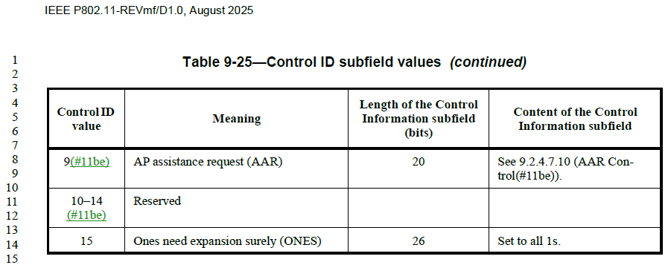

**In TGbn D1.0:**

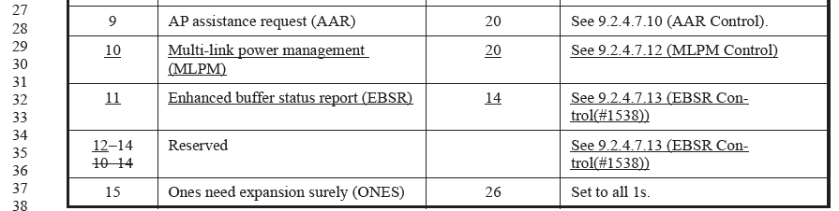

The updated text will be like:

12–14

~~10–14~~

This style prevents the confusion caused by crossline and endash.

**End of discussion**

## CID 5306

|  |  |  |  |  |
| --- | --- | --- | --- | --- |
| **Page** | **Clause** | **Comment** | **Proposed Change** | **Resolution** |
| 219.18 | 37.15.1.3.1 | Move the following reference " (see Figure 9-aa13 (MAPC Capabilities field format))" after "corresponding field" in the upper line. | As in comment. | Accepted |

**Discussion**

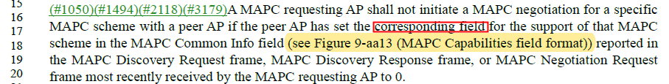

**End of discussion**

## CID 6071

|  |  |  |  |  |
| --- | --- | --- | --- | --- |
| **Page** | **Clause** | **Comment** | **Proposed Change** | **Resolution** |
|  |  | There are still "an UHR". Search on PDF says that there are 24 occurences, pp.lls 76.01, 93.01, 183.52, 199.40, 205.12, 208.63, 210.01, 210.04, 210.09*2, 211.15, 212.06, 282.06, 282.14, 282.25, 283.33, 283.43, 305.58, 356.09, 363.26, 364.47, 457.05, 457.06, and 458.01. | Change all those appearing as "an UHR ..." to "a UHR ...". | Revised  TGbn editor: please change an UHR to a UHR for page.line of IEEE P802.11bn D1.0:  76.01, 93.01, 183.52, 199.40, 205.12, 210.04, 210.09*2, 211.15, 212.06, 282.06, 282.14, 282.25, 283.33, 283.43, 305.58, 356.09, 363.26, 364.47, 457.05, 457.06, and 458.01 (22 instances).  please change An UHR to A UHR for page.line of IEEE P802.11bn D1.0:  208.63, 210.01 (2 instances). |

**CID 9637**

|  |  |  |  |  |
| --- | --- | --- | --- | --- |
| **Page** | **Clause** | **Comment** | **Proposed Change** | **Resolution** |
|  |  | "an UHR" -> "a UHR" | Please search the whole D1.0 document and change as commented. | Revised  TGbn editor: please make the changes as the resolution of CID 6071 in 11-25/1791r0 |

**CID 7172**

|  |  |  |  |  |
| --- | --- | --- | --- | --- |
| **Page** | **Clause** | **Comment** | **Proposed Change** | **Resolution** |
| 1.1 | 3 | Throughout the draft, both "an UHR" and "a UHR" are used inconsistently; these expressions should be unified. | as in comment. | Revised  TGbn editor: please make the changes as the resolution of CID 6071 in 11-25/1791r0 |

**CID 9635**

|  |  |  |  |  |
| --- | --- | --- | --- | --- |
| **Page** | **Clause** | **Comment** | **Proposed Change** | **Resolution** |
|  |  | "a MAPC" -> "an MAPC" | Please search the whole D1.0 document and change as commented. | Revised  TGbn editor: please change “a MAPC” to “an MPAC” for page.line of IEEE P802.11bn D1.0:  31.29, 31.30, 31.34, 131.56, 133.1, 133.36, 133.40, 133.45, 137.60, 140.13, 161.42, 161. 45, 161.45, 162.7, 162.9, 162.9, 162.36, 162.38, 163.1, 163.3, 163.3, 163.10, 163.33, 163.37, 163.39, 163.39, 190.36, 190.36, 190.63, 190.63, 190. 63, 218.18, 218.42, 218.47, 218.53, 218.53, 218.59, 218.59, 219.12, 219.12, 219.15, 219.15, 219.22, 219.22, 219.25, 219.25, 219.28, 219.38, 219.41, 219.42, 219.52, 219.56, 220.1, 220.1, 220.15, 220.23, 220.28, 220.31, 220.31, 220.32, 220.34, 220.35, 220.42, 220.42, 220.49, 220.52, 221.12, 221.16, 221.23, 222.1, 222.2, 222.37, 222.51, 222.52, 222.53, 222.54, 222.54, 222.58, 223.1, 223.2, 223.2, 223.6, 223.7, 227.45, 227.60, 227.61, 227.62, 227.62, 227.62, 228.1, 228.6, 228.7, 228.7, 228.10, 228.11, 230. 38, 230.43, 230.53, 230.55, 231.12, 232.12, 233.30, 234.27, 234.58, 234.59, 237.17 (106 instances) |

**Discussion**

For a valid comment, the commenter should point out all the page.line that need to be updated.

**Discussion ended**

**CID 7648**

|  |  |  |  |  |
| --- | --- | --- | --- | --- |
| **Page** | **Clause** | **Comment** | **Proposed Change** | **Resolution** |
| 11.43 | Contents | "an MAPC" should be "a MAPC" to be consistent with other text. Occurs twice in the specification | Replace "an MAPC" with "a MAPC" throughout the specification | Revised  An MAPC should be used.  TGbn editor: please make the changes as the resolution of CID 9635 in 11/25-1791r0. |

**CID 9636**

|  |  |  |  |  |
| --- | --- | --- | --- | --- |
| **Page** | **Clause** | **Comment** | **Proposed Change** | **Resolution** |
|  |  | "a 80 MHz" -> "an 80 MHz" | Please search the whole D1.0 document and change as commented. | Revised  TGbn editor: please change “a 80 MHz” to “an 80 MHz” for page.line of IEEE P802.11bn D1.0:  328.51, 328.62, 329.8, 329.19, 329.30, 329.42, 422.40, 423.13 (8 instances) |

**Discussion**

For a valid comment, the commenter should point out all the page.line that need to be updated.

**Discussion ended**

**CID 9939**

|  |  |  |  |  |
| --- | --- | --- | --- | --- |
| **Page** | **Clause** | **Comment** | **Proposed Change** | **Resolution** |
|  |  | A lot of (line-break?) hyphens are embedded incorrectly in words throughout the amendment. Examples "do-main" P32.2, "BSS-transition" P36.39, "re-turning" P187.62, "pa-rameters" P251.7, "Re-quired" P252.7) | Detemine the cause(s) of these hyphens, and remove them/fix the cause. | Revised  TGbn editor:  Please remove the hyphen from do-main at P.L. 32.2, from re-turning at 187.62, from Re-quired" at 252.7. |

**Discussion**

The line breaks are caused when copy the text from Word to Framemaker. BSS-transition is not a typo of such case. No changes are made for BSS-transition.

**Discussion ended**

**CID 12558**

|  |  |  |  |  |
| --- | --- | --- | --- | --- |
| **Page** | **Clause** | **Comment** | **Proposed Change** | **Resolution** |
|  |  | Some lines in certain paragraphs seems to have a slight indent. E.g., P254L12, P254L32, P253L13, P253L27, P252L11, etc. | Fix the formating to remove the indent where it occurs throughout the specification | Revised  TGbn editor: remove the indent from P254L12, P254L32, P253L13, P253L27, P252L11 of IEEE P802.11bn D1.0 |

**Discussion**

The editor tried to use the slight indent to prevent one word from breaking into two lines. The editor will remove the slight indent, and will not prevent one word from breaking into two lines, unless for some special cases, e.g., hyphen is at the boundary of two lines.

**Discussion ended**

**CID 12560**

|  |  |  |  |  |
| --- | --- | --- | --- | --- |
| **Page** | **Clause** | **Comment** | **Proposed Change** | **Resolution** |
|  |  | Could we choose either "non-AP UHR STA" or "UHR non-AP STA"? E.g., "non-AP UHR STA" | Replace all instances of "UHR non-AP STA" with "non-AP UHR STA" throughout the specification | Revised  TGbn editor: please change “UHR non-AP STA” to “non-AP UHR STA” at P.L. of IEEE P802.11bn D1.0:  60.11, 60.12, 67.64, 88.31, 116.23, 193.44, 202.18, 204.30, 205.55, 206.1, 206.49, 206.53, 207.3, 209.29, 212.50, 222.42, 227.50, 240.6, 250.64, 251.6, 255.24, 264.27, 269.13, 269.16, 269.40, 275.30, 275.33, 278.28, 278.43  please change “ultra-high reliability (UHR) non-AP STAs” to “non-AP ultra-high reliability (UHR) STAs” at P.L. 30.53  please change “non-UHR non-AP STA” to “non-AP non-UHR STA” at P.L. 116.22. |

**Discussion**

In REVmf, 2 instances of HE non-AP STA, 283 instances of non-AP HE STA; in IEEE 802.11be-2024, 11 instances of EHT non-AP STA, 250 instances of non-AP EHT STA. Will use non-AP UHR STA.

**Discussion ended**

**CID 12539**

|  |  |  |  |  |
| --- | --- | --- | --- | --- |
| **Page** | **Clause** | **Comment** | **Proposed Change** | **Resolution** |
| 101.55 | 9.4.2.5.1 | "starting bit 56" -> "starting from bit 56" | As in comment | Accepted |

**CID 7598**

|  |  |  |  |  |
| --- | --- | --- | --- | --- |
| **Page** | **Clause** | **Comment** | **Proposed Change** | **Resolution** |
| 101.07 | 9.4.2.1 | Remove element from the Element name for the first four rows | as in comment | Accepted |

**Discussion**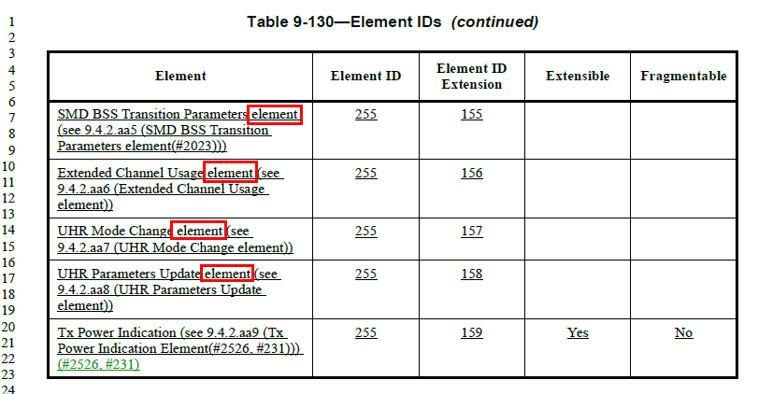

**Discussion ended**

**CID 11673**

|  |  |  |  |  |
| --- | --- | --- | --- | --- |
| **Page** | **Clause** | **Comment** | **Proposed Change** | **Resolution** |
| 105.08 | 9.4.2.35 | Is the inclusion of the first 4 entries new for UHR or just calling out baseline? Please clarify/ | As in comment. | Revised  TGbn editor: please make the changes as shown in 11-25/1791r0 with CID tag 11673. |

**Discussion**

The baseline is from 11bi D2.0:

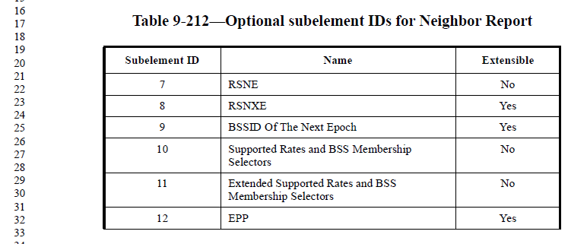 **Discussion ended**

**TGbn editor, please remove the four rows to page 105, line 7 of IEEE P802.11bn D1.0 as shown below:**

|  |  |  |
| --- | --- | --- |
| * Optional subelement IDs for Neighbor Report(#11673) | | |
| Subelement ID | Name | Extensible |
| … |  |  |
|  |  |  |
|  |  |  |
|  |  |  |
|  |  |  |
| … | … | ... |
| 13 | UHR Capabilities | YES |
| 14 | UHR Operation | YES |
| 15 | SMD Information | YES |
| 16(#2526,231) | Tx Power Indication | YES |

**End of proposed changes**

**CID 8723**

|  |  |  |  |  |
| --- | --- | --- | --- | --- |
| **Page** | **Clause** | **Comment** | **Proposed Change** | **Resolution** |
| 110.51 | 9.4.2.322.2.2 | Figures are out of order and text has no marking if it is an update. | Clarify the changes to the text and move the figures, 9-1072o and 9-1074p, to the correct places. | Revised  TGbn editor: please make the changes as shown in 11-25/1791r0 with tag CID 8723. |

**Discussion**

The out of orders are due to the Framemaker tool.

**Discussion ended**

**TGbn editor, please move figure 9-10720 after “Figure 9-1074o (Presence Bitmap subfield of the Basic Multi-Link element format).” of IEEE P802.11bn D1.0.**

**TGbn editor, please make the changes to page 110, line 55 of IEEE P802.11bn D1.0**

***Add the following paragraph(#8723) at the end of 9.4.2.323.2.2:***

(#8723)The Enhanced Critical Updates Information Present subfield is set to 1 if the Enhanced Critical Updates Information subfield is present in the Common Info field of the Basic Multi-Link element. Otherwise, the Enhanced Critical Updates Information Present subfield is set to 0. A non-AP STA sets this subfield to 0 in the Basic Multi-Link element that it transmits. This subfield is set to 1 in the Basic Multi-Link element transmitted by an AP except when the element is carried in an Authentication frame or FT Action frame.

**End of proposed changes**

**CID 11827**

|  |  |  |  |  |
| --- | --- | --- | --- | --- |
| **Page** | **Clause** | **Comment** | **Proposed Change** | **Resolution** |
| 110.38 | 9.4.2.322 | Instruction to the editor is missing. Please add it. Also make sure that all instructions to the editor are consistent (e.g., don't use the term update for instructions). | As in comment. | Revised  TGbn editor: please make the changes as shown in 11-25/1791r0 with tag CID 11827. |

**TGbn editor, please make the changes to page 110, line 48 of IEEE P802.11bn D1.0**

**9.4.2.322 Multi-Link element**

**9.4.2.322.2 Basic Multi-Link element**

**9.4.2.322.2.2 Presence Bitmap subfield of the Multi-Link Control field in a Basic Multi-Link**

**element**

***Change Figure 9-1072o in this subclause as shown below:***

**End of proposed changes**

**CID 8592**

|  |  |  |  |  |
| --- | --- | --- | --- | --- |
| **Page** | **Clause** | **Comment** | **Proposed Change** | **Resolution** |
| 111.17 | 9.4.2.322.2.2 | Number of 5 bits for Reserved subfield to be updated after changes to the Presence Bitmap subfield | modify number of Bits for Reserved subfield to 4 | Accepted |

**Discussion**

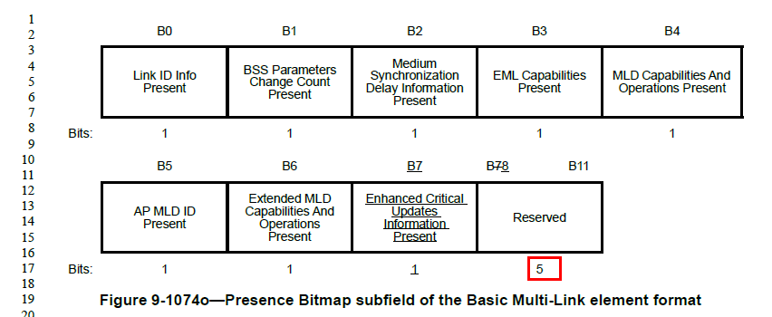

**Discussion ended**

**CID 11419**

|  |  |  |  |  |
| --- | --- | --- | --- | --- |
| **Page** | **Clause** | **Comment** | **Proposed Change** | **Resolution** |
| 111.17 | 9.4.2.322.2.2 | The number of Reserved bits in Figure 9-1074o must be 4. | Please fix this typo. | Accepted |

**CID 11852**

|  |  |  |  |  |
| --- | --- | --- | --- | --- |
| **Page** | **Clause** | **Comment** | **Proposed Change** | **Resolution** |
| 111.17 | 9.4.2.322.2.2 | "5" ahould be "4" | As suggested. | Accepted |

**CID 7625**

|  |  |  |  |  |
| --- | --- | --- | --- | --- |
| **Page** | **Clause** | **Comment** | **Proposed Change** | **Resolution** |
| 112.14 | 9.4.2.322.2.3 | Correct 37.28.3 to 37.32.4. | As in comment | Accepted |

**Discussion**





**Discussion ended**

End of the document