IEEE P802.11
Wireless LANs
Proposed resolution for REVmf LB289 comments - Part 3
Date: 2025-10-06
Author:
Name | Affiliation | Address | Phone | Email
Edward Au | Huawei | Ottawa, ON, Canada |  | edward.ks.au@gmail.com

This submission present proposed resolutions to the following CIDs: 387, 388, 507, 499, 434, 461.

The proposed changes are based on REVmf D1.0.

Revision history:

R0 – initial version
R1 – updated the resolutions based on offline comments (thanks Mark R!).
R2 – add proposed resolutions for the following additional CIDs: 499, 434, 461

CID | Clause | Page | Line | Comment | Proposed Change
387 |  |  |  | "optionally present if" doesn't always have some kind of "otherwise not present" afterwards. One example is "The parameter is optionally present if dot11DMGOptionImplemented is true." but sadly there are 500 other hits for "optionally present if" | As it says in the comment

Discussion:
There are 526 instances of “optionally present if” and all are in Clause 6, Clause 9, and Clause 10. While the commenter is correct that some kind of “otherwise not present” should be added, the followings are exceptions that need to restructure the sentence without simply adding “otherwise, not present”:
P834.28:
“The BSS Average Access Delay element is present if dot11RMBSSAverageAccessDelayActivated is true and the AP Average Access Delay field is not equal to 255 (measurement not available); otherwise, the BSS Average Access Delay element is optionally present if dot11RMBSSAverageAccessDelayActivated is true.”
P834.33:
“The Antenna element is present if dot11RMAntennaInformationActivated is true and the Antenna ID field is not equal to 0 (unknown antenna); otherwise, the Antenna element is optionally present if dot11RMAntennaInformationActivated is true.”
P834.46:
“The BSS AC Access Delay element is present if dot11RMBSSAverageAccessDelayActivated is true and at least one field of the element is not equal to 255 (measurement not available); otherwise, the BSS AC Access Delay element is optionally present if dot11RMBSSAverageAccessDelayActivated is true.”
P835.16:
“The Supported Operating Classes element is present if dot11ExtendedChannelSwitchActivated or dot11OperatingClassesRequired is true. The Supported Operating Classes element is optionally present if dot11TVHTOptionImplemented is true.”

Proposed resolution:
Revised
Review each of the 526 instances of “optionally present if”. For those instances that do not have some kind of “otherwise not present” following except P834.28, P834.33, P834.46, and P835.16, append the following: “Otherwise, not present”.

P834.28:
Change from “The BSS Average Access Delay element is present if dot11RMBSSAverageAccessDelayActivated is true and the AP Average Access Delay field is not equal to 255 (measurement not available); otherwise, the BSS Average Access Delay element is optionally present if dot11RMBSSAverageAccessDelayActivated is true.”
to “If dot11RMBSSAverageAccessDelayActivated is true, the BSS Average Access Delay element is present if the AP Average Access Delay field is not equal to 255 (measurement not available) and optionally present otherwise. Otherwise, this element is not present”.
P834.33:
Change from “The Antenna element is present if dot11RMAntennaInformationActivated is true and the Antenna ID field is not equal to 0 (unknown antenna); otherwise, the Antenna element is optionally present if dot11RMAntennaInformationActivated is true.”
to “If dot11RMAntennaInformationActivated is true, the Antenna element is present if the Antenna ID field is not equal to 0 (unknown antenna) and optionally present otherwise. Otherwise, this element is not present.”
P834.46:
Change from “The BSS AC Access Delay element is present if dot11RMBSSAverageAccessDelayActivated is true and at least one field of the element is not equal to 255 (measurement not available); otherwise, the BSS AC Access Delay element is optionally present if dot11RMBSSAverageAccessDelayActivated is true.”
to “If dot11RMBSSAverageAccessDelayActivated is true, the BSS AC Access Delay element is present if at least one field of the element is not equal to 255 (measurement not available) and optionally present otherwise. Otherwise, this element is not present”
P835.16:
Change from “The Supported Operating Classes element is present if dot11ExtendedChannelSwitchActivated or dot11OperatingClassesRequired is true. The Supported Operating Classes element is optionally present if dot11TVHTOptionImplemented is true.”
to “If dot11ExtendedChannelSwitchActivated or dot11OperatingClassesRequired is true, the Supported Operating Classes element is present. Otherwise, if dot11TVHTOptionImplemented is true, the Supported Operating Classes element is optionally present. Otherwise, this element is not present.”

CID | Clause | Page | Line | Comment | Proposed Change
388 |  |  |  | C.3 sometimes uses "station" rather than consistently using "STA" | As it says in the comment

Proposed resolution:
Revised
Check the “DESCRIPTION” of each of the MIB variables and replace the word “station” with “STA”.
Note to the Editors: There are over 700 instances of “station”.

CID | Clause | Page | Line | Comment | Proposed Change
507 |  |  |  | Use glyphs rather than Floor(), e.g. in the BIPN = equations and the NOTE 1; ditto Ceil() | Fix in Equation (9-5), (12-1), (12-2), (26-4), the NOTE 1 on page 1297 (2x), Table 9-14, the equation at the bottom of page 2410, the middle of page 2421, the top of page 2425, (10-19) and 6 lines down, the bottom of page 2434, the same NOTE 1 on page 1297 (2x), 4411.6, 5368.27

Discussion:
Agree with the commenter in principle, except that the two Floor() and two Ceil() in page 1297 should be page 3297.
Proposed resolution:
Revised.
Replace Floor()/Ceil() with glyphs in Equation (9-5), (12-1), (12-2), (26-4), the NOTE 1 on page 3297 (2x), Table 9-14, the equation at the bottom of page 2410, the middle of page 2421, the top of page 2425, (10-19) and 6 lines down, the bottom of page 2434, the same NOTE 1 on page 3297 (2x), 4411.6, 5368.27.
Note to the commenter: The changes are those proposed by the commenter, except that page 1297 should be page 3297.

CID | Clause | Page | Line | Comment | Proposed Change
499 |  | 3068 | 2 | "the expiration of the GAS Comeback Delay" should be "the expiration of the GAS comeback delay timer" | As it says in the comment

Discussion:
The related subclause is 11.22.3.2.5:
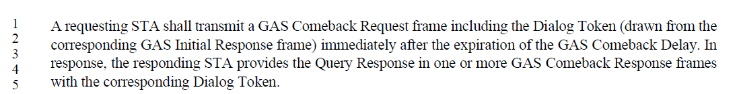
Proposed resolution:
Accepted.

CID | Clause | Page | Line | Comment | Proposed Change
434 | 12.7.1.3 | 3347 | 49 | Figure 12-32--Pairwise key hierarchy has weird line/box artefacts above the bottom middle two boxes | As it says in the comment

Discussion:
The original figure is shown below for convenience:
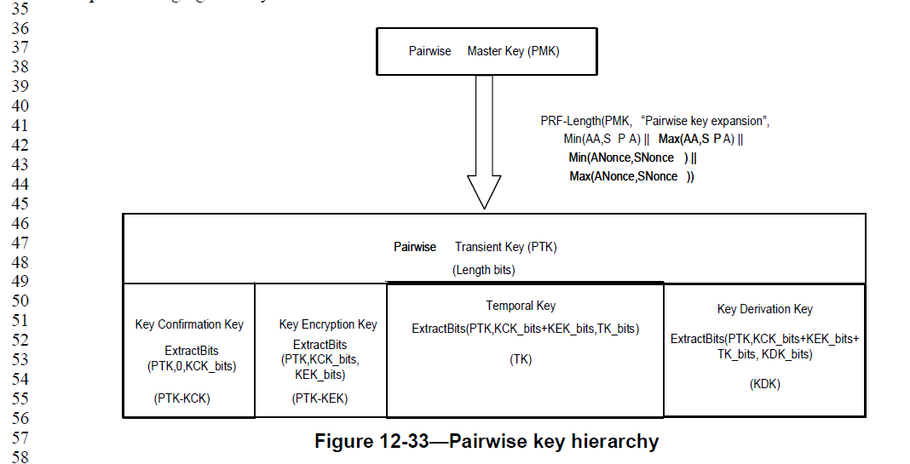

Proposed resolution:
Revised.
Agreed with the commenter that the figure has weird line/box artefacts above the bottom middle two boxes. Redrew the figure to eliminate the weird line/box artefacts.

CID | Clause | Page | Line | Comment | Proposed Change
461 | C.3 | 6357 | 40 | "dot11EHTEMLSROptionImplemented" is bad because it suggests there's a non-EHT EMLSR | Delete "EHT"

Discussion:
There are further works in IEEE 802.11bn on EMLSR. Perhaps TGbn is the appropriate Task Group to consider renaming dot11EHTEMLSROptionImplemented (and dot11EHTEMLSROptionActivated).
Proposed resolution:
Rejected.
As for the scope of REVmf Draft 1.0, EMLSR operation exists in EHT only.

