### **IEEE P802.11 Wireless LANs**

|  |  |  |
| --- | --- | --- |
| 11bp PDT Duty-cycle operation | | |
| Date: 2025-09-08 | | |
| Author(s): | | |
| Name | Affiliation | Email |
| Chuanfeng He | OPPO | hechuanfeng@oppo.com |
| Sanket Kalamkar | Qualcomm Technologies, Inc. |  |
| Rojan Chitrakar | Huawei |  |
| Lei Zhou | New H3C |  |
| Zhanjing Bao | ZTE |  |
| Yaron Ben-Arie | Huawei |  |
| Mahmoud Hasabelnaby | Huawei |  |
| Solomon Trainin | Wiliot |  |
| Sebastian Max | Ericsson |  |
| Rakesh Taori | Infineon |  |
| Li-Hsiang Sun | MediaTek |  |
| Ian Bajaj | Huawei |  |
|  |  |  |

Abstract

This document contains Proposed Draft Text (PDT) for Duty-cycle operation of the proposed TGbp (AMP, Ambient Power) amendment to the 802.11 standard.

**Revision information**

The following is a summary of the important changes that occurred within each revision of this document:

|  |  |
| --- | --- |
| **Revision** | **Major changes** |
| 0 | Initial revision |
| 1 | Revised version based on the comments from task group members. |
|  |  |
|  |  |
|  |  |
|  |  |

# **Introduction**

Interpretation of a Motion to Adopt.

A motion to approve this submission means that the editing instructions and any changed or added material are actioned in the TGbp Draft. The abstract, revision information, introduction, explanation of the proposed changes and references sections are not part of the adopted material.

***Editing instructions formatted like this are intended to be copied into the TGbp Draft (i.e. they are instructions to the 802.11 editor on how to merge the text with the baseline documents).***

# **Explanation of the proposed changes:**

The proposed changes to the 802.11 TGbp draft within this document are based on the following motions adopted by the TGbp task group:

## Relevant passing motions [1]:

* **MM-4**: If an AMP device is able to support TSF, it can monitor AMP DL Frame in a duty-cycle manner.

[Motion #32, [1], [21] and [22]]

* **MM-24**: 802.11bp defines one mechanism that a non-AP AMP STA can derive its specific AMP service period in order to monitor AMP DL Frame.

[Motion #101, [1], [100], [101] and [103]]

* **MM-22**: IEEE 802.11bp defines an AMP Service Period, that allows an Active Tx non-AP AMP STA to enter doze state after a minimum wake up time since the start of the AMP Service Period, if the Active Tx non-AP AMP STA does not receive any AMP DL PPDU from the AMP AP.

[Motion #75, [1], [22], [74] and [75]]

* **FM-8**: 802.11bp allows duty-cycle configuration to be carried in an AMP trigger Frame.
  + Details of Duty-cycle configuration (e.g., AMP service period) are TBD.
  + Note: The presence of the duty-cycle configuration is configurable.

[Motion #100, [1], [100], [101], [102] and [103]]

# **Text to be adopted begins here.**

***TGbp editor: Please add the following text to the respective subclauses in 802.11bp draft D0.1:***

## 39.5.1 Duty-cycle operation

AMP duty cycle operation identifies an amount of time that a non-AP AMP STA needs to be in the awake state during a time period. AMP duty cycle operation is determined by the following parameters: AMP service period and *TBD*, (see Figure 39-X).

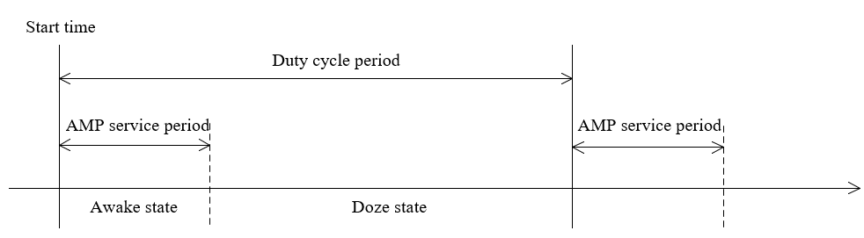

**Figure 39-X—Duty Cycle Operation**

A non-AP AMP STA that enters an awake state at the start of an AMP service period, shall stay in the awake state for a minimum wake up time since the start of the AMP service period, after which time the non-AP AMP STA may enter doze state if it does not receive any AMP DL PPDU from the AMP AP. The non-AP AMP STA should enter an awake state at the start of the subsequent AMP service period, which is a *TBDName* duration from the start of a previous AMP service period.

The duty cycle configuration parameters to enable non-AP AMP STA to monitor AMP DL frame in a duty-cycle manner are indicated by the AMP AP and contained in the NAMETBD1 field in an AMP trigger frame specified in Clause 9.10.2. Upon receiving the parameters in an AMP trigger frame, obtained from NAMETBD1 field, an non-AP AMP STA shall derive its specific AMP service period.

# **Text to be adopted ends here.**

**References:**

1. 11-24/1613r12: 11-24-1613-10-00bp-specification-framework-for-tgbp, Yinan Qi (OPPO)