IEEE P802.11
Wireless LANs
Clarification on TX Spectral Mask Measurement
Date: 2025-9-14
Author(s):
Name | Affiliation | Address | Phone | email
Youhan Kim | Qualcomm Technologies, Inc. |  |  | youhank@qti.qualcomm.com
Sigurd Schelstraete | MaxLinear |  |  | sschelstraete@maxlinear.com
Hongyuan Zhang | NXP |  |  | hongyuan.zhang@nxp.com

Abstract
This submission proposes resolutions for the following comment(s) from LB289 on P802.11REVmf D1.0:

46

NOTE – Set the Track Changes Viewing Option in the MS Word to “All Markup” to clearly see the proposed text edits.

Revision History:

R0: Initial version

CID 46

CID  Clause  Page.Line | Comment | Proposed Change
46  36.3.20.1.1  5614.50 | The TX spectral mask really has two requirements.  (1) The relative dBr requirement, and  (2) The absolute dBm/MHz lower level requirement (e.g., -39 dBm/MHz in 5 GHz).  The sentence "Measurements shall be made using a 100 kHz resolution bandwidth and a 7.5 kHz video bandwidth for EHT  PPDU" really applies to the first relative dBr requirement, as it does not make sense to measure a "/MHz" requirement using 100 KHz resolution bandwidth.  This comment is not just on EHT, but also on other PHYs in 2.4, 5 and 6 GHz bands. | Clarify that the dBm/MHz requirement should be measured separately using a 1 MHz resolution bandwidth.  Commenter will submit a more detailed proposal.

Discussion
Using the EHT 20 MHz case as an example, the transmit spectrum requirement is
REVmf D1.0:
P5610: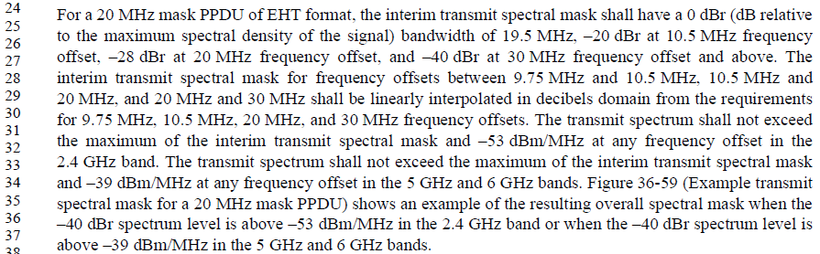
P5614:
Essentially there are two requirements:
- A ‘relative’ mask which has the -20/-28/-40 dBr requirement as a function of frequency offset from the center of the transmission
- An absolute emission level (e.g., -53 dBm/MHz for 2.4 GHz, -39 dBm/MHz for 5/6 GHz)
The reason for the absolute emission level requirement is to aid the transmit spectrum when the transmit power is low. For example, suppose a STA transmits a 20 MHz EHT PPDU with -10 dBm TX power. Then, the inband transmit power density per 100 kHz would be -33 dBm/100 kHz, which means that the transmission needs to have -73 dBm/100 kHz at 30 MHz or higher frequency offset. Such emission level is unnecessarily low and not practical to achieve. Hence, the IEEE 802.11 standard allows the transmit spectrum to go above the relative mask as long as it stays below an absolute emission level.
Note that WLAN STAs need to adhere to not only the IEEE transmit spectral mask requirements, but also to regulatory requirements. Most regulatory bodies have requirements unwanted emission levels, and most of them use measurement bandwidth of 1 MHz. See for example:
- FCC: https://www.ecfr.gov/current/title-47/chapter-I/subchapter-A/part-15/subpart-A/section-15.35
  - “… measurements above 1000 MHz shall be performed using a minimum resolution bandwidth of 1 MHz.”
- ETSI: https://www.etsi.org/deliver/etsi_en/301800_301899/301893/02.02.01_60/en_301893v020201p.pdf
  - 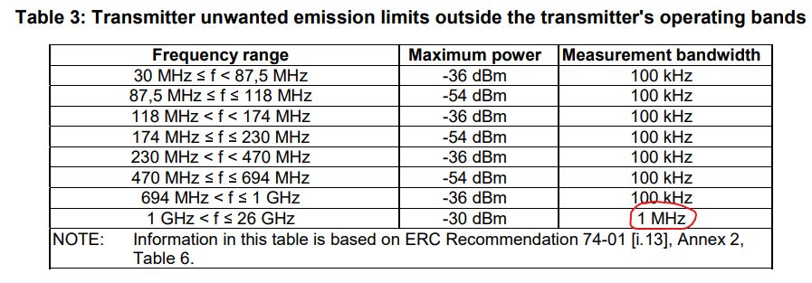
Hence, the absolute emission level requirement for IEEE 802.11 was also specified in “/MHz” to be clear that the measurement is done over 1 MHz resolution – e.g., -53 dBm/MHz for 2.4 GHz and -39 dBm/MHz for 5/6 GHz.
While the sentence at REVmf D1.0 P5614L50 about using 100 kHz resolution bandwidth was intended for the ‘relative’ mask, we are noticing that testing devices are sometimes applying the 100 kHz resolution bandwidth for the absolute emission level comparison as well, leading to unintended consequences. For example, one might test the -53 dBm/MHz requirement by comparing it against -53 dBm using 100 kHz resolution bandwidth. This allows an emission level of -43 dBm/MHz which is not desired. Another example could be that one might test the -53 dBm/MHz requirement by comparing it against -63 dBm using 100 kHz resolution bandwidth. This is also not equivalent to -53 dBm/MHz as transmit spectrum is often not perfectly flat across frequency. For example, a spurious emission of -60 dBm with bandwidth narrower than 1 MHz would fail a comparison against -63 dBm/100 kHz but could still be in compliance with -53 dBm/MHz.
Therefore, the proposed text in this document further clarifies that the absolute emission level needs to be measured using 1 MHz resolution bandwidth as the unit of the threshold (“/MHz”) already does.

While making the related text changes, we also noticed that there are some other typos/errors related to transmit spectral mask requirements, which this document also fixes:
- HR/DSSS PHY (16.3.7.4, REVmf D1.0 P3658L13) uses 100 kHz video bandwidth, while all other 2.4/5/6 GHz PHYs (including DSSS PHY) use 30 kHz video bandwidth. This seems to be a typo, hence changed to 30 kHz in this document.
- https://mentor.ieee.org/802.11/dcn/21/11-21-1448-03-000m-psd-floor-of-tx-mask.docx had updated the absolute emission floor limit for 2.4/5/6 GHz OFDM based PHYs, except that it missed updating the 5/10 MHz cases in OFDM PHY (17.3.9.3). This document makes these missing changes as well.

Proposed Resolution: CID 46
REVISED

Instruction to TGmf Editor:
Implement the proposed text update for CID 46 in https://mentor.ieee.org/802.11/dcn/25/11-25-1511-01-000m-clarification-on-tx-spectral-mask-measurement.docx

Note to commenter:
The proposed text update further clarifies that the dBm/MHz requirement needs to be measured using 1 MHz resolution bandwidth. The proposed text also fixes a few other typos related to the transmit spectral mask.

Proposed Text Update: CID 46

15.4.5.5 Transmit spectrum mask
Instruction to TGmf Editor: Update TGmf D1.0 P3629L15 as shown below.
The interim transmit spectrum mask shall be 0 dBr (decibel relative to the SINx/x peak) for fc – 11 MHz < f < fc +11 MHz, –30 dBr for fc – 22 MHz < f < fc –11 MHz and fc +11 MHz < f < fc + 22 MHz, –50 dBr for f < fc –22 MHz and f > fc + 22 MHz, where fc is the channel center frequency. The transmit spectrum mask shall not exceed the maximum of the interim transmit spectrum mask and –53 dBm/MHz at any frequency offset in the 2.4 GHz band. The transmit spectrum mask when the –50 dBr spectrum level is above –53 dBm/MHz is shown in Figure 15-10 (Transmit spectrum mask). The measurements for comparison against the interim transmit spectral mask shall be made using a 100 kHz resolution bandwidth and a 30 kHz video bandwidth. Measurements for comparison against –53 dBm/MHz shall be made using a 1 MHz resolution bandwidth and a 30 kHz video bandwidth.

16.3.7.4 Transmit spectral mask
Instruction to TGmf Editor: Update TGmf D1.0 P3658L13 as shown below.
The transmit spectrum mask shall not exceed the maximum of the interim transmit spectrum mask and –53 dBm/MHz at any frequency offset in the 2.4 GHz band. The transmit spectrum mask when the –50 dBr spectrum level is above –53 dBm/MHz is shown in Figure 16-8 (Transmit spectrum mask). The measurements for comparison against the interim transmit spectral mask shall be made using a 100 kHz resolution bandwidth and a 30 kHz video bandwidth. Measurements for comparison against –53 dBm/MHz shall be made using a 1 MHz resolution bandwidth and a 30 kHz video bandwidth.

17.3.9.3 Transmit spectral mask
Instruction to TGmf Editor: Update TGmf D1.0 P3702L56 as shown below.
For operation using 20 MHz channel spacing, the transmitted spectrum shall have a 0 dBr (dB relative to the maximum spectral density of the signal) bandwidth not exceeding 18 MHz, –20 dBr at 11 MHz frequency offset, –28 dBr at 20 MHz frequency offset, and the maximum of –40 dBr and –39 dBm/MHz at 30 MHz frequency offset and above. The transmitted spectral density of the transmitted signal shall fall within the spectral mask, as shown in Figure 17-13 (Transmit spectrum mask for 20 MHz transmission). Measurements for comparison against –39 dBm/MHz shall be made using a 1 MHz resolution bandwidth and a 30 kHz video bandwidth. Other measurements shall be made using a 100 kHz resolution bandwidth and a 30 kHz video bandwidth.
For operation using 10 MHz channel spacing, the transmitted spectrum shall have a 0 dBr bandwidth not exceeding 9 MHz, –20 dBr at 5.5 MHz frequency offset, –28 dBr at 10 MHz frequency offset, and the maximum of –40 dBr and –39 dBm/MHz at 15 MHz frequency offset and above. The transmitted spectral density of the transmitted signal shall fall within the spectral mask, as shown in Figure 17-14 (Transmit spectrum mask for 10 MHz transmission). Measurements for comparison against –39 dBm/MHz shall be made using a 1 MHz resolution bandwidth and a 30 kHz video bandwidth. Other measurements shall be made using a 100 kHz resolution bandwidth and a 30 kHz video bandwidth.
For operation using 5 MHz channel spacing, the transmitted spectrum shall have a 0 dBr bandwidth not exceeding 4.5 MHz, –20 dBr at 2.75 MHz frequency offset, –28 dBr at 5 MHz frequency offset, and the maximum of –40 dBr and –39 dBm/MHz at 7.5 MHz frequency offset and above. The transmitted spectral density of the transmitted signal shall fall within the spectral mask, as shown in Figure 17-15 (Transmit spectrum mask for 5 MHz transmission). Measurements for comparison against –39 dBm/MHz shall be made using a 1 MHz resolution bandwidth and a 30 kHz video bandwidth. Other measurements shall be made using a 100 kHz resolution bandwidth and a 30 kHz video bandwidth.

19.3.18.1 Transmit spectrum mask
Instruction to TGmf Editor: Update TGmf D1.0 P3806L22 as shown below.
For the 2.4 GHz band, when transmitting in a 20 MHz channel, the transmitted spectrum shall have a 0 dBr (dB relative to the maximum spectral density of the signal) bandwidth not exceeding 18 MHz, –20 dBr at 11 MHz frequency offset, –28 dBr at 20 MHz frequency offset, and the maximum of –40 dBr and –53 dBm/MHz at 30 MHz frequency offset and above. The transmitted spectral density of the transmitted signal shall fall within the spectral mask, as shown in Figure 19-17 (Transmit spectral mask for 20 MHz transmission in the 2.4 GHz band).
For the 2.4 GHz band, when transmitting in a 40 MHz channel, the transmitted spectrum shall have a 0 dBr bandwidth not exceeding 38 MHz, –20 dBr at 21 MHz frequency offset, –28 dBr at 40 MHz offset, and the maximum of –40 dBr and –56 dBm/MHz at 60 MHz frequency offset and above. The transmitted spectral density of the transmitted signal shall fall within the spectral mask, as shown in Figure 19-18 (Transmit spectral mask for a 40 MHz channel in the 2.4 GHz band).
For the 5 GHz band, when transmitting in a 20 MHz channel, the transmitted spectrum shall have a 0 dBr (dB relative to the maximum spectral density of the signal) bandwidth not exceeding 18 MHz, –20 dBr at 11 MHz frequency offset, –28 dBr at 20 MHz frequency offset, and the maximum of –40 dBr and –39 dBm/MHz at 30 MHz frequency offset and above. The transmitted spectral density of the transmitted signal shall fall within the spectral mask, as shown in Figure 19-19 (Transmit spectral mask for 20 MHz transmission in the 5 GHz band).
For the 5 GHz band, when transmitting in a 40 MHz channel, the transmitted spectrum shall have a 0 dBr bandwidth not exceeding 38 MHz, –20 dBr at 21 MHz frequency offset, –28 dBr at 40 MHz offset, and the maximum of –40 dBr and –39 dBm/MHz at 60 MHz frequency offset and above. The transmitted spectral density of the transmitted signal shall fall within the spectral mask, as shown in Figure 19-20 (Transmit spectral mask for a 40 MHz channel in the 5 GHz band).
Transmission with CH_OFF_20U, CH_OFF_20L, or CH_OFF_40 shall comply with the same mask that is used for the 40 MHz channel.
Measurements for comparison against –53 dBm/MHz and –39 dBm/MHz shall be made using a 1 MHz resolution bandwidth and a 30 kHz video bandwidth. Other measurements shall be made using a 100 kHz resolution bandwidth and a 30 kHz video bandwidth.

21.3.17.1 Transmit spectrum mask
Instruction to TGmf Editor: Update TGmf D1.0 P3980L64 as shown below.
Measurements for comparison against the interim transmit spectral mask shall be made using a 100 kHz resolution bandwidth and a 30 kHz video bandwidth. Measurements for comparison against –53 dBm/MHz and –39 dBm/MHz shall be made using a 1 MHz resolution bandwidth and a 30 kHz video bandwidth.

27.3.21.1 Transmit spectrum mask
Instruction to TGmf Editor: Update TGmf D1.0 P4690L43 as shown below.
Measurements for comparison against the interim transmit spectral mask shall be made using a 100 kHz resolution bandwidth and a 7.5 kHz video bandwidth. Measurements for comparison against –53 dBm/MHz and –39 dBm/MHz shall be made using a 1 MHz resolution bandwidth and a 7.5 kHz video bandwidth.

36.3.20.1 Transmit spectral mask
36.3.20.1.1 General
Instruction to TGmf Editor: Update TGmf D1.0 P5614L50 as shown below.
Measurements for comparison against the interim transmit spectral mask shall be made using a 100 kHz resolution bandwidth and a 7.5 kHz video bandwidth for EHT PPDU. Measurements for comparison against –53 dBm/MHz and –39 dBm/MHz shall be made using a 1 MHz resolution bandwidth and a 7.5 kHz video bandwidth for EHT PPDU.
Measurements for comparison against the interim transmit spectral mask shall be made using a 100 kHz resolution bandwidth and a 30 kHz video bandwidth for non-HT duplicate PPDU. Measurements for comparison against –53 dBm/MHz and –39 dBm/MHz shall be made using a 1 MHz resolution bandwidth and a 30 kHz video bandwidth for non-HT duplicate PPDU.

[End of File]

