IEEE P802.11
Wireless LANs
40 MHz Channels in China 5 GHz
Date: 2025-9-11
Author(s):
Name | Affiliation | Address | Phone | email
Youhan Kim | Qualcomm Technologies, Inc. |  |  | youhank@qti.qualcomm.com
Xiaogang Chen | Spreadtrum |  |  | xiaogang.g.chen@gmail.com
Bo Sun | Sanechips |  |  | sun.bo1@SANECHIPS.COM.CN
Ross Jian Yu | Huawei |  |  | ross.yujian@huawei.com
Edward Au | Huawei Technologies |  |  | edward.ks.au@gmail.com

Abstract
This submission proposes resolutions for the following comment(s) from LB289 on P802.11REVmf D1.0:

TBD

NOTE – Set the Track Changes Viewing Option in the MS Word to “All Markup” to clearly see the proposed text edits.

Revision History:

R0: Initial version
R1: Added coauthors and incorporated feedback

CID TBD

CID  Clause  Page.Line | Comment | Proposed Change
TBD  E.1  6656.25 | Table E-6 does not have operating classes to allow the primary 20 MHz channel to be at the upper half of the 40 MHz channel bandwidth in China. | Add operating classes with PrimaryChannelUpperBehavior with 40 MHz channel spacing in Table E-6.

Discussion
REVmf D1.0 P6656:
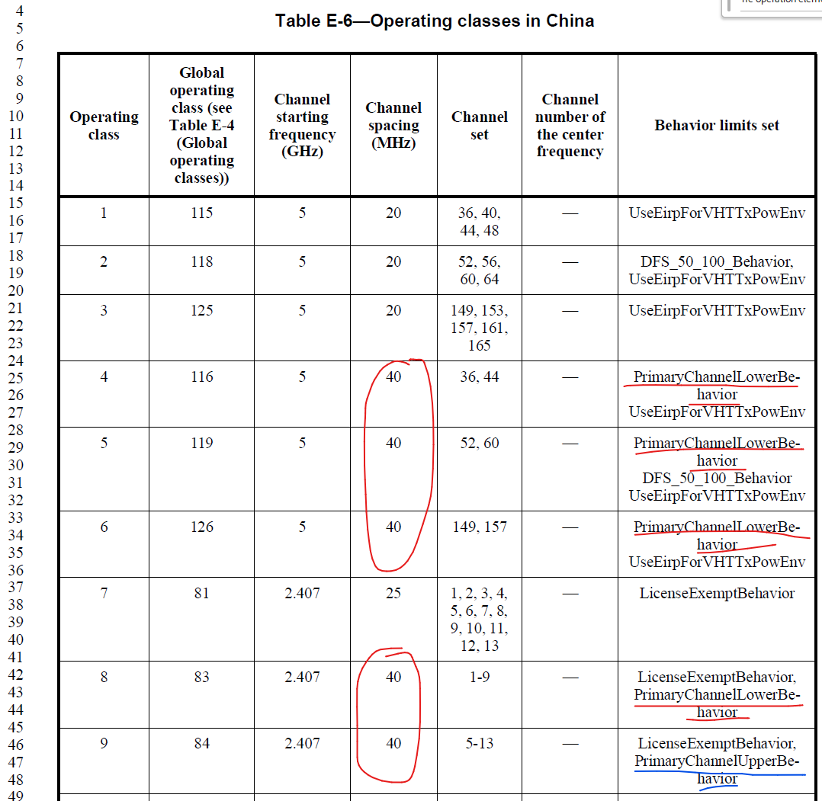
Primary 20 MHz channel could be either in the lower or upper half of a 40 MHz channel. In the Operating classes table, this is denoted by PrimaryChannelLowerBehavior and PrimaryChannelUpperBehavior.
Note that Table E-6 (Operating classes in China) only has PrimaryChannelLowerBehavior for 40 MHz channels in the 5 GHz band (see operating classes 4, 5 and 6). In comparison, 40 MHz channels in the 2.4 GHz band has both PrimaryChannelLowerBehavior (operating class 8) and PrimaryChannelUpperBehavior (operating class 9).
Note also that other operating classes tables have both PrimaryChannelLowerBehavior and PrimaryChannelUpperBehavior for 40 MHz channels in the 5 GHz band. For example, Table E-4 (Global operating classes) has both PrimaryChannelLowerBehavior (operating classes 116, 119, 126) and PrimaryChannelUpperBehavior (operating classes 117, 120, 127).
Speaking with some experts on Chinese regulations, it seems the omission of PrimaryChannelUpperBehavior in Table E-6 was an unintentional oversight.

Update in R1:
During the review, Edward Au suggested to update Table D-1 (Regulatory requirement list) with the latest documents for the Chinese regulations. The proposed text update makes these changes.

Proposed Resolution: CID TBD
REVISED

Instruction to TGmf Editor:
Implement the proposed text update for CID TBD in https://mentor.ieee.org/802.11/dcn/25/11-25-1510-01-000m-40-mhz-channels-in-china-5-ghz.docx

Note to commenter:
The proposed text update adds 40 MHz operating classes with PrimaryChannelUpperBehavior in Table E-6. It also updates Table D-1 with the latest regulatory documents for China.

Proposed Text Update: CID TBD
D.1 External regulatory references
Instruction to TGmf Editor: Update TGmf D1.0 P6629L45 as shown below.
- Regulatory requirement list
Geographic area | Approval standards | Documents | Approval authority
… | … | … | …
China | Ministry of Industry and Information Technology (MIIT) | Gōngxìnbù wú (2002) 277  Gōngxìnbù wú (2002) 353  Gōngxìnbù wú (2005) 423  Gōngxìnbù wú (2012) 620  Gōngxìnbù wú (2021) 129 | MIIT

E.1 Country information and operating classes
Instruction to TGmf Editor: Update TGmf D1.0 P6656L63 as shown below.
- Operating classes in China
Operating class | Global  operating  class (see Table E-4) | Channel starting frequency (GHz) | Channel spacing (MHz) | Channel set | Channel number of the center frequency | Behavior limits set
1 | 115 | 5 | 20 | 36, 40, 44, 48 | — | UseEirpForVHTTxPowEnv
2 | 118 | 5 | 20 | 52, 56, 60, 64 | — | DFS_50_100_Behavior,  UseEirpForVHTTxPowEnv
3 | 125 | 5 | 20 | 149, 153, 157, 161, 165 | — | UseEirpForVHTTxPowEnv
4 | 116 | 5 | 40 | 36, 44 | — | PrimaryChannelLowerBehavior  UseEirpForVHTTxPowEnv
5 | 119 | 5 | 40 | 52, 60 | — | PrimaryChannelLowerBehavior  DFS_50_100_Behavior  UseEirpForVHTTxPowEnv
6 | 126 | 5 | 40 | 149, 157 | — | PrimaryChannelLowerBehavior  UseEirpForVHTTxPowEnv
7 | 81 | 2.407 | 25 | 1, 2, 3, 4, 5, 6, 7, 8, 9, 10, 11, 12, 13 | — | LicenseExemptBehavior
8 | 83 | 2.407 | 40 | 1-9 | — | LicenseExemptBehavior, PrimaryChannelLowerBehavior
9 | 84 | 2.407 | 40 | 5-13 | — | LicenseExemptBehavior, PrimaryChannelUpperBehavior
10 | 181 | 56.16 | 2160 | 2, 3 | — | —
11 | 182 | 56.70 | 1080 | 35, 36, 37, 38 | — | —
12 | 183 | 42.66 | 540 | 1, 2, 3, 4, 5, 6, 7, 8 | — | LicenseExemptBehavior
13 | 184 | 47.52 | 540 | 9, 10 | — | LicenseExemptBehavior
14 | 185 | 42.93 | 1080 | 11, 12, 13, 14 | — | LicenseExemptBehavior
15 | 186 | 47.79 | 1080 | 15 | — | LicenseExemptBehavior
16 | 117 | 5 | 40 | 40, 48 | — | PrimaryChannelUpperBehavior  UseEirpForVHTTxPowEnv
17 | 120 | 5 | 40 | 56, 64 | — | PrimaryChannelUpperBehavior  DFS_50_100_Behavior  UseEirpForVHTTxPowEnv
18 | 127 | 5 | 40 | 153, 161 | — | PrimaryChannelUpperBehavior  UseEirpForVHTTxPowEnv
19–127 | Reserved | Reserved | Reserved | Reserved | Reserved | Reserved
128 | 128 | 5 | 80 | — | 42, 58, 155 | UseEirpForVHTTxPowEnv
129 | 129 | 5 | 160 | — | 50 | UseEirpForVHTTxPowEnv
130 | 130 | 5 | 80 | — | 42, 58, 155 | 80+  UseEirpForVHTTxPowEnv
131–255 | Reserved | Reserved | Reserved | Reserved | Reserved | Reserved
Instruction to TGmf Editor: Add a “period” at the end of the first sentence in NOTE 1 (between “segment” and “In”).

NOTE 1—The channel spacing for operating classes 4 to 6 specifies the maximum radio bandwidth of one frequency segment. In these operating classes, the AP operates in a 20/40 MHz BSS, and the operating channel width for a non-AP STA is either 20 MHz or 40 MHz.
NOTE 2—The channel spacing for operating classes 128, 129, and 130 specifies the maximum radio bandwidth of one frequency segment.

[End of File]

