IEEE P802.11
Wireless LANs
Country Element in 6 GHz
Date: 2025-9-16
Author(s):
Name | Affiliation | Address | Phone | email
Youhan Kim | Qualcomm Technologies, Inc. |  |  | youhank@qti.qualcomm.com
Carlos Cordeiro | Intel |  |  | carlos.cordeiro@intel.com

Abstract
This submission proposes resolutions for the following comment(s) from LB289 on P802.11REVmf D1.0:

48

NOTE – Set the Track Changes Viewing Option in the MS Word to “All Markup” to clearly see the proposed text edits.

Revision History:

R0: Initial version
R1: Updated CID per LB289, and updated coauthors. Also fixed two minor typos (e.g., is are)
R2: Added more valid examples for the content of Country element in the 6 GHz band. Also, created two options for ambiguity #1.
R3: Consolidate to only option 2 for ambiguity #1.

CID 48

CID  Clause  Page.Line | Comment | Proposed Change
48  9.4.2.7  1039.46 | Allowed format for Country element in the 6 GHz band deserves additional clarification.  For example, 10.22.3 (P2245L33) states that any Operating Triplet field may be omitted in the 6 GHz.  I.e., there could be zero Operating Triplet fields, which means there is no Operating/Subband Sequence field.  However, 9.4.2.7 (P1039L46) states that there is "one or more" Operating/Subband Sequence field in 6 GHz.  Also, it is not clear that if an AP chooses to include the Operating/Subband Sequence in the 6 GHz, whether 20 MHz operating class must be included, or if it is OK to include only the operating class of larger BW only.  Another point of clarification is whether the list of channels included in the Subband Triplet Sequence in an Operating/Subband sequence should list all channels in the 6 GHz, or only the channels which are capable of the same "regulatory class" (e.g., list only Standard Power allowed channels if the AP is operating as a Standard Power AP). | Commenter will submit a more detailed proposal for the changes.

Discussion
This comment asks for clarification on three ambiguities regarding the Country element in the 6 GHz band.
Before we dive into the ambiguities, let us first review the Country element in the 6 GHz band.
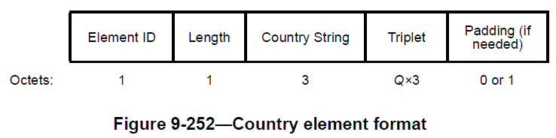
In the 6 GHz band, the Triplet field is
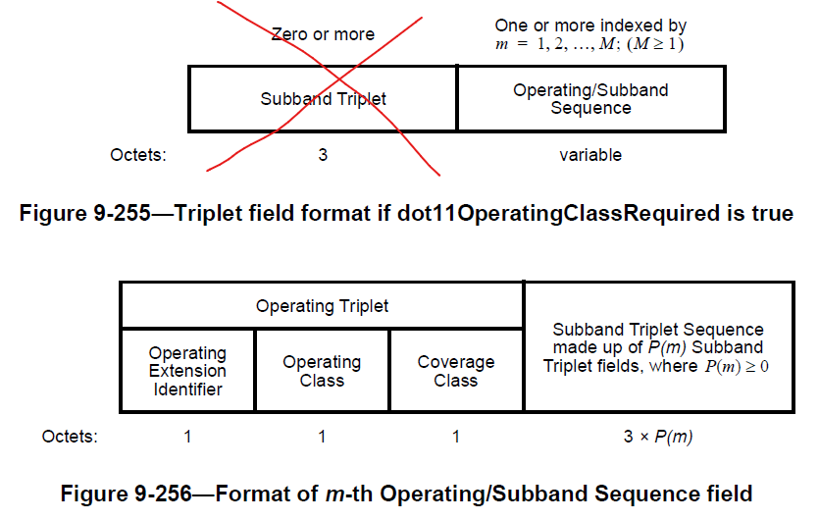
where the Subband Triplet field before the Operating/Subband Sequence field is not present in the 6 GHz band.

Ambiguity #1:
REVmf D1.0 P1039 states that there is always at least one Operating/Subband Sequence field.
…
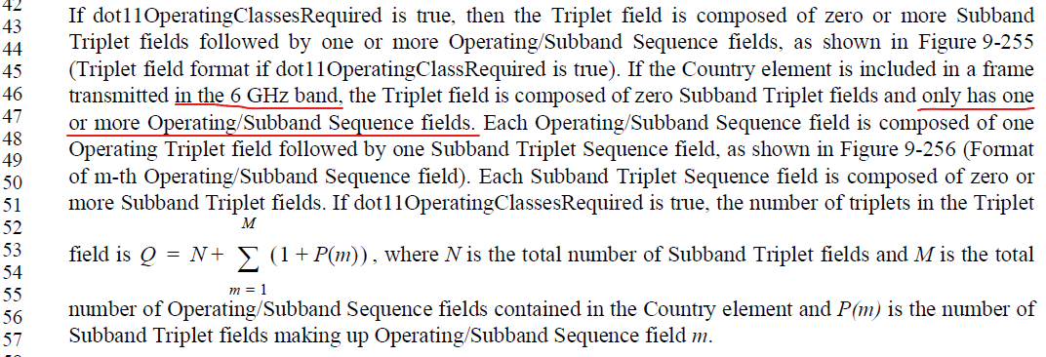

However, REVmf D1.0 P2245 states that any Operating Triplet field may be omitted. And if there is no Operating Triplet field, then there is no Operating/Subband Sequence field.
…

So which is correct? Does the Country element in the 6 GHz band must have at least one Operating/Subband Sequence field, or can the Country element contain no Operating/Subband Sequence field at all?
Update in R2:
In this document, we propose two options for potential resolution to this.
- Option A:
  - Since 9.4.2.7 is a clause of ‘format’, while 10.22.3 contains normative statements, option A takes 10.22.3 as the correct reference, and thus allows the Country element to contain no Operating/Subband Sequence field in the 6 GHz band. Hence, 9.4.2.7 is updated accordingly.
- Option B:
  - 10.22.3 is updated to clarify that while Operating Triplet field may be omitted, there must be at least one Operating/Subband sequence (and hence at least one Operating Triplet field) in a Country element
Update in R3:
There seem to be non-AP STAs which expect at least one Operating/Subband sequence. Hence, Option B is put forth as the proposed resolution.

Ambiguity #2:
Each operating class in Table E-4 correspond to a channel bandwidth. And it is not clear which channel bandwidth operating class should be included in the Country element. For example, if a 6 GHz AP is operating a 160 MHz BSS, should the Country element
- Include operating class for 20 MHz channel bandwidth only
- Include operating class for 160 MHz channel bandwidth only
- Include multiple operating classes, one each for 20, 40, 80 and 160 MHz channel bandwidths?
- Others?
REVmf D1.0 P1041 states
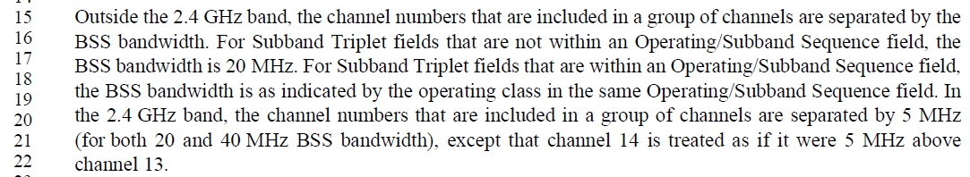
However, it does not seem the “BSS bandwidth” in this paragraph refers to “current operating” BSS bandwidth. For example, an AP in the 5 GHz band can have Subband Triplet field(s) before the Operating/Subband Sequence field, and the “BSS bandwidth” of those Triplet fields will be 20 MHz even if the AP’s current operating BSS bandwidth is, say, 160 MHz (see the second sentence above - “For Subband Triplet fields that are not within an Operating/Subband Sequence field, the BSS bandwidth is 20 MHz.”).
We could not find anything in 9.7.2.7 (Country element) or 10.22.3 (Operation with operating classes) which prohibits #1, #2 or #3 above. Furthermore, we see in the field some APs using #1, some other APs using #2, and yet other APs using #3. Hence, the proposed text update includes a NOTE which includes examples of valid construction of the Country element.
Update in R2:
After some offline discussion, we have expanded the list of examples of valid Country element content in 6 GHz as shown in the figure below, where the BSS operating bandwidth is assumed to be 160 MHz.
Please note that the figure below is for Option 1 of Ambiguity #1. For Option 2 of Ambiguity #2, Example 1 in the figure is not included.
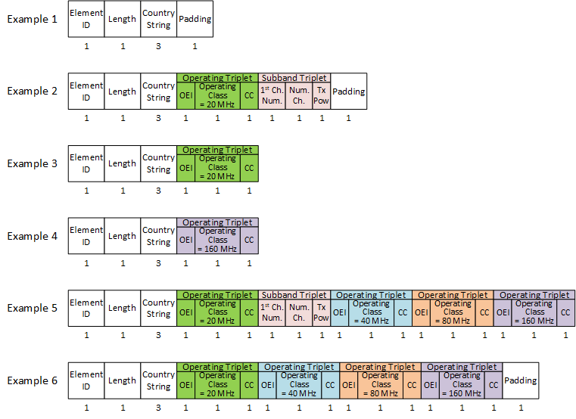
Update in R3:
Since R3 proposes to go with Option B (in R2) for ambiguity #1, this makes example 1 in the figure above INCORRECT.

Ambiguity #3:
There are different AP ‘types’ in the 6 GHz, such as an indoor AP (a.k.a. LPI AP), standard power AP, etc. See Annex E.2.7.
When an AP in the 6 GHz band includes the Subband Triplet Sequence field, it is not clear whether the listed channels should be that of the same AP ‘type’ or not.
For example, U-NII 5/6/7/8 allows LPI APs in the US, while only U-NII 5 and 7 allow standard power AP. (See Figure 3 in https://www.cisco.com/c/en/us/products/collateral/wireless/catalyst-9100ax-access-points/ghz-unlicensed-spectrum-reg-wp.html) So, if a standard power AP (say, operatingin in U-NII 5) includes the Subband Triplet Sequence field in its Country element, should it include the channels in U-NII 6 and 8 (which do not support standard power operation) or not?
The proposed resolution in this document ‘allows’ the AP to include channels irrespective of the AP ‘type’ (e.g., a standard power AP could include channels in which standard power is not allowed.) By not ‘mandating’ that all channels be included, we avoid making existing APs which might be excluding channels not supporting the same AP ‘type’ to be still in compliance as well.

Proposed Resolution: CID 48
REVISED

Instruction to TGmf Editor:
Implement the proposed text update for CID 48 in https://mentor.ieee.org/802.11/dcn/25/11-25-1509-03-000m-country-element-in-6-ghz.docx

Note to commenter:
The proposed text update clarifies the ambiguities in the Country element identified by the commenter.

Proposed Text Update: CID 48
Instruction to TGmf Editor: Update TGmf D1.0 subclause 9.4.2.7 as shown below.
9.4.2.7 Country element
The Country element contains the information required to allow a STA to identify the regulatory domain in which the STA is located and to configure its PHY for operation in that regulatory domain. The format of this element is as shown in Figure 9-252 (Country element format).

 | Element ID | Length | Country String | Triplet | Padding (if needed)
Octets: | 1 | 1 | 3 | Q×3 | 0 or 1
- Country element format

The Element ID and Length fields are defined in 9.4.2.1 (General).
The AP and mesh STA set the Country String field to the value contained in dot11CountryString before transmission in a Beacon or Probe Response frame. Upon reception of this element, a STA sets the dot11CountryString to the value contained in this field. The three octets of the Country String have additional structure as defined by dot11CountryString (see Annex C).
If dot11OperatingClassesRequired is false, then the Triplet field is a single Subband Triplet Sequence field, as shown in Figure 9-253 (Subband Triplet Sequence format), that is composed of Q Subband Triplet fields, where Q is one or more. The format of the Subband Triplet field is shown in Figure 9-254 (Subband Triplet field format).
 | One or more
 | Subband Triplet
Octets: | 3
- Subband Triplet Sequence format

 | First Channel Number | Number of Channels | Maximum Transmit Power Level
Octets: | 1 | 1 | 1
- Subband Triplet field format
If dot11OperatingClassesRequired is true, then the Triplet field is composed of zero or more Subband Triplet fields followed by one or more Operating/Subband Sequence fields, as shown in Figure 9-255 (Triplet field format if dot11OperatingClassRequired is true). If the Country element is included in a frame transmitted in the 6 GHz band, the Triplet field is composed of zero Subband Triplet fields and only has one or more Operating/Subband Sequence fields.
Instruction to 11mf Editor: Start a new paragraph here.
Each Operating/Subband Sequence field is composed of one Operating Triplet field followed by one Subband Triplet Sequence field, as shown in Figure 9-256 (Format of m-th Operating/Subband Sequence field). Each Subband Triplet Sequence field is composed of zero or more Subband Triplet fields. If dot11OperatingClassesRequired is true, the number of triplets in the Triplet field is , where N is the total number of Subband Triplet fields and M is the total number of Operating/Subband Sequence fields contained in the Country element and P(m) is the number of Subband Triplet fields making up Operating/Subband Sequence field m.
 | Zero or more | One or more indexed by  m = 1, 2, …, M; (M ≥ 1)
 | Subband Triplet | Operating/Subband Sequence
Octets: | 3 | variable
- Triplet field format if dot11OperatingClassRequired is true

 | Operating Triplet |  |  | Subband Triplet Sequence made up of P(m) Subband Triplet fields, where
 | Operating Extension Identifier | Operating Class | Coverage Class
Octets: | 1 | 1 | 1 | 3 × P(m)
- Format of m-th Operating/Subband Sequence field

The number Q of Subband fields or Operating triplet fields in the element is determined by the Length field.
An operating class for an 80+80 MHz channel width is expressed by two consecutive Operating/Subband Sequence fields, where the first Operating/Subband Sequence field contains an Operating Triplet field indicating an 80 MHz channel spacing with an 80+ behavior limit and the second Operating/Subband Sequence field contains an Operating Triplet field indicating an 80 MHz channel spacing without an 80+ behavior limit.
Operating/Subband Sequence fields that contain an Operating Class field for which the Channel spacing (MHz) column in the appropriate table in Annex E equals 80 or 160 contain zero Subband Triplet fields.
NOTE 1—Any Operating Triplet field indicating 80 MHz, 160 MHz, and 80+80 MHz can be omitted from the Country element (see 10.22.3 (Operation with operating classes)).
NOTE 2—The Transmit Power Envelope element is always used for TPC for 80 MHz, 160 MHz, or 80+80 MHz operating classes instead of Subband Triplet fields (see 11.38.1 (Basic VHT BSS functionality)).
An Operating/Subband Sequence field contains zero Subband Triplet fields if all the following conditions are true:
- The operating class table number indicated in the Country String field is Table E-4 (Global operating classes) (see dot11CountryString).
- The value in the Channel starting frequency (GHz) column in Table E-4 (Global operating classes) is greater than or equal to 5.925 and less than or equal to 7.125 for the operating class indicated in the Operating Class field.
- The value in the Channel spacing (MHz) column in Table E-4 (Global operating classes) is greater than or equal to 40 MHz for the operating class indicated in the Operating Class field.
NOTE 3—Any Operating Triplet field for an operating class for which the Channel starting frequency column in Table E-4 (Global operating classes) is greater than or equal to 5.925 and less than or equal to 7.125 can be omitted from the Country element (see 10.22.3 (Operation with operating classes)).
NOTE 4—The Transmit Power Envelope element is always used for TPC for operating classes in the 6 GHz band instead of Subband Triplet fields (see 26.15.8 (Additional rules for PPDUs sent in the 6 GHz band)).
The first octet in each Subband Triplet field or Operating Triplet field identifies the type of field. If it is less than or equal to 200, then the field is a Subband Triplet field (see Figure 9-254 (Subband Triplet field format)). Otherwise, the field is an Operating Triplet field (see left half of Figure 9-256 (Format of m-th Operating/Subband Sequence field)).
The First Channel Number field indicates the lowest channel number in the Subband Triplet field. No channel is indicated by more than one pair of First Channel Number and Number of Channels fields within a Subband Triplet Sequence field. [For example, the (First Channel Number, Number of Channels) pairs (2,4) and (5,2) in 2.4 GHz each indicate channel 5, therefore are not used within the same Subband Triplet Sequence field.] The First Channel Numbers are monotonically increasing within a Subband Triplet Sequence field. The First Channel Number and the Number of Channels pairs in a Country element are used to describe channels only in the band on which the frame containing the element is transmitted.
NOTE 5—It is not possible to indicate a first channel number above 200 in the 6 GHz band (i.e., a first channel above approximately 7 GHz), since this would be interpreted as the Operating Extension Identifier field of an Operating Triplet field.
Outside the 2.4 GHz band, the channel numbers that are included in a group of channels are separated by the BSS bandwidth. For Subband Triplet fields that are not within an Operating/Subband Sequence field, the BSS bandwidth is 20 MHz. For Subband Triplet fields that are within an Operating/Subband Sequence field, the BSS bandwidth is as indicated by the operating class in the same Operating/Subband Sequence field. In the 2.4 GHz band, the channel numbers that are included in a group of channels are separated by 5 MHz (for both 20 and 40 MHz BSS bandwidth), except that channel 14 is treated as if it were 5 MHz above channel 13.
NOTE 6—For example, the channels 1 to 11 in the 2.4 GHz band can be represented using one Subband Triplet field with First Channel Number = 1 and Number of Channels = 11. The channels 36, 40, 44, and 48 with 20 MHz BSS bandwidth in the 5 GHz band can be represented using one Subband Triplet field with First Channel Number = 36 and Number of Channels = 4. The six channels 183, 184, 185, 187, 188, and 189 (but not 186) with 10 MHz BSS bandwidth can be represented using three Subband Triplet fields: one with First Channel Number = 183 and Number of Channels = 4, one with First Channel Number = 184 and Number of Channels = 1 and one with First Channel Number = 188 and Number of Channels = 1.
NOTE 6a – Following are some examples of valid contents for the Country element in the 6 GHz band. Suppose an HE AP is operating a 160 MHz BSS in the United States. Then, the Country String field is set to (in hexadecimal) 0x55, 0x53, 0x04, where the third octet is 0x04 because Table E-4 is used when operating in the 6 GHz band (see E.2.7). After the Country String, all the following are valid choices for the Country element content. (Note that these are not the only valid choices.)
- The Triplet field contains zero Subband Triplet field and one Operating/Subband Sequence (i.e., M = 1 in Figure 9-255).
  - The Operating/Subband Sequence consists of one Operating Triplet field and one Suband Tripplet Sequence (i.e., P(1) = 1 in Figure 9-256).
    - The Operating Class field in the Operating Triplet field is set to 131 (20 MHz channel spacing).
    - The Subband Triplet Sequence consists of one Subband Triplet field, and it has the First Channel Number field set to 1 and the Number of Channels field set to 59.
- The Triplet field contains zero Subband Triplet field and one Operating/Subband Sequence (i.e., M = 1).
  - The Operating/Subband Sequence consists of one Operating Triplet field and the Subband Triplet Sequence is not present (i.e., P(1) = 0).
    - The Operating Class field in the Operating Triplet field is set to 131 (20 MHz channel spacing).
- The Triplet field contains zero Subband Triplet field and one Operating/Subband Sequence (i.e., M = 1).
  - The Operating/Subband Sequence consists of one Operating Triplet field and the Subband Triplet Sequence is not present (i.e., P(1) = 0).
    - The Operating Class field in the Operating Triplet field is set to 134 (160 MHz channel spacing).
- The Triplet field contains zero Subband Triplet field and four Operating/Subband Sequence (i.e., M = 4).
  - The first Operating/Subband Sequence consists of one Operating Triplet field and one Suband Tripplet Sequence (i.e., P(1) = 1).
    - The Operating Class field in the Operating Triplet field is set to 131 (20 MHz channel spacing).
    - The Subband Triplet Sequence consists of one Subband Triplet field, and it has the First Channel Number field set to 1 and the Number of Channels field set to 59.
  - The second Operating/Subband Sequence consists of one Operating Triplet field and the Subband Triplet Sequence is not present (i.e., P(1) = 0).
    - The Operating Class field in the Operating Triplet field is set to 132 (40 MHz channel spacing).
  - The third Operating/Subband Sequence consists of one Operating Triplet field and the Subband Triplet Sequence is not present (i.e., P(1) = 0).
    - The Operating Class field in the Operating Triplet field is set to 133 (80 MHz channel spacing).
  - The fourth Operating/Subband Sequence consists of one Operating Triplet field and the Subband Triplet Sequence is not present (i.e., P(1) = 0).
    - The Operating Class field in the Operating Triplet field is set to 134 (160 MHz channel spacing).
- The Triplet field contains zero Subband Triplet field and four Operating/Subband Sequence (i.e., M = 4).
  - The first Operating/Subband Sequence consists of one Operating Triplet field and the Subband Triplet Sequence is not present (i.e., P(1) = 0).
    - The Operating Class field in the Operating Triplet field is set to 131 (20 MHz channel spacing).
  - The second Operating/Subband Sequence consists of one Operating Triplet field and the Subband Triplet Sequence is not present (i.e., P(1) = 0).
    - The Operating Class field in the Operating Triplet field is set to 132 (40 MHz channel spacing).
  - The third Operating/Subband Sequence consists of one Operating Triplet field and the Subband Triplet Sequence is not present (i.e., P(1) = 0).
    - The Operating Class field in the Operating Triplet field is set to 133 (80 MHz channel spacing).
  - The fourth Operating/Subband Sequence consists of one Operating Triplet field and the Subband Triplet Sequence is not present (i.e., P(1) = 0).
    - The Operating Class field in the Operating Triplet field is set to 134 (160 MHz channel spacing).
If the Subband Triplet Sequence is present in an Operating/Subband Sequence field for an operating class in the 6 GHz band, then the channels represented by the First Channel Number field and the Number of Channels field are not restricted to any particular operational mode of the AP conveyed by the Regulatory Info subfield in the Control field of the 6 GHz Operation Information field of the HE Operation element.
NOTE 6b – For example, a standard power AP in the 6 GHz band operating in the United States might set the Operating Class field in the Operating Triplet field to 131, First Channel Number field in the Subband Triplet field to 1, and the Number of Channels field to 59 even though standard power AP operation is not allowed in some of these 20 MHz channels.
The Maximum Transmit Power Level field is a 2s complement signed integer. The Maximum Transmit Power Level field indi-cates the maximum power, in dBm, allowed to be transmitted. As the method of measurement for maximum transmit power level differs by regulatory domain, the value in this field is interpreted according to the regulations applicable for the domain identified by the Country String.
The Maximum Transmit Power Level field is reserved if it is within an Operating/Subband Sequence field with the operating class for which the Channel starting frequency column in Table E-4 (Global operating classes) is greater than or equal to 5.925 and less than or equal to 7.125.
NOTE 7—Maximum transmit power information for channels in the 6 GHz band is conveyed using the Transmit Power Envelope element (see 10.22.4 (Operation with the Transmit Power Envelope element)).
The Operating Extension Identifier field is an arbitrary value, subject to the minimum defined above for Operating Triplet fields.
NOTE 8—The same value might be used in more than one Operating Triplet field within the Country element.
An operating class is an index into a set of values for radio equipment sets of rules.
The Operating Class field specifies the operating class to which the immediately following Subband Triplet fields, if any, within the Operating/Subband Sequence field (see Figure 9-256 (Format of m-th Operating/Subband Sequence field)) pertain.
NOTE 9—The Operating/Subchannel Sequence field ends at the next Operating Class field, if any.
A coverage class is an index into a set of values for aAirPropagationTime.
The Coverage Class field is reserved in a DMG BSS. Otherwise, it specifies the aAirPropagationTime characteristic used in BSS operation, as shown in Table 9-151 (Coverage Class field parameters). The characteristic aAirPropagationTime describes variations in actual propagation time that are accounted for in a BSS and, together with maximum transmit power level, allow control of BSS diameter.
- Coverage Class field parameters
Coverage class value | aAirPropagationTime  (µs)
0–31 | , where n is the value of the coverage class
32–255 | Reserved

The Padding field is used to add, if needed, a single octet (with the value 0) to the Country element so that its length is evenly divisible by 2.

10.22 Operation across regulatory domains
Instruction to TGmf Editor: Update TGmf D1.0 subclause 10.22.3 as shown below.
- Operation with operating classes
The following, and only the following, are extended spectrum management capable: a VHT STA, an HE STA, and a STA that has dot11ExtendedSpectrumManagementImplemented true. A non-VHT STA that has dot11ExtendedSpectrumManagementImplemented true shall indicate that it is extended spectrum management capable using the Extended Spectrum Management Capable field of the Extended Capabilities element.
When communicating with a STA that supports global operating classes, all requests and Action and Action No Ack frames that convey elements containing operating classes shall use global operating class values.
When dot11OperatingClassesImplemented is true, the following statements apply:
- When dot11OperatingClassesRequired is false, or where operating classes domain information is not present in a STA, that STA is not required to change its operation in response to an element that contains an operating class.
- When dot11OperatingClassesRequired is true, or where operating classes domain information is present in a STA, the STA shall indicate current operating class information in the Country element and Supported Operating Classes element, except for the following cases:
- A VHT STA may omit from the Country element any Operating Triplet field for an Operating Class for which the Channel spacing (MHz) column indicates 80 MHz or wider and for which the Behavior limits set column in the applicable table in Annex E contains only a blank entry or either or both of “80+” and “UseEirpForVHTTxPowEnv.”
- An HE STA may omit from the Country element any Operating Triplet field for an Operating Class for which the Channel starting frequency column in Table E-4 (Global operating classes) is greater than or equal to 5.925 and less than or equal to 7.125, except that the Country element shall include at least one Operating/Subband Sequence.
NOTE — Hence, there is at least one Operating Triplet field in the Country element transmitted in the 6 GHz band.

- When dot11OperatingClassesRequired and dot11ExtendedChannelSwitchActivated are true and a STA is capable of operating as specified in more than one operating class, the STA shall include the Supported Operating Classes element in (Re)Association Request and Response frames.
- When dot11OperatingClassesRequired is true, or where operating classes domain information is present and the STA parsing a Country element finds an invalid First Channel Number field or Operating Class field with a value that is reserved, the STA shall ignore the remainder of the Country element and shall parse any remaining management frame body for additional elements.
- When dot11OperatingClassesRequired is true and the STA supports one or more global operating classes, or where global operating classes domain information is present in a STA, the STA shall indicate current operating class information in the Country element and Supported Operating Classes element using the country string for the global operating classes, except for the following cases:
- A VHT STA may omit from the Country element any Operating Triplet field for an Operating Class for which the Channel spacing (MHz) column indicates 80 MHz or wider and for which the Behavior limits set column in the applicable table in Annex E contains only a blank entry or either or both of “80+” and “UseEirpForVHTTxPowEnv.”
- An HE STA may omit from the Country element any Operating Triplet field for an Operating Class for which the Channel starting frequency column in Table E-4 (Global operating classes) is greater than or equal to 5.925 and less than or equal to 7.125.

[End of File]

