IEEE P802.11
Wireless LANs
TPC Report Element
Date: 2025-9-14
Author(s):
Name | Affiliation | Address | Phone | email
Youhan Kim | Qualcomm Technologies, Inc. |  |  | youhank@qti.qualcomm.com

Abstract
This submission proposes resolutions for the following comment(s) from LB289 on P802.11REVmf D1.0:

44

NOTE – Set the Track Changes Viewing Option in the MS Word to “All Markup” to clearly see the proposed text edits.

Revision History:

R0: Initial version
R1: Updated CID number per LB289

CID 44

CID  Clause  Page.Line | Comment | Proposed Change
44  9.4.2.15  1046.19 | If the Beacon frame or Probe Response frame is transmitted in a Non-HT duplicate PPDU with bandwidth greater than 20 MHz, is the Transmit Power that of the (a) Primary 20 MHz or (b) the entire PPDU BW? | Clarify whether the Transmit Power that of the (a) Primary 20 MHz or (b) the entire PPDU BW.

Discussion
REVmf D1.0 P1046:
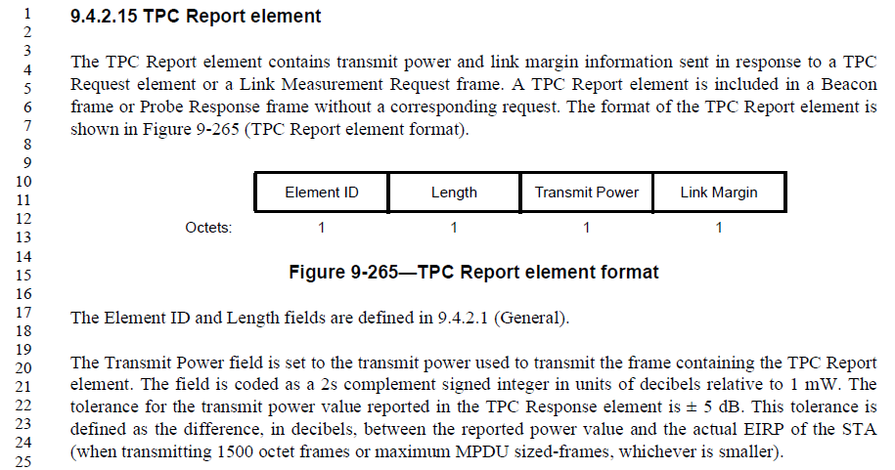
When the TPC Report element is carried in a non-HT duplicate PPDU, it is not clear whether the Transmit Power field should convey
- The total PPDU transmit power or
- Transmit power per 20 MHz.
Note that there is no explicit way for receivers of non-HT duplicate PPDUs to know the bandwidth of the PPDU as there is no bandwidth information in the preamble (i.e., L-SIG) of non-HT (duplicate) PPDUs. (Yes, bandwidth could be determined if the non-HT duplicate PPDU uses the bandwidth signaling TA. But the use of bandwidth signaling TA is limited to only certain cases, such as RTS.)
As many receivers would not be able to distinguish non-HT PPDUs (20 MHz) from non-HT duplicate PPDUs (>20 MHz), it would make sense that the Transmit Power field in a TPC Report element carried in non-HT duplicate PPDUs convey the TX power per 20 MHz.

Proposed Resolution: CID 44
REVISED

Instruction to TGmf Editor:
Implement the proposed text update for CID 44 in https://mentor.ieee.org/802.11/dcn/25/11-25-1508-01-000m-tpc-report-element.docx

Note to commenter:
The proposed text update clarifies that the Transmit Power field conveys the TX power per 20 MHz when the TPC Report element is carried in a non-HT duplicate PPDU.

Proposed Text Update: CID 44
9.4.2.15 TPC Report element
Instruction to TGmf Editor: Update TGmf D1.0 P1046L20 as shown below.
If a frame containing the TPC Report element is carried in a non-HT duplicate PPDU, the Transmit Power field is set to the transmit power per 20 MHz bandwidth. Otherwise, the Transmit Power field is set to the transmit power of the entire bandwidth of the PPDU carrying the frame containing the TPC Report element. The field is coded as a 2s complement signed integer in units of decibels relative to 1 mW. The tolerance for the transmit power value reported in the TPC Response element is ± 5 dB. This tolerance is defined as the difference, in decibels, between the reported power value and the actual EIRP of the STA (when transmitting 1500 octet frames or maximum MPDU sized-frames, whichever is smaller).

[End of File]

