IEEE P802.11
Wireless LANs
DSSS TX Power Ramp
Date: 2025-9-15
Author(s):
Name | Affiliation | Address | Phone | email
Youhan Kim | Qualcomm Technologies, Inc. |  |  | youhank@qti.qualcomm.com
Srinivas Kandala | Samsung Electronics |  |  | srini.k1@samsung.com
Sigurd Schelstraete | MaxLinear |  |  | sschelstraete@maxlinear.com
Hongyuan Zhang | NXP |  |  | hongyuan.zhang@nxp.com
Juan Fang | Intel |  |  | juan.fang@intel.com
Genadiy Nudelman | Intel |  |  | genadiy.nudelman@intel.com
Noam Lavi | Intel |  |  | noam.lavi@intel.com

Abstract
This submission proposes resolutions for the following comment(s) from LB289 on P802.11REVmf D1.0:

45

NOTE – Set the Track Changes Viewing Option in the MS Word to “All Markup” to clearly see the proposed text edits.

Revision History:

R0: Initial version
R1: Allow two methods to be used for TX power ramp measurement.
R2: Updated CID number per LB289
R3: Updated coauthors

CID 45

CID  Clause  Page.Line | Comment | Proposed Change
45  15.4.5.8  3629.52 | The DSSS and DSSS/HR TX power ramp requirement did not take into consideration the instantaneous TX power fluctuation.  See https://mentor.ieee.org/802.11/dcn/25/11-25-1325-00-000m-dsss-tx-power-ramp.pptx | Change the reference for the 90% from maximum power to average power.  Commenter will submit a more detailed proposed solution.

Discussion
DSSS (Clause 15) and DSSS/HR (Clause 16) PHYs have the transmit power ramp up/down requirements – see 15.4.5.8 and 16.3.7.7. As discussed in https://mentor.ieee.org/802.11/dcn/25/11-25-1325-00-000m-dsss-tx-power-ramp.pptx, these requirements did not take into consideration the instantaneous TX power fluctuation, making it ambiguous for testing equipments to determine the correct time location to measure the TX power ramp up/down.
Two options to resolve this issue were proposed in https://mentor.ieee.org/802.11/dcn/25/11-25-1325-00-000m-dsss-tx-power-ramp.pptx. After offline discussion with many other members, it seems the option 2 (changing the reference from “maximum TX power” to “average TX power”) seems to be the most desirable direction.

Update in R1:
Two options are presented in R1.

Option 1 is the same as in R0 technically (use average TX power as reference). We did make an editorial change in that 16.3.7.7 (HR/DSSS) now simply points to 15.4.5.8 (DSSS) instead of repeating the same text twice.

Option 2 offers two measurement methods.
- Method 1 = The method in REVmf D1.0 (use maximum TX power as reference)
- Method 2 = The method proposed in Option 1 (use average TX power as reference)
A STA is required to pass the TX power ramp test using just one method of their choice. It is not necessary for the STA to pass with both methods.
Option 2 is offered in case some vendors prefer to stay with the current measurement method, while other vendors could benefit from the new method 2 which takes into account the practical TX power fluctuation of DSSS and HR/DSSS waveforms.

Proposed Resolution: CID 45
REVISED

Instruction to TGmf Editor:
Implement the proposed text update under Option X for CID 45 in https://mentor.ieee.org/802.11/dcn/25/11-25-1507-00-000m-dsss-tx-power-ramp.docx

Note to commenter:
The proposed text update changes the reference from maximum TX power to average TX power as suggested by the commenter.

Proposed Text Update: CID 45

Option 1
Instruction to TGmf Editor: Update TGmf D1.0 P3629L54 as shown below.
15.4.5.8 Transmit power-on and power-down ramp
The transmit power-on ramp for 10% to 90% of average transmit power shall be no greater than 2 µs, where the average transmit power is measured over the entire PPDU duration. The transmit power-on ramp is shown in Figure 15-11 (Transmit power-on ramp).

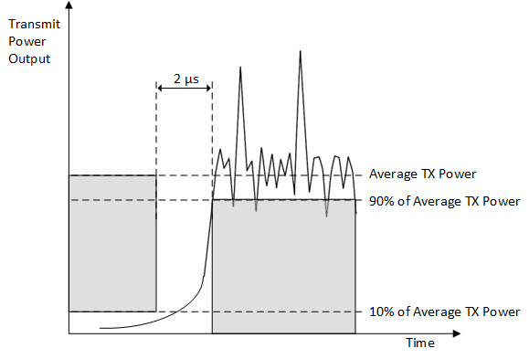
Figure 15-11 – Transmit power-on ramp
The transmit power-down ramp for 90% to 10% of the average transmit power shall be no greater than 2 µs. The transmit power-down ramp is shown in Figure 15-12 (Transmit power-down ramp).

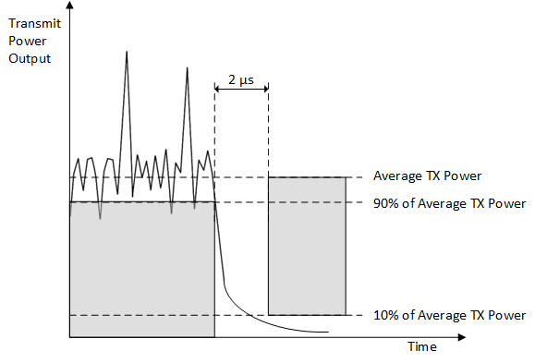
Figure 15-12 – Transmit power-down ramp
The transmit power ramps shall be constructed such that the DSSS PHY emissions comply with the spurious frequency product specification defined in 15.4.4.6 (Transmit and receive in-band and out-of-band spurious emissions).

Instruction to TGmf Editor: Update TGmf D1.0 P3658L53 as shown below.
16.3.7.7 Transmit power-on and power-down ramp
Transmit power-on and power-down ramp requirement is the same as the requirement for DSSS PPDUs in 15.4.5.8 (Transmit power-on and power-down ramp).

Option 2:
Instruction to TGmf Editor: Update TGmf D1.0 P3629L54 as shown below.
15.4.5.8 Transmit power-on and power-down ramp
Transmit power-on and power-down ramp may be measured using either the maximum transmit power based method and average transmit power based method. A DSSS STA is not required to compliant using both methods.
NOTE – If a STA is compliant using one method but not compliant using the other method, then the STA is considered to be compliant with the transmit power-on and power-down ramp.
In the maximum transmit power based method, the transmit power-on ramp for 10% to 90% of maximum power shall be no greater than 2 µs. The transmit power-on ramp is shown in Figure 15-11 (Transmit power-on ramp).

In the maximum transmit power based method, the transmit power-down ramp for 90% to 10% maximum power shall be no greater than 2 µs. The transmit power-down ramp is shown in Figure 15-12 (Transmit power-down ramp).

In the average transit power based method, the transmit power-on ramp for 10% to 90% of average transmit power shall be no greater than 2 µs, where the average transmit power is measured over the entire PPDU duration. The transmit power-on ramp is shown in Figure 15-12a (Transmit power-on ramp).

Figure 15-12a – Transmit power-on ramp
In the average transit power based method, the transmit power-down ramp for 90% to 10% of the average transmit power shall be no greater than 2 µs. The transmit power-down ramp is shown in Figure 15-12b (Transmit power-down ramp).

Figure 15-12b – Transmit power-down ramp
The transmit power ramps shall be constructed such that the DSSS PHY emissions comply with the spurious frequency product specification defined in 15.4.4.6 (Transmit and receive in-band and out-of-band spurious emissions).

Instruction to TGmf Editor: Update TGmf D1.0 P3658L53 as shown below.
- Transmit power-on and power-down ramp
Transmit power-on and power-down ramp requirement is the same as the requirement for DSSS PPDUs in 15.4.5.8 (Transmit power-on and power-down ramp).

The transmit power ramps shall be constructed such that the HR/DSSS PHY emissions comply with spurious frequency product specification defined in 16.3.6.7 (Transmit and receive in-band and out-of-band spurious emissions).

[End of File]

