|  |  |  |  |  |
| --- | --- | --- | --- | --- |
| OMP Request with NPCA Feedback Information | | | | |
| Date: Sept 03, 2025 | | | | |
| Author(s): | | | | |
| Name | Affiliation | Address | Phone | email |
| Shravan Kumar Kalyankar | Huawei |  |  | kalyankar.shravan.kumar@huawei.com |
| Rojan Chitrakar |  |  |  |
| Huang Lei |  |  |  |
| Yunbo Li |  |  |  |
|  |  |  |  |

**IEEE P802.11  
Wireless LANs**

**Background:**

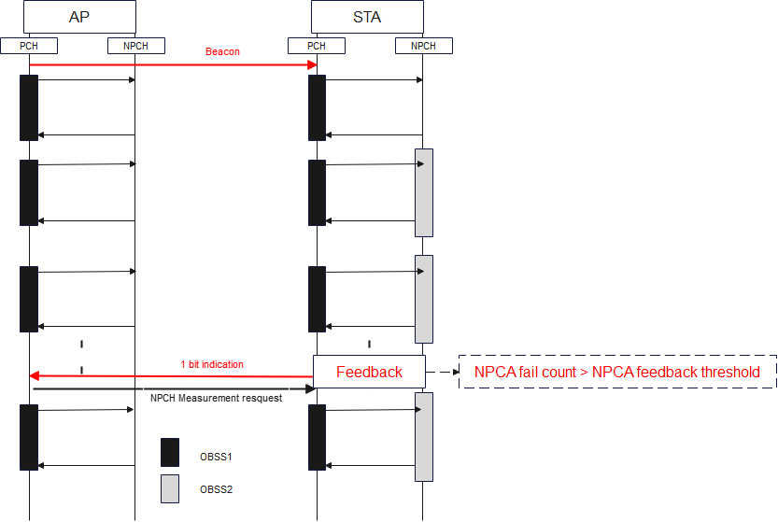If the NPCA primary channel is known to be busy due to ongoing OBSS or the NPCA primary channel condition is worse. In this case, the NPCA non-AP STA is unable to use the NPCA primary channel until a new NPCA primary channel is announced by the AP. Furthermore, NPCA non-AP STA wastes power in switching back-and-forth (PCH2NPCH) until a new NPCA primary channel is announced. Moreover, NPCA AP is unable to assess the hidden OBSS or other hidden conditions on the NPCA primary channel. There is no mechanism defined to inform the NPCA AP about the poor NPCA primary channel condition and request a channel switch.

Fig. 1-bit NPCA feedback mechanism.

Proposal: A 1-bit feedback indication to inform the AP about poor NPCA primary channel condition.

**Proposed Text:**

**9.4.2.aa1 UHR Operation element**

The NPCA Disabled Subchannel Bitmap field is a bitmap where the lowest numbered bit corresponds to the

20 MHz subchannel that lies within the BSS bandwidth and is the lowest in frequency of the set of all 20

MHz subchannels within the BSS bandwidth. Each successive bit in the bitmap corresponds to the next

higher frequency 20 MHz subchannel. A bit in the bitmap that lies within the BSS bandwidth is set to 1 to

indicate that the corresponding 20 MHz subchannel is punctured and is set to 0 to indicate that the

corresponding 20 MHz subchannel is not punctured. A bit in the bitmap that falls outside of the BSS

bandwidth is reserved. This field is present when the value of the NPCA Disabled Subchannel Bitmap Field

Present field is equal to 1, and not present, otherwise.

The NPCA Feedback Threshold field is a 2-bit threshold indicating the required number of failures at an NPCA STA while accessing NPCA channel before sending a NPCA feedback indication to an NPCA AP. Where the failure count is the number of failed NPCA attempts due to partially or fully busy NPCA primary channel because of OBSS over a Beacon interval.

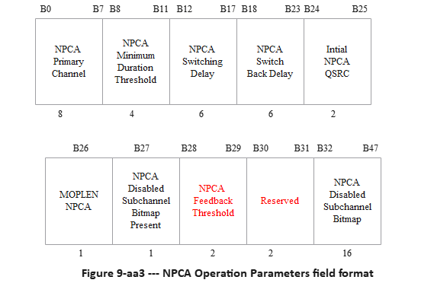

|  |  |
| --- | --- |
| **NPCA Feedback Threshold** | **Fail Count** |
| 00 | 1 failure |
| 01 | 5 failures |
| 10 | 10 failures |
| 11 | 20 failures |

**Table.9xx. NPCA Feedback Threshold.**

**9.4.2.aa7.2 Mode Specific Parameters for NPCA**

When the value of the Mode ID field is 1,

— the Mode Tuple field corresponds to NPCA, and

— the Mode Specific Control field is reserved, and

— the Mode Specific Parameters field carries the parameters for NPCA.

The Mode Specific Parameters field for NPCA is defined in Figure 9-aa58 (Mode Specific Parameters field for NPCA).

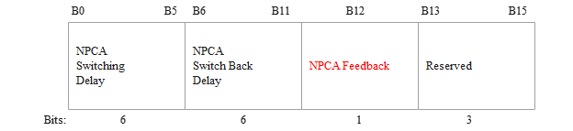

**Figure 9-aa58—Mode Specific Parameters field for NPCA**

The encoding of fields in the Mode Specific Parameters field for NPCA is the same as the encoding of the corresponding fields in the NPCA Operation Parameters field defined in 9.4.2.aa1 (UHR Operation element(#1498)). However, NPCA Feedback bit indicates the NPCA primary channel condition at the non-AP STA as shown in Table. 9xx. In case, the non-AP STA fail to access the NPCA primary channel due to ongoing OBSS more than number of attempts indicated in NPCA Feedback Threshold, the non-AP STA may indicate the NPCA Feedback value as “1” in the OMP Request.

|  |  |
| --- | --- |
| NPCA Feedback | Description |
| 1 | Counter $≥$ NPCA Feedback Threshold |
| 0 | Counter $<$ NPCA Feedback Threshold |

Tab. 9xx. NPCA Feedback.

**9.4.2.aa8.2 Mode Specific Parameters for NPCA**

When the value of the Mode ID field is 1,

— the Mode Tuple field corresponds to NPCA, and

— the Mode Specific Parameters field carries the parameters for NPCA.

The Mode Specific Parameters field for NPCA is defined in Figure 9-aa63 (Mode Specific Parameters field

for NPCA format).

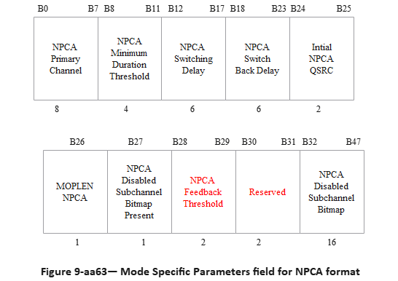

The encoding of fields in the Mode Specific Parameters field for NPCA is the same as the encoding of the corresponding fields in the NPCA Operation Parameters field defined in 9.4.2.aa1 (UHR Operation element(#1498))).

**37.18 Non-primary channel access (NPCA)**

**37.18.1 General**

An NPCA AP shall indicate a value in the NPCA Primary Channel field of transmitted NPCA Operation

Parameters fields that corresponds to a channel that is located within the secondary 40 MHz of the BSS

operating channel if the BSS is an 80 MHz BSS, that corresponds to a channel that is located within the

secondary 80 MHz of the BSS operating channel if the BSS is a 160 MHz BSS and that corresponds to a

channel that is located within the secondary 160 MHz of the BSS operating channel if the BSS is a 320 MHz

BSS.(#1052)(#2358)

A non-AP NPCA (#3040)(#545)STA shall indicate(#1509)(#1722) its NPCA switching delay and NPCA

switch back delay respectively in the NPCA Switching Delay field, NPCA Switch Back Delay fields, and NPCA Feedback field of the OMP Request frames.(#1053)

(#2478, 2480, 252, 3650) When a non-AP STA that supports NPCA mode (re)associates with an AP, the

NPCA mode is disabled by default for the non-AP STA. A UHR non-AP STA that supports NPCA mode

and that intends to enable, disable or update the parameters of NPCA mode shall follow the procedure

defined in 37.31 (Procedure for operating mode and parameter updates). In the UHR OMP request sent to

enable or update the parameters of NPCA mode for the non-AP STA, the non-AP STA shall include the

following in the Mode Parameters field of the Mode Tuple field:

— NPCA switching delay,

— NPCA switch back delay,

— NPCA Feedback.

(#2478, 2491)The associated AP shall accept the request and follow the procedure defined in 37.31 (Procedure

for operating mode and parameter updates).

(#2478, 2491)NOTE—For a non-AP STA to enable NPCA mode, the associated AP must support

**Straw Poll:**

**SP1. Do you support to define a NPCA Feedback Mechanism to assist NPCA AP in reselection of NPCA parameters (e.g., NPCA PCH, NPCA DSB)?**

* + Y/N/A

SP2. Do you support to include a 1-bit NPCA Feedback in OMP request frame?

|  |  |
| --- | --- |
| NPCA Feedback | Description |
| 1 | Request to change the NPCA Primary Channel |
| 0 | No need to change the NPCA Primary Channel |

* + Y/N/A