**IEEE P802.11  
Wireless LANs**

|  |  |  |  |  |
| --- | --- | --- | --- | --- |
| CR for PASN ID in MLO | | | | |
| **Date**: Mar 5, 2025. | | | | |
| **Author(s):** | | | | |
| **Name** | **Affiliation** | **Address** | **Phone** | **email** |
| Yan Li | ZTE |  |  | Li.yan16@zte.com.cn |
| Jay Yang |  |  |  |
| Yun Li |  |  |  |

**Abstract**

This submission proposes resolution for following CIDs of LB289:

10,65

**Revisions:**

Rev 0: Initial version of the document.

***TGm editor: The baseline for this document is P802.11mfD1.0***

Interpretation of a Motion to Adopt

A motion to approve this submission means that the editing instructions and any changed or added material are actioned in the TGm Draft. This introduction is not part of the adopted material.

***Editing instructions formatted like this are intended to be copied into the TGmf Draft (i.e., they are instructions to the 802.11 editor on how to merge the text with the baseline documents).***

***TGm Editor: Editing instructions preceded by “TGm Editor” are instructions to the TGm editor to modify existing material in the TGm draft. As a result of adopting the changes, the TGm editor will execute the instructions rather than copy them to the TGm Draft.***

|  |  |  |  |  |  |
| --- | --- | --- | --- | --- | --- |
| CID | Clause | Page/Line | Comment | Proposed Change | Resolution |
| 10 | 12.2.14.1 | 3233.38 | For MLO, an AP MLD shall provide a device ID and a PASN ID, and the latter one may be used in the next PASN procedure when the AP MLD become an AP. | change to "For MLO, an AP MLD shall provide a device ID and a PASN ID to a non-AP MLD using the following procedures:" | Revised.  Agree in principle.  For MLO, the case of storage and recognition of both devcie ID and PASN ID should be considered as well.  TGm editor, please make the changes tagged by CID #10 in 11-25/1490r0 |
| 65 | 12.2.14.1 | 3233.38 | For the transition case that a non-AP MLD may become a non-AP STA and then perform PASN authentication with an AP, it's necessary to provide a PASN ID to the non-AP MLD in advance for better identification | as the comments | Revised.  Agree in principle.  For MLO, the case of storage and recognition of both devcie ID and PASN ID should be considered as well.  TGm editor, please make the changes tagged by CID #10 in 11-25/1490r0 |

**Discussion**

This submission proposes that AP MLD may provide non-AP MLD a PASN ID to be used, when the non-AP MLD becomes a non-AP STA, for identification of the non-AP STA during PASN authentication for the purpose of communicating with an AP in the same ESS; otherwise, the non-AP STA and non-AP MLD may be recognized as different devices, which leads to the missing of shared identity state

transition of non-AP MLD to non-AP STA is supported

According to 11mf D1.0 P3235L30, a non-AP MLD may become a non-AP STA and then even become a non-AP MLD back. For instance, there are AP MLD 1 and AP2(non-MLD AP, such as 11ax AP) in the same ESS.

                At the first time ,non-AP MLD sets up multi-link association with AP MLD1.

                Then,the non-AP MLD go away from the ESS.

At the second time, it comes back and associates with AP2. Since the AP2 doesn't support MLO, the non-AP MLD has to become a non-AP STA to associate with AP2

                At the third time ,the non-AP STA moves back to the AP MLD1 and becomes non-AP MLD to perform multi-link association with AP MLD1

the motivation of this contribution is as below

    At the first time, non-AP MLD associates with AP MLD1 and AP MLD1 only provides Device ID( no PASN ID, because MLD doesn't support PASN), according to 11be spec

     And then the non-AP MLD goes out of ESS1 and at the second time, it goes back to perform PASN authentication with non-MLD AP2. In this case, the device should operate as a non-AP STA. But unfortunately, the non-AP STA can not report any PASN ID to AP2(because AP MLD1 did not provide any PASN ID in advance),  which means AP2 can not recognize the STA

        So the motivation is that if the AP MLD1 can provide PASN ID in advance, then when the non-AP MLD becomes a non-AP STA and performs PASN authentication with any non-MLD AP， it can report the PASN ID and the non-MLD AP can recognize the STA via the PASN ID.

        BTW, as MLD doesn't support PASN, it's weird to force the AP MLD to provide PASN ID. Therefore,  we should consider PASN capability of the affiliated AP instead of AP MLD. The affiliated AP may also serve some legacy non-AP STA(11ax STA) and it has non-MLD and MLD upper MAC sublayer(see 11mf D1.0 P387 Figure 4-35), which means it supports PASN if relevant MIB is true.

        In general, if the affiliated AP supports PASN, the AP MLD may provide the non-AP MLD a PASN ID, which is used when the non-AP MLD becomes a non-AP STA and perform PASN authenticaiton with any legacy AP in the same ESS

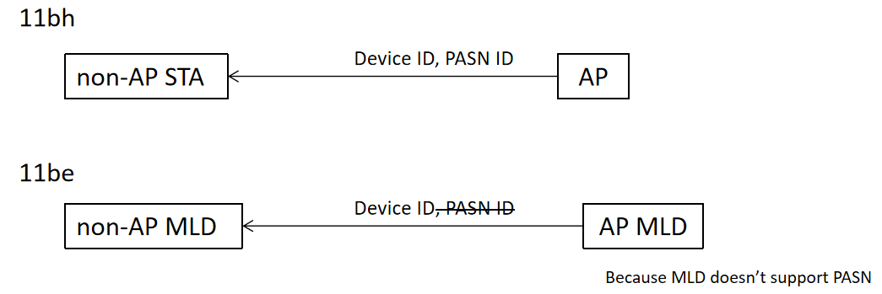

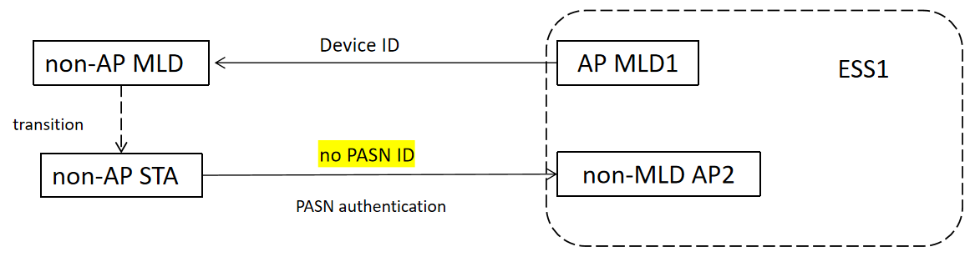

**12.2.14.1 Device ID**

P3233L8: initial connection

***TGm editor: Please channge the paragraph as follows:***

(#10)If an AP or an AP MLD with dot11DeviceIDActivated equal to true receives an Association Request frame that includes an Extended RSN Capabilities field with the Device ID Support field equal to 1 from a non-AP STA or a non-AP STA affiliated with a non-AP MLD, respectively, the AP or the AP MLD may provide both a device ID and, if dot11PASNActivated is true, a PASN ID using the procedure described below:

1) When using FILS authentication and the non-AP STA or the non-AP MLD did not provide a device ID in the Device ID element in the Association Request frame, the AP or the AP MLD may provide a device ID in the Device ID element setting the Device ID Status field to 2 to indicate Not Applicable and, if dot11PASNActivated is true, a PASN ID in the PASN ID element setting the PASN ID Status field to 2 to indicate Not Applicable in the Association Response frame.

2) When not using PASN or FILS authentication and the non-AP STA or the non-AP MLD did not provide a device ID in the Device ID KDE in message 2 of the 4-way handshake, the AP or the AP MLD may provide a device ID in the Device ID KDE setting the Device ID Status field to 2 to indicate Not Applicable and, if dot11PASNActivated is true, a PASN ID in the PASN ID KDE setting the PASN ID Status field to 2 to indicate Not Applicable in message 3 of the 4-way handshake.

(#10)NOTE—For MLO,the AP MLD shall consider whether dot11PASNActivated is true for the affiliated AP receiving the Association Request frame other than the AP MLD with which it is affiliated, because the affliated AP may serve non-EHT non-AP STA and support PASN authenticaiton while the AP MLD does not support PASN authentication

P3233L38

***TGm editor: Please channge the paragraph as follows:***

(#10)

P3234L1: storage of both IDs

***TGm editor: Please channge the paragraphs as follows:***

(#10)A STA or an MLD may delete either or both of a stored device ID and a stored PASN ID at any point in time for implementation specific reasons.

For non-MLO, when a non-AP STA sends a device ID or a PASN ID to an AP, it shall use the device ID or the PASN ID most recently received from any AP (#10)or AP MLD belonging to the same ESS.

(#10)(#10)For MLO, when a non-AP MLD sends a device ID to an AP MLD, it shall use the device ID most recently received from any AP or AP MLD belonging to the same ESS.

P3234L53: not recognized case

***TGm editor: Please channge the paragraphs as follows:***

(#10)If an AP or an AP MLD has a Device ID element or Device ID KDE with the Device ID Status field set to 1, indicating Not Recognized, then the AP or the AP MLD may also provide in that same Device ID element or Device ID KDE a new device ID and, in a PASN ID element or PASN ID KDE, a new PASN ID, thus establishing a new shared identity state. An AP or an AP MLD shall set a Device ID Status field to 1 indicating Not Recognized if the AP or the AP MLD cannot unequivocally identify the non-AP STA or the non-AP MLD shared identity state, respectively.

(#10)

P3235L30: transition between MLD and non-MLD

***TGm editor: Please channge the paragraphs as follows:***

(#10)A non-AP MLD that stores a device ID or a PASN ID received from an AP MLD in an ESS and later becomes a non-AP STA for the purpose of communicating with an AP in the same ESS, may provide that device ID or that PASN ID in a frame following the procedures defined in this subclause for the non-AP STA. Similarly, a non-AP STA that stores a device ID received from an AP in an ESS and later becomes a non-AP MLD for the purpose of communicating with an AP MLD in the same ESS, may provide that device ID in a frame following the procedures defined in this subclause for the non-AP MLD