IEEE P802.11  
Wireless LANs

|  |  |  |  |  |
| --- | --- | --- | --- | --- |
| UCM TIG Unified Channel Model Use Cases proposal | | | | |
| Date: 2025-08-19 | | | | |
| Author(s): | | | | |
| Name | Affiliation | Address | Phone | email |
| Yanchun Li | Huawei | Shenzhen, China | +86 13 1288 44874 | liyanchun@huawei.com |
| Bingsen Liu | Huawei |  |  | liubingsen@huawei.com |
| Ming Gan | Huawei |  |  | ming.gan@huawei.com |
| Stephen McCann | Huawei |  |  | stephen.mccann@ieee.org |
|  |  |  |  |  |
|  |  |  |  |  |

Abstract

This submission proposes use cases for unified channel model which enables performance evaluation and comparison of proposals for multilink operation (MLO) across sub‑7 GHz / mm-wave / optical bands.

**1 Introduction**

Recent IEEE 802.11 based WLAN evolves to multi-STA, multi-link, multi-AP and multi-band systems. In these new systems, signals are transmitted from/to multiple STAs, over multiple links/bands in various schemes. To evaluate system performance accurately, spatial consistency of channel needs to be taken in to consideration.

Spatial consistency among multiple scheduled STAs should be taken into account since 802.11ac’s introduction of **downlink (DL) MU-MIMO** and 802.11ax’s introduction of **uplink MU-MIMO**. Based on double scattering channel model, the multiple scheduled STAs encounter correlated fading at AP side. For DL MU-MIMO, high similarity among multiple STA’s transmit correlation matrices will be more likely to cause inter-STA interference.

Spatial consistency among multiple links between AP and non-AP STA should be considered since 802.11be’s introduction of **multi-link operations**. A non-AP MLD’s 2.4GHz link in deep shadowing state due to wall blockage will very like to indicate the non-AP MLD’s 5GHz link also in deep shadowing state. In this case, uncorrelated and independent modeling of the channels over these two links causes over-optimistic assumption about the channel state, and may provide illusion that transmission can be performed on a link not in deep shadowing state while the other linke is in deep shadowing state.

Spatial consistency among multiple links between APs and non-AP STAs should be considered for since 802.11bn’s introduction of various **multi-AP (MAP) schemes**, including MAP transmission schemes and SMD BSS transistion [2].

Spatial consistency among multiple links in sub-7GHz band and mmWave should be considered for since 802.11bq’s introduction of **integrated mmWave** system framework. TGbq is investigating schemes including low-band assisted mmWave discovery and beam searching/tracking.

Motivated by recent evolution of 802.11 systems, this document provides some investigation on various use case of a unified channel model across sub‑7 GHz / mm-wave / optical bands. More comprehensive use cases will be considered in future works.

**2. Unified Channel Model Use Cases for 802.11**

**2.1 Unified Channel Model for coordinated beamforming**

WLAN deployment in industial and residential scenarios is getting denser and denser. It leads to increased inter-BSS interference, collision and delay. 11bn TG aiming at ultra high reliability, has defined a coordinated beamforming (Co-BF) scheme, which two APs serves each of their non-AP STAs simultaneously via spatial multiplexing. In a two-BSS setup (Fig.1), via intra and inter BSS NDP sounding, AP1 and AP2 can obtain channel matrices of $H_{STA1,AP1}$ and $H_{STA2,AP1}$, $H_{STA1,AP2}$ and $H_{STA2,AP2}$, respectively. Each AP can carefully pick its precoding vector(s) so as to maximize signal and minimize leakage.

In Florian‘s research [3], the transmit correlation matrix is defined as

$$R_{Tx}\left(H\right)=E\left\{H^{H}H\right\}$$

The receive correlation matrix is defined as

$$R_{Rx}\left(H\right)=E\left\{HH^{H}\right\}$$

A number of similarity measures between two correlation matrices have been proposed. Chordal distance is a typical one:

$$d\left(R_{1},R_{2}\right)={\left\|R_{1}{R_{1}}^{H}-R_{2}{R_{2}}^{H}\right\|}_{F}^{2}$$

where ${\left\|∙\right\|}_{F}$ denotes the Frobenius norm.

When $d\left(R_{Tx}\left(H_{STA1,AP1}\right),R_{Tx}\left(H_{STA2,AP1}\right)\right)$ is low, there is high similarity between $H_{STA1,AP1}$ and $H_{STA2,AP1}$‘s transmit correlation matrix. It means that it is difficult for AP1 to choose a prevoding vector to avoid leakage to OBSS STA2.

When $d\left(R_{Rx}\left(H_{STA1,AP1}\right),R_{Rx}\left(H_{STA1,AP2}\right)\right)$ is low, there is high similarity between $H_{STA1,AP1}$ and $H_{STA1,AP2}$‘s receive correlation matrix. It means that it is difficult for STA1 to choose a receive prevoding vector to avoid interference from OBSS AP2.

Obviously, legacy 11ac/ax channel model generates independent channel matrices and leads to over-optimistic performance evaluation.

A Unified Channel Model (UCM) with spatial consistency can provide multi-AP multi-STA channel matrices with realistic inter-AP and inter-STA transmit/receive correlation. 11bn’s PAR has specified the target of 25% increasing of throughput. And Co-BF is a very useful scheme contributing to throughput gain. So, it is important for the validation of system level performance of Co-BF with UCM.

AP1

AP2

STA1

STA2

$$H_{STA1,AP1}$$

$$H_{STA2,AP2}$$

$$H_{STA1,AP2}$$

$$H_{STA2,AP1}$$

Fig.1 Co-BF Use cases

**2.2 Unified Channel Model for integrated mmW(IMMW)**

11bq considers a WLAN system natively integrated sub-7GHz and millimetre Wave (mmW). mmW WLAN communication usally needs beam alignment to satisfy link budget requirement. However, in industrial, medical and residential scenarios, IMMW STA mounted on robot, AR halmet and AGV will encounter time-varying channel. Frequent beam searching and alignment can be very costly in radio resources. Rather than sololy rely on mmW for a standalone beam searching, 11bq based WLAN can take advantage of multi-band spatial consistency to assist beam searching, Fig.3.

Several SOTAs have proposed to use angle of arrival/departure information in sub-7GHz to assist beam selection, as shown in Fig. 4 [4,5].

AP1

STA1

$$H_{STA,AP}^{mmW}$$

$$H_{STA,AP}^{sub-7GHz}$$

$$θ_{AoD}$$

Fig.2 sub-7GHz assisted mmW beamforming Use cases for integrated mmW

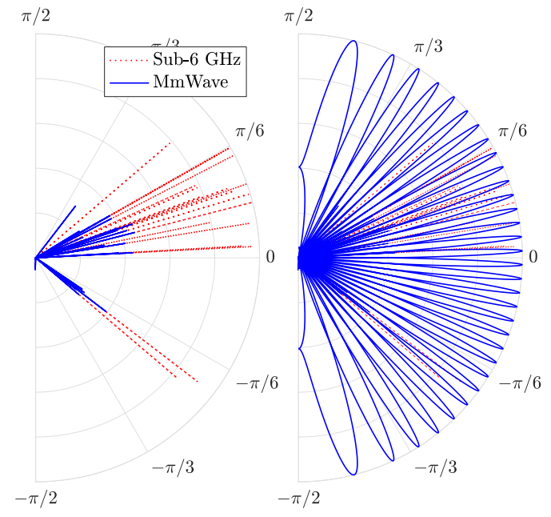

Fig.3 spatial consistency between sub-6GHz and mmW in angular domain (left) and beam space (right). [4]

Muhammad et.al. also proposes to use out of band information for mmW beam selection. They consider to use the LED in optical band to obtain angle of arrival information, so that STA can choose its candidate beam [6].

AP1 with LED

STA1

$$H_{STA,AP}^{mmW}$$

AoA estimation from AP’s indicator LED

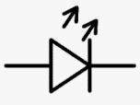

Fig.4 optical band assisted mmW beamforming Use cases for integrated mmW

**3 Conclusions**

Channel spatial consistency is very important in the performance evaluation under aforementioned use cases. Spatial Consistency shall be considered over multiple links/bands and over multiple APs/STAs. The unified channel model (UCM) developed by UCM TIG can cover these use cases to support evolution of IEEE 802.11 based WLAN standard development and applications.

**References:**

[1] https://mentor.ieee.org/802.11/dcn/25/11-25-1067-02-0wng-unified-channel-model-for-802-11.pptx

[2] IEEE 802.11bn/D0.3

[3] Kaltenberger, Florian, David Gesbert, Raymond Knopp, and Marios Kountouris. "Correlation and capacity of measured multi-user MIMO channels." In *2008 IEEE 19th International Symposium on Personal, Indoor and Mobile Radio Communications*, pp. 1-5. IEEE, 2008.

[4] Ali, Anum, Nuria González-Prelcic, and Robert W. Heath. "Millimeter wave beam-selection using out-of-band spatial information." *IEEE Transactions on Wireless Communications* 17, no. 2 (2017): 1038-1052.

[5] Nitsche, Thomas, Adriana B. Flores, Edward W. Knightly, and Joerg Widmer. "Steering with eyes closed: mm-wave beam steering without in-band measurement." In *2015 IEEE Conference on Computer Communications (INFOCOM)*, pp. 2416-2424. IEEE, 2015.

[6] Haider, Muhammad Kumail, Yasaman Ghasempour, Dimitrios Koutsonikolas, and Edward W. Knightly. "Listeer: Mmwave beam acquisition and steering by tracking indicator leds on wireless aps." In *Proceedings of the 24th Annual International Conference on Mobile Computing and Networking*, pp. 273-288. 2018.