IEEE P802.11  
Wireless LANs

|  |  |  |  |  |
| --- | --- | --- | --- | --- |
| Proposed Technical Report Text For Streaming Use Case | | | | |
| Date: 2025-09-05 | | | | |
| Author(s): | | | | |
| Name | Affiliation | Address | Phone | email |
| Azin Neishaboori | General Motors | 29427 Louis Chevrolet Road, Warren MI 48093 |  | Azin,neishaboori@gm.com |

Abstract

This document contains the proposed technical report text of the IEEE 802.11 Automotive TIG, with a focus on streaming use case.

Revision history:

This document is intended to be used together with proposed text for other use cases drafted for Automotive TIG technical report including 25/1295r0-r1 [1].

# Table of Contents

1. **Introduction**
   1. Terminologies
   2. Background information
2. **Automotive Use cases for IEEE 802.11**
   1. **Use case 3: Streaming services**
      1. **Use case description**

Streaming services data constitute a significant portion of vehicle infotainment downlink data. In this section, WLAN requiements for sustained streaming services are examined.

Streaming data are generally latency-sensitive and data rate-sensitive. However, streaming applications often utilize various tunable parameters to mitigate the impact of added latency, variable data rates, session disruptions, jitter, and other undesirable channel conditions. Among these are configurable buffer duration, and adapative data rate. Buffering helps mitigate the impact of intermittent connection loss, while adaptive data rate streaming protocols help smoothens the impact of varying effective throughput. Table 1 shows typical data rate and buffer duration values for audio and video streaming services under different quality expectations [2].

|  |  |  |  |  |
| --- | --- | --- | --- | --- |
| Application parameter/Expected Quality | Audio Streaming data rate | Audio Streaming buffering duration | Video streaming data rate | Video streaming buffering duration |
| Basic quality | 24 kpbs | 3-4 Mbps | 10-15 sec | 15 + sec |
| Medium quality | 128 kbps | 5-8 Mbps | 3-6 sec | 5-10 sec |
| High quality | 320 kbps | 25 Mbps | 1-2 sec | 2-3 sec |

Table 1- Streaming Services Characteristics Based on Quality Tier

1. **High-level requirements and potential features analysis** 
   1. **Requirements**

The automotive use cases described in section 2 highlights WLAN’s critical role in supporting automotive applications. This section defines the key requirements for vehicles to be able to offload vecular downlink and uplink data transmission from cellular to WLAN, persistently or opportunistically depending on the use case, whether in stationary/near‑stationary or in mobile scenarios in urban and busy suburban environments.

* + 1. **Requirements for streaming use case**

Streaming services require persistent connectivity through AP handovers. Disruption to the connection persistence could only be tolerated as long as its duration does not exceed the streaming buffer duration, and that the buffer is sufficiently full to playback stored streaming data during the connection disruption. That would not only demand careful design of the streaming applications intended to be used in environments prone to connection disruption, such as vehicular settings, but also for WLAN STA on the vehicle and the APs catering to them to meet several requirements. We first start with a numeriacal example, and then proceed with the requirements.

**Example 1:**

A vehicle moving at the constst speed of 40 km/h (25 mph), along a straight line, where APs have 100 meters coverage range and are placed every 100 meters along the line of vehicle movement, takes about 9 seconds to traverse the area where it is both in range of AP1, its current AP, and AP2, its target AP. Let us assume that the vehicle STA decides to roam from AP1 to AP2 as soon as it falls under the latter’s coverage. To maintain persistent streaming service during and after this handover, the following inequality needs to hold:

$Delay (vehicle traversing overlapping coverage area) + Buffer duration > Delay (complete handover operation)$ (1)

Given the specific numbers in the example, and also considering a 2-second buffer duration for the streaming service, 9 + 2 > Delay(handover). That is, during the time interval when the vehicle is both in range of AP1 and AP2, the maximum amount of time the handover can take place without any service disruption is 11 seconds. The later the vehicle STA decides to roam from AP1 to AP2, the less time it will have to perform the AP handover operations without user experiencing service disruption. Note that in the above analysis, it was assumed that the buffer is filled sufficiently prior to connection loss, so as to allow playback at current or, if needed, a lower data rate during the time-interval connection was disrupted due to handover. Assuming that maximum such connection disruption would require the full use of the buffer, this in turn means that:

goodput × buffer-duration ≥ buffer-length ≥ min-acceptable data rate × buffer-duration (2)

Using the example above, several challenging factors can be identified to work against a smooth streaming services experience over WLAN. These include: (i) limited coverage range of WLAN APs, and accordingly the short duration of time when a moving vehicle is in range of the current AP, and (ii) loss of WLAN coverage exceeding buffer duration causes service disruption,.

Considering the example and discussion above, in the rest of this subsection, the WLAN requirements for data streaming for vehicles moving in urban or busy suburban areas are discussed, subject to the following assumptions:

**Assumption 1** – Vehicles, while mobile, are considered to move at a speed of 40 km/h or less. This is a reasonable assumption for vehicular speed in urban and busy suburban areas, and also limits the impact of Doppler-induced Carreir Frequency Offset (CFO).

**Assumption 2** – A vehicle STA connecting to an external AP requires a secure and authenticated link between itself and the AP.

Note 1 – Clearly, for vehicular WLAN-based connectivity in mobile scenarios, sufficient externally avaialble APs need to be present and accessible. Such external APs should also be able to provide authentication and security to vehicle STAs they connect with.

Note 2 – While the requirements below aim to address the most demanding scenario of a vehilce moving at 40 km/h, they also help with vehicule STAs connecitivity over WLAN to externally available APs during more relaxed mobility conditions, i.e., static scenarios such as parked and/or charing vehicles, and semi-stationary scenarios such as stuck or inching forward in traffic jams or behind red-light, and proceeding through a drive-through service such as those for fast food or coffee.

current and predicted trajectory. (3) Fast Selection: selecting, among multiple roaming candidate APs, one or more APs with which the vehicle STA can successfully authenticate and establish a secure link.

**Sustained connectivity:**

1. **Fast network discovery:**

A moving or semi-strationary vehicle STA, in its first link establishment to WLAN, or to continue connectivity to WLAN via externally accessible APs needs to continuously scan in-range APs to identify candidate APs the vehicle is or will shortly be in range of. This often requires a scan radio in addition to the main radio.

Specifically, as streaming services require uninterrupted connectivity, short of for a buffer duration that can obfuscate temporary disruptions from users, fast network discovery is critical.

1. **Fast Selection:**

Selecting, among multiple roaming candidate APs, an AP with which the vehicle STA can successfully authenticate and establish a secure link. Two main factors are important for AP selection:

*Maximize expected coverage time* - It is particularly helpful to identify those APs that are along the vehicle’s current and predicted trajectory, as such APs extend the duration of time the vehicle STA remains under their coverage, and thereby minimize the number of times roaming to another AP is needed.

*Increase the likelihood of successful authentication* - It is also important to identify, if possible, the APs that the vehicle can successfully authenticate and establish a secure link with.

1. **Seamless roaming:**

A moving vehicle providing streaming service often falls out of range of the AP it is currently connected to, and in range of other APs. Accordingly, once the tasks of identifying qualified APs, and selecting among them is done, the roaming operation from current to target AP needs to be (a) triggered at a suitable time instance, and (b) completed seamlessly, minimizing the time needed to establish a secure link with the (authenticated) target AP with minimal to zero tangible user experience impact.

How fast network discovery should identify roaming candidates, select a suitable AP, and trigger roaming, depends on the layout of the WLAN APs against the layout of the roads in urban and busy suburban areas, the QoS requirements of the streaming service, and the speed of a vehicle relying on WLAN connectitivity for their streaming services. Below, we study a simplified scenario and derive maximum tolerable roaming latency:

Simplified Analysis

Consider first a rectangular road segment where WLAN APs are placed Y meters away from the road. Figure 1 shows once such AP, AP1 with coverage range of $r_{1}$, and another AP, AP2 with coverage range of $r_{2}$ placed d meters away from AP1 anong the road segment. It can be seen that the where the two circles overlap on the road segment is where there is coverage both from AP1 and AP2. It can be seen that the maximum stretch of the road where a vehicle would have coverage from both APs is of length D = $r_{1}$ + $r_{2} - d$. Now, let us further assume that $r_{1}$ = $r_{2}=d$. Therefore, we will have $D = d$.

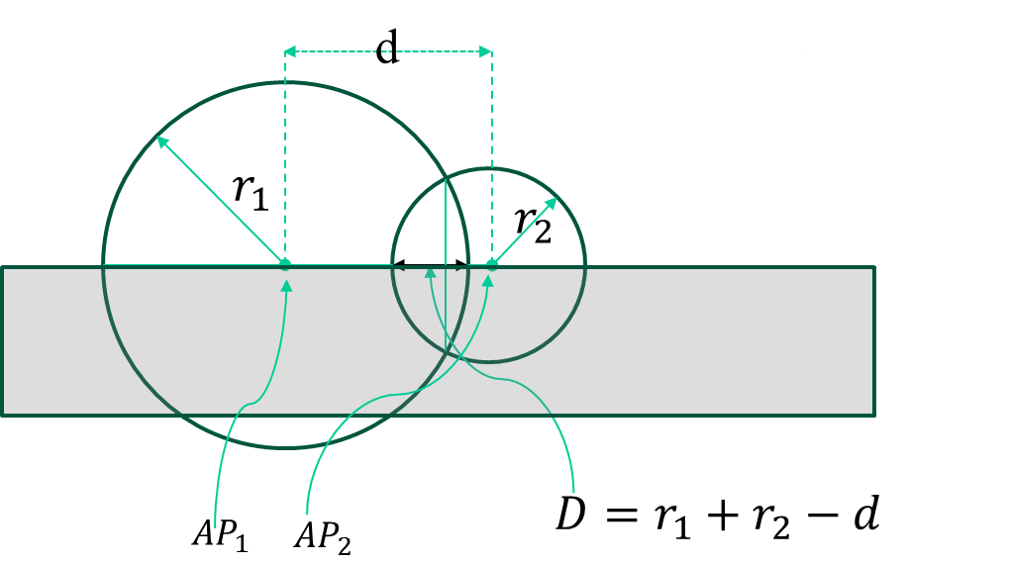

Figure 1- A simple layout of a road segment and WLAN APs

Consider a vehicle moving in a street where the above described WLAN APs are placed every $d$ meters, and they each have a coverage range of $d$ meters. A vehicle moving with constant speed of V traverses through the road segment where both AP1 and AP2 have coverage in $D/V$ seconds.

Consider the time interval $[t_{1},t_{1}+\frac{D}{V}]$ when the vehicle STA is in coverage of both AP1 and AP2, which it eventually selects as its target AP.

Let us denote the roaming instance as $t_{rs}$, where $t_{1}≤$ $t_{rs}$. Let us denote the duration of time it takes for the roaming operation to complete as $∆_{r}$. Thus, the time roaming completes is $t_{rs}+∆_{r}$. Let us also denote the buffer duration as $∆_{B}$.

Figure 2 Figure 2- Time instances of vehicle STA movement and roaming relative to WLAN APs

If $t_{1}≤$ $t_{rs}≤t_{1}+\frac{D}{V}$, and $t_{rs}{+∆}_{r}≤t_{1}+\frac{D}{V}$, that is, the roaming operation starts and finishes while the vehicle STA is withing the range of both AP1 and AP2, then the steaming operation sees not disruption.

If $t_{1}≤$ $t_{rs}≤t_{1}+\frac{D}{V}$, and $t_{rs}{+∆}_{r}≥t_{1}+\frac{D}{V}$, that is, if the roaming operation starts during the time that the vehicle STA is in range of both AP1 and AP2, but finishing after the vehicle STA falls out of range with AP1, for the streaming session not to get disrupted during the handover, we would need to have:

$t_{rs}{+∆}_{r}-(t_{1}+\frac{D}{V})≥∆_{B}$ (3)

If $t_{rs}≥t_{1}+\frac{D}{V}$, that is, if the roaming operation starts after the vehicle STA falls out of range with AP1, but is in range with AP2, and before it falls out of range with AP2, then:

${∆_{B}≤t}_{rs}{-(t_{1}+\frac{D}{V})+∆}_{r}≤t_{1}+\frac{2D}{V}$ (4)

The longer the vehicle STA waits before starting the roaming operation from AP1 to AP2, the less amount of time the vehicle STA will have to complete the roaming operation without causing disruption in the streaming service. Note that in Example 1, equation (1) was obtained under the assumption that the roaming operation started at the earliest possible time, i.e., $t_{1}$.

**Efficient data transfer:**

Use cases listed in section 2 have different data transfer needs. However, they all benefit from adherence to QoS expectations of different application data packets in metrics such as data rate, latency, and jitter. Techniques often used for increased throughput and link robustness also help these use cases. These include the use of multi-links, the use of extra LTFs, and leveraging diversity gain from multiple antennas. Transmitting larger data packets at higher MCSs, and packet aggregation, on the other hand, can also improve data rates. However, given the transitory nature of outdoor environments, particularly for moving vehicle scenarios, improved data rates might benefit from further augmentations at PHY, such as using PPDUs with midambles to combat faster channel variations. Furthermore, link adaptation algorithms may also be optimized for such conditions.

**QoS:**

Streaming services often offer various tiers of quality: basic, medium, and high quality. These different tiers offer different data rates, and possibly buffering duration.

Data rates often required for a video or audio streaming session can vary based on the quality tier as shown in the table below. The data rates are often dynamically adjusted by the application based on what can be afforded by the underlying link.

Sample data rates for different quality tiers for streaming applications are shown in Table 1. Note that the figures displayed in the table are ballpark values, and that different platform providers may configure their tiered services differently. Also, note that for a streaming application to offer the best user experience to users in moving vehicles and connecting over WLANs, some of these parameters, such as beffering duration, might benefit from customized to these enviorments.

**Scalability:**

Scalability is also to be considered in scenarios where multiple vehicle STAs rely on the same set of avaialble APs, e.g., in downtown areas with WLAN coverage where numerous vehicles in the same street may desire to offload their data needs from cellular to WLAN.

**References:**

[1]. 802.11-25/1295r1, Proposed Technical Report Text on Regional HD Map Downloads and Sensor Data Sharing Use Cases

[2]. 802.11-24/1525r2, Use Case Study for Sustained Streaming Services in Moving Vehicles