IEEE P802.11
Wireless LANs
MCS 14
Date: 2025-7-29
Author(s):
Name | Affiliation | Address | Phone | email
Youhan Kim | Qualcomm Technologies, Inc. |  |  | youhank@qti.qualcomm.com
Darcy Poulin | Skyworks |  |  | darcy.poulin@skyworksinc.com

Abstract
This submission proposes text update to clarify that MCS 14 is not used in UHR.

NOTE – Set the Track Changes Viewing Option in the MS Word to “All Markup” to clearly see the proposed text edits.

Revision History:

R0: Initial version.
R1: Added removal of MCS 14 from Table 38-52.

Background

During comment resolution on CIDs 358, 361 and 3707, TGbn decided not to define MCS 14 in UHR – see https://mentor.ieee.org/802.11/dcn/25/11-25-0855-00-00bn-comment-resolution-for-38-5-parameters-of-uhr-mcs.docx

Further clean up of MCS 14 from the TGbn draft was done in https://mentor.ieee.org/802.11/dcn/25/11-25-0775-02-00bn-crs-on-new-mcss-for-subclause-38-5.docx.

However, there are still two locations in 11bn D0.3 which refer to MCS 14.

11bn D0.3 P321L57:
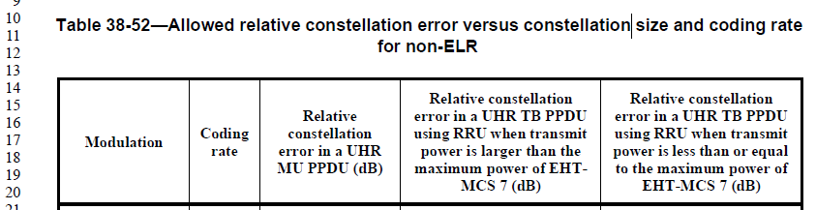
…

11bn D0.3 P342L13:
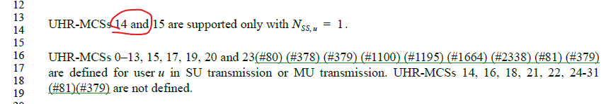

This document proposes text update to remove the above references to MCS 14.

Proposed Text Updates

Instruction to TGbn Editor: Update Table 38-52 on 11bn D0.3 P321 as shown below:
Table 38-52 – Allowed relative constellation error versus constellation size and coding rate for non-ELR
Modulation | Coding rate | Relative constellation error in a UHR MU PPDU (dB) | Relative constellation error in a UHR TB PPDU using RRU when transmit power is larger than the maximum power of UHR-MCS 7 (dB) | Relative constellation error in a UHR TB PPDU using RRU when transmit power is less than or equal to the maximum power of UHR-MCS 7 (dB)
BPSK | 1/2 | –5 | –13 | –27
QPSK | 1/2 | –10 | –13 | –27
QPSK | 2/3 | –12 | –13 | –27
QPSK | 3/4 | –13 | –13 | –27
16-QAM | 1/2 | –16 | –16 | –27
16-QAM | 2/3 | –18 | –18 | –27
16-QAM | 3/4 | –19 | –19 | –27
16-QAM | 5/6 | -20 | -20 | -27
64-QAM | 2/3 | –22 | –22 | –27
64-QAM | 3/4 | –25 | –25 | –27
64-QAM | 5/6 | –27 | –27 | –27
256-QAM | 2/3 | –29 | –29 | –29
256-QAM | 3/4 | –30 | –30 | –30
256-QAM | 5/6 | –32 | –32 | –32
1024-QAM | 3/4 | –35 | –35 | –35
1024-QAM | 5/6 | –35 | –35 | –35
4096-QAM | 3/4 | –38 | –38 | –38
4096-QAM | 5/6 | –38 | –38 | –38
BPSK-DCM (UHR-MCS 15) | 1/2 | –5 | –13 | –27
NOTE 1—The maximum power of UHR-MCS 7 can be measured by setting the UL Target Receive Power subfield as defined in Table 9-29j (UL Target Receive Power subfield in Trigger frame) in the Trigger frame to 127 for the RU for which the EVM test is conducted.
NOTE 2—N/A = not supported by the PPDU format.

Instruction to TGbn Editor: Update 11bn D0.3 P342L13 as shown below:

UHR-MCS 15 is supported only with N_{ss,u} = 1.

Straw Poll
Do you support to instruct the TGbn Editor to update the 11bn amendment with the proposed text updates specified in 11-25/1369r1 (removes residual text on MCS 14)?
[End of File]

