IEEE P802.11
Wireless LANs
MCS 14
Date: 2025-7-28
Author(s):
Name | Affiliation | Address | Phone | email
Youhan Kim | Qualcomm Technologies, Inc. |  |  | youhank@qti.qualcomm.com

Abstract
This submission proposes text update to clarify that MCS 14 is not used in UHR.

NOTE – Set the Track Changes Viewing Option in the MS Word to “All Markup” to clearly see the proposed text edits.

Revision History:

R0: Initial version.

Background

During comment resolution on CIDs 358, 361 and 3707, TGbn decided not to define MCS 14 in UHR – see https://mentor.ieee.org/802.11/dcn/25/11-25-0855-00-00bn-comment-resolution-for-38-5-parameters-of-uhr-mcs.docx

Further clean up of MCS 14 from the TGbn draft was done in https://mentor.ieee.org/802.11/dcn/25/11-25-0775-02-00bn-crs-on-new-mcss-for-subclause-38-5.docx.

However, there is still one location which states that UHR supports MCS 14.

11bn D0.3 P342L13:
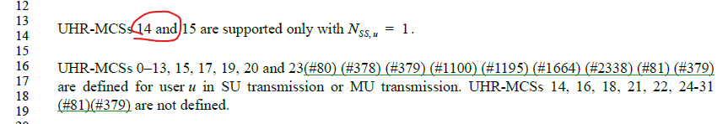

This document proposes text update to remove the above reference to UHR MCS 14.

Proposed Text Update

Instruction to TGbn Editor: Update 11bn D0.3 P342L13 as shown below:

UHR-MCS 15 is supported only with N_{ss,u} = 1.

[End of File]

