IEEE P802.11  
Wireless LANs

|  |  |  |  |  |
| --- | --- | --- | --- | --- |
| PDT WPT Energizer control | | | | |
| Date: 2025-07-28 | | | | |
| Author(s): | | | | |
| Name | Affiliation | Address | Phone | email |
| Ian Bajaj | Huawei |  |  | ian.bajaj@huawei.com |
| Yinan Qi | OPPO |  |  | v-qiyinan@oppo.com |
| Sanket Kalamkar | Qualcomm |  |  | sankal@qti.qualcomm.com |
| You-Wei Chen | MediaTek |  |  | you-wei.chen@mediatek.com |
|  |  |  |  |  |
|  |  |  |  |  |
|  |  |  |  |  |
|  |  |  |  |  |
|  |  |  |  |  |
|  |  |  |  |  |
|  |  |  |  |  |
|  |  |  |  |  |
|  |  |  |  |  |
|  |  |  |  |  |
|  |  |  |  |  |

Abstract

This document contains Proposed Draft Text (PDT) for the WPT Energizer Control of the proposed 11bp (AMP, Ambient Power) amendment to the 802.11 standard.

# Revision information

The following is a summary of the important changes that occurred within each revision of this document:

|  |  |
| --- | --- |
| **Revision** | **Major changes** |
| 0 | Initial revision |
| 1 | Revision based on feedback. Removed Supported Bands field, as current Motion #81 limits WPT transmission to S1G, and excitation to 2.4GHz band. |
| 2 | Addressed minor comments received during September 2nd TGbp teleconference call. |
| 3 | Addressed comments received during 16th September F2F (Highlighted in CYAN) |
| 4 | Addressed minor changes suggested by TTT members (Highlighted in GREEN) |
|  |  |

# Introduction

Interpretation of a Motion to Adopt

A motion to approve this submission means that the editing instructions and any changed or added material are actioned in the TGbp Draft. The abstract, revision information, introduction, explanation of the proposed changes and references sections are not part of the adopted material.

***Editing instructions formatted like this are intended to be copied into the TGbp Draft (i.e. they are instructions to the 802.11 editor on how to merge the text with the baseline documents).***

## Explanation of the proposed changes:

The proposed changes to the 802.11 TGbp draft within this document are based on the following motions adopted by the TGbp task group:

### Relevant passing motions [1]:

[Motion #34]

* IEEE 802.11bp defines an AMP Energizer that contains an Energizing Function, which is capable of transmitting WPT waveform and/or excitation waveform for backscattering operation. Additionally, the AMP Energizer may contain or be co-located (which one is TBD) with an IEEE 802.11 non-AMP non-AP STA.
* Note: WPT waveform is transmitted over sub1-GHz. Depending on whether the backscattering operation happens in sub1-GHz or 2.4GHz, accordingly the excitation waveform will be transmitted in the same band.

[Motion #35]

* IEEE 802.11bp defines a mechanism that allows control information to be sent by AMP AP STA to the AMP Energizer. The control information is TBD.

[Motion #53]

* Control information that is sent from the AMP AP to the AMP Energizer relating to the WPT waveform may include at least one or more of the following: Start Time, Duration, Interval, Transmit Power, and frequency related parameters.
* The frequency related parameters may include central frequency information, bandwidth information, etc.
* Note: Interval refers to a repetition of the WPT waveform.

[Motion #55]

* Energizer should report its WPT and excitation related capability to the AMP AP. The parameters to be reported are TBD.

[Motion #74]

* Control information that may be sent from the AMP AP to the AMP Energizer relating to the excitation signal includes one or more of the following: Start Time, Duration, Transmit Power and frequency related parameters.
* The frequency related parameters may include central frequency information, etc.

[Motion #81]

* IEEE 802.11bp defines at least the following capability parameters to be reported by the energizer to the AMP AP.
  + Whether or not support S1G WPT transmission
    - If supported, frequency related parameters for WPT. The frequency related parameters may include central frequency information, bandwidth information, etc.
  + Whether or not support 2.4G excitation waveform transmission.
  + Maximum Tx power.
  + Note: The energizer should at least support one of the following transmissions: S1G WPT transmission or 2.4G excitation waveform transmission

# Text to be adopted begins here:

***TGbp editor: Please add the following to subclause 9.4.2.x AMP Capabilities element to generate the 802.11bp draft D0.1:***

9.4.2.x AMP Capabilities element

The AMP Capabilities element is used to report Energizer capability parameters from the AMP Energizer to the AMP AP to support AMP operation. The AMP Capabilities element is shown in Figure 9-x1 (AMP Capabilities element format).

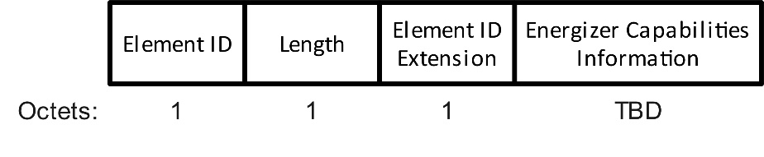

Figure 9-x1 – AMP Capabilities element format

The Element ID, Length, and Element ID Extension fields are defined in 9.4.2.1.

The Energizer Capabilities Information field of the AMP Capabilities element is shown in Figure 9-x2 (Energizer Capabilities Information field format).

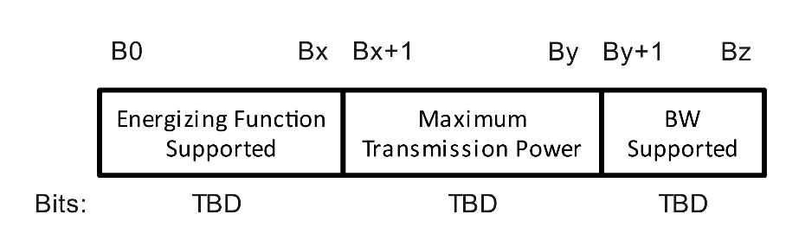

Figure 9-x2 – Energizer Capabilities Information field format

The Energizing Function Supported field of the Energizer Capabilities Information field is shown in Figure 9-x3 (Energizing Function Supported field format).

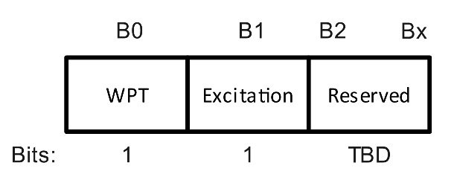

Figure 9-x3 – Energizing Function Supported field format

The WPT field of the Energizing Function Supported field is set to 1 if the AMP Energizer supports transmission of WPT in the S1G band; otherwise the WPT field is set to 0.

The Excitation field of the Energizing Function Supported field is set to 1 if the AMP Energizer supports transmission of the excitation signal in the 2.4 GHz band; otherwise the Excitation field is set to 0.

Other values of the Energizing Function Supported field are reserved.

The Maximum Transmission Power field of the Energizer Capabilities Information field indicates the maximum transmission power of the AMP Energizer in dBm. The BW Supported field of the Energizer Capabilities Information field indicates the bandwidths supported for WPT waveform transmission or excitation signal transmission.

***TGbp editor: Please add the following new subclause 39.7.2 WPT Energizer control to generate the 802.11bp draft D0.1:***

39.7.2 AMP Energizer control

The AMP Energizer shall support at least WPT or excitation signal transmission.

An AMP Energizer that is non-colocated with the AMP AP shall indicate its capability parameters to the AMP AP, which include at least, the support of WPT waveform transmission in a S1G band, the support of excitation signal transmission in a 2.4 GHz band, and the maximum transmission power.

The AMP AP shall transmit control information in a TBD 802.11 frame to the AMP Energizer that is non-colocated with the AMP AP, to manage the transmission of the WPT waveform and/or excitation signal.

The AMP AP shall include the start time of the WPT waveform or the excitation signal transmission in the control information sent to the AMP Energizer.

The AMP AP shall include the duration of the WPT waveform or the excitation signal transmission in the control information sent to the AMP Energizer.

The AMP AP may include the interval of the WPT waveform transmission in the control information sent to the AMP Energizer. The interval allows the AMP AP to schedule repeated transmissions of the WPT waveform at the specified time interval based on the start time of the WPT waverform transmission.

The AMP AP may include the transmission power of the WPT waveform or the excitation signal in the control information sent to the AMP Energizer. The indicated transmission power by the AMP AP shall not exceed the value indicated in the Maximum Tansmission Power field of the Energizer Capabilities Information field, shown in Figure 9-x2.

The AMP AP shall include frequency-related parameters corresponding to the transmission of the WPT waveform or the excitation signal in the control information sent to the AMP Energizer. The frequency-related parameters may include central frequency information when referring to WPT waveform or excitation signal transmission, and may include frequency band information when referring to WPT waveform. Other frequency-related parameters are TBD.

The AMP Energizer shall transmit WPT waveform or excitation signal based on the control information received from the AMP AP.

# Text to be adopted ends here.

**References:**

1. [11-24/1613r10](https://mentor.ieee.org/802.11/dcn/24/11-24-1613-10-00bp-specification-framework-for-tgbp.docx): 11-24-1613-10-00bp-specification-framework-for-tgbp, Yinan Qi (OPPO)