IEEE P802.11  
Wireless LANs

|  |  |  |  |  |
| --- | --- | --- | --- | --- |
| PDT WPT Energizer control | | | | |
| Date: 2025-07-28 | | | | |
| Author(s): | | | | |
| Name | Affiliation | Address | Phone | email |
| Ian Bajaj | Huawei |  |  | ian.bajaj@huawei.com |
| Yinan Qi | OPPO |  |  | v-qiyinan@oppo.com |
|  |  |  |  |  |
|  |  |  |  |  |
|  |  |  |  |  |
|  |  |  |  |  |
|  |  |  |  |  |
|  |  |  |  |  |
|  |  |  |  |  |
|  |  |  |  |  |
|  |  |  |  |  |
|  |  |  |  |  |
|  |  |  |  |  |
|  |  |  |  |  |
|  |  |  |  |  |

Abstract

This document contains Proposed Draft Text (PDT) for the WPT Energizer Control of the proposed 11bp (AMP, Ambient Power) amendment to the 802.11 standard.

# Revision information

The following is a summary of the important changes that occurred within each revision of this document:

|  |  |
| --- | --- |
| **Revision** | **Major changes** |
| 0 | Initial revision |
|  |  |
|  |  |
|  |  |
|  |  |
|  |  |

# Introduction

Interpretation of a Motion to Adopt

A motion to approve this submission means that the editing instructions and any changed or added material are actioned in the TGbp Draft. The abstract, revision information, introduction, explanation of the proposed changes and references sections are not part of the adopted material.

***Editing instructions formatted like this are intended to be copied into the TGbp Draft (i.e. they are instructions to the 802.11 editor on how to merge the text with the baseline documents).***

## Explanation of the proposed changes:

The proposed changes to the 802.11 TGbp draft within this document are based on the following motions adopted by the TGbp task group:

### Relevant passing motions [1]:

[Motion #35]

* IEEE 802.11bp defines a mechanism that allows control information to be sent by AMP AP STA to the AMP Energizer. The control information is TBD.

[Motion #53]

* Control information that is sent from the AMP AP to the AMP Energizer relating to the WPT waveform may include at least one or more of the following: Start Time, Duration, Interval, Transmit Power, and frequency related parameters.
* The frequency related parameters may include central frequency information, bandwidth information, etc.
* Note: Interval refers to a repetition of the WPT waveform.

[Motion #55]

* Energizer should report its WPT and excitation related capability to the AMP AP. The parameters to be reported are TBD.

[Motion #74]

* Control information that may be sent from the AMP AP to the AMP Energizer relating to the excitation signal includes one or more of the following: Start Time, Duration, Transmit Power and frequency related parameters.
* The frequency related parameters may include central frequency information, etc.

[Motion #81]

* IEEE 802.11bp defines at least the following capability parameters to be reported by the energizer to the AMP AP.
  + Whether or not support S1G WPT transmission
    - If supported, frequency related parameters for WPT. The frequency related parameters may include central frequency information, bandwidth information, etc.
  + Whether or not support 2.4G excitation waveform transmission.
  + Maximum Tx power.
  + Note: The energizer should at least support one of the following transmissions: S1G WPT transmission or 2.4G excitation waveform transmission

# Text to be adopted begins here:

***TGbp editor: Please add the following to subclause 9.4.2.x AMP Capabilities element to the 802.11bp draft D0.1:***

9.4.2.x AMP Capabilities element

The AMP Capabilities element is used to report capability parameters from the non-AP STA to the AMP AP to support AMP operation. The AMP Capabilities element is shown in Figure 9-x1.

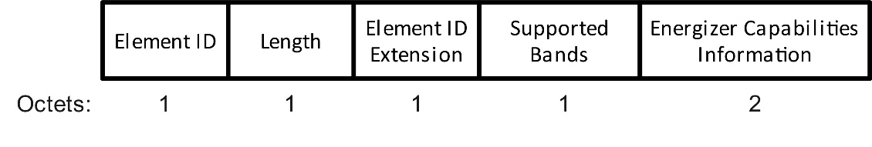

Figure 9-x1 – AMP Capabilities element format

The Element ID, Length, and Element ID Extension fields are defined in 9.4.2.1.

When the AMP Capabilities element is transmitted by an AMP Energizer, the Supported Bands field of the AMP Capabilities element indicates the supported bands for the WPT and/or excitation signal transmission. The Supported Bands field of the AMP Capabilities element is shown in Figure 9-x2.

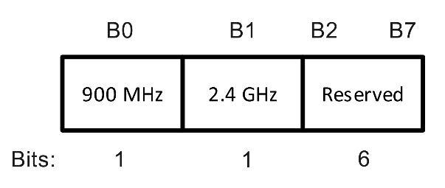

Figure 9-x2 – Supported Bands field format

The 900 MHz subfield of the Supported Bands field is set to 1, if the AMP Energizer supports the transmission of WPT and/or the excitation signal in the 900 MHz band. Otherwise, the 900 MHz subfield of the Supported Bands field is set to 0. The 2.4 GHz subfield of the Supported Bands field is set to 1, if the AMP Energizer supports the transmission of the excitation signal on the 2.4 GHz band. Otherwise, the 900 MHz subfield of the Supported Bands field is set to 0. The AMP Energizer must support transmission in at least the 900 MHz or 2.4 GHz band.

The Energizer Capabilities Information field of the AMP Capabilities element is shown in Figure 9-x3.

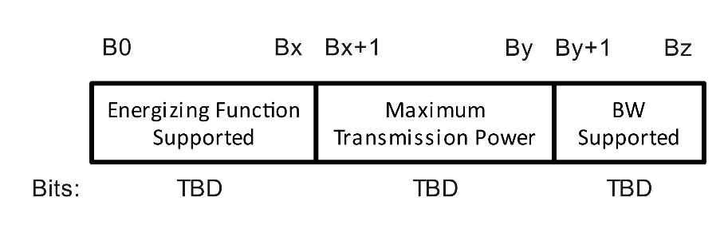

Figure 9-x3 – Energizing Capabilities Information field format

The Energizing Function Supported subfield of the Energizing Capabilities Information field is set as 0 to indicate the capability of the AMP Energizer to transmit the WPT waveform, and is set as 1 to indicate the capability of the AMP Energizer to transmit the excitation signal. The other bits of the Energizing Function Supported subfield are Reserved. The Maximum Transmission Power subfield of the Energizing Capabilities Information field indicates the maximum transmission power of the AMP Energizer in dBm. The BW Supported subfield of the Energizing Capabilities Information field indicates the supported bandwidths for WPT waveform transmission.

***TGbp editor: Please add the following new subclause 39.7.2 WPT Energizer control to the 802.11bp draft D0.1:***

39.7.2 WPT Energizer control

The AMP AP shall send control information to the AMP Energizer to control the transmission of the WPT waveform and/or excitation signal.

The AMP AP sets the start time of the WPT waveform or the excitation signal transmission in the control information sent to the AMP Energizer. The start time refers to the transmission time, and can be expressed as the partial TSF bits of the AMP AP’s TSF. The AMP AP may determine the start time for the AMP Energizer to transmit the WPT waveform, based on the charging needs of the non-AP AMP STAs in its BSS. The AMP AP may determine the start time for the AMP Energizer to transmit the excitation signal, based on the Backscatter PPDU format, which includes an excitation field to charge the non-AP AMP STA to receive the DL PPDU from the AMP AP, and a subsequent excitation field to backscatter the solicited UL response from the non-AP AMP STA.

The AMP AP sets the duration of the WPT waveform or the excitation signal transmission in the control information sent to the AMP Energizer. The AMP AP may determine the duration for the AMP Energizer to transmit the WPT waveform to adequately charge the non-AP AMP STA’s capacitor, or based on the WPT feedback from the non-AP AMP STA, described in 39.7.1. The AMP AP may determine the duration for the AMP Energizer to transmit the first excitation signal in the Backscatter PPDU to charge the non-AP AMP STA to receive the AMP-Sync and AMP-Data field from the AMP AP. The AMP AP may determine the duration for the AMP Energizer to transmit the second excitation signal in the Backscatter PPDU, ensuring that it is sufficiently long to backscatter the solicited response from the non-AP AMP STA. The duration of the excitation fields may be optimized based on the non-AMP AMP STA reported feedback to the AMP AP.

The AMP AP sets the interval of the WPT waveform transmission in the control information sent to the AMP Energizer. The interval allows the AMP AP to schedule repeated transmissions of the WPT waveform at the specified time interval based on the start time field, with a single control signal. The interval represents the time period from the start of the first transmission to the start of the subsequent transmission from the AMP Energizer. The interval may be set to 0 to indicate an implicit teardown of scheduled transmissions from the AMP Energizer.

The AMP AP sets the transmission power of the WPT waveform or the excitation signal in the control information sent to the AMP Energizer. The transmission power is represented in dBm. The AMP AP may determine the transmission power based on the maximum transmission power of the AMP Energizer indicated by the Energizer Capabilities Information field, shown in Figure 9-x3.

The AMP AP sets frequency parameters related to the transmission of the WPT waveform or the excitation signal in the control information sent to the AMP Energizer. The frequency related parameters may include the central frequency information when relating to the WPT waveform or excitation signal transmission, and may include the bandwidth information when relating to the WPT waveform. The other frequency related parameters are TBD.

The AMP Energizer shall report its capability parameters to the AMP AP, which include at least, the support of WPT waveform transmission, the support of excitation signal transmission, the supported operating band, i.e. Sub-1GHz, or 2.4GHz, and the maximum transmission power. The AMP Energizer shall support transmission of at least one of the WPT waveform or excitation signal.

# Text to be adopted ends here.

**References:**

1. [11-24/1613r10](https://mentor.ieee.org/802.11/dcn/24/11-24-1613-10-00bp-specification-framework-for-tgbp.docx): 11-24-1613-10-00bp-specification-framework-for-tgbp, Yinan Qi (OPPO)