IEEE P802.11
Wireless LANs
Miscellaneous PHY CIDs
Date: 2025-7-28
Author(s):
Name | Affiliation | Address | Phone | email
Youhan Kim | Qualcomm Technologies, Inc. |  |  | youhank@qti.qualcomm.com
Edward Au | Huawei |  |  | edward.ks.au@gmail.com

Abstract
This submission proposes resolutions to the following comments from CC50 on P802.11bn D0.1:

1629, 3302, 2284, 2772, 1154, 3560, 2283, 934

NOTE – Set the Track Changes Viewing Option in the MS Word to “All Markup” to clearly see the proposed text edits.

Revision History:

R0: Initial version.

CID 1629

CID  Clause  Page.Line | Comment | Proposed Change
1629  38.3.14  137.40 | Define Mathematical description of signals | as in comment
3371  38.3.18  204.27 | There is no new BW being introduced in UHR, so there is no need for a section for non-HT duplicate transmission. Just refer to EHT. | Delete the section 38.3.18 Non-HT duplicate transmission

Proposed Resolution: CID 1629
REVISED

Instruction to TGbn Editor:
Implement the proposed text updates for CID 1629 in https://mentor.ieee.org/802.11/dcn/25/11-25-1353-00-00bn-miscellaneous-phy-cids.docx.

Note to commenter:
11bn D0.3 already filled in 38.3.14.3 (Channel frequencies) and 38.3.14.4 (Transmitted signal).
Proposed resolution below fills in the remaining 38.3.14.1 (Notation) and 38.3.14.2 (Subcarrier indices in use).

Proposed Text Updates: CID 1629
Instruction to TGbn Editor: Update 11bn D0.3 P234L26 as shown below:
38.3.14 Mathematical description of signals
38.3.14.1 Notation

For a description of the conventions used for the mathematical description of the signals, see 17.3.2.5 (Mathematical conventions in the signal descriptions). In addition, the following notational conventions are used in Clause 38 (Ultra high reliability (UHR) PHY specification):
- [Q]_{m,n} indicates the element in row m and column n of the matrix Q, where 1 ≤ m ≤ N_{row} and 1 ≤ m ≤ N_{col}, with N_{row} and N_{col} being the number of rows and columns, respectively, of the matrix Q.
- [Q]_{m:n} indicates a matrix consisting of columns m to n of the matrix Q.

38.3.14.2 Subcarrier indices in use

For a description on subcarrier indices over which the signal is transmitted for non-HT, HT, and VHT PPDUs, see 21.3.7 (Mathematical description of signals). For a description on subcarrier indices over which the signal is transmitted for HE PPDUs, see 27.3.10 (Mathematical description of signals). For a description on subcarrier indices over which the signal is transmitted for EHT PPDUs, see 36.3.11 (Mathematical description of signals).
Subcarrier indices over which the signal is transmitted for UHR PPDUs are the same as those for EHT PPDUs (see 36.3.11 (Mathematical description of signals)).

CID 3302

CID  Clause  Page.Line | Comment | Proposed Change
3302  38.3.14.4  138.11 | Some of the equations can not read. | Correct the equation 38-2. Same for Equation 38-3~38-5, 38-7~38-10, 38-13, 38-24, 38-25, 38-32, 38-36 ~ 38-43, 38-51, 38-52, 38-55~38-58

Discussion

Example: 11bn D0.1 P138
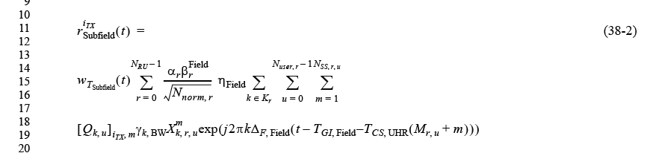

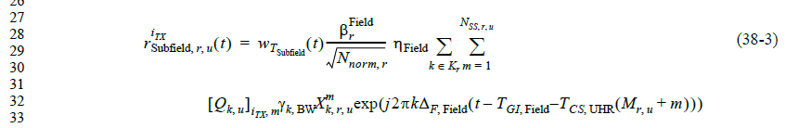

Equations seem quite legible.

Proposed Resolution: CID 3302
REJECTED

Equations seem quite legible, and it is not clear what the commenter meant by ‘equations can not read’.

CID 2284

CID  Clause  Page.Line | Comment | Proposed Change
2284  38.3.14.4  138.11 | Many parameters used in Equations (38-2) and (38-3) are not defined, and they are referred in the later subclauses. Please add the definitions. | As in comment

Discussion

Background: 11bn D0.1 P138
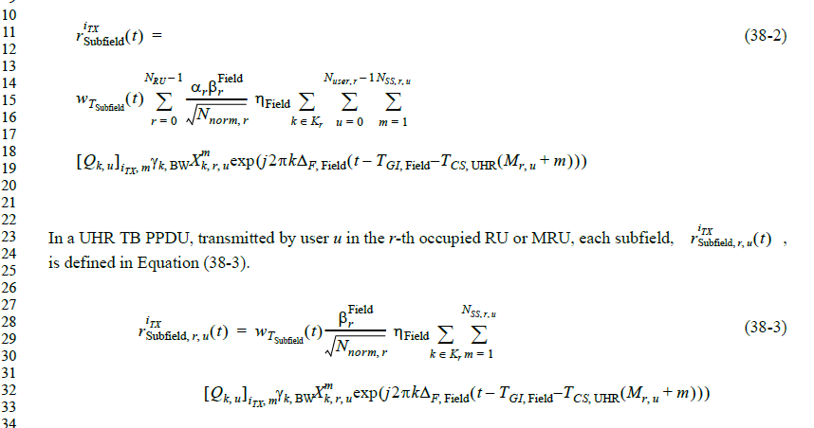

Note that 11bn D0.3 added definition for all the parameters used in these equations. See D0.3 P237-239.

Proposed Resolution: CID 2284
REVISED

Instruction to TGbn Editor:
No further text changes are needed as D0.3 already has the necessary text updates.

Note to commenter:
11bn D0.3 already added definition for the parameters used in Equations (38-2) and (38-3).

CID 2772, 1154

CID  Clause  Page.Line | Comment | Proposed Change
2772  38.3.14  138.23 | Add "or DRU" after "or MRU" | see comments
1154  38.3.14.4  139.23 | DRU can be used for TB PPDU. So, DRU also should be included in this sentence. | As the comment.

Background

Note that CID 1154 seems to be on D0.1 P138L23, not P139L23.

The text in 11bn D0.3 is on P237:

CID 2772 is REVISED rather than ACCEPTED because we need to delete “or” from “or MRU”.

Proposed Resolution: CIDs 2772, 1154
REVISED

Instruction to TGbn Editor:
Implement the proposed text updates for CIDs 2772 and 1154 in https://mentor.ieee.org/802.11/dcn/25/11-25-1353-00-00bn-miscellaneous-phy-cids.docx

Note to TGbn Editor:
CIDs 2772 and 1154 have the same resolution and text changes.

Note to commenter:
The proposed text updates adds DRU as suggested by the commenter.

Proposed Text Updates: CID 2772
Instruction to TGbn Editor: Update 11bn D0.3 P237L14 as shown below:
In a UHR TB PPDU, transmitted by user u in the r-th occupied RU, MRU or DRU, each subfield, , is defined in Equation (38-5).

CID 3560, 2283, 934

CID  Clause  Page.Line | Comment | Proposed Change
3560  38.3.14.4  138.23-38 | Missing spec | In HE and EHT TB-PPDU, L-STF and L-LTF, (R)L-SIG, and USIG/HE-SIGA, were allowed to be deboosted by up to sqrt(2).  Was the intention to disallow this in UHR as this is missing?  But then it should not specify eta_STF/LTF/LSIG to be potentially not 1 for TB-PPDU in the mathematical descriptions of those signals  Also mathematical description of TB-PPDU USIG is referred to EHT description (which by itself is not a good practice)
2283  38.3.14.4  138.29 | In equation (38-3), eta_Field should be "eta_preUHR". For UHR TB PPDU, the same scaling factor is applied to pre-UHR fields if the value is not 1, as in EHT TB PPDU. | As in comment
934  38.3.14.4  138.43 | eta_Field for TB PPDU is not 1. Add correct value for TB PPDU. | As in comment

Background

11bn D0.1 P138:
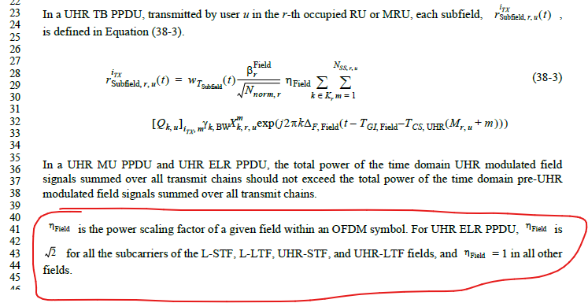

Commenters are all saying that ηField is not 1 for UHR TB PPDU, and the commenters are correct – see 11be D7.0 P799L32.

Note that 11bn D0.3 P239 already fixed this.
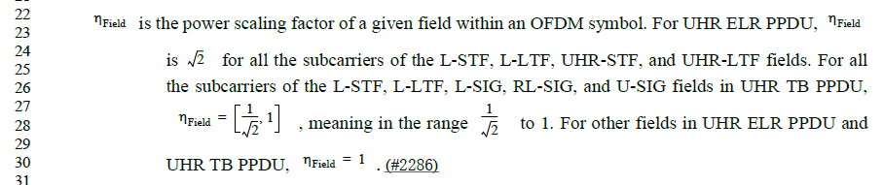

Proposed Resolution: CID 3560, 934
REVISED

Instruction to TGbn Editor:
No further text changes are needed as D0.3 already has the necessary text updates.

Note to commenter:
11bn D0.3 P239L26 already specifies that eta is not 1 for UHR TB PPDU.

Proposed Resolution: CID 2283
REVISED

Instruction to TGbn Editor:
No further text changes are needed as D0.3 already has the necessary text updates.

Note to commenter:
11bn D0.3 P239L26 already specifies that eta is not 1 for UHR TB PPDU. Furthermore, eta is also used for UHR-STF and UHR-LTF of UHR ELR PPDUs. Since UHR-STF and UHR-LTF are not pre-UHR modulated fields, the name proposed by the commenter “eta_preUHR” is not appropriate. Hence, the current name of “eta_Field” is kept.

[End of File]

