IEEE P802.11  
Wireless LANs

|  |  |  |  |  |
| --- | --- | --- | --- | --- |
| PDT No MCS 15 for UHR-SIG field | | | | |
| Date: July 25, 2025 | | | | |
| Author(s): | | | | |
| Name | Affiliation | Address | Phone | email |
| Ross Jian Yu | Huawei |  |  | ross.yujian@huawei.com |
| Ming Gan | Huawei |  |  |  |
|  | Huawei |  |  |  |
|  |  |  |  |  |
|  |  |  |  |  |

Abstract

This submission proposes a typo fixed for UHR-SIG MCS:

**Discussion:**

No MCS 15 for UHR-SIG field as shown below. But there is some typo for the text.

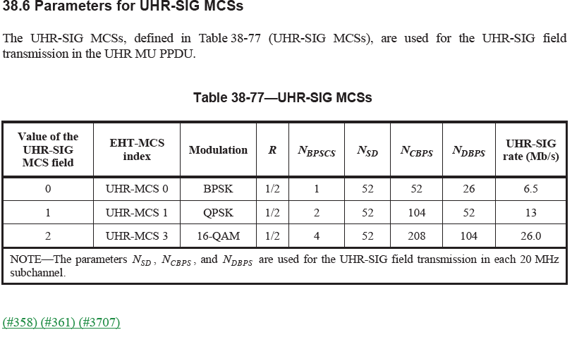

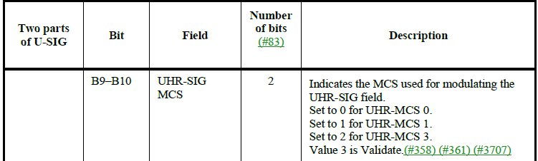

**TGbn editor, please make the changes on page 229 of draft IEEE P802.11bn D0.3.**

**38.3.12 UHR-SIG modulation and coding schemes (UHR-SIG-MCSs)**

The UHR-SIG-MCS is a compact representation of the modulation and coding used in the UHR-SIG field of

the UHR MU PPDU. The UHR-SIG modulation and coding scheme is carried in the UHR-SIG MCS field of

the U-SIG field in the UHR MU PPDU and supports UHR-MCS 0, UHR-MCS 1and UHR-MCS 3.

End of the document