IEEE P802.11
Wireless LANs
11be Bug Fix for Link Reconfiguration
Date: 2025-07-25
Author(s):
Name | Affiliation | Address | Phone | email
Binita Gupta | Cisco Systems |  |  | binitag@cisco.com
Brian Hart | Cisco Systems |  |  | brianh@cisco.com

Abstract
This submission proposes a bug fix to 802.11be D7.0 for link reconfiguration.

Revision History:

R0: Initial version.

Discussion:

The Basic ML element in the Link Reconfiguration Response frame carries complete profile in the Per-STA Profile subelement for added links, just like in the (Re)Assocaition Response frame for accepted links. Hence, in line 28 of following paragraph in clause 9.4.2.322.2.4 in 11be D7.0, the Link Reconfiguration Frame needs to be listed as well.

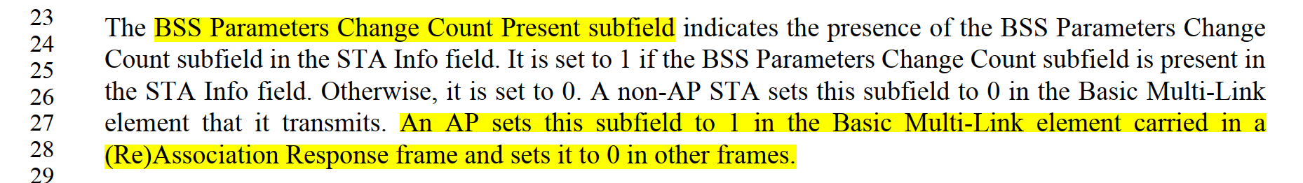

Need to revise the text to indicate that the AP sets the BSS Parameters Change Count Present subfield to 1 in a Per-STA Profile subelement that contains a complete profile. Then this description does not dependent on specific frames which could lead to similar bug in future.

Proposed Resolution:

REVISED

Instruction to TGmf Editor:
Implement the proposed text updates.

﻿9.4.2.322.2.4 Link Info field of the Basic Multi-Link element
TGmf Editor: Instruction: Modify 4th paragraph on page 260 of this clause in D7.0 as shown below:

﻿The BSS Parameters Change Count Present subfield indicates the presence of the BSS Parameters Change
Count subfield in the STA Info field. It is set to 1 if the BSS Parameters Change Count subfield is present in
the STA Info field. Otherwise, it is set to 0. A non-AP STA sets this subfield to 0 in the Basic Multi-Link
element that it transmits. An AP sets this subfield to 1 if the Complete Profile subfield is set to 1 in the STA Control field, and otherwise sets it to 0 .

