IEEE P802.11
Wireless LANs
CR for CID 2548: Shortening the Duration of P-EDCA Periods
Date: July 22, 2025
Author(s):
Name | Affiliation | Address | Phone | email
Behnam Dezfouli | Nokia  Technologies |  |  | Behnam.dezfouli@nokia.com
Mikhail Liubogoshchev
Klaus Doppler
Kerstin Johnsson

Abstract
This submission proposes the resolution to CID 2548 received for CC50 for 802.11bn.
The resolution proposed by this submission also applies to CIDs related to balancing the impact of P-EDCA on legacy STAs.

Revisions:
- Rev 0: Initial version of the document.
- Rev 1: Updated figure 2. Updated the proposed resolution to clarity the use of HPTO for initial transmission of DSCTS and its subsequent transmissions.

TGbn editor: Baselines for this document are P802.11bn D0.3, P802.11REVmeD7.0 and IEEE 802.11-25/0627r14.

Introduction

This submission proposes the resolution to CID 2548 received for CC50-802.11bn-D0.1, which is copied below for convenience:

CID | Commenter | Clause | Page, line | Comment | Proposed Change | Resolution
2548 | Behnam Dezfouli | 37.2 | 67, 25 | P-EDCA must minimize additional channel usage by avoiding extra frame transmissions (e.g., Defer Signal), particularly when the data to be sent is below a defined threshold. | Instead of transmitting a Defer Signal (along with RTS and CTS), a STA may use a shorter timeout duration to detect transmission failure and then compete for channel access again. If the channel is detected as idle during the timeout interval, the STA can immediately compete for channel access without waiting for a response frame.  However, if the channel is detected as busy, the STA must wait either to receive a frame or until the channel becomes idle. | Approved  Proposed text is provided which specifies that a STA sending RTS frame can wait for a shorter duration to detect transmission failure and send DS frame.  TGbn Editor: Please apply changes as marked as #2548.

Discussion

According to IEEE Std 802.11 [1] when a STA transmits a response-soliciting frame, such as an RTS frame that expects a response (e.g., CTS), it must wait for the duration of the CTS/ACK Timeout plus AIFS[AC] before reattempting channel access if the transmission fails. However, during periods of heavy, high-priority channel use, this waiting period can unnecessarily tie up valuable channel time, delaying attempts to regain access after a failed transmission. The problem is exacerbated during P-EDCA’s protected contention periods, where STAs eligible to use P-EDCA must complete their channel access as soon as possible to reduce the timing overhead of this mechanism and reduce the impact of P-EDCA on legacy devices.

In the proposed solution [2], we suggest allowing STAs operating during an EDCA period to bypass the standard ACK/CTS Timeout duration in favor of a shorter timeout called HPTO (High-Priority Timeout). This mechanism enables STAs to determine transmission failure more quickly and become eligible for channel access sooner. In this approach, when a STA transmits a response-soliciting frame, such as an RTS frame, the STA may attempt to access the channel again after waiting for HPTO, defined as aSIFSTime + aSlotTime, following the end of its frame. If the channel is sensed as idle during the HPTO interval, this indicates unsuccessful packet delivery. HPTO is designed to provide enough time for the receiving STA to process the incoming frame, switch to transmit mode, and begin sending a response. The additional aSlotTime after aSIFSTime allows the sender to perform carrier sensing (CCA) and prepare for possible retransmission. Notably, the sum of aSIFSTime and aSlotTime is equivalent to the PIFS (priority inter-frame space) described in Section 10.3.2.3.4 of the IEEE 802.11 standard [1].

Figure 1 compares failure detection with and without HPTO. Sub-figure (a) shows the time between the end of an RTS frame and the DS frame transmission without HPTO, while (b) shows this interval when HPTO is used.
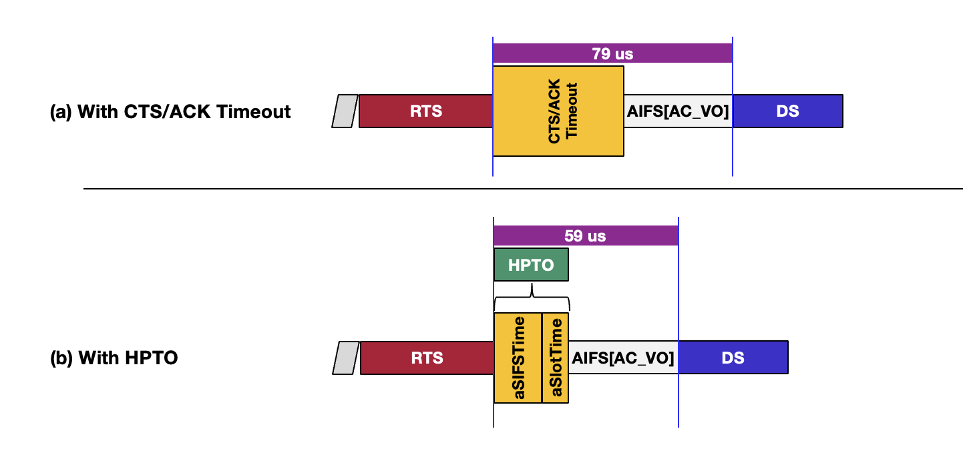
Figure 1: The use of HPTO for transmission failure detection results in faster utilization of P-EDCA protection contention periods by eligible STAs.

Figure 2 illustrates the utilization of HPTO prior to a STA transmitting its initial DS frame. It is assumed that a STA initiates P-EDCA contention by transmitting a DS frame when QSRC[AC_VO] equals a. When QSRC[AC_VO] is reduced to a - 1, and following the transmission of an RTS frame, the STA employs HPTO to assess whether the RTS frame transmission was unsuccessful. If the channel is detected as idle during the aSlotTime within HPTO, the STA proceeds to transmit a DS frame after AIFS.

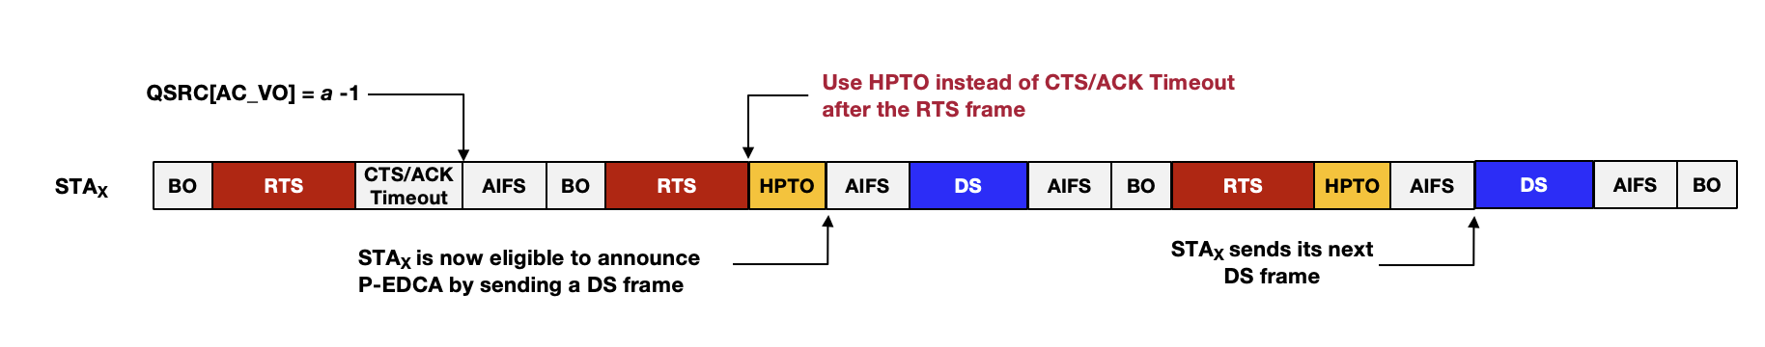
Figure 2: The use of HPTO for the transmission of the first and subsequent DS frames.

For more details about the proposed solution, please refer to [2].

Proposed Solution

Text to be adopted begins here:
TGbn editor: please make changes to the following subclause:
37.5 Prioritized EDCA
Prioritized EDCA (P-EDCA) is an enhancement of the EDCA mechanism (see 10.23.2 (HCF contention based channel access (EDCA)) that reduces the access delay distribution tail for (#856, #1426, #3436) AC_VO traffic (#2378, #3250, #477, #3355, #1483). The use of P-EDCA by a UHR STA balances the impact on STAs that do not support (#479) P-EDCA by the rules and restrictions that are defined below. (#186, #478, #858, #879, #1044, #2379, #2545, #1858, #1816, #1427, #1488, #2966, #3315, #3354, #3356, #3966, #479, #2548)
(#857, #1387, #1805, #2380, #2381, #2382, #2383, #2384, #2385, #2386, #1484, #1490) A STA that has dot11PEDCAOptionActivated equal to true is called a P-EDCA STA and shall set the P-EDCA Support subfield of the UHR MAC Capabilities Information field of the UHR Capabilities element to 1, otherwise the STA shall set the P-EDCA Support subfield to 0.
An AP that has enabled P-EDCA operation shall set the P-EDCA Enabled field in UHR operation element to 1.
P-EDCA STAs shall maintain a P-EDCA station retry counter, PSRC[AC_VO]. The initial value for PSRC[AC_VO] shall be 0. PSRC[AC_VO] shall be incremented by 1 with every transmission of the DSCTS frame. PSRC[AC_VO] shall be set to 0 when QSRC[AC_VO] is set to 0.
A P-EDCA STA may start a P-EDCA contention if all of the following conditions are satisfied:
- (#2644, # 2645, # 3944) P-EDCA is enabled by the AP in the BSS and the P-EDCA non-AP STA has notified the AP of its intent to use P-EDCA on the link.
- The P-EDCA STA has pending AC_VO buffered traffic
- QSRC[AC_VO] is equal or greater than dot11PEDCARetryThreshold and PSRC[AC_VO] is not greater than dot11PEDCAConsecutiveAttempt

When QSRC[AC_VO] ≥ dot11PEDCARetryThreshold – 1 and PSRC[AC_VO] < dot11PEDCAConsecutiveAttempt, a P-EDCA STA shall use the High-Priority Timeout (HPTO), defined as SIFS + aSlotTime, to detect the failure of an RTS frame transmission. If the channel is sensed as idle during the aSlotTime portion of the HPTO, the STA shall start the DSAIFS[AC_VO] duration at the end of the aSlotTime. If the channel remains idle throughout the entire period of HPTO + DSAIFS[AC_VO], the STA shall transmit a DSCTS frame at the end of DSAIFS[AC_VO]. If the channel is not sensed as idle during the aSlotTime portion of the HPTO, the P-EDCA STA uses the CTSTimeout method (see 10.23.2.4) instead of HPTO to determine RTS failure. (#2548)

To start the P-EDCA contention, the P-EDCA STA shall transmit [#339] a Defer Signal CTS (DS-CTS) frame.
The DSAIFS[AC_VO] is a duration derived from the relation:
DSAIFS[AC_VO] = aSIFSTime + (AIFSN + DSr) × aSlotTime
where AIFSN is 2 and DSr is an integer value chosen randomly with a uniform distribution taking values in the range 0 to CWds[AC_VO] for every transmission of DS-CTS frame. The transmission of the (#339) DS-CTS frame shall occur at the DSAIFS[AC_VO] slot boundary if the STA's CS mechanism (see 10.3.2.1 (CS mechanism)) determines that the medium is idle. The (#339) DS-CTS frame shall be transmitted in a non-HT PPDU or non-HT PPDU duplicate format, using 6 Mb/s data rate, and SCRAMBLER_INITIAL_VALUE is fixed. The RA field shall be set to the unicast MAC address with OUI 00:0F:AC and the remaining bits set by <ANA>, and the Duration field shall be set to the value of the P-EDCA contention duration in Table 37-1 (Default P-EDCA parameter set).
The P-EDCA contention shall start immediately after the end of the transmitted (#339) DS-CTS frame and shall follow the random backoff procedure defined in 10.23.2.4 (Obtaining an EDCA TXOP) except that:
- Only EDCAF[AC_VO] shall be allowed to contend during the P-EDCA contention. Operation of the other EDCAFs is suspended.
- (#341)The EDCAF[AC_VO] shall initialize AIFSN, CWmin, and CWmax with the values of PEDCA AIFSN, P-EDCA CWmin, and P-EDCA CWmax respectively. CW[AC_VO] shall be initialized to CWmin[AC_VO].
The EDCAF[AC_VO] shall set the backoff counter to an integer value chosen randomly with a uniform distribution taking values in the range 0 to CW[AC_VO].
- After each RTS frame transmission using P-EDCA backoff contention, and as long as PSRC[AC_VO] is less than dot11PEDCAConsecutiveAttempt, a P-EDCA STA shall use the HPTO method to detect the failure of the RTS transmission. If the RTS is considered failed, determined by sensing an idle channel during the aSlotTime portion of HPTO, the STA shall increment QSRC[AC_VO] and initiate the DSAIFS[AC_VO] duration at the end of the aSlotTime. If the medium remains idle throughout the entire period of HPTO + DSAIFS[AC_VO], the STA shall transmit the DSCTS frame at the end of DSAIFS[AC_VO]. However, if the channel is not sensed as idle during the aSlotTime portion of HPTO, the P-EDCA STA shall use the CTSTimeout method (see 10.23.2.4) instead of HPTO to determine RTS failure. (#2548)

Table 37-1 (Default P-EDCA parameter set) defines the default P-EDCA parameter used by a P-EDCA STA when the AP does not advertise a P-EDCA parameter set for the P-EDCA contention, for the transmission of a DS-CTS frame, and for the conditions to start P-EDCA. If the AP advertises P-EDCA parameter set for the parameters in Table 37-1 (Default P-EDCA parameter set), then the P-EDCA STA shall update the P-EDCA parameter set to the most recent received P-EDCA parameter set.
A P-EDCA STA that initiates a TXOP (see 10.23.2.4) during a P-EDCA contention shall transmit an RTS frame as initial frame in the TXOP (#1486, #1487).
Table 37-1 — [#M341] Default P-EDCA parameter set

AC | P-EDCA CWmin | P-EDCA CWmax | P-EDCA AIFSN | P-EDCA contention duration | CWds | P-EDCA PSRC threshold | P-EDCA QSRC threshold
AC_VO | 7 | 7 | 2 | 97 µs | 0 | 1 | 2
NOTE 1— The NAV set by the Duration field of the DS-CTS frame protects the medium for the maximum P-EDCA contention duration: aSifsTime + (AIFSN + CWMax) * aSlotTime. Hence, the values relate as follows: 97 µs = 16 µs + (2 + 7) × 9 µs
NOTE 2—The value of the P-EDCA contention duration is fixed and is not advertised by the AP

A P-EDCA STA that successfully (as defined in 10.23.2.2 EDCA Backoff procedure) delivered one or more pending MPDUs in a TXOP obtained during P-EDCA contention shall not start P-EDCA contention until conditions to start P-EDCA are satisfied. Additionally, the EDCAF[AC_VO] shall update AIFSN, CWmin, and CWmax with the values in dot11EDCATable (dot11QAPEDCATable for the AP) and an operation of EDCAF[AC_VI], EDCAF[AC_BE], EDCAF[AC_BK] is resumed.
NOTE 1—After successful delivery of one or more pending MPDUs the STA resets QSRC[AC_VO], therefore conditions to start P-EDCA contention are no longer satisfied.
A P-EDCA STA that participated in a P-EDCA contention but did not initiate a TXOP (see 10.23.2.4) during the P-EDCA contention or that initiated a TXOP but did not receive the CTS frame in response to the RTS frame used to initiate the TXOP may start another P-EDCA contention by sending the DS-CTS frame at DSAIFSN[AC_VO] slot boundary if the STA's CS mechanism (see 10.2.3.1 (CS mechanism)) determines that the medium is idle, for up to dot11PEDCAConsecutiveAttempt. If PSRC[AC_VO] reaches dot11PEDCAConsecutiveAttempt transmission attempts, the P-EDCA STA shall not attempt to start PEDCA contention until the QSRC[AC_VO] counter is reset and all the conditions to start P-EDCA defined in this subclause are satisfied. Additionally, the EDCAF[AC_VO] shall update the AIFSN, CWmin, and CWmax with the values in dot11EDCATable (dot11QAPEDCATable for the AP) and an operation of the EDCAF[AC_VI], EDCAF[AC_BE], EDCAF[AC_BK] is resumed.
NOTE 2—The STA follows the EIFS, HPTO, CTSTimeout, and NAVTimeout deferral rules before attempting to transmit a DSCTS to start a P-EDCA contention.
Note 3—A P-EDCA STA shall use the High-Priority Timeout (HPTO) instead of the CTSTimeout after transmitting an RTS frame, based on the values of QSRC[AC_VO] and PSRC[AC_VO], as described in this section. (#2548)

Text to be adopted ends here.

SP: Do you agree to incorporate the proposed text changes for P-EDCA in document 11-25/1167r1 into the latest TGbn draft?

References

[1] IEEE P802.11-REVme/D7.0, August 2024
[2] High-Priority Timeout for P-EDCA Operation, [online] https://mentor.ieee.org/802.11/dcn/25/11-25-0357-02-00bn-retry-timeout-adjustment-during-edca-periods.pdf

