IEEE P802.11  
Wireless LANs

|  |  |  |  |  |
| --- | --- | --- | --- | --- |
| CC50 CR for CIDs 2822 and 2823 – NPCA operation | | | | |
| Date: 2025-07-29 | | | | |
| Author(s): | | | | |
| Name | Affiliation | Address | Phone | email |
| Serhat Erkucuk | Ofinno | Reston, VA, 20190 |  | [serkucuk@ofinno.com](mailto:serkucuk@ofinno.com) |
| Jeongki Kim |  | [jkim@ofinno.com](mailto:jkim@ofinno.com) |
| Leonardo Lanante |  | [llanante@ofinno.com](mailto:llanante@ofinno.com) |
| Jiayi Zhang |  | [jzhang@ofinno.com](mailto:jzhang@ofinno.com) |
| Javier Perez-Ramirez |  | [JPerez-Ramirez@ofinno.com](mailto:JPerez-Ramirez@ofinno.com) |
| Mrugen Deshmukh |  | mdeshmukh@ofinno.com |
| Roya Doostnejad |  | rdoostnejad@ofinno.com |
| Safi Hoque |  | shoque@ofinno.com |

This document proposes resolution to the following CC50 CIDs (changes relative to D0.3):

2822, 2823

Revisions:

* Rev0: Initial version of the document.
* Rev1: Editorial: Fixing header

|  |  |  |  |  |  |
| --- | --- | --- | --- | --- | --- |
| **CID** | **Clause** | **Page.line** | **Comment** | **Proposed Change** | **Resolution** |
| 2822 | 37.10 | 78.39 | The draft spec defines an NPCA AP enabling a mode of operation in which untriggered UL transmissions on the NPCA primary channel by NPCA non-AP STAs is not permitted. This mode of operation is mainly for the NPCA AP to win the NPCA primary channel access. In this mode of operation, if an NPCA non-AP STA is not triggered by the NPCA AP (and if the NPCA primary channel is available), the NPCA non-AP STA should be able to perform untriggered UL transmissions on the NPCA primary channel after a time period. | Define a mechanism where an NPCA non-AP STA may perform untriggered UL transmissions on the NPCA primary channel after a time period, if not triggered by the NPCA AP and the NPCA primary channel is available. | **Revised**  Agree with the commenter in principle.  **TGbn editor, please incorporate changes tagged with #2822 in 11-25/1160r1.** |
| 2823 | 37.10 | 79.42 | The draft spec defines some rules when an NPCA STA switches to the NPCA primary channel for NPCA operation. The draft spec currently does not define conditions for switching back from NPCA primary channel to BSS primary channel. While it may be expected that an NPCA STA switches back to the BSS primary channel before the end of NAV duration on the BSS primary channel, NPCA AP should be able to extend its switch back duration beyond the NAV duration on the BSS primary channel in case NPCA AP has buffered low latency data, for example. | Define conditions where NPCA AP may switch back to the BSS primary channel after the OBSS NAV duration on the BSS primary channel. | **Revised**  Agree with the commenter in principle.  **TGbn editor, please incorporate changes tagged with #2823 in 11-25/1160r1.** |

**Discussion:**

1. **Performing untriggered UL transmissions on the NPCA primary channel after a time period**

If the untriggered UL transmission mode is disabled, an NPCA non-AP STA (i.e., NPCA STA) may only perform trigger-based UL transmissions after switching to the NPCA primary channel. When the untriggered UL transmission mode is disabled, there may be a likely scenario where an NPCA AP is observing a busy channel on the NPCA primary after switching (for example, despite the detected energy level by the NPCA AP being low, the NPCA AP may not be able to transmit a frame). Accordingly, the NPCA STA may not be able to transmit UL data despite the UHR AP may be able to receive it successfully.

By allowing an NPCA STA (i.e., UHR STA) perform untriggered UL transmissions on the NPCA primary channel after a time period (e.g., after a duration T), if the NPCA STA is not triggered by the NPCA AP and the NPCA primary channel is available, the NPCA STA may transmit its buffered data to the NPCA AP. This mode of operation may either be a modification to the existing mode of operation (i.e., disabling of untriggered UL transmissions mode) or a new mode of operation.

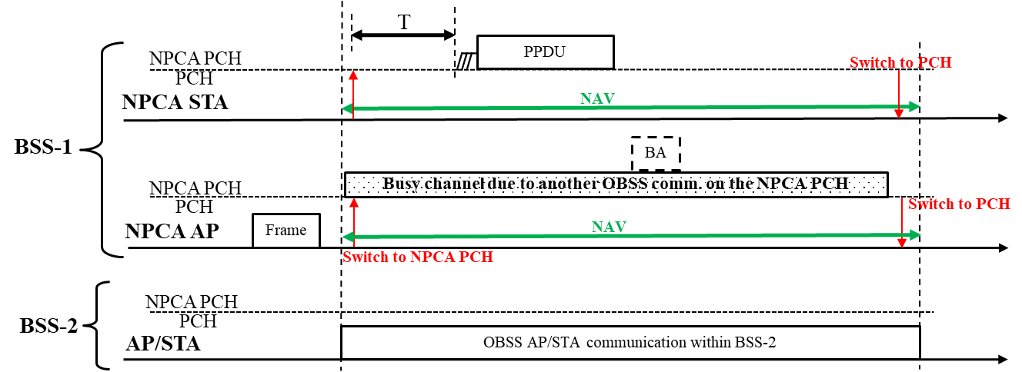

More details of the proposed resolution for CID 2822 can be found in 11-24/1853r1.

1. **Switching back to the BSS primary channel after OBSS NAV duration**

During NPCA operation, it is expected that the baseline for an NPCA AP/STA to switch back to the BSS primary channel should be an NPCA AP/STA switching back before the end of the OBSS NAV duration on the BSS primary channel. On the other hand, in a likely scenario where the NPCA AP may have buffered data (e.g., low latency data) to be transmitted to an NPCA non-AP STA (i.e., NPCA STA), the available/remaining duration on the NPCA primary channel may not be enough. Accordingly, without transmitting the low latency data, NPCA AP and NPCA STA may have to switch back to the BSS primary channel. If the NPCA AP cannot win the channel access on the BSS primary channel, then the low latency data may be discarded.

To solve the above mentioned problem, the following exception can be made. While an NPCA AP STA or a non-AP STA that has switched to the NPCA primary channel shall switch back to the BSS primary channel from the NPCA primary channel by the expiry of a timer (e.g., the timer may be based on the OBSS NAV duration), an NPCA AP may update the timer if the time required to transmit a specific category of data (e.g., low latency data) on the NPCA primary channel exceeds the OBSS NAV duration on the BSS primary channel.

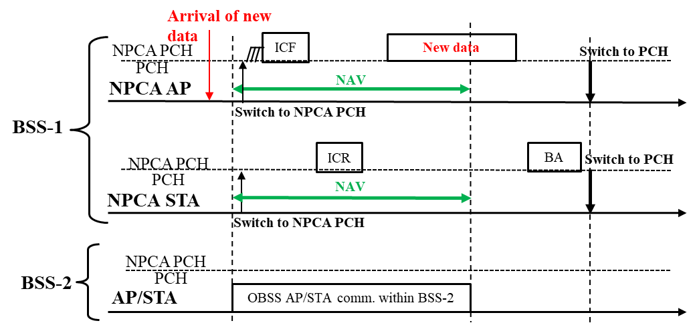

More details of the proposed resolution for CID 2823 can be found in 11-25/0138r0.

**Text to be adopted begins here.**

***TGbn editor: Please modify subclause 37.16 Non-primary channel access (NPCA) in D0.3 as follows:***

**37.16 Non-primary channel access (NPCA)**

…

The AP transmits a frame indicating disabling the use of untriggered UL transmissions by the associated non-AP STA for a time period, and a beacon frame indicating the time period. (#2822)

When an NPCA STA switches to the NPCA primary channel for NPCA operation, then the following rules apply:

1) …

2) …

3) …

4) Once the STA becomes ready to transmit on the NPCA primary channel, the STA may initiate a TXOP on the NPCA primary channel by following the rules defined in 10.23.2.2 (EDCA backoff procedure) and 10.23.2.4 (Obtaining an EDCA TXOP) with the following exceptions:

a. Each time that the STA switches to the NPCA primary channel, it shall initialize CW_NPCA[AC] to TBD value and randomly choose a new initial value between 0 and CW_NPCA[AC] for the backoff counter (BO_NPCA[AC]).

b. QSRC_NPCA[AC] shall be set to 0.

c. An AP may disable the use of untriggered UL transmissions on the NPCA primary channel by an associated non-AP STA for a time period. If the AP has disabled the use of untriggered UL transmissions on the NPCA primary channel for the associated non-AP STA, then the non-AP STA shall not initiate a TXOP on the NPCA primary channel during the time period. The non-AP STA sets a timer based on the time period and may initiate a TXOP on the NPCA primary channel when the timer expires, if the NPCA primary channel is available. The time period may be less than or equal to the duration obtained from the received inter-BSS PPDU. (#2822)

NOTE—The baseline EDCA procedure is followed on the BSS primary channel. The values of CW_NPCA[AC] and BO_NPCA[AC] are discarded by the NPCA STA when it switches back to the BSS primary channel.

5) …

6) …

7) …

8) The 20 MHz channels occupied by PPDUs transmitted by the STA shall meet all of the following conditions:

a. include at least the NPCA primary channel.

b. all be within the BSS bandwidth.

c. not include any of the channels occupied by the inter-BSS traffic that caused the STA to switch from the BSS primary channel to the NPCA primary channel.

d. not include channels that are indicated as punctured in the Disabled Subchannel Bitmap field in the EHT Operation element.

e. It is TBD whether a frame that solicits a response other than TB PPDUs can puncture 20 MHz subchannels not indicated as punctured in the Disabled Subchannel Bitmap field of the EHT Operation element.

An NPCA non-AP STA or an NPCA AP that has switched to the NPCA primary channel sets an NPCA_TIMER based on a duration obtained from the received inter-BSS PPDU. The NPCA non-AP STA or the NPCA AP switches back to the BSS primary channel from the NPCA primary channel when the NPCA_TIMER expires. Before the NPCA_TIMER expires, the NPCA AP may update the NPCA_TIMER based on the time required to transmit a specific category of buffered data (e.g., low latency buffered data) on the NPCA primary channel, if the required time exceeds a remaining portion of the duration obtained from the inter-BSS PPDU. (#2823)

**Text to be adopted ends here.**