IEEE P802.11  
Wireless LANs

|  |  |  |  |  |
| --- | --- | --- | --- | --- |
| CC50 CR for CIDs 2820 and 2821 – NPCA operation | | | | |
| Date: 2025-07-29 | | | | |
| Author(s): | | | | |
| Name | Affiliation | Address | Phone | email |
| Serhat Erkucuk | Ofinno | Reston, VA, 20190 |  | [serkucuk@ofinno.com](mailto:serkucuk@ofinno.com) |
| Jeongki Kim |  | [jkim@ofinno.com](mailto:jkim@ofinno.com) |
| Leonardo Lanante |  | [llanante@ofinno.com](mailto:llanante@ofinno.com) |
| Jiayi Zhang |  | [jzhang@ofinno.com](mailto:jzhang@ofinno.com) |
| Javier Perez-Ramirez |  | [JPerez-Ramirez@ofinno.com](mailto:JPerez-Ramirez@ofinno.com) |
| Mrugen Deshmukh |  | mdeshmukh@ofinno.com |
| Roya Doostnejad |  | rdoostnejad@ofinno.com |
| Safi Hoque |  | shoque@ofinno.com |

This document proposes resolution to the following CC50 CIDs (changes relative to D0.3):

2820, 2821

Revisions:

* Rev0: Initial version of the document.
* Rev1: Editorial: Fixing header

|  |  |  |  |  |  |
| --- | --- | --- | --- | --- | --- |
| **CID** | **Clause** | **Page.line** | **Comment** | **Proposed Change** | **Resolution** |
| 2820 | 37.10 | 78.50 | NPCA STA switching conditions depend on the STA receiving an OBSS PPDU. However, a STA not receiving the OBSS PPDU may not switch to the NPCA primary channel. For an efficient communication on the NPCA primary channel, there may be a mechanism needed for announcing to the NPCA non-AP STAs about NPCA AP's switching to the NPCA primary channel. | Define a mechanism for an NPCA AP to inform its associated NPCA non-AP STAs to switch from the PCH to the NPCA PCH after determining that a PPDU received via the PCH is an inter-BSS PPDU. | **Revised**  Agree with the commenter in principle.  **TGbn editor, please incorporate changes tagged with #2820 in 11-25/1159r1.** |
| 2821 | 37.10 | 79.43 | If an OBSS AP terminates the communication before the end of the NAV duration, a UHR STA being on the NPCA primary channel may not switch to the BSS primary channel before the end of the NAV duration (since it does not know about the TXOP truncation) and may not contend for the BSS primary channel. When the UHR AP switches back to the BSS primary channel by the end of the NAV duration and contends for the channel, it may not obtain the primary channel access. Another related problem may occur if an associated STA of the UHR AP, which has not switched to the NPCA primary channel, may obtain the primary channel access (after TXOP truncation), transmit a frame to the UHR AP and may not receive a response from the UHR AP that is operating on the NPCA primary channel. These two problems may occur due to TXOP truncation on the BSS primary channel when NPCA operation is enabled. | Define a mechanism for an NPCA AP to negotiate with an OBSS AP (UHR AP) for the OBSS AP either not to truncate TXOP on the BSS primary channel, or a mechanism for an OBSS AP (a UHR AP) to inform the NPCA AP of TXOP truncation on the BSS primary channel, if the NPCA AP has enabled NPCA operation. | **Revised**  Agree with the commenter in principle.  **TGbn editor, please incorporate changes tagged with #2821 in 11-25/1159r1.** |

**Discussion:**

1. **Mechanism for informing NPCA non-AP STAs of NPCA AP’s switching to NPCA primary channel**

When an NPCA AP detects an inter-BSS PPDU, it switches from the BSS primary channel to the NPCA primary channel. NPCA AP may have buffered traffic for a NPCA non-AP STA (i.e., NPCA STA). If the NPCA STA is outside the communication range of BSS2, NPCA STA may not hear the inter-BSS PPDU and stays on the BSS primary channel. NPCA AP may not be able to transmit the buffered traffic to NPCA STA.

As one solution, after detecting an inter-BSS PPDU, NPCA AP transmits an indication to NPCA STA (or to all NPCA non-AP STAs) on the BSS primary channel using spatial reuse (or with lower transmit power) to inform NPCA STA to switch from the BSS primary channel to the NPCA primary channel, before switching to the NPCA primary channel. NPCA AP may adjust its transmit power based on prior information of whether each NPCA non-AP STA is hearing the OBSS AP (e.g., AP2) or not. After switching to the NPCA primary channel, if untriggered UL transmission mode is disabled, NPCA AP may then communicate with NPCA STA.

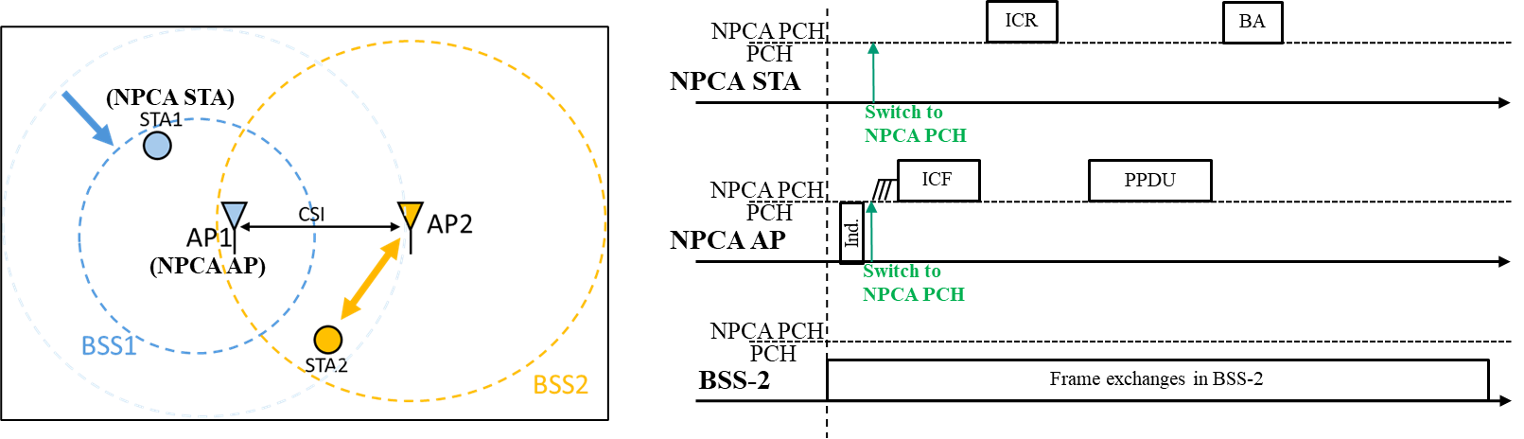

More details of the proposed resolution for CID 2820 can be found in 11-24/1852r1.

1. **Regarding TXOP truncation on the BSS primary channel during NPCA operation**

An NPCA AP that switched to the NPCA primary channel does not switch back to the BSS primary channel before the end of the OBSS NAV duration. If the OBSS AP terminates the TXOP on the BSS primary channel before the end of the OBSS NAV duration, a STA (e.g., a legacy STA) associated with the NPCA AP and that has not switched to the NPCA primary channel may reset its basic NAV on the BSS primary channel and may attempt to communicate with the NPCA AP. However, as the NPCA AP is still on the NPCA primary channel, the STA will not receive a response from the NPCA AP. Also, as another problem, when the NPCA AP switches back to the BSS primary channel by the end of the OBSS NAV duration, NPCA AP may not be able to access the BSS primary channel (e.g., due to another STA having already accessed the channel right after the TXOP truncation).

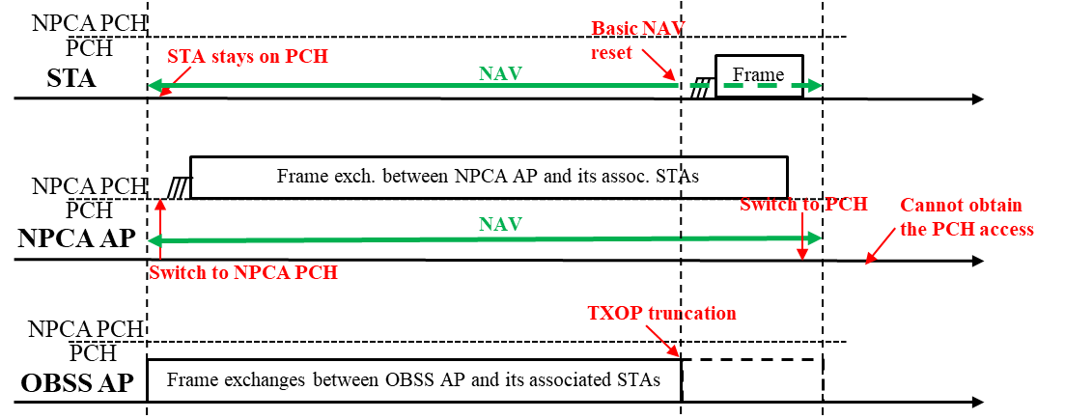

Two possible solutions to this problem can be:

1. OBSS AP does not perform TXOP truncation on the BSS primary channel if a neighboring NPCA AP has enabled NPCA operation.

* The OBSS AP and the NPCA AP may negotiate this operation.
* NPCA AP may transmit a frame indicating that it has enabled NPCA operation. OBSS AP learns that the NPCA AP has enabled NPCA operation based on the frame.

1. OBSS AP may inform NPCA AP of TXOP truncation on the BSS primary channel.

* Informing may be before or after truncation of the TXOP.
* Informing may be via the NPCA primary channel (if the NPCA primary channel is idle) or via a reserved channel.

Since OBSS AP informing NPCA AP of TXOP truncation (i.e., Solution-2) has its own challenges including transmission over the NPCA primary channel or unavailability of a reserved channel, Solution-1 may be a more feasible resolution.

More details of the proposed resolution for CID 2821 can be found in 11-24/1852r1.

**Text to be adopted begins here.**

***TGbn editor: Please modify subclause 37.16 Non-primary channel access (NPCA) in D0.3 as follows:***

**37.16 Non-primary channel access (NPCA)**

…

An NPCA STA may switch to the NPCA primary channel for NPCA operation if the value of the most recently received or transmitted NPCA Operation Information Present field corresponding to the BSS of which it is a member is equal to 1 and either condition 1) or 2) is met:

1) the STA received a PPDU and/or received a PHY-RXSTART.indication primitive for an HE/EHT/UHR PPDU on the BSS primary channel and all of the following conditions are true:

a. the PPDU is classified by the STA as an inter-BSS PPDU following the procedure defined in 26.2.2 (Intra-BSS and inter-BSS PPDU classification).

b. the duration of the PPDU, (determined by the MAC in a manner TBD, but necessarily involving some of the parameters of the RXVECTOR associated with the received PPDU) or the duration of the PPDU plus the value of the RXVECTOR parameter TXOP_DURATION of the PPDU, is greater than the value indicated in the most recently received or transmitted NPCA Minimum Duration Threshold field corresponding to the BSS of which it is a member.

i) whether the RXVECTOR parameter TXOP_DURATION of the PPDU is considered for this comparison and whether it is indicated by the AP is TBD.

c. the 20/40/80/160 MHz channel occupied by the PPDU is identified by the STA, based on the Bandwidth field in the PHY preamble of the PPDU and the channel allocations in the corresponding band, and the channel occupied by the PPDU does not overlap with the NPCA primary channel.

d. TBD conditions.

2) the STA received a PPDU containing a Control frame and a PPDU containing an initial response frame of a Control frame exchange on the BSS primary channel and all of the following conditions apply:

a. the received PPDU(s) are classified by the STA as inter-BSS PPDU(s) following the procedure defined in 26.2.2 (Intra-BSS and inter-BSS PPDU classification).

b. the TXOP duration, determined from the Duration field of the received frame(s), is greater than the value indicated in the most recently received or transmitted NPCA Minimum Duration Threshold field corresponding to its BSS.

i) Whether the RXVECTOR parameter TXOP_DURATION of the received PPDU(s) are considered for this comparison is TBD.

c. the 20/40/80/160 MHz channel occupied by the received PPDU(s), identified by the STA based on the channel allocations in the corresponding band and the PPDU bandwidth that is signaled in the received PPDU(s) or obtained from the RXVECTOR parameter CH_BANDWIDTH_IN_NON_HT of the received PPDU(s), does not overlap with the NPCA primary channel.

i) if the Control frame is an RTS frame in a non-HT (duplicate) PPDU, then it includes a bandwidth signaling TA and the signaled PPDU bandwidth is 20 MHz, 40 MHz, 80 MHz, or 160 MHz.

ii) identification of the channel occupied by a received CTS frame in a non-HT (duplicate) PPDU is determined by examining the RTS frame or the MU-RTS frame that elicited the CTS response.

d. TBD conditions.

Before switching from the BSS primary channel to the NPCA primary channel, an NPCA AP may transmit an NPCA switching request frame using spatial reuse (e.g., OBSS PD-based spatial reuse) to request its associated NPCA non-AP STAs to switch from the BSS primary channel to the NPCA primary channel. The AP shall switch from the BSS primary channel to the NPCA primary channel after transmitting the NPCA switching request frame. (#2820)

On receiving the NPCA switching request frame, the NPCA non-AP STA may switch from the BSS primary channel to the NPCA primary channel if the value of the most recently received or transmitted NPCA Operation Information Present field corresponding to the BSS of which it is a member is equal to 1. (#2820)

An NPCA AP may send a request to an OBSS AP (e.g., another NPCA AP) for the OBSS AP not to truncate its TXOP on the BSS primary channel if the NPCA AP has enabled NPCA operation. (#2821)

The OBSS AP may send a response accepting or rejecting the request from the NPCA AP. If the OBSS AP accepts the request, the OBSS AP should not truncate its TXOP on the BSS primary channel when it receives the frame indicating that the NPCA AP has enabled NPCA operation. (#2821)

**Text to be adopted ends here.**