IEEE P802.11  
Wireless LANs

|  |  |  |  |  |
| --- | --- | --- | --- | --- |
| CC50 CR on CID 866 | | | | |
| Date: July 17, 2025 | | | | |
| Author(s): | | | | |
| Name | Affiliation | Address | Phone | email |
| Ross Jian Yu | Huawei |  |  | ross.yujian@huawei.com |
| Ming Gan | Huawei |  |  |  |
|  |  |  |  |  |
|  |  |  |  |  |
|  |  |  |  |  |

Abstract

This submission proposes resolution for CID 866:

1 CID: CID 866

Revisions:

* Rev 0: Initial version of the document.

## CID 866

|  |  |  |  |  |
| --- | --- | --- | --- | --- |
| **Page** | **Clause** | **Comment** | **Proposed Change** | **Resolution** |
| 0.00 | 37.8.2.3 | Only 37.8.2.3 has the acronym in the subclause title. Unify the description under 37.8.2. | As in comment | Revised  Specify the changes. Make the subclause title consistent by using full name (abbreviation) style.  TGbn editor, please make the changes as shown in 11-25/1151r0 |

**Discussion**

In the current multi-AP coordination schemes, two of them are with full name and abbreviations, and two of them are with full name only.

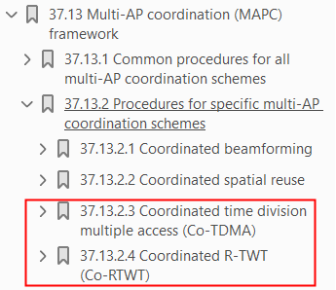

**Discussion ends**

***TGbn editor, please make the changes as shown below to the subclause titles of 37.13.2 Procedures for specific multi-AP coordination schemes on page 133, line 25 and line 39 of Draft P802.11bn D0.3.***

**37.13.2.1 Coordinated beamforming (Co-BF)(#866)**

**37.13.2.2 Coordinated spatial reuse (Co-SR) (#866)**

End of the document