IEEE P802.11  
Wireless LANs

|  |  |  |  |  |
| --- | --- | --- | --- | --- |
| PDT MAC CR for PUO CID 269 | | | | |
| Date: 2025-06-26 | | | | |
| Author(s): | | | | |
| Name | Affiliation | Address | Phone | email |
| Yongsen Ma | Samsung |  |  | yongsen.ma@samsung.com |
| Srinivas Kandala | Samsung |  |  | srini.k1@samsung.com |
| Michail Koundourakis | Samsung |  |  | m.koundou@partner.samsung.com |
| Zhanjing Bao | TCL |  |  | baozhanjing@gmail.com |
|  |  |  |  |  |
|  |  |  |  |  |

Abstract

This document contains proposed resolutions to the following CID received on 802.11bn D0.1:

269

**Revisions:**

* Rev 0: Initial version of the document.

***TGbn editor: Baseline for this document is 11bn D0.3***

|  |  |  |  |  |  |
| --- | --- | --- | --- | --- | --- |
| **CID** | **Commenter** | **Page** | **Comment** | **Proposed Change** | **Resolution** |
| 269 | Zhanjing Bao | 83.52 | Considering that the AP cannot serve its associated STAs during periods of being unavailable, it should be allowed to perform periodic power saving operations by either becoming completely doze or maintaining a lower capability mode. In other words, the AP should be permitted to periodically enter a lower capability mode. | Indicate the AP's periodic lower capability mode power saving operation through the TWT element. | Revised: agree with the commenter in general.  To editor: please apply the changes marked with #269 in this document. |

### **Discussions**

### ****Background****

Draft P802.11bn D0.3 [1] defines periodic unavailability operation (PUO) mode for AP:

* Inside of broadcast TWT SPs: the AP is available
* Outside of broadcast TWT SPs: the AP is in unavailable

During Comment Collection on D0.1 [2], CID 269 was received on AP PUO mode:

* “Indicate the AP's periodic lower capability mode power saving operation through the TWT element.”

The CID is rejected in the comment resolution document [25/0508](https://mentor.ieee.org/802.11/dcn/25/11-25-0508-02-00bn-d0-1-cc-subclause-37-11-3.docx) [3].

### ****Revised Resolutions****

This document presents the following revised resolutions for CID 269 on AP PUO mode:

* An APPUO AP may operate in a lower capability mode with reduced bandwidth or limited capability outside of broadcast TWT SPs.
* If an APPUO AP is also a DPS AP, the AP may operate in lower capability mode with DPS enabled outside of broadcast TWT SPs.

### Examples

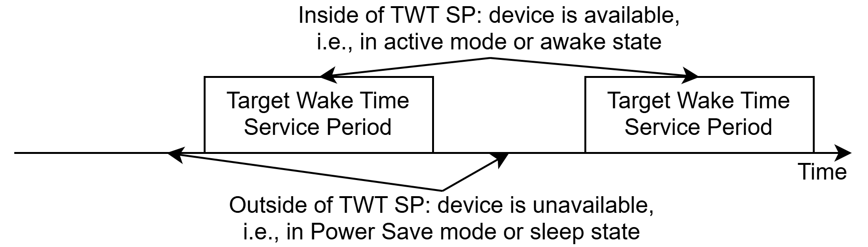

Figure 1 AP PUO mode in 11bn D0.3

Figure 1 shows the AP PUO mode in 11bn D0.3 [1] before the revised resolutions:

* Outside of TWT SPs: in Power Save mode or sleep state
  + the AP is unavailable and not able to receive or transmit
* Inside of TWT SPs: in active mode or awake state

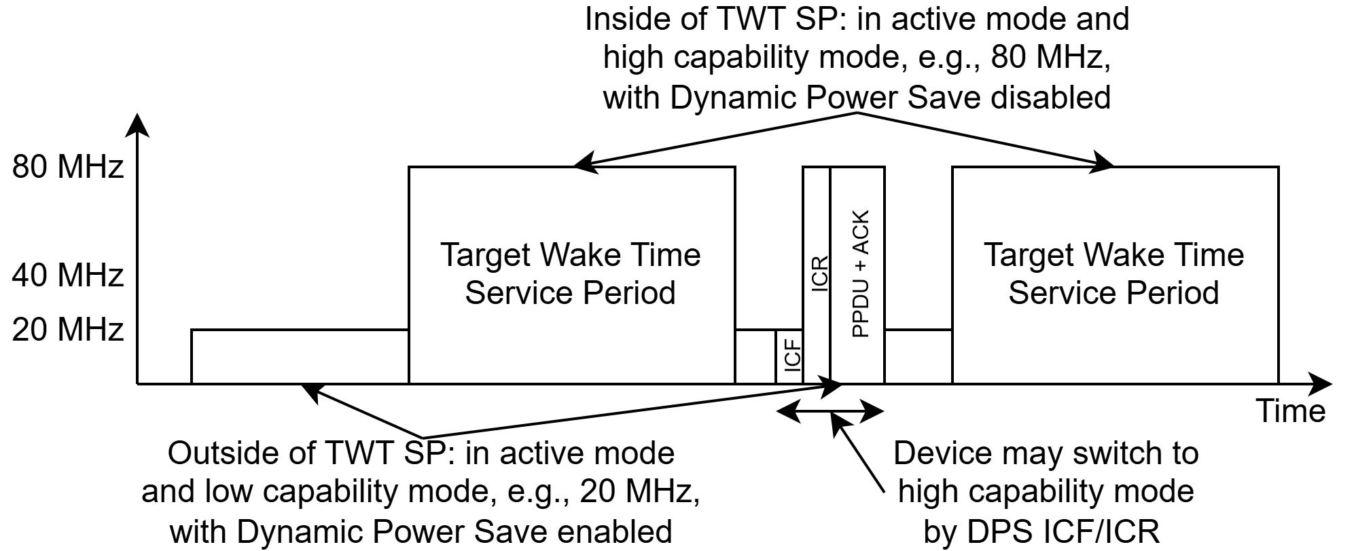

Figure 2 AP PUO mode with the proposed changes

Figure 2 shows an example for the AP PUO mode with the revised resolutions:

* Outside of TWT SPs: in a lower capability mode on the primary 20MHz channel
  + The AP is able to receive and transmit
  + The AP may enable DPS: STAs may tranition to higher capability mode after ICF
* Inside of TWT SPs: in active mode on the whole bandwidth of 80MHz
  + STAs can operate in high capability mode without ICF/ICR/IFCS/padding or capability switching operations
* When there are legacy STAs, the AP may
  + disable AP PUO mode,
  + use TWT/OMN/OMI to indicate certain legacy STAs, e.g., 11ax/11be, to transition to lower capability mode,
  + adjust TWT parameters to operate in only one capability mode by default regardless of service periods,
  + or decline subscription to broadcast TWT to a legacy STA if the TWT SP involves DPS or PUO.

More details and examples are presented in [25/0578](https://mentor.ieee.org/802.11/dcn/25/11-25-0578-00-00bn-twt-based-ap-power-save.pptx) [4].

### Signaling Options

Requirements:

* Need to indicate that broadcast TWT SPs are associated with certain capability modes.
* If AP PUO and DPS are both supported, e.g., for mobile AP: need to indicate that DPS is enabled/disabled outside of broadcast TWT SPs.
* Need to indicate the lower capability mode.

Options:

* Indicate that a TWT is associated with certain capability modes and/or DPS enabled/disabled for AP PUO mode: [4]
  + Reuse Broadcast TWT Recommendation field of the TWT element to indicate that the TWT is associated with certain capability mode. Values 5-7 are reserved.
  + Reuse Control field or B-TWT Info field of the TWT Information Extension element to indicate that the TWT is associated with certain capability mode. B1-B7 of Control field and B5-B7 of B-TWT Info field are reserved.
  + Other options.
* Indicate the lower capability mode: can reuse the lower capability mode of DPS.

Table 1 Summary of signaling options for AP PUO mode

|  |  |  |
| --- | --- | --- |
| Mode | Element/field | Notes (underlined red texts are proposed options) |
| AP PUO mode | UHR Capabilities element | AP PUO Support (802.11bn D0.3) |
| TWT element | Responder PM Mode = 1 and Broadcast TWT ID = 0 for AP PUO (802.11bn D0.3) |
| Option 1: TWT element | **Option 1.a: Broadcast TWT Recommendation field**  Broadcast TWT Recommendation field = 5: lower capability mode outside of broadcast TWT SPs  Broadcast TWT Recommendation field = 6: lower capability mode with DPS enabled outside of broadcast TWT SPs |
| **Option 1.b: Broadcast TWT Recommendation field + existing field**  Broadcast TWT Recommendation field = 5: indicating the broadcast TWT SP is for PUO,  and reuse existing field, such as Broadcast TWT ID, to indicate lower capability mode/DPS enabled outside of broadcast TWT SPs |
| **Option 1.c: Broadcast TWT Recommendation field + new field**  Broadcast TWT Recommendation field = 5: indicating the broadcast TWT SP is for PUO,  and define PUO Operation Parameters element/field to indicate lower capability mode/DPS enabled outside of broadcast TWT SPs |
| Option 2: TWT Information Extension element (used for TDLS in 802.11be) | **Option 2.a: Control field**  B1=1: lower capability mode outside of broadcast TWT SPs  B2=1: lower capability mode with DPS enabled outside of broadcast TWT SPs |
| **Option 2.b: B-TWT Info field**  B5=1: lower capability mode outside of broadcast TWT SPs  B6=1: lower capability mode with DPS enabled outside of broadcast TWT SPs |
| DPS mode | UHR Capabilities element (802.11bn D0.3) | DPS Assisted Support |
| DPS Assisting Support |
| UHR Operation element (802.11bn D0.3) | DPS Enabled – Specify DPS Enabled only covers inside of broadcast TWT SPs for AP PUO mode |
| DPS Operation Parameters – Reuse the definition of lower capability mode of DPS and apply it for AP PUO mode |

### Summary

The proposed resolutions enable an AP/non-AP STA to operate in lower capability outside/inside specific service periods and provide enhancements to PUO and DPS:

* Enhancements on DPS mode (Motion #9) [5]:
  + STA has the option to transition between lower capability mode and higher capability mode based on certain service periods, in addition to relying on ICF/ICR/IFCS/padding when operating in DPS mode.
  + STA may enable or disable DPS along with the transition between lower capability mode and higher capability mode based on specific service periods.
* Enhancements on AP PUO mode (Motion #161) [5]:
  + AP has the option to be in lower capability mode outside of broadcast TWT SPs, in addition to the Power Save mode of the AP PUO mode of D0.3.
  + AP has the option to adjust the TWT parameters, optionally with other mechanisms such as OMN/OMI, to accommodate legacy STAs.

References

[1] IEEE P802.11bn/D0.3

[2] <https://mentor.ieee.org/802.11/dcn/25/11-25-0296-24-00bn-ieee-802-11bn-cc50-comments-on-d0-1.xlsx>

[3] <https://mentor.ieee.org/802.11/dcn/25/11-25-0508-02-00bn-d0-1-cc-subclause-37-11-3.docx>

[4] <https://mentor.ieee.org/802.11/dcn/25/11-25-0578-00-00bn-twt-based-ap-power-save.pptx>

[5] <https://mentor.ieee.org/802.11/dcn/24/11-24-0209-15-00bn-specification-framework-for-tgbn.docx>

* AP PUO mode

AP PUO mode allows a UHR AP to manage activity in the BSS, composed of STAs that support this feature, by defining service periods, and to either save power or use internal resources elsewhere by allowing the UHR AP to be unavailable to all associated UHR STAs outside of these service periods. A UHR AP supporting AP periodic unavailability operation mode is called a (name TBD) AP and shall set TBD field in the TBD Capabilities element it transmits to 1. A UHR STA supporting operation with a (name TBD) AP is called a TBD Supporting non-AP STA and shall set the TBD field of the TBD Capabilities element that the AP transmits to 1.

To be unavailable outside of broadcast TWT SPs, a TBD AP shall ensure that all associated STAs support the mechanism and shall follow the rules defined in 26.8.3.2 (Rules for TWT scheduling AP) by advertising a TWT element that carries one or more Broadcast TWT Parameter Set fields with a Broadcast TWT ID field set to 0, a Responder PM Mode subfield equal to 1 and an NDP Paging Indicator/Unavailability Mode subfield that is set to either 0 or 1. A (name TBD) Supporting non-AP STA that intends to exchange frames with the (name TBD) AP shall follow the rules defined in 26.8.3.3 (Rules for TWT scheduled STA).

An APPUO AP may operate in a lower capability mode with reduced bandwidth or limited capability outside of broadcast TWT SPs. To operate in a lower capability mode outside of broadcast TWT SPs, an APPUO AP shall set [insert option 1.b]. If an APPUO AP is also a DPS AP, the AP may set [insert option 1.b] to operate in a lower capability mode with DPS enabled outside of broadcast TWT SPs. [#269]

NOTE—If the STA transmits PPDUs containing frames addressed to the AP during the AP's unavailability period, then the expectation is that the STA does not take into account the failed reception of the frames contained in the PPDUs for its rate selection algorithm nor for its EDCA function for the AC used to transmit these frames, unless required by regulatory rules.