IEEE P802.11  
Wireless LANs

|  |  |  |  |  |
| --- | --- | --- | --- | --- |
| PDT MAC CR for PUO CID 1596 | | | | |
| Date: 2025-06-26 | | | | |
| Author(s): | | | | |
| Name | Affiliation | Address | Phone | email |
| Yongsen Ma | Samsung |  |  | yongsen.ma@samsung.com |
| Srinivas Kandala | Samsung |  |  | srini.k1@samsung.com |
| Michail Koundourakis | Samsung |  |  | m.koundou@partner.samsung.com |
| Jason Yuchen Guo | Huawei |  |  | guoyuchen@huawei.com |
|  |  |  |  |  |
|  |  |  |  |  |

Abstract

This document contains proposed resolutions to the following CID received on 802.11bn D0.1:

1596

**Revisions:**

* Rev 0: Initial version of the document.

***TGbn editor: Baseline for this document is 11bn D0.3***

|  |  |  |  |  |  |
| --- | --- | --- | --- | --- | --- |
| **CID** | **Commenter** | **Page** | **Comment** | **Proposed Change** | **Resolution** |
| 1596 | Yuchen Guo | 82.52 | During PUO, the non-AP STA may still be able to do communication with the AP since the traffic of another trchnology may not be exact periodic. Complete unavailability during the SP is not necessary. | Define a mode where the AP can check the non-AP's availability during the unavailability SP | Revised: agree with the commenter in general.  To editor: please apply the changes marked with #1596 in this document. |

### **Discussions**

### ****Background****

Draft P802.11bn D0.3 [1] defines periodic unavailability operation (PUO) mode for non-AP STA:

* Inside of P2P TWT SPs: the non-AP STA is unavailable
* Outside of P2P TWT SPs: the non-AP STA is available

During Comment Collection on D0.1 [2], CID 1596 was received on non-AP STA PUO mode:

* “Define a mode where the AP can check the non-AP's availability during the unavailability SP”

The CID is rejected in the comment resolution document [25/0508](https://mentor.ieee.org/802.11/dcn/25/11-25-0508-02-00bn-d0-1-cc-subclause-37-11-3.docx) [3].

### ****Revised Resolutions****

This document presents the following revised resolutions for CID 1596 on non-AP STA PUO mode:

* A PUO non-AP STA may operate in a lower capability mode during specific service periods.
* If a PUO non-AP STA is also a DPS STA, the non-AP STA may operate in lower capability mode with DPS enabled inside of P2P TWT SPs.
* If a PUO non-AP STA is also a DUO STA, the non-AP STA may be unavailable or may respond to DUO ICF inside of P2P TWT SPs. If the AP does not receive the DUO ICR from the non-AP STA, the non-AP STA is considered as unavailable during the current service period.

### ****Examples****

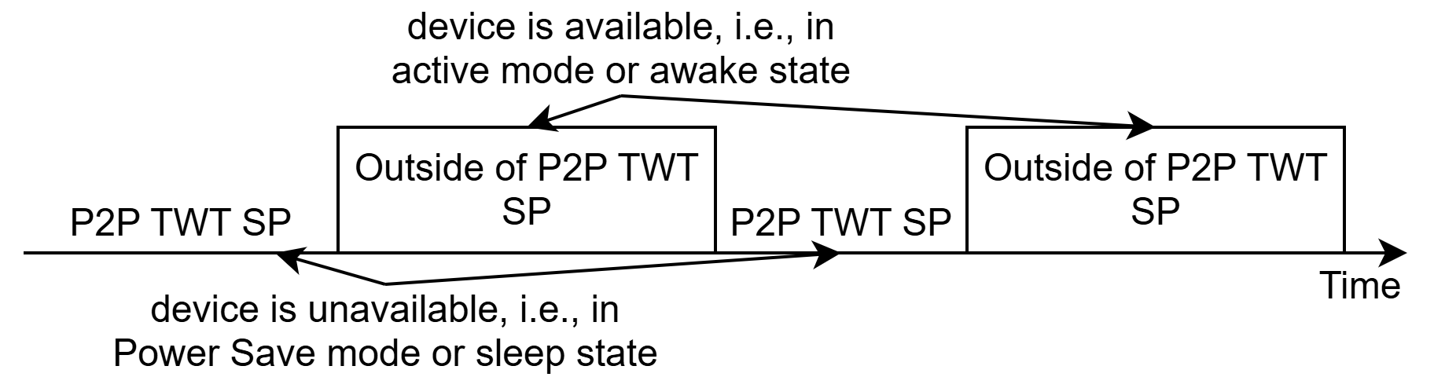

Figure 1 Non-AP STA PUO mode in 11bn D0.3

Figure 1 shows the non-AP STA PUO mode in 11bn D0.3 [1] before the revised resolutions:

* Inside of P2P TWT SPs: non-AP STA is unavailable or in Power Save mode
  + the AP or peer STAs need certain scheduling/queuing/transmiting policy to track the availability/unavailability and SP start/stop time of the non-AP STA, adding complexity given the queueing delay and channel access delay are unpredictable and the TSF/SP alignment between the non-AP STA and peer STAs/AP is not guaranteed
* Outside of P2P TWT SPs: non-AP STA is in active mode or awake state

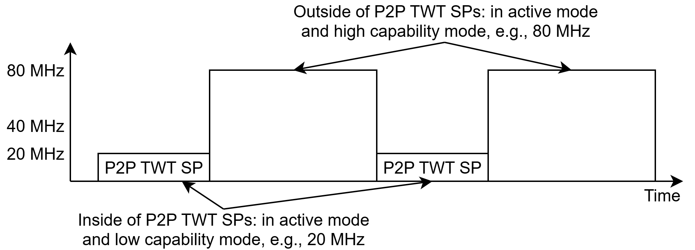

Figure 2 Non-AP STA PUO mode with the proposed changes

Figure 2 shows an example for the non-AP STA PUO mode with the proposed changes:

* Inside of P2P TWT SPs: in a lower capability mode on the primary 20MHz channel
  + The non-AP STA is able to receive and transmit.
  + The AP/peer STAs do not need special scheduling/queueing/transmiting policy or strict timing/SP alignment with the non-AP STA
  + The AP/peer STAs can still check the current status of the non-AP STA, e.g., by ICF/ICR
  + The non-AP STA may enable DPS to transition to higher capability mode after ICF.
* Outside of P2P TWT SPs: in active mode, operating in a higher capability mode on the whole bandwidth of 80MHz
  + The non-AP STA can operate in high capability mode without ICF/ICR/IFCS/padding or capability switching operations
* During specific service periods, the non-AP STA may be unavailable or may respond to certain ICFs.
  + If the AP does not receive the ICR from the non-AP STA, the non-AP STA is considered as unavailable during the current service period.
* The non-AP STA may update the TWT parameters to adjust the duration and frequency of the service periods for operating in lower capability mode and higher capability mode.

More details and examples are presented in [25/0578](https://mentor.ieee.org/802.11/dcn/25/11-25-0578-00-00bn-twt-based-ap-power-save.pptx) [4].

### ****Signaling**** Options

Requirements:

* Need to indicate that specific P2P TWT SPs are associated with certain capability modes.
* If PUO and DPS are both supported: need to indicate that DPS is enabled/disabled inside specific P2P TWT SPs.
* If PUO and DUO are both supported: need to indicate that DUO is enabled and the STA may respond to certain ICFs inside specific P2P TWT SPs.
* Need to indicate the lower capability mode.

Options:

* Indicate that a TWT is associated with certain capability modes and/or DPS enabled/disabled for non-AP STA PUO mode:
  + Ruese Channel Usage element. Value 6-254 of Usage Mode are reserved.
  + Other options.
* Indicate the lower capability mode: can reuse the lower capability mode of DPS.

Table 1 Summary of signaling options for non-AP STA PUO mode

|  |  |  |
| --- | --- | --- |
| Mode | Element/field | Notes (underlined red texts are proposed options) |
| Non-AP PUO mode | UHR Capabilities element | PUO Support (802.11bn D0.3) |
| Channel Usage element - Usage Mode field | 3: unavailability indication (802.11-2024) |
| 6: lower capability mode inside of P2P TWT SPs |
| 7: lower capability mode with DPS enabled inside of P2P TWT SPs  8: unavailable or be able to respond to DUO ICF inside of P2P TWT SPs |
| DPS mode | UHR Capabilities element (802.11bn D0.3) | DPS Assisted Support |
| DPS Assisting Support |
| UHR Operation element (802.11bn D0.3) | DPS Enabled – Specify DPS Enabled only covers outside of specific P2P TWT SPs for non-AP STA PUO mode |
| DPS Operation Parameters – Reuse the definition of lower capability mode of DPS and apply it for non-AP STA PUO mode |

### ****Summary****

The proposed resolutions enable a non-AP STA to operate in lower capability outside/inside specific service periods and provide enhancements to PUO and DPS:

* Enhancements on DPS mode (Motion #9) [5]:
  + STA has the option to transition between lower capability mode and higher capability mode based on certain service periods, in addition to relying on ICF/ICR/IFCS/padding when operating in DPS mode.
  + STA may enable or disable DPS along with the transition between lower capability mode and higher capability mode based on specific service periods.
* Enhancements on non-AP STA PUO mode (Motion #30) [5]:
  + Non-AP STA has the option to be in low capability mode during specific P2P TWT SPs, in addition to the Power Save mode of the non-AP STA PUO mode of D0.3.

References

[1] IEEE P802.11bn/D0.3

[2] <https://mentor.ieee.org/802.11/dcn/25/11-25-0296-24-00bn-ieee-802-11bn-cc50-comments-on-d0-1.xlsx>

[3] <https://mentor.ieee.org/802.11/dcn/25/11-25-0508-02-00bn-d0-1-cc-subclause-37-11-3.docx>

[4] <https://mentor.ieee.org/802.11/dcn/25/11-25-0578-00-00bn-twt-based-ap-power-save.pptx>

[5] <https://mentor.ieee.org/802.11/dcn/24/11-24-0209-15-00bn-specification-framework-for-tgbn.docx>

* Non-AP STA periodic unavailability operation (PUO) mode

Periodic unavailability operation (PUO) allows a non-AP STA to indicate, to its associated AP, that the STA will be unavailable during periodic service periods.

A UHR AP that supports PUO is called a PUO Supporting AP and shall set the PUO Supporting AP field of the UHR MAC Capabilities Information field of the UHR Capabilities that it transmits to 1. A PUO Supporting AP shall have dot11ChannelUsageActivated equal to true and shall set the Peer-to-peer TWT Support field in the Extended Capabilities elements that the AP transmits to 1.

A UHR STA that supports PUO is called a PUO non-AP STA and shall set to 1 the PUO Support field of the UHR MAC Capabilities Information field of the UHR Capabilities element that it transmits. A PUO non-AP STA shall support the channel usage procedure in 11.21.15 (Channel Usage Procedures) and have the TWT Requester Support subfield set to 1 in the HE Capabilities element that the STA transmits.

To be unavailable during specific service periods, a PUO non-AP STA shall follow the rules defined in 11.21.15 (Channel Usage Procedures) to report its periodic unavailability to its associated PUO Supporting AP. A PUO Supporting AP that intends to exchange frames with the PUO non-AP STA shall follow the rules defined in 11.21.15 (Channel Usage Procedures) related to the P2P TWT procedure.

A PUO non-AP STA may operate in a low capability mode during specific service periods. To operate in a lower capability mode inside of P2P TWT SPs, a PUO non-AP STA shall set the Usage Mode of the Channel Usage element to 6. If a PUO non-AP STA is also a DPS STA, the non-AP STA may set the Usage Mode of the Channel Usage element to 7 to enable DPS inside of P2P TWT SPs. If a PUO non-AP STA is also a DUO STA, the non-AP STA may set the Usage Mode of the Channel Usage element to 8 to operate in a mode to be unavailable or be able to respond to DUO ICF inside of P2P TWT SPs. If the AP does not receive the DUO ICR from the non-AP STA, the non-AP STA is considered as unavailable during the current service period. [#1596]

Enhancements to the P2P TWT procedure are TBD.

When an PUO Supporting AP considers a PUO non-AP STA as being unavailable during a service period after having received a periodic unavailability indication through P2P TWT as described in this subclause, the PUO Supporting AP should not schedule for transmission PPDUs containing frames addressed to the PUO non-AP STA that overlaps with its unavailability service period and if the AP still transmits, the PUO non-AP STA is not expected to receive the PPDUs.

NOTE—If the PUO Supporting AP transmits PPDUs containing frames addressed to the PUO non-AP STA during the STA's unavailability service period, then the expectation is that the PUO Supporting AP does not take into account the failed reception of the frames contained in the PPDUs for its rate selection algorithm nor for its EDCA function for the AC used to transmit these frames, unless required by regulatory rules.