**IEEE P802.11  
Wireless LANs**

|  |  |  |  |  |
| --- | --- | --- | --- | --- |
| CC50 CR for clause 6 part 3 | | | | |
| **Date**: July. 8, 2025. | | | | |
| **Author(s):** | | | | |
| **Name** | **Affiliation** | **Address** | **Phone** | **email** |
| Yan Li | ZTE |  |  | li.yan16@zte.com.cn |
| Jay Yang |  |  | yang.zhijie@zte.com.cn |
| Zisheng Wang |  |  | wang.zisheng@zte.com.cn |
| Brian Hart | Cisco |  |  | brianh@cisco.com |

**Abstract**

This submission proposes resolutions for following CIDs received for TGbn CC50:

142, 143(2 CIDs)

**Revisions:**

Rev 0: Initial version of the document and resolve 2 TBDs in clause 6

***TGbn editor: The baseline for this document is P802.11bn D0.3 and P802.11-2024***

Interpretation of a Motion to Adopt

A motion to approve this submission means that the editing instructions and any changed or added material are actioned in the TGbn Draft. This introduction is not part of the adopted material.

***Editing instructions formatted like this are intended to be copied into the TGbn Draft (i.e., they are instructions to the 802.11 editor on how to merge the text with the baseline documents).***

***TGbn Editor: Editing instructions preceded by “TGbn Editor” are instructions to the TGbn editor to modify existing material in the TGbn draft. As a result of adopting the changes, the TGbn editor will execute the instructions rather than copy them to the TGbn Draft.***

|  |  |  |  |  |  |
| --- | --- | --- | --- | --- | --- |
| **CID** | **Clause** | **Pg/Ln** | **Comment** | **Proposed Change** | **Resolution** |
| 142 | 6.5.3.3.2 | 27.27 | the UHR Capabilities shall be in Beacon frame as previous generation did | please remove "TBD" | Revised  According to beacon optimization in 25/552r8, the UHR capabilities element is not carried in the beacon frame while the UHR operation element is still available. Therefore, the corresponding UHR Capabilities should not exist in the MLME-SCAN.confirm primitive.  **TGbn editor, please incorporate changes tagged with 142 in this document** |
| 143 | 6.5.3.3.3 | 28.29 | the UHR Capabilities shall be in Beacon frame as previous generation did | please remove "TBD" | Revised  According to beacon optimization in 25/552r8, the UHR capabilities element is not carried in the beacon frame while the UHR operation element is still available. Therefore, the corresponding UHR Capabilities should not exist in the MLME-SCAN.confirm primitive.  **TGbn editor, please incorporate changes tagged with 142 in this document** |

**Introduction：**

To keep consistent with the requirement of *beacon optimization* in (25/552r8), the UHR Capabilities is removed from the MLME-SCAN.confirm while UHR Operation is still available.

Based on the online discussion of 25/707r6, the behavior before MLME-xxx.request primitive in Figure 6-7a should be out of band communications instead of over-the-DS communications, as MAPC is not prohibited across ESS.

The Figure 6-7a in 25/707r6 as below:

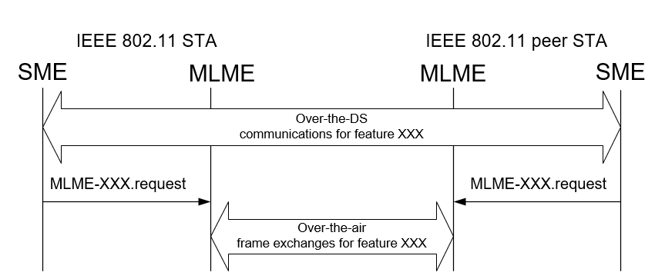

**Proposed Texts**

1. **Layer management**

**6.3.7 Type 6**

*TGbn editor: please replace the figure 6-7a(above) in 802.11bn D0.3 with the figure below*

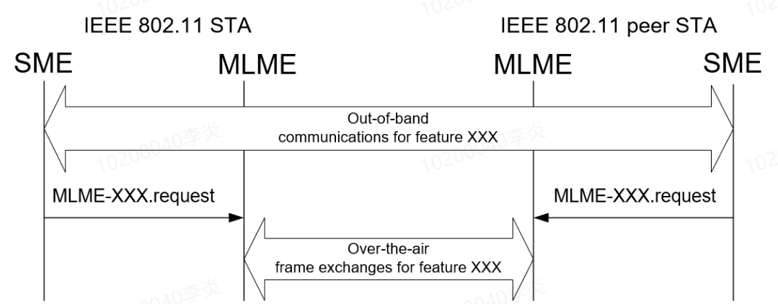

Figure 6-7a—Example usage of the Type 6 form of MLME SAP primitives, to notify the MLMEs of a STA and peer STA of communications between the SMEs of the STAs



**6.5 MLME SAP primitive**

**6.5.3 Scan**

**6.5.3.3 MLME-SCAN.confirm**

**6.5.3.3.2 Semantics of the service primitive**

*TGbn editor: please change the table below as follows:*

|  |  |  |  |  |
| --- | --- | --- | --- | --- |
| Name | Type | Valid range | Description | IBSS adoption |
| UHR Capabilities | As defined in UHR Capabilities element | As defined in 9.4.2.xxx  (UHR Capabilities element) | The value from the UHR Capabilities element. The parameter is present if  dot11UHROptionImplemented  is true and an UHR Capabilities  element was present in the  Probe Response(#142) from which the BSSDescriptionSet was determined. Otherwise, the parameter is not present. | Do not adopt |
| UHR Operation | As defined in UHR Operation element | As defined in 9.4.2.yyy  (UHR Operation element) | The value from the UHR Operation element. The parameter is present if dot11UHROptionImplemented is true and an UHR Operation element was present in the Probe Response or Beacon frame(#142) from which the BSSDescriptionSet was determined. Otherwise, the parameter is not present. | Adopt |