IEEE P802.11  
Wireless LANs

|  |  |  |  |  |
| --- | --- | --- | --- | --- |
| Missing subfield description for M-BA frame | | | | |
| Date: 2025-06-17 | | | | |
| Author(s): | | | | |
| Name | Affiliation | Address | Phone | email |
| Haorui Yang | China Mobile |  |  | yanghaorui0217@163.com |
|  |  |  |  |  |

Abstract

This document adds the missing field description for Multi-STA BlockAck frame.

**Reason for change:**

In 9.3.1.8.6 (Multi-STA BlockAck variant) of Draft P802.11REVmf_D2.0, the definition of the Per AID TID Info subfield format as in Figure 9-61 is not complete, i.e. the definition of Block Ack Starting Sequence Control subfield is missing.

Therefore, it is proposed to add the definition of Block Ack Starting Sequence Control subfield.

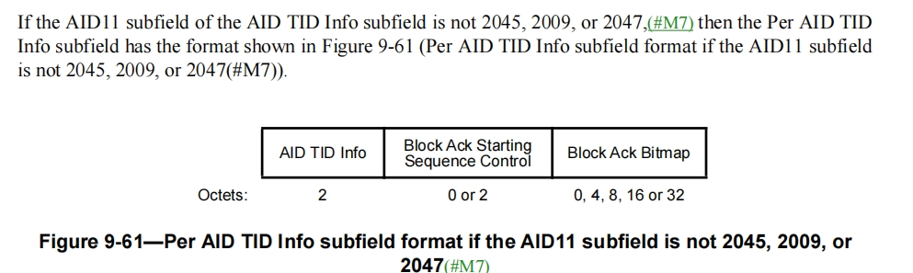

**Proposed changes:**

**9.3.1.8.6 Multi-STA BlockAck variant**

*Update the following paragraph:*

If the AID11 subfield of the AID TID Info subfield is not 2045, 2009, or 2047,(#M7) then the Per AID TID Info subfield has the format shown in Figure 9-61 (Per AID TID Info subfield format if the AID11 subfield is not 2045, 2009, or 2047(#M7)). The Block Ack Starting Sequence Control subfield is shown in Figure 9-49 (Block Ack Starting Sequence Control subfield format). The Starting Sequence Number subfield of the Block Ack Starting Sequence Control subfield contains the sequence number of the first MSDU or A-MSDU for whitch the Multi-STA BlockAck frame is sent. The Fragment Number subfield of the Block Ack Starting Sequence Control subfield is set as defined in Table 9-40 (Fragment Number subfield encoding for the Multi-STA BlockAck variant).

|  |  |  |
| --- | --- | --- |
| AID TID Info | Block Ack Starting Sequence Control | Block Ack Bitmap |

Octets: 2 0 or 2 0, 4, 8, 16 or 32

**Figure 9-61—Per AID TID Info subfield format if the AID11 subfield is not 2045, 2009, or**

**2047**(#M7)

**References:**