|  |  |  |  |  |
| --- | --- | --- | --- | --- |
| Challenges in Using Single NPCA Minimum Duration Threshold | | | | |
| Date: May 12, 2025 | | | | |
| Author(s): | | | | |
| Name | Affiliation | Address | Phone | email |
| Shravan Kumar Kalyankar | Huawei |  |  | kalyankar.shravan.kumar@huawei.com |
| Rojan Chitrakar |  |  |  |
| Huang Lei |  |  |  |
| Yunbo Li |  |  |  |
|  |  |  |  |

**IEEE P802.11  
Wireless LANs**

Abstract

This submission proposes resolution for CID 1783 received for CC50.

**Revisions:**

* Rev 0: Initial version of the document.

***TGbn editor: The baseline for this document is P802.11bn D0.2 and P802.11REVmeD7.0***

***TGbn Editor: Editing instructions preceded by “TGbn Editor” are instructions to the TGbn editor to modify existing material in the TGbn draft. As a result of adopting the changes, the TGbn editor will execute the instructions rather than copy them to the TGbn Draft.***

# **CID 1783:**

|  |  |  |  |  |  |
| --- | --- | --- | --- | --- | --- |
| **CID** | **Commenter** | **Clause** | **Comment** | **Proposed Change** | **Resolution** |
| 1783 | Chaoming Luo | 37.10 | The NPCA Minimum Duration Threshold should be long enough to complete at least one frame exchange in the NPCA P-channel, otherwise it's waste of power to do the switch. | As in comment | **Revised**  Agree with the commenter in principle. Proposed a revision to include two thresholds instead of one. |

**Discussion:**

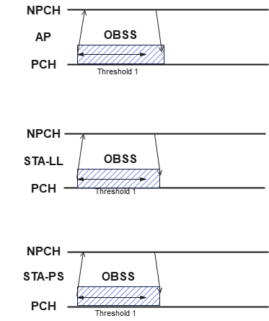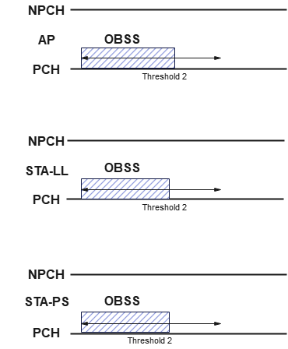

Fig. 1. Using a short threshold value.

Fig. 2. Using a long threshold value.

* Using a shorter NPCA Minimum duration threshold (threshold duration equal to single frame exchange) will be ineffective when the OBSS duration is short leading to power wastage for the STAs which fail to access the NPCA primary channel.
* Multiple STAs contend to access the NPCA primary channel, even when the NPCA duration is sufficient for a single frame exchange.
* The single threshold approach is ineffective especially when the STAs have power constraints or STAs want power saving.
* Using a longer NPCA Minimum duration threshold will limit the main motivation of NPCA mechanism.
* Using longer threshold would reduce the probability of benefiting from NPCA mechanism especially when the STAs have LL requirement.
* The single threshold approach is ineffective especially when the STAs have different requirements.

**Proposed changes:**

**9.4.2.aa1 UHR Operation Element**

|  |  |  |  |  |
| --- | --- | --- | --- | --- |
| B0 B7 | B8 Bx | Bx+1 Bx+6 | Bx+7 Bx+12 | Bx+13 Bx+18 |
| NPCA Primary Channel | NPCA Minimum Duration Threshold1 | NPCA Minimum Duration Threshold2 | NPCA Switching Delay | NPCA Switch Back Delay |
| 8 | TBD | TBD | 6 | 6 |
| Figure 9-aa3 – NPCA Operation Information field format. |  |  | | | |

Two NPCA Minimum Duration Thresholds are indicated. The NPCA Minimum Duration Threshold1 field indicates the minimum duration of inter-BSS activity (inter-BSS PPDU or inter-BSS TXOP) that is required to have been indicated on the primary channel of the BSS as a necessary condition to permit an NPCA STA with latency sensitive traffic to switch to the NPCA primary channel to perform NPCA operation. The NPCA Minimum Duration Threshold2 field indicates the minimum duration of inter-BSS activity (inter-BSS PPDU or inter-BSS TXOP) that is required to have been indicated on the primary channel of the BSS as a necessary condition to permit the other NPCA STA to switch to the NPCA primary channel to perform NPCA operation. The encoding and the maximum value of these fields are TBD.

**37.11 Non-primary channel access (NPCA)**

**TGbn editor: Modify the sub-clause as following:**

1)

b. If the STA has latency sensitive traffic, the TXOP duration, determined from the Duration field of the received frame(s), is greater than the value indicated in the most recently received or transmitted NPCA Minimum Duration Threshold1 field corresponding to its BSS

i) Whether the RXVECTOR parameter TXOP_DURATION of the received PPDU(s)

are considered for this comparison is TBD

c. If the STA has doesn’t have the latency sensitive traffic, the TXOP duration, determined from the Duration field of the received frame(s), is greater than the value indicated in the most recently received or transmitted NPCA Minimum Duration Threshold2 field corresponding to its BSS

i) Whether the RXVECTOR parameter TXOP_DURATION of the received PPDU(s)

are considered for this comparison is TBD

2)

b. If the STA has latency sensitive traffic, the TXOP duration, determined from the Duration field of the received frame(s), is greater than the value indicated in the most recently received or transmitted NPCA Minimum Duration Threshold1 field corresponding to its BSS

i). Whether the RXVECTOR parameter TXOP_DURATION of the received PPDU(s) are considered for this comparison is TBD.

c. If the STA doesn’t have latency sensitive traffic, the TXOP duration, determined from the Duration field of the received frame(s), is greater than the value indicated in the most recently received or transmitted NPCA Minimum Duration Threshold2 field corresponding to its BSS

i). Whether the RXVECTOR parameter TXOP_DURATION of the received PPDU(s) are considered for this comparison is TBD.

# **SP**

Do you support resolution to the CID 1783 and incorporate the corresponding text changes into the latest TGbn draft?

Y/N/A