|  |  |  |  |  |
| --- | --- | --- | --- | --- |
| CR 1482 Discussion on NPCA Primary Channel Condition | | | | |
| Date: May 12, 2025 | | | | |
| Author(s): | | | | |
| Name | Affiliation | Address | Phone | email |
| Shravan Kumar Kalyankar | Huawei |  |  | kalyankar.shravan.kumar@huawei.com |
| Rojan Chitrakar |  |  |  |
| Huang Lei |  |  |  |
| Yunbo Li |  |  |  |
|  |  |  |  |

**IEEE P802.11  
Wireless LANs**

Abstract

This submission proposes resolution for CID 1482 received for CC50.

**Revisions:**

* Rev 0: Initial version of the document.

***TGbn editor: The baseline for this document is P802.11bn D0.2 and P802.11REVmeD7.0***

***TGbn Editor: Editing instructions preceded by “TGbn Editor” are instructions to the TGbn editor to modify existing material in the TGbn draft. As a result of adopting the changes, the TGbn editor will execute the instructions rather than copy them to the TGbn Draft.***

# **CID 1783:**

|  |  |  |  |  |  |
| --- | --- | --- | --- | --- | --- |
| **CID** | **Commenter** | **Clause** | **Comment** | **Proposed Change** | **Resolution** |
| 1482 | Akira Kishida | 37.10 | There might be a case where the channel condition of the NPCA primary channel is worse than that of the original BSS primary channel. | It should be clarified that NPCA transition to the NPCA primary channel is not necessary in such cases. | **Revised**  Agree with the commenter in principle. And propose to introduce a NPCH feedback mechanism |

**Discussion:**

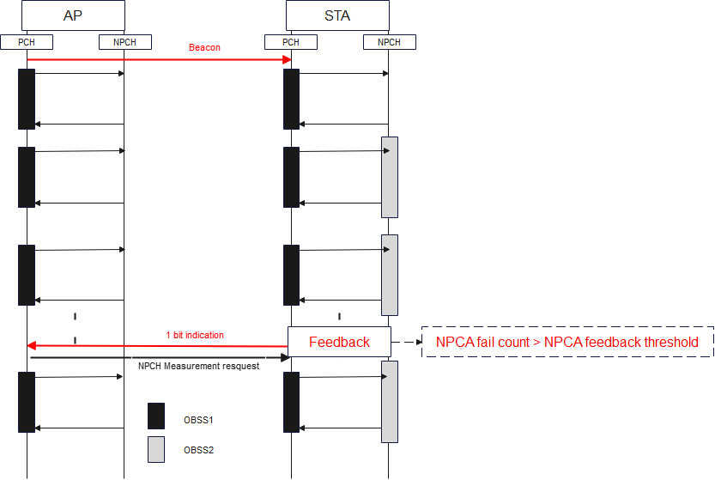If the NPCA primary channel is known to be busy due to ongoing OBSS or the NPCA primary channel condition is worse. In this case, the NPCA STA is unable to use the NPCA primary channel until a new NPCA primary channel is announced by the AP. Furthermore, NPCA STA wastes power in switching back-and-forth (PCH2NPCH) until a new NPCA primary channel is announced. Moreover, NPCA AP is unable to assess the hidden OBSS or other hidden conditions on the NPCA primary channel. There is no mechanism defined to inform the NPCA AP about the poor NPCA primary channel condition and request a channel switch.

Fig. 1-bit NPCA feedback mechanism.

Proposing a 1-bit feedback indication to inform the AP about poor NPCA primary channel condition and NPCA mode (enable/disable).

**Proposed Text:**

**9.4.2.aa1 UHR Operation Element**

**TGbn editor: Modify the sub-clause as following:**

B0 B7 B8 Bx Bx+1 Bx+6 Bx+7 Bx+12 Bx+13 Bx+18

|  |  |  |  |  |
| --- | --- | --- | --- | --- |
| NPCA Primary Channel | NPCA Minimum Duration Threshold | NPCA Switching Delay | NPCA Switch Back Delay | NPCA Feedback Threshold |

Bits: 8 TBD 6 6 6

The NPCA Switch Back Delay field indicates the time needed by an NPCA STA to switch from the NPCA primary channel to the BSS primary channel in units of 4 µs.

The NPCA Feedback Threshold field indicates the required NPCA fail count at an NPCA STA to send feedback to the NPCA AP. Where the NPCA fail count is number of failed NPCA attempts due to partially or fully busy NPCA primary channel because of OBSS or other conditions.

**9.4.xx.**

**TGbn editor: Proposal to introduce a NPCA feedback bit and NPCA mode bit in the BA frame.**

|  |  |  |  |  |  |  |  |
| --- | --- | --- | --- | --- | --- | --- | --- |
| Frame  Control | Duration | RA | TA | BA Control | Starting  Sequence  Control | Block Ack  Bitmap | FCS |

2 2 6 6 2 2 8 or 128 4

|  |  |  |  |  |  |  |
| --- | --- | --- | --- | --- | --- | --- |
| BA Ack Policy | Multi-TID | Compressed Bitmap | NPCA  Feedback | NPCA mode | Reserved | TID/NumTIDs |

B0 B1 B2 B3 B4 B5-B11 B12-B15

Fig. xx. Block Acknowledgement.

|  |  |
| --- | --- |
| Value | Description |
| 1 | NPCA fail count $≥$ NPCA Feedback Threshold |
| 0 | NPCA fail count $<$ NPCA Feedback Threshold |

Tab. xx. NPCA Feedback Bit.

|  |  |
| --- | --- |
| Value | Description |
| 1 | NPCA Mode Enabled |
| 0 | NPCA Mode Disabled |

Tab. xx. NPCA Mode.

**Definitions**:

* NPCA Feedback Bit: A STA sends a 1-bit indication to indicate the NPCA primary channel condition.
* NPCA mode: A 1-bit indication to indicate whether the NPCA mode is enabled or disabled.
* Reserved: These bits are reserved.
* TID/NumTIDs: Traffic Identified for which the block acknowledgement is requested.

*Note: NPCA fail count is a counter value that a STA counts. It counts the number of failed NPCA attempts due to partially or fully busy NPCA primary channel because of OBSS or other conditions.*

# **SP**

Do you support resolution to the CID 1482 and incorporate the corresponding text changes into the latest TGbn draft?

Y/N/A