IEEE P802.11
Wireless LANs
cc50-cid-2693- NPCA behavior for non-AP MLDs during seamless roaming
Date: June 7, 2025
Author(s):
Name | Affiliation | Address | Phone | email
Eda Genc | Nokia |  |  | eda.genc@nokia.com
Salvatore Talarico |  |  |  | salvatore.talarico@nokia.com
Prabodh Varshney |  |  |  | prabodh.varshney@nokia.com
Klaus Doppler |  |  |  | klaus.doppler@nokia.com
Mika Kasslin |  |  |  | mika.kasslin@nokia.com
Behnam Dezfouli |  |  |  | behnam.dezfouli@nokia.com
Juhyung Lee |  |  |  | juhyung.lee@nokia.com
Kerstin Johnsson |  |  |  | kerstin.johnsson@nokia.com
Mario Costa |  |  |  | mario.costa@nokia.com
Mikhail Liubogoshchev |  |  |  | mikhail.liubogoshchev@nokia.com
Okan Mutgan |  |  |  | okan.mutgan@nokia.com

Abstract
This submission proposes the resolution to CID 2693 received for CC50 for 802.11bn.

Revisions:
- Rev 0: Initial version of the document.
- Rev 1: Typo fixes for P802.11bn draft numbering, wording changes in Discussion, and clarification added in the proposed text.
- Rev 2: Editorial edits and wording changes in the text suggestion.
- Rev 3: Discussion section update
- Rev 4: Editorial changes
- Rev 5: Change of the proposed clause for the text by members and editorial changes on the proposed text

TGbn editor: The baseline for this document is P802.11bn D0.3, P802.11REVmeD7.0 and the document IEEE 802.11-25/0756r5.

TGbn Editor: Editing instructions preceded by “TGbn Editor” are instructions to the TGbn editor to modify existing material in the TGbn draft. As a result of adopting the changes, the TGbn editor will execute the instructions rather than copy them to the TGbn Draft.
Introduction

This submission proposes the resolution to CID 2693 received for CC50 for 802.11bn, which is copied below for convenience:

Comment:

CID | Commenter | Clause | Page,line | Comment | Proposed Change | Resolution
2693 | Salvatore Talarico | 37.16 | 149,58 | Roaming procedure should include behaviour for NPCA capable non-AP STAs | Procedure on how to ensure seamless roaming for an NPCA capable non-AP STA is missing including related information which should be part of the context transfer and STA behaviour. | Proposed text is provided which specifies that non-AP STA affiliated with the non-AP MLD shall send initial UL data using the primary channel of the AP affiliated with the target AP MLD.  TGbn editor, please incorporate changes tagged with 2693 in 11-25/0756r5.

The page and line numbers above refer to those in P802.11bn D0.3 [2].

- Discussion

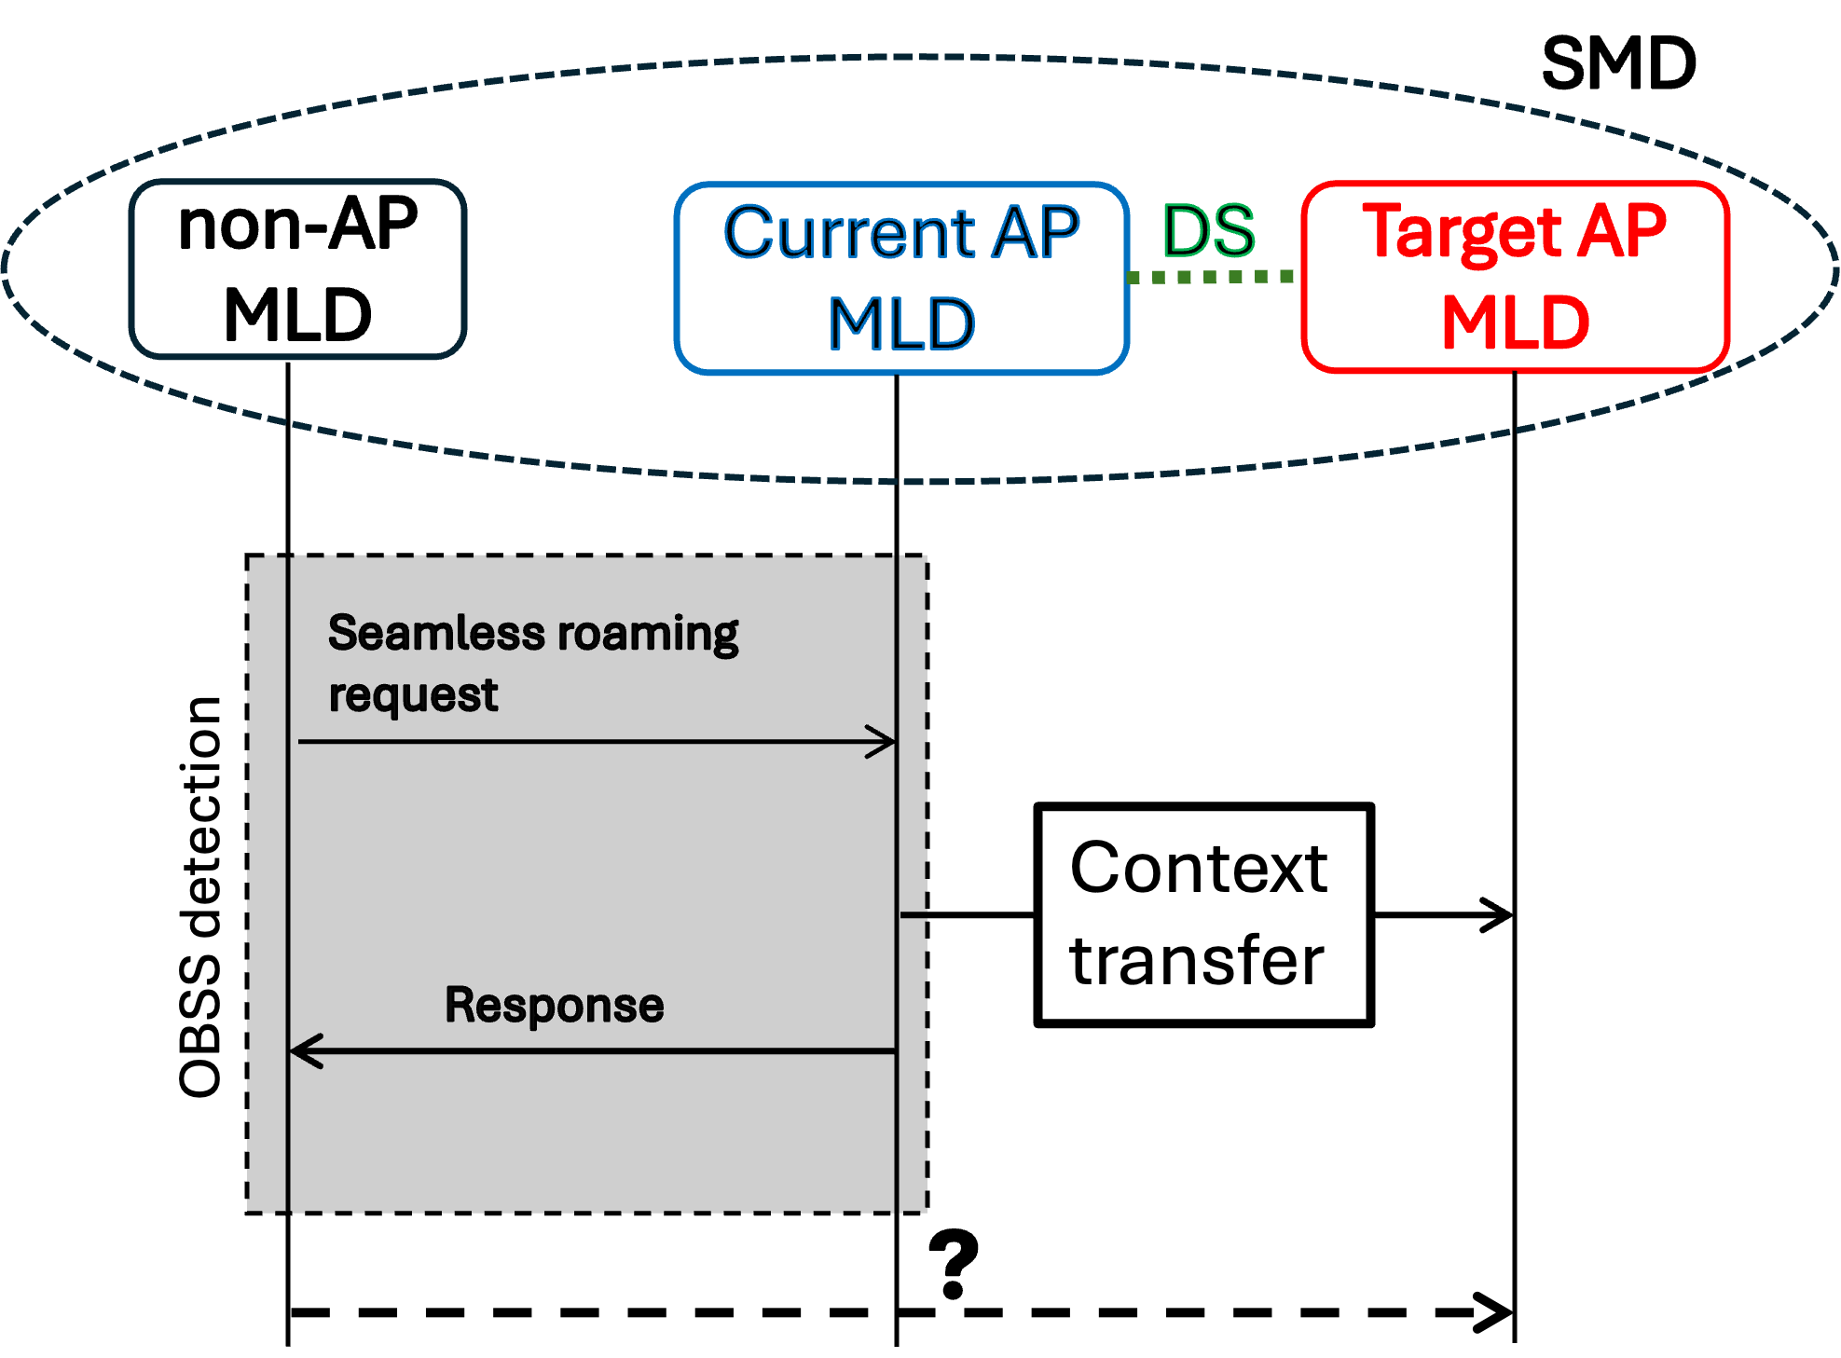
Figure 1 – Illustration of the seamless roaming operation when NPCA switch may happen
The current draft allows a non-AP MLD to complete SMD BSS transition execution either via the current AP MLD or via the target AP MLD, but it does not define which channel the non-AP STA affiliated with the non-AP MLD should use to establish the link with the target AP MLD. This lack of specification creates ambiguity, especially for NPCA-capable STAs, where the non-AP NPCA STA affiliated with the non-AP MLD may switch to NPCA primary channel of the AP affiliated with the target AP MLD based on prior NPCA related information or OBSS detection, assuming that the AP is operating there. However, the timing of the information might not match the actual activity of the AP affiliated with the target AP MLD. To prevent unpredicted behavior, the non-AP NPCA STA affiliated with the non-AP MLD should establish the link with the target AP MLD on a specific channel, primary or NPCA primary channel, which must be clearly defined.
Without a clearly defined default behavior, non-AP STA affiliated with the non-AP MLD may attempt to communicate on a channel where the AP affiliated with the target AP MLD is not operating or reachable, leading to failed link setup, increased latency, or ping-pong behavior.
To address this, the proposed change establishes that the non-AP STA affiliated with the non-AP MLD shall switch to the primary channel of the AP affiliated with the target AP MLD to complete SMD BSS transition. This behavior is especially important in the absence of coordination or context transfer mechanisms that explicitly convey NPCA parameters and status details.
This default behavior corresponds to Option 1 from contribution [11-25/0651r0], and aims to provide clarity, reduce interoperability risks, and support predictable roaming outcomes without reliance on NPCA coordination.

- Proposed Resolution
TGbn editor: Please change the 11bn spec as shown below. The reference version is P802.11bn D0.3 (#2693)

37.16 Non-primary channel access (NPCA)
TGbn editor: Please update following paragraph in this subclause as shown below - P802.11bn D0.3, page 149 line 58 (#2693)

A STA that supports NPCA operation is called an NPCA STA. An AP that supports NPCA operation is called an NPCA AP. A non-AP NPCA STA shall set the NPCA Supported field of the UHR MAC Capabil-ities Information field of the UHR Capabilities element to 1. A non-AP NPCA STA may enable the NPCA mode only if it is associated with an NPCA AP, and during SMD BSS transition, a non-AP NPCA STA affiliated with the non-AP MLD may only enable NPCA mode after it successfully transmits at least one Class 3 to the target AP MLD. (#2693) It is TBD how the non-AP STA enables NPCA mode.

An NPCA AP that has an operating bandwidth less than TBD (but either 80 or 160 MHz) shall not enable
NPCA operation. An AP of a multiple BSSID set which enables NPCA operation shall indicate the same
NPCA primary channel as all of the other APs of the same multiple BSSID set which have enabled NPCA
operation.
…

- References

[1] IEEE P802.11-REVme™ Draft Standard for Information Technology— Telecommunications and Information Exchange between Systems Local and Metropolitan Area Networks— Specific Requirements
Part 11: Wireless LAN Medium Access Control (MAC) and Physical Layer (PHY) Specifications.
[2] IEEE P802.11bn™/D0.3 Draft Standard for Information technology— Telecommunications
and information exchange between systems Local and metropolitan area networks— Specific requirements
Part 11: Wireless LAN medium access control (MAC) and physical layer (PHY) specifications, Amendment 6: Enhancements for ultra high reliability (UHR)”, May 2025.
[3] Improvements for NPCA and Seamless Roaming Interoperability, IEEE 802.11-25/0651r0, May 2025.

