IEEE P802.11
Wireless LANs
cc50-cid-2693- NPCA behavior for non-AP MLDs during seamless roaming
Date: May 13, 2025
Author(s):
Name | Affiliation | Address | Phone | email
Eda Genc | Nokia |  |  | eda.genc@nokia.com
Salvatore Talarico |  |  |  | salvatore.talarico@nokia.com
Prabodh Varshney |  |  |  | prabodh.varshney@nokia.com
Klaus Doppler |  |  |  | klaus.doppler@nokia.com
Mika Kasslin |  |  |  | mika.kasslin@nokia.com
Behnam Dezfouli |  |  |  | behnam.dezfouli@nokia.com
Juhyung Lee |  |  |  | juhyung.lee@nokia.com
Kerstin Johnsson |  |  |  | kerstin.johnsson@nokia.com
Mario Costa |  |  |  | mario.costa@nokia.com
Mikhail Liubogoshchev |  |  |  | mikhail.liubogoshchev@nokia.com
Okan Mutgan |  |  |  | okan.mutgan@nokia.com

Abstract
This submission proposes the resolution to CID 2693 received for CC50 for 802.11bn.

Revisions:
- Rev 0: Initial version of the document.
- Rev 1: Typo fixes for P802.11bn draft numbering, wording changes in Discussion, and clarification added in the proposed text.
- Rev 2: Editorial edits and wording changes in the text suggestion.

TGbn editor: The baseline for this document is P802.11bn D0.2, P802.11REVmeD7.0 and the document IEEE 802.11-25/0756r1.

TGbn Editor: Editing instructions preceded by “TGbn Editor” are instructions to the TGbn editor to modify existing material in the TGbn draft. As a result of adopting the changes, the TGbn editor will execute the instructions rather than copy them to the TGbn Draft.

Introduction

This submission proposes the resolution to CID 2693 received for CC50 for 802.11bn, which is copied below for convenience:

Comment:

CID | Commenter | Clause | Page,line | Comment | Proposed Change | Resolution
2693 | Salvatore Talarico | 37.8.2.5.2 | 75,61 | Roaming procedure should include behaviour for NPCA capable non-AP STAs | Procedure on how to ensure seamless roaming for an NPCA capable non-AP STA is missing including related information which should be part of the context transfer and STA behaviour. | Proposed text is provided which specifies that non-AP STA affiliated with the non-AP MLD shall send initial UL data using the primary channel of the AP affiliated with the target AP MLD.  TGbn editor, please incorporate changes tagged with 2693 in 11-25/0756r1.

The page and line numbers above refer to those in P802.11bn D0.2 [2].

- Discussion

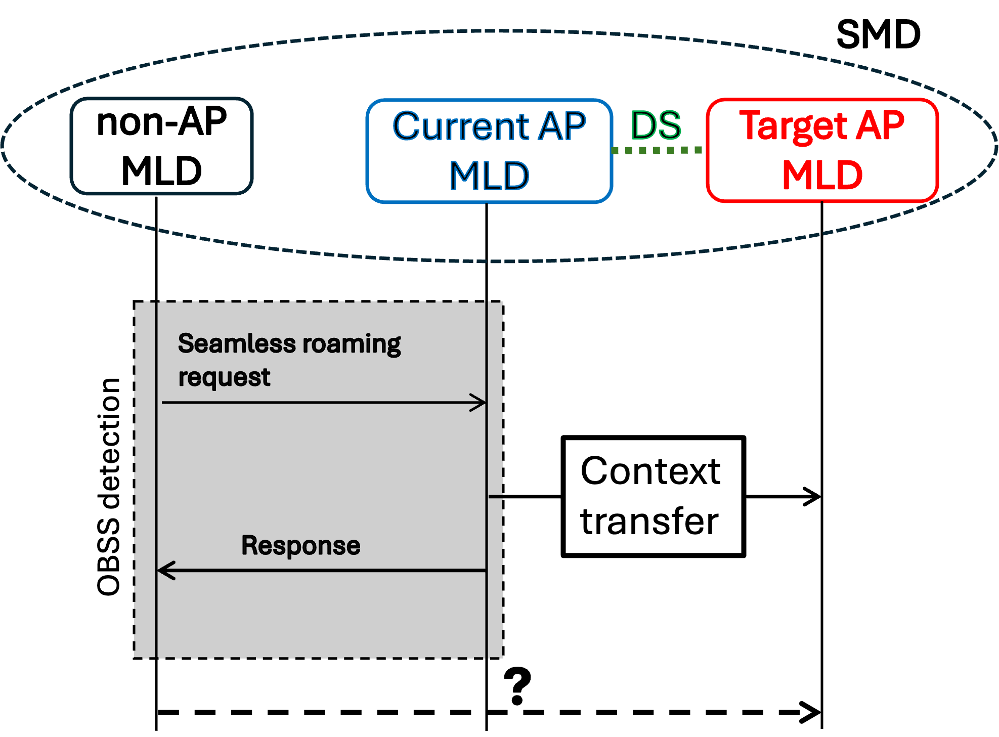
Figure 1 – Illustration of the seamless roaming operation when NPCA switch may happen

The current draft allows a non-AP MLD to complete seamless roaming either via the current AP MLD or via the target AP MLD, but it does not define which channel the non-AP STA affiliated with the non-AP MLD should use to establish the link with the target AP MLD. This lack of specification creates ambiguity, especially for NPCA-capable APs and STAs, where the AP affiliated with the current AP MLD and the non-AP STA affiliated with the non-AP MLD may switch to NPCA primary channel based on the switching conditions. In this case, the non-AP STA affiliated with the non-AP MLD establishes the link with the target AP MLD on a specific channel, primary or NPCA primary channel, which must be clearly defined.
Without a clearly defined default behavior, non-AP STA affiliated with the non-AP MLD may attempt to communicate on a channel where the AP affiliated with the target AP MLD is not operating or reachable, leading to failed link setup, increased latency, or ping-pong behavior.
To address this, the proposed change establishes that the non-AP STA affiliated with the non-AP MLD shall switch to the primary channel of the AP affiliated with the target AP MLD to complete seamless roaming. This behavior is especially important in the absence of coordination or context transfer mechanisms that explicitly convey NPCA parameters and status details.
This default behavior corresponds to Option A from contribution [11-25/0651r0], and aims to provide clarity, reduce interoperability risks, and support predictable roaming outcomes without reliance on NPCA coordination.

- Proposed Resolution
TGbn editor: Please change the 11bn spec as shown below. The reference version is P802.11bn D0.2 (#2693)

37.9.3 Roaming execution procedure
TGbn editor: Please update following paragraph in this subclause as shown below - P802.11bn D0.2, page 82 line 35 (#2693)

When a non-AP MLD uses Seamless roaming to transition from the current AP MLD to a target AP MLD,
the non-AP MLD shall send a TBD Request frame to the current AP MLD. The current AP MLD may
transmit individually addressed DL Data frames to the non-AP MLD for a period of TBD time. The period
of TBD time starts from the time the TBD Response frame is received. If the non-AP MLD chooses to
receive the individually addressed buffered downlink Data frames from the current AP MLD, it may do so
for a period of TBD time.

After receiving the TBD Request frame:
— The current AP MLD shall transfer the context (see 37.9.4 (Context)) that is required for enabling
operations with the target AP MLD. The context that can be transferred or renegotiated in this procedure is defined in 37.9.4 (Context).
— The current AP MLD shall send a TBD Response frame to the non-AP MLD after the transfer or
renegotiation of the context is completed.

The non-AP MLD shall not transmit Class 3 frames to the target AP MLD until it has received the TBD
Response frame sent by the current AP MLD.

The NPCA non-AP STA affiliated with the non-AP MLD shall transmit Class 3 frames to the target AP MLD using the primary channel of the AP affiliated with the target AP MLD. Only then, if it assesses that the NPCA Operation Information Present field of its AP affiliated with target AP MLD is equal to 1 it may switch to the NPCA primary channel based on the conditions defined in 37.11.

After the TBD Request and Response frame exchange, if necessary and if the DS is not already notified
about the update of the destination mapping for the non-AP MLD, the DS is notified about the update of the
destination mapping for the non-AP MLD.

- References

[1] IEEE P802.11-REVme™ Draft Standard for Information Technology— Telecommunications and Information Exchange between Systems Local and Metropolitan Area Networks— Specific Requirements
Part 11: Wireless LAN Medium Access Control (MAC) and Physical Layer (PHY) Specifications.
[2] IEEE P802.11bn™/D0.2 Draft Standard for Information technology— Telecommunications
and information exchange between systems Local and metropolitan area networks— Specific requirements
Part 11: Wireless LAN medium access control (MAC) and physical layer (PHY) specifications, Amendment 6: Enhancements for ultra high reliability (UHR)”, March 2025.
[3] Improvements for NPCA and Seamless Roaming Interoperability, IEEE 802.11-25/0651r0, May 2025.

