IEEE P802.11
Wireless LANs
CR for 38.3.15.9.6 User Specific Field – Part 2 on P802.11bn D0.2
Date: 2025.04.28
Author(s):
Name | Company | Address | Phone | email
Oded Redlich | Huawei Technologies
Genadiy Tsodik | Huawei Technologies
Abstract
This submission contains proposed comment resolutions to CIDs 331, 333, 371, 3310, 1206, 1093, 1169, 1355, 2071, 2295, 3538, 551, 2182, 3539 (total 14 CIDs) on P802.11bn D0.2.

Revision Notes

R0 | Initial revision
R1 | Added CID 2182 (with a correction to the page number)

CID 331
Page.  Line | Clause Number | Comment | Proposed Change | Resolution
176.40 | 38.3.15.9.6 | "The modulation order from the first to the sixth". Improve wording. | Change to e.g. "Values 0 to 6 for modulation order correspond to ...." | Revised  Instructions to the editor:  Update the NOTE text in D0.2 page 186.40 to:  "Modulation orders 1, 2, 3, 4, 5 and 6 correspond to QPSK, 16-QAM, 64-QAM, 256-QAM, 1024-QAM and 4096-QAM respectively."

CID 371, 3310
CID | Page.  Line | Clause Number | Comment | Proposed Change | Resolution
371 | 176.34 | 38.3.15.9.6 | In statement "In 38-28 (UEQM pattern subfield encoding)" where " 38-28" should be replaced as "Table 38-28" | As in comment | Revised  Instructions to the editor:  In D0.2, page 186.34 replace the text "In 38.29" with "In Table 38.29"
3310 | 176.34 | 38.3.15.9.6 | Change to "In Table 38-28". | As in comment | Instructions to the editor:  Please make the changes as shown under CID 371.

CID 1206, 1093, 1169, 1354, 2070, 2295, 3538
CID | Page.  Line | Clause Number | Comment | Proposed Change | Resolution
1206 | 176.55 | 38.3.15.9.6 | Missing values for UEQM Pattern Subfield for N_SS=3 | Add value "1" for [s, s, s-2] and "2" for [s, s-1, s-2] | ACCEPTED  Instructions to the editor:  Use the proposed change in D0.2 page 186.55-59 in the UEQM Pattern Subfield for the case of NSS subfield=2
1093 | 176.55 | 38.3.15.9.6 | Table 38-28 UEQM pattern subfield encoding, Number of Spatial streams =3, UEQM pattern subfield only have one value "0". Should have 3 values "0, 1, 2" instead | Split cell to 3 cells with values "0,1,2" | Revised  Instructions to the editor:  Please make the changes as shown under CID 1206.
1169 | 176.55 | 38.3.15.9.6 | In table 38-28, when Nss subfield =2, the value of 1 and 2 should be included in the UEQM pattern subfield | As the comment. | Revised  Instructions to the editor:  Please make the changes as shown under CID 1206.
1355 | 176.55 | 38.3.15.9.6 | missing UEQM pattern subfeild value for 2nd and 3rd pattern. | adding UEQM pattern subfeild value for 2nd and 3rd pattern | Revised  Instructions to the editor:  Please make the changes as shown under CID 1206.
2071 | 176.55 | 38.3.15.9.6 | In Table 38-28, for "NumberofSpatialStreams=3", "UEQM Pattern Subfield" should have three entries. | 0 corresponding to 1st pattern (s s s-1 N/A)  1 corresponding to 2nd pattern (s s s-2 N/A)  2 corresponding to 3rd pattern (s s-1 s-2 N/A) | Revised  Instructions to the editor:  Please make the changes as shown under CID 1206.
2295 | 176.55 | 38.3.15.9.6 | Table 38-28 UEQM pattern subfield values are missing for 3 spatial streams. | As in comment | Revised  Instructions to the editor:  Please make the changes as shown under CID 1206.
3538 | 176.55 | 38.3.15.9.6 | typo | In Table 38-28, with "NSS Subfield" = 2 and "Number of Spatial Streams" = 3, the "UEQM Pattern Subfield" sould be 0~3 for the 3 respective rows | Revised  Instructions to the editor:  Please make the changes as shown under CID 1206.

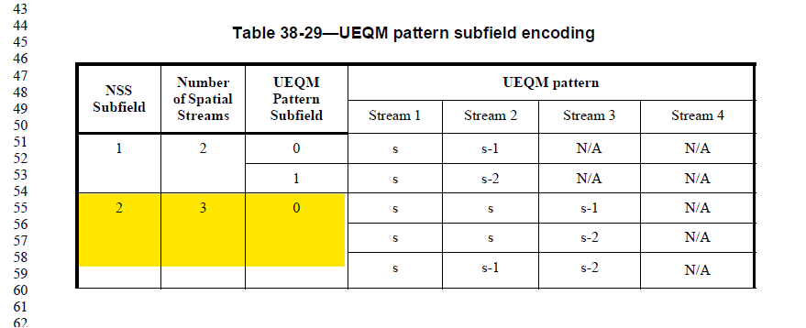

CID 333
Page.  Line | Clause Number | Comment | Proposed Change | Resolution
178.42 | 38.3.15.9.6 | "followed by the ones" | Change to "followed by the user fields" | Revised  Instructions to the editor:  Apply the proposed change to D0.2 page 188.42

CID 551
Page.  Line | Clause Number | Comment | Proposed Change | Resolution
178.38 | 38.3.15.9.6 | The text below Table 38-29, "The Spatial Configuration field in User field of UHR-SIG field in PPDUs for Co-BF transmission re-uses the same design as in UHR DL MU-MIMO. The encoding table will be the same as that in HE", is inappropriate for normative text. | Proposed changing the text to: "The encoding of the Spatial Configuration subfield in the User field of UHR-SIG field in UHR MU PPDUs for Co-BF Transmission uses Table 27-31 (Spatial Configuration subfield encoding) where the values for more than 4 spatial streams are reserved." | Revised  Instructions to the editor:  The encoding of the Spatial Configuration subfield in User field of UHR-SIG field in UHR-MU PPDUs for Co-BF transmission uses Table 27-30  (Spatial Configuration subfield encoding) where the values for more than 4 spatial streams are reserved."  Note to the editor: The Table number in the above text is 27-30 and not 27-31 as written in the proposed change.

CID 2182
Page.  Line | Clause Number | Comment | Proposed Change | Resolution
177.36 | 38.3.15.9.6 | Suggest to rephrase the sentence that starts with "and s-delta represents" (singular 'stream', the term 'that' should be replaced, 'order' and 'level' are both used). | replace with "and 's-delta' represents the modulation order(s) used by the remaining spatial stream(s) with delta modulaiton orders lower than s". | Revised  Instructions to the editor:  Replace the paragraph below Table 38-28 in D0.2 page 187, with the following text:  In 38-29 (UEQM pattern subfield encoding), “s” is the constellation index value corresponding to the  modulation order of the UHR-MCS used in the first spatial stream, which is defined in Table 9-417u  (Constellation index), and “s-Δ” represents the modulation order(s) used by any of the remaining spatial stream(s)  with Δ modulation orders lower than s.

CID 3539
Page.  Line | Clause Number | Comment | Proposed Change | Resolution
177.53 | 38.3.15.9.6 | typo | that are reserved or do not exist in Table 27-31->  that are reserved or do not exist in Table 27-30 | Revised  Instructions to the editor:  Use the proposed change in D0.2 page 187.53.  A similar correction may also be inserted in 187.49

