IEEE P802.11  
Wireless LANs

|  |  |  |  |  |
| --- | --- | --- | --- | --- |
| CC50 CR of CID 710 | | | | |
| Date: 2025-04-16 | | | | |
| Author(s): | | | | |
| Name | Affiliation | Address | Phone | email |
| Frank Hsu | Mediatek Inc. |  |  | frank.hsu@mediatek.com |
| Jame Yee |  |  |  |
| Bruce Kang |  |  |  |

Abstract

This submission is to resolve CC50’s 1 comment as below.

710

The baseline is 11bn D0.2

Revision History:

* Rev 0: Initial version of the document.

**CC50 Comment**

|  |  |  |  |  |  |  |
| --- | --- | --- | --- | --- | --- | --- |
| **CID** | **Commenter** | **Clause** | **Pg/Ln** | **Comment** | **Proposed Change** | **Resolution** |
| 710 | Chien-Fang Hsu | 9.3.1.8.6 | 38.39 | The Unavailability Target Start Time subfield carries partial TSF and when the target time is close to the transmission time of the MSBA frame, due to unsynchronous TSF between TX and RX, and processing delay on the RX side, it is possible that the target start time wraps around so that the RX regards the target start time is much later than the TX indends to indicate. | A mechanism is required to resolve the wrap-around issue of the partial TSF. The commenter will bring a proposal to address the issue. | **Revised.**  Agree with the comment in principle.  *TGbn editor: please implement changes as shown in this document tagged 710.* |

**Discucssion**

In the current Feedback subfield, “Unavailability Target Start Time” is from TSF by taking partial bits [14:6], and the resolution is 64 us. When AP receives the feedback subfield from a non-AP STA, AP should consider the non-AP STA to become unavailable from the instant indicated by the Unavailability Target Start Time field. However, when the non-AP STA transmits the frame at an instant very close to the “Unavailability Target Start Time” indicated in the Feedback subfield, due to AP’s frame processing delay, unsynchronized TSF between AP and the non-AP STA, and frame transmission latency, it is possible that at the instant AP processes the Feedback subfield, the indicated “Unavailability Target Start Time” is behind AP’s TSF, so that wrap-around happens. As a result, AP may regard the non-AP’s unavailability to be scheduled over 30 ms later.

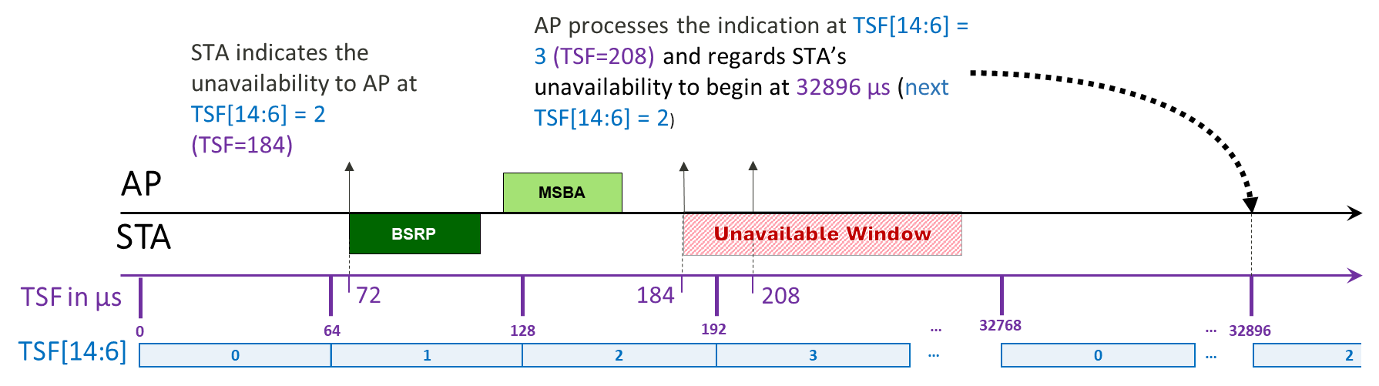

**Baseline solution, FTM:**

In FTM Parameters field format, Partial TSF Timer subfield uses TSF[25:10] with 1 TU (1024 us) time resolution.

“Earlier” has a range 1024 TUs (64512~0), and “Unused” has a range 1024 TUs (63488~64512).

When the indicated TSF[25:10] is ahead from the responding STA’s TSF[25:10] within 1024 TUs, the indicated TSF can be regarded earlier than the responding STA’s TSF.

When the indicated TSF[25:10] is ahead from the responding STA’s TSF[25:10] larger than 1024 TUs, the indicated TSF is not used.

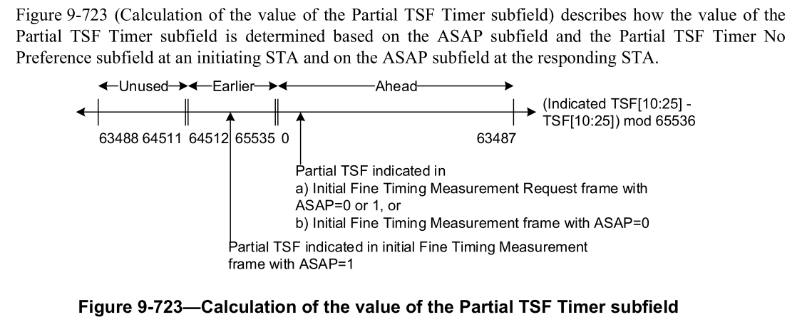 [1]

To avoid the wrap-around when taking only partial TSF as the unavailability start time, there should be a margin to allow aggregated frame processing time, frame transmission time, and unsynchronized TSF between two STAs to be regarded as “Earlier” in the unavailability timing processing. In FTM, the “Unused” is to resolve ambiguity arising from 1) imperfect synchronization between the initiating and responding STAs, and 2) retries of the initial Fine Timing Measurement Request frame or retransmissions of the initial Fine Timing Measurement frame [2]. To indicate the unavailability in Control frames, it is not necessary to consider the retry cases.

**Pros**:

* Allowing a non-AP STA to indicate an unavailability start time close to the future transmission time of the frame carrying the indication.
* Allowing the AP to have more time to process the unavailability indication to avoid wrap-around.
* Relaxing the TSF synchronization constraint between the AP and the non-AP STA.

**Cons**:

* Available start time is reduced. For example, 32.704 ms to 31.680 ms when 1024 us is used for the “Earlier” processing margin.

**Proposal**

***TGbn editor: Please modify the following subclause 37.12.2***

**37.12.2 Dynamic Unavailability Operation (DUO) mode**

…

When a DUO Supporting AP receives from a DUO non-AP STA operating in the DUO mode a Multi-STA BlockAck frame addressed to the AP, in responseto a preceding BSRP Trigger frame, that includes an Unavailability Target Start Time field, the UHR AP shall consider the STA as being unavailable:

— (#710)from the target time for a duration indicated in the Unavailability Duration field, if the unavailability duration is known, where the target time is calculated as,

•if *T >= 0* and *T < 496*, the target time is equal to ;

•otherwise, the target time is equal to *,*

where *T =* , and the indicated TSF is the partial TSF indicated in the Unavailability Target Start Time field,

and until TBD (referring to the conditions for the STA to become available again) if the unavailability duration is unknown.

NOTE— The target time is regarded earlier than AP’s TSF when *T* is in the range from 496 to 511 and can be earlier than AP’s TSF up to 1024 μs.

…

**References**

[1] IEEE 802.11me D7.0

[2] 11-15-0171r4 Clarification to fine timing protocol