IEEE P802.11
Wireless LANs
Miscellaneous PHY CIDs
Date: 2024-3-11
Author(s):
Name | Affiliation | Address | Phone | email
Youhan Kim | Qualcomm Technologies, Inc. |  |  | youhank@qti.qualcomm.com

Abstract
This submission proposes resolutions to the following comments from CC50 on P802.11bn D0.1:

1653, 3371, 1661, 1662

NOTE – Set the Track Changes Viewing Option in the MS Word to “All Markup” to clearly see the proposed text edits.

Revision History:

R0: Initial version.

CID 1653, 3371

CID  Clause  Page.Line | Comment | Proposed Change
1653  38.3.18  204.27 | Define Non-HT duplicate transmission, or refer to 11be | as in comment
3371  38.3.18  204.27 | There is no new BW being introduced in UHR, so there is no need for a section for non-HT duplicate transmission. Just refer to EHT. | Delete the section 38.3.18 Non-HT duplicate transmission

Discussion

Background: 11bn D0.2 P214

UHR does not define any new PPDU bandwidth modes compared to EHT. I.e., both EHT and UHR STAs support the same 20, 40, 80, 160 and 320 MHz PPDU bandwidth modes. Therefore, there is no need for Clause 38 to write down new equations for Non-HT duplicate transmissions. Rather, it is sufficient to refer back to existing equations in prior PHY clauses.

Proposed Resolution: CID 1653, 3371
REVISED

Instruction to TGbn Editor:
Implement the proposed text updates for CIDs 1653 and 3371in https://mentor.ieee.org/802.11/dcn/25/11-25-0664-00-00bn-misc-phy-cids.docx

Note to TGbn Editor:
CIDs 1653 and 3371 have the same proposed text updates.

Note to commenter:
The proposed text defines Non-HT duplicate transmission for UHR.

Proposed Text Updates: CID 1653, 3371
Instruction to TGbn Editor: Update 11bn D0.2 P214L28 as shown below:
38.3.18 Non-HT duplicate transmission

If the TXVECTOR parameter FORMAT is NON_HT and the TXVECTOR parameter NON_HT_MODULATION is NON_HT_DUP_OFDM, the transmitted PPDU is a non-HT duplicate PPDU. Non-HT duplicate transmission is used to transmit to non-HT STAs, HT STAs, VHT STAs, HE STAs, EHT STAs and UHR STAs that may be present in a part of a 40 MHz, 80 MHz, 160 MHz, or 320 MHz channel (see Table 38-2). The RL-SIG, U-SIG, UHR-SIG, UHR-STF, UHR-LTF, and PE fields are not transmitted.
The L-STF and L-LTF fields shall be transmitted in the same way as in the UHR transmission. The L-SIG field shall be transmitted in the same way as in the UHR transmission, with the following exceptions:
—The Rate and Length fields shall follow 17.3.4 (SIGNAL field)
—The four additional subcarriers at indices and are not modulated (no energy)
NOTE—For a non-HT duplicate PPDU transmission that is a preamble punctured PPDU, the L-STF, L-LTF, and L-SIG fields are not transmitted in each punctured 20 MHz subchannel.
In a 40 MHz non-HT duplicate transmission, the Data field shall be as defined by Equation (19-61).
In an 80 MHz or 160 MHz non-HT duplicate transmission, the Data field shall be as defined by Equation (27-123).
In a 320 MHz non-HT duplicate transmission, the Data field shall be as defined by Equation (36-98).

CID 1661

CID  Clause  Page.Line | Comment | Proposed Change
1661  38.3.27  215.3 | Define channel numbering, or refer to 11be | as in comment

Discussion

Background: 11bn D0.2 P225

There are no new channel bandwidth or channels (i.e. channel numbers) being added specifically for UHR. Hence, it is sufficient for the channel numbering in Clause 38 (UHR) to simply refer back to EHT.

FYI, following is the EHT text on channel numbering.
11be D7.0 P947:
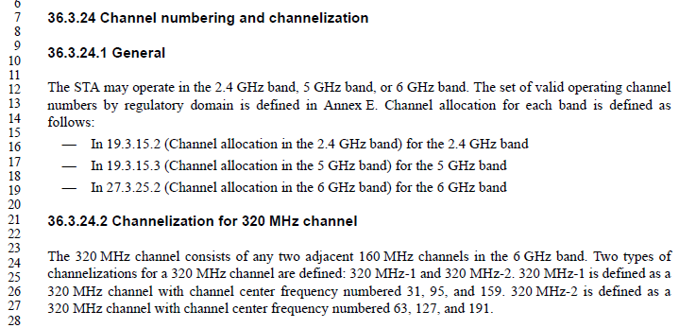

Proposed Resolution: CID 1661
REVISED

Instruction to TGbn Editor:
Implement the proposed text updates for CID 1661in https://mentor.ieee.org/802.11/dcn/25/11-25-0664-00-00bn-misc-phy-cids.docx

Note to commenter:
The proposed text refers readers to Clause 36 (EHT) for channel numbering and channelization.

Proposed Text Updates: CID 1661
Instruction to TGbn Editor: Update 11bn D0.2 P225L55 as shown below:
38.3.28 Channel numbering and channelization

Channel numbering and channelization for UHR STAs are the same as those for EHT STAs. See 36.3.24 (Channel numbering and channelization).

CID 1662

CID  Clause  Page.Line | Comment | Proposed Change
1662  38.3.28  215.6 | Define Regulatory requirements | as in comment

Discussion

Background: 11bn D0.2 P225

While it is not desirable to replicate the same text in the IEEE 802.11 standard in multiple locations in general, regulatory requirements could have severe consequences to products even though it is outside the scope of the IEEE 802.11 standard. Hence, to be ‘on par’ with other PHY clauses, the same text from EHT (36.3.25) is copied to 38.3.29 for now.

Proposed Resolution: CID 1662
REVISED

Instruction to TGbn Editor:
Implement the proposed text updates for CID 1662in https://mentor.ieee.org/802.11/dcn/25/11-25-0664-00-00bn-misc-phy-cids.docx

Note to commenter:
The proposed text copies the regulatory requirements from Clause 36 (EHT).

Proposed Text Updates: CID 1662
Instruction to TGbn Editor: Update 11bn D0.2 P225L60 as shown below:
38.3.29 Regulatory requirements

WLANs implemented in accordance with this standard are subject to equipment certification and operating requirements established by regional and national regulatory administrations. The PHY specification establishes minimum technical requirements for interoperability, based upon established regulations at the time this standard was issued. These regulations are subject to change. Requirements that are subject to local geographic regulations are annotated within the PHY specification. Regulatory requirements that do not affect interoperability are not addressed in this standard. Implementers are referred to the regulatory sources in Annex D for further information. Operation in countries within defined regulatory domains might be subject to additional or alternative national regulations.

[End of File]

