IEEE P802.11  
Wireless LANs

|  |  |  |  |  |
| --- | --- | --- | --- | --- |
| PPDU Duration based NPCA | | | | |
| Date: 2025-04-03 | | | | |
| Author(s): | | | | |
| Name | Affiliation | Address | Phone | email |
| Oren Kedem | Maxlinear |  |  |  |
| Iñaki Val Beitia | Maxlinear |  |  |  |
| Avner Epstein | Maxlinear |  |  |  |
| Elad Ben Yosef | Maxlinear |  |  |  |
| Amir Rosenblum | Maxlinear |  |  |  |
|  |  |  |  |  |
|  |  |  |  |  |

Abstract

This document contains Proposed Text for the Non Primary Channel Access (NPCA) feature of the proposed TGbn (UHR, Ultra High Reliability) amendment to the 802.11 standard.

# Revision information

The following is a summary of the important changes that occurred within each revision of this document:

|  |  |
| --- | --- |
| **Revision** | **Major changes** |
| 0 | Initial revision |
|  |  |

# Introduction

## DISCUSSION:

[24/2110r0](https://mentor.ieee.org/802.11/dcn/24/11-24-2110-00-00bn-impact-of-hidden-nodes-on-npca-performance.pptx) (impact-of-hidden-nodes-on-npca-performance) simulation shows the risk in TXOP Based NPCA that can reduce overall performance in case the OBSS TXOP was shortened by the originator. In this case the Primary is already taken by OBSS by the time NPCA STA returns from NPCA Primary.

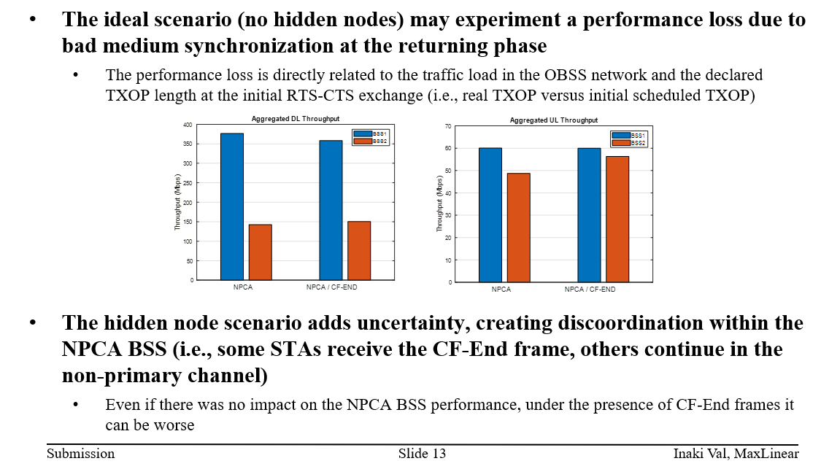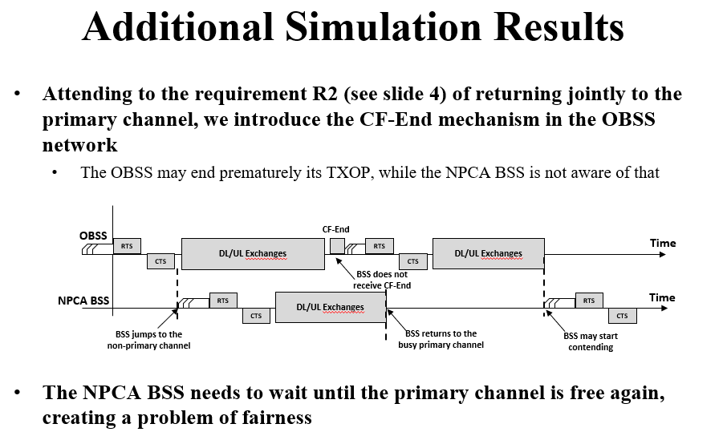

TXOP duration may be shortened due to the following reasons:

* TXOP Duration is estimated in RTS based on Originator sensed CCA and may be changed due to the negotiated TXOP BW by the CTS.
* Window Size and retransmission may change the original transmission plan of the originator.
* In case Multiple Protection is used, it may be shortened afterwards via CF-End.
* In case of Single Protection, the RTS protects the first PPDU and then extends it in the second PPDU.

The RXVECTOR parameter TXOP_DURATION is optional in HE/EHT/UHR PPDU.

All the above can lead to **loss of TXOP opportunities in the BSS Primary Channel** upon return from NPCA TXOP.

NPCA based on PPDU Duration is more robust since:

* PPDU Duration is not reduced after PHY Preamble has been transmitted
* It allows sufficient NPCA TXOP time (up to 5.4ms)

PPDU based NPCA **does not involve risk in reducing overall performance.**

Below table summarizes all the PPDU types valid for PPDU based NPCA:

|  |  |  |
| --- | --- | --- |
| HE PPDU |  | **L-SIG**  PPDU Duration  **SIG-A**  BSS Color  Bandwidth |
| EHT PPDU |  | **L-SIG**  PPDU Duration  **U-SIG**  BSS Color  Bandwidth |
| UHR |  | **L-SIG**  PPDU Duration  **U-SIG**  BSS Color  Bandwidth |
| VHT |  | **L-SIG**  PPDU Duration  **VHT-SIG-A**  Bandwidth  No means to identify Inter/Intra by the PHY Preamble |

In case of HE/EHT/UHR PPDUs, NPCA STA may switch to NPCA Primary immediately after decoding HE-SIG-A (HE) or U-SIG (EHT/UHR) without the need to decode the PSDU payload.

In case of VHT PPDU, the identification of Inter/Intra NAV cannot be performed based solely on the preamble.

Identifying the Inter/Intra based on PSDU payload (MAC Header) complicates the design and generates uncertainty to the NPCA switching point.

Therefore, it must be performed based on the preceding RTS/CTS (if exist).



**Note:** HT are not applicable for 5GHz/6GHz.

25/xxxxr0 (0-00bn-npca-follow up) simulation shows:

* A non-AP STA may receive OBSS transmissions while the AP does not receive it and vice versa, therefore it is not guaranteed that both AP and non-AP STA will be present on the NPCA Primary at a given NPCA opportunity. Therefore, **BSRP frame as NPCA ICF/ICR to verify the presence of NPCA non-AP STA in NPCA Primary channel is required and increases the probability of successful NPCA TXOP**.
* BSRP frame can also accommodate the non-AP STA requirements for any EHT/UHR feature also in the NPCA Primary (EMLSR/DPS/DSO/DUO ect).
* The main risk to switch to NPCA Primary in a "PPDU Based NPCA" is the increase of STA power consumption (compared to power save while in Basic NAV). In order to reduce this risk, **NPCA AP should advertise its criteria for switching to the NPCA Primary for avoiding false NPCA switch by the STA**.

NPCA AP can minimize non-AP STA false NPCA switches by advertising the following information:

* The minimum OBSS PPDU Duration to be utilized for NPCA TXOP.
* The minimum NPCA TXOP bandwidth (as sensed by CCA prior the NPCA Switch) to be utilized for NPCA TXOP.
* The maximum NPCA switching delay it accommodates to initiate NPCA TXOP.
* The PPDU BSS-Color options that are applicable for NPCA Switch (in case HE/EHT/UHR PPDU)

**In case NPCA STA has switched to NPCA Primary and has received a PPDU which is not BSRP from its associated AP, it may switch back to Primary channel.**

# Proposed text to be adopted begins here:

**37.11 Non-primary channel access (NPCA)**

**37.11.1 TXOP based NPCA**

*Move all existing text from 37.11 to be demoted under this paragraph*

**37.11.2 PPDU based NPCA**

*This should be a new paragraph*

NPCA STA may switch to the NPCA primary channel for NPCA TXOP operation if the value of the recently received or transmitted NPCA Operation Information Present field corresponding to the BSS of which it is a member is equal to 1 and either condition 1) or 2) is met:

1. The STA received on the BSS primary channel a PHY-RXSTART.indication primitive containing the following valid RXVECTOR parameters that satisfy all the requirements below:
2. FORMAT equals any one of the following options HE_SU, HE_MU, HE_ER_SU, HE_TB, EHT_MU, EHT_TB, UHR_MU, UHR_TB and UHR_ELR.
3. BSS_COLOR satisfies the inter-BSS conditions following the procedure defined in 26.2.2 (Intra-BSS and inter-BSS PPDU classification) and the BSS_COLOR is equal to one of the OBSS Colors that are advertised by the AP in the NPCA OBSS Parameters field format.
4. The PPDU RXTIME based on received L_LENGTH is greater than Minimum NPCA PPDU Duration advertised in NPCA Operation Information:
   1. In case FORMAT is either HE_SU, HE_MU, HE_ER_SU or HE_TB, the PPDU RXTIME is calculated according to Equation (27-147).
   2. In case FORMAT is either EHT_MU or EHT_TB, the PPDU RXTIME is calculated according to Equation (36-108).
   3. In case FORMAT is either UHR_MU, UHR_TB or UHR_ELR, the PPDU RXTIME is calculated according to Equation (TBD).
5. CH_BANDWIDTH value is indicated as supported in the NPCA PPDU Parameters last indicated by the AP in the NPCA Operation Information
6. The STA received on the BSS primary channel a PHY-RXSTART.indication primitive containing the following valid RXVECTOR parameters that satisfy all the requirements below:
7. FORMAT is VHT.
8. PARTIAL_AID satisfies the inter-BSS conditions following the procedure defined in 26.2.2 (Intra-BSS and inter-BSS PPDU classification) or the STA received on the BSS primary channel a successful RTS/CTS sequence a SIFS before the a PHY-RXSTART.indication primitive that satisfies the inter-BSS conditions following the procedure defined in 26.2.2 (Intra-BSS and inter-BSS PPDU classification).
9. The PPDU RXTIME calculated based on received L_LENGTH and Equation (21-105) is greater than Minimum NPCA PPDU Duration advertised in NPCA Operation Information.
10. CH_BANDWIDTH is indicated as supported in the NPCA PPDU Parameters last indicated by the AP in the NPCA Operation Information.

NPCA non-AP STA shall be ready to receive an initial control frame in Non-HT or non-HT Duplicate mode on the NPCA Primary channel after NPCA Switching Delay time as indicated in its NPCA Capability Parameters starting from one of the below NPCA Switching Point:

1. NPCA-Switching-Point-A: Immediately after the successful receiving of SIG-A or U-SIG field in case NPCA switch was due to condition (1)
2. NPCA-Switching-Point-B: Immediately after the successful receiving VHT-SIG-A field in case NPCA switch was due to condition 2)

NPCA Non-AP STA may consider the NPCA Minimum Primary CCA value last indicated by the AP in the NPCA Operation Information in its decision whether to switch to the NPCA Primary.

An NPCA non-AP STA may switch back from the NPCA primary to the BSS primary upon a reception of PPDU which is not BSRP frame sent by its associated AP.

NPCA AP may initiate NPCA TXOP according to the following rules:

1. TXOP shall be obtained by the rules defined in 10.23.2.2 (EDCA backoff procedure) and 10.23.2.4 (Obtaining an EDCA TXOP).
2. AP shall contend the NPCA Primary channel using the same EDCA parameter set as used in Primary channel
3. Each time that the AP switches to the NPCA primary channel, it shall randomly choose a new initial value between 0 and CW_NPCA[AC] for the backoff counter.
4. NPCA TXOP shall not affect QSRC[AC].
5. NPCA TXOP shall not start before the Maximum NPCA Switching Delay indicated in the NPCA Operation Information started from the NPCA-Switching-Point that triggered the NPCA TXOP.
6. NPCA TXOP shall start with BSRP frame using non-HT PPDU or non-HT duplicate PPDU format using a rate of 6 Mb/s, 12 Mb/s, or 24 Mb/s.

The AP shall set the length of the Padding field of the initial Control frame based on the rules defined in 35.5.2.2.3 (Padding for a Trigger frame) to ensure that the MAC padding duration of the initial Control frame is greater than or equal to the NPCA Maximum Initial Control Padding field last indicated by the AP in the NPCA Operation Information.

The BSRP frame that initiates the NPCA TXOP shall include padding field which is at least the maximum of all padding requirements for the non-AP STA addressed by the trigger frame according to their operating state.

An NPCA AP that transmits a trigger frame on the NPCA primary channel shall indicate RU index values that use the NPCA primary channel as the reference primary channel. The Trigger frame shall include an explicit indication that it is transmitted on the NPCA primary channel.

The 20 MHz channels occupied by PPDUs transmitted by the NPCA STA shall meet all the following conditions:

1. Include at least the NPCA primary channel
2. Shall be within the BSS Operating Channels.
3. Shall not include channels occupied by CH_BANDWIDTH of the PHY-RXSTART.indication that trigger the NPCA switch.
4. Do not include channels that are indicated as punctured in the Disabled Subchannel Bitmap field in the EHT Operation element

NPCA TXOP shall not exceed the OBSS PPDU RXTIME that triggers the NPCA TXOP minus the Maximum NPCA Switching Back Delay as advertised in NPCA Operation Information.

**9.4.2.aa1 UHR Operation Element**

The format of the NPCA Operation Information field is defined in Figure 9-aa1 (NPCA Operation Information

field format).

|  |  |  |  |  |  |  |  |
| --- | --- | --- | --- | --- | --- | --- | --- |
|  | B0- B7 | TBD - TBD | TBD | TBD | TBD | TBD |  |
|  | NPCA Primary Channel | NPCA Operation Modes | NPCA Parameters Present | NPCA Switching  Parameters | NPCA OBSS Parameters | NPCA  TXOP Parameters | NPCA  PPDU Parameters |
| Bits: | 8 | 8 | 8 | TBD | TBD | TBD | TBD |

**Figure 9-aa1—** **NPCA Operation Information field format**

The NPCA Primary Channel field indicates the channel number of a channel within the BSS bandwidth that

corresponds to the channel that the NPCA AP and its associated NPCA non-AP STAs switch to in order to

perform NPCA operation, as described in 37.11 (Non-primary channel access (NPCA)).

The format of the NPCA Operation Modes field is defined in Figure 9-aa2 (NPCA Operation Modes field format),

|  |  |  |  |  |
| --- | --- | --- | --- | --- |
|  | B0 | B1 | B2 | B3-B7 |
|  | NPCA TXOP Based Supported | NPCA PPDU Based Supported | NPCA Untriggered UL Supported | Reserved |
| Bits: | 1 | 1 | 1 | 5 |

**Figure 9-aa2—** **NPCA Operation Modes field format**

The NPCA TXOP Based Supported field indicates the support of NPCA TXOP Based functionality as described in 37.11.1 PPDU based NPCA

The NPCA PPDU Based Supported field indicates the support of NPCA PPDU Based functionality as described in 37.11.2 PPDU based NPCA

NPCA Untriggered UL Supported field indicates that non-AP STA may initiate NPCA TXOP on NPCA Primary channel.

The format of the NPCA Parameters Present field is defined in Figure 9-aa3 (NPCA Parameters Present field format),

|  |  |  |  |  |  |
| --- | --- | --- | --- | --- | --- |
|  | B0 | B1 | B2 | B3 | B4-B7 |
|  | NPCA OBSS Present | NPCA TXOP Present | NPCA PPDU Present | Reserve | Reserve |
| Bits: | 1 | 1 | 1 |  | 4 |

**Figure 9-aa3—** **NPCA Parameters Present field format**

The NPCA Switching Present field indicates that NPCA Switching Parameters field is present in the NPCA Operation Information field.

The NPCA OPSS Present field indicates that NPCA OBSS Parameters field is present in the NPCA Operation Information field.

The NPCA TXOP Present field indicates that NPCA TXOP Parameters field is present in the NPCA Operation Information field.

The NPCA PPDU Present field indicates that NPCA PPDU Parameters field is present in the NPCA Operation Information field.

The format of the NPCA Switching Parameters field defined in Figure 9-aa4 (NPCA Switching Parameters field format),

|  |  |  |  |  |
| --- | --- | --- | --- | --- |
|  | B0- B7 | B8- BD |  |  |
|  | NPCA Maximum Switching Delay | NPCA Maximum Switching Back Delay | NPCA Maximum Initial Control Padding | NPCA Minimum Primary CCA |
| Bits: | 8 | 8 | 8 | 3 |

**Figure 9-aa4—** **NPCA Switching Parameters field format**

The NPCA Maximum Switching Delay field indicates the maximum delay time AP waits after NPCA-Switching-Point that triggered to NPCA TXOP before initiating NPCA TXOP on NPCA primary channel and is units of 4 μs.

The NPCA Maximum Switching Back Delay field indicates the maximum delay time AP intend to allow in the end of NPCA TXOP to return the BSS Primary channel in units of 4 μs.

The NPCA Maximum Initial Control Padding field indicates the maximum padding delay time AP sets in the initial control frame in units of 4 μs.

The NPCA Minimum Primary CCA field indicates the NPCA Primary channels CCA Status should be sensed at the time of NPCA-Switching-Point (A or B) for NPCA TXOP.

**Table 9-aa—** **NPCA Minimum Primary CCA field**

|  |  |
| --- | --- |
| **NPCA Minimum Primary CCA value** | **NPCA Minimum Primary CCA value Description** |
| 0 | NPCA AP switches to NPCA Primary at the time of NPCA-Switching-Point regardless of the CCA status condition of NPCA channels |
| 1 | NPCA AP switches to NPCA Primary at the time of NPCA-Switching-Point condition that the NPCA Primary channels CCA are free. |
| 2 | NPCA AP switches to NPCA Primary at the time of NPCA-Switching-Point condition that the NPCA Primary and Secondary20 channels CCA are free. |
| 3 | NPCA AP switches to NPCA Primary at the time of NPCA-Switching-Point condition that the NPCA Primary, Secondary20 and Secondary40 channels CCA are free. |
|  |  |

The format of the NPCA OBSS Parameters field is defined in Figure 9-aa4 (NPCA OBSS Parameters field format),

|  |  |  |  |  |  |
| --- | --- | --- | --- | --- | --- |
|  | B0- B3 | B4- TBD | TBD - TBD |  |  |
|  | OBSS Color Size | OBSS Color 1 | OBSS Color 2 | OBSS Color N | padding aligned to 8bit |
| Bits: | 4 | 6 | 6 |  |  |

**Figure 9-X5—** **NPCA OBSS Parameters field format**

The NPCA Color Size field indicates the number of OBSS Colors indicated in the NPCA OBSS Parameters field.

The NPCA Color field indicates the BSS Color value carried by the HE/EHT/UHR PPDU to trigger NPCA TXOP.

|  |  |  |
| --- | --- | --- |
|  | B0- B15 | B16- B23 |
|  | NPCA Minimum OBSS PPDU TxTime Threshold | NPCA Minimum OBSS PSDU Channel Bandwidth |
| Bits: | 16 | 8 |

**Figure 9-X5—** **NPCA PPDU Parameters field format**

The NPCA Minimum OBSS PPDU TxTime Threshold field indicates the minimum PPDU TXTIME required to trigger NPCA TXOP in units of 4 μs.

.

|  |  |  |  |  |  |  |  |
| --- | --- | --- | --- | --- | --- | --- | --- |
|  | B0 | B1 | B2 | B3 | B4 | B4 | B6-B7 |
|  | NPCA CBW20 PPDU Supported | NPCA CBW40 PPDU Supported | NPCA CBW80 PPDU Supported | NPCA CBW160 PPDU Supported | NPCA CBW320-1 PPDU Supported | NPCA CBW320-2 PPDU Supported | Reserved |
| Bits: | 1 | 1 | 1 | 1 | 1 | 1 | 2 |

**Figure 9-X5—** **NPCA OBSS PPDU Channel Bandwidth field format**

The NPCA CBW20 PPDU Supported field indicates that OBSS PPDU which its CH_BANDWIDTH equal CBW20 value triggers NPCA TXOP.

|  |  |  |
| --- | --- | --- |
|  | B0- B3 | B4- TBD |
|  | NPCA Minimum  Duration Threshold | reserved |
| Bits: | 4 | 16 |

**Figure 9-X5—** **NPCA TXOP Parameters field format**

The NPCA Minimum Duration Threshold field indicates the minimum duration of inter-BSS activity (inter-

BSS PPDU or inter-BSS TXOP) that is required to have been indicated on the primary channel of the BSS as

a necessary condition to permit an NPCA STA to switch to the NPCA primary channel to perform NPCA

operation. The encoding and the maximum value of this field are TBD.