IEEE P802.11  
Wireless LANs

|  |  |  |  |  |
| --- | --- | --- | --- | --- |
| cc50-cid-1774-discussion-on-npca-and-dps | | | | |
| Date: May 13, 2025 | | | | |
| Author(s): | | | | |
| Name | Affiliation | Address | Phone | email |
| Chaoming Luo | OPPO |  |  | luochaoming@oppo.com |
| Liuming Lu |  |  | luliuming@oppo.com |
| Ning Gao |  |  | gaoning1@oppo.com |
| Yapu Li |  |  | liyapu1@oppo.com |
| Liangxiao Xin |  |  | v-xinliangxiao@oppo.com |

Abstract

This submission proposes resolution for CID 1774 received for CC50.

**Revisions:**

* Rev 0: Initial version of the document.
* Rev 1: Change the document format from ppt to doc

***TGbn editor: The baseline for this document is P802.11bn D0.2 and P802.11REVmeD7.0***

# **CID 1780**:

***TGbn Editor: Editing instructions preceded by “TGbn Editor” are instructions to the TGbn editor to modify existing material in the TGbn draft. As a result of adopting the changes, the TGbn editor will execute the instructions rather than copy them to the TGbn Draft.***

|  |  |  |  |  |  |  |
| --- | --- | --- | --- | --- | --- | --- |
| **CID** | **Commenter** | **Clause** | **Page.line** | **Comment** | **Proposed Change** | **Resolution** |
| 1774 | Chaoming Luo | 37.10 | 78.01 | Could a DPS STA enable NPCA? Should a DPS STA switch to HC mode by default when switch to NPCA P-channel? | Define the behavior of a DPS STA switching to HC mode in NPCA procedure. | **Revised**  Agree with the commenter in principle.  **TGbn editor, please incorporate changes tagged with 1774 in 11-25/0557r1.** |

## **Discussion:**

* Could a DPS STA enable NPCA?
  + Does not find a reason to disallow this.
* Should a DPS STA switch to higher capability mode when switch to NPCA P-channel?
  + [1] proposes when a DPS STA is in low capability mode and transitions from the BSS primary channel to the NPCA primary channel, it still is in low capability mode.
  + However, why a NPCA STA switches to NPCA P-channel? A typical reason is it has much data to transmit or receive. And, a DPS STA switches from LC mode to HC mode due to the same reason.
  + Both NPCA switch and DPS switch consume time. If the DPS STA switches to HC mode the same time when it switches to NPCA P-channel, the DPS assisting AP saves time in the NPCA TXOP.
  + We should allow a DPS STA to make the decision based on its own traffic status and power status.
    - E.g., with low latency traffic, switch to HC mode may be better
    - E.g., with low power level, keep in LC mode may be better

So, we propose:

* A DPS STA is in low capability mode and transitions from the BSS primary channel to the NPCA primary channel, by default it still is in low capability mode.
* The DPS STA may change the default behavior and switch to HC mode when it switches to the NPCA P-channel.
* The DPS STA may announce in advance that it switches to HC mode when it switches to the NPCA P-channel.
  + E.g., announcement in EHT OM control using the reserved bits or NPCA enablement frame (the TBD frame used to enable NPCA) or DPS enablement frame (the TBD frame used to enable DPS)

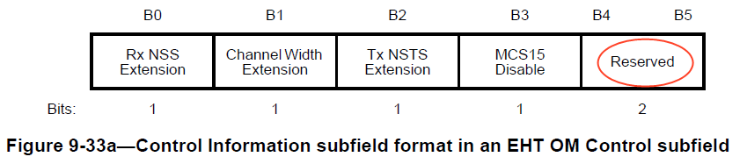

## **Proposed Text starts here:**

**37.10.1 Dynamic power save (DPS) operation**

…

A DPS assisting STA shall solicit the transition of the peer DPS STA to HC mode by sending an Initial Control frame, which is transmitted in non-HT (duplicate) PPDU using a rate of 6 Mb/s, 12 Mb/s, or 24 Mb/s [TBD]. The Initial Control frame addressed to the DPS STA shall include an intermediate FCS field if the DPS STA has indicated a non zero DPS padding delay and shall include sufficient padding to ensure that the padding requirement(s) of the DPS STA(s) that are addressed by that ICF are satisfied as defined in 37.15 (Padding for an Initial Control frame). It is TBD whether a DPS assisting STA shall initiate any frame exchange with a DPS STA by sending an ICF or only some frame exchanges.

***TGbn Editor: Please add the following paragraphs at P83L56 in 11bn D0.2:***

A DPS STA that is in lower capability mode and switches to the NPCA primary channel for NPCA operation following the procedure defined in 37.11 (Non-primary channel access (NPCA)), shall remain in lower capability mode, unless the DPS STA announced in the most recently sent EHT OM Control or NPCA enablement frame or DPS enablement request frame that it switches to higher capability mode when it switches to the NPCA primary channel. [1774]

## **Proposed Text ends here**

# **SP**

Do you support resolution to the CID 1774 and incorporate the corresponding text changes in 11-25/0557r1 into the latest TGbn draft?

Y/N/A

# **References**

[1] 11-24-1886-00-00bn-npca-with-emlsr-dps-coex-mode