IEEE P802.11  
Wireless LANs

|  |
| --- |
| **CC50 Comment Resolutions for 38.3.15.10.2 UHR-STF for DRUs** |
| **Date:** 2025-04-03 |
| **Author(s):** |

|  |  |  |  |  |
| --- | --- | --- | --- | --- |
| **Name** | **Affiliation** | **Address** | **Phone** | **Email** |
| Eunsung Park | LG Electronics | 19, Yangjae-daero 11gil, Seocho-gu, Seoul 137-130, Korea |  | esung.park@lge.com |
| Dongguk Lim |  | dongguk.lim@lge.com |
| Insik Jung |  | insik0618.jung@lge.com |
| Jinsoo Choi |  | js.choi@lge.com |

Abstract

This submission proposes resolutions for comments of TGbn D0.2 with the following 13 CIDs:

337 338 592 593 594 1641 1898 2183 2300 2301 2302 2306 3523

Revisions:

* Rev 0: Initial version of the document.

Interpretation of a Motion to Adopt

A motion to approve this submission means that the editing instructions and any changed or added material are actioned in the TGbn D0.2 Draft. This introduction is not part of the adopted material.

***Editing instructions formatted like this are intended to be copied into the TGbn D0.2 Draft (i.e. they are instructions to the 802.11 editor on how to merge the text with the baseline documents).***

***TGbn Editor: Editing instructions preceded by “TGbn Editor” are instructions to the TGbn editor to modify existing material in the TGbn draft. As a result of adopting the changes, the TGbn editor will execute the instructions rather than copy them to the TGbn Draft.***

#### *CIDs 337*

|  |  |  |  |  |  |
| --- | --- | --- | --- | --- | --- |
| **CID** | **Clause** | **PP.LL** | **Comment** | **Proposed Change** | **Resolution** |
| 337 | 38.3.15.10.2 | 192.01 | " the occupied STF tones are the same as that of the largest RRU corresponding to  the distribution BW within the PPDU BW.". This is confusing. Surely not all RRU tones can be used in a DRU. | Clarify | Rejected.  TGbn agreed to use the occupied STF tones corresponding to the largest RRU of the DBW, not the STF tones overlapped with DRU |

#### *CIDs 2183, 1898*

|  |  |  |  |  |  |
| --- | --- | --- | --- | --- | --- |
| **CID** | **Clause** | **PP.LL** | **Comment** | **Proposed Change** | **Resolution** |
| 2183 | 38.3.15.10.2 | 191.63 | the abbreviation for Distribution Bandwidth (DBW) is already used prior to this section | Use either 'distribution bandwidth' or the abbreviation 'DBW' which is already used in prior sections | Revised  Agree in principle with the commenter.  TGbn editor: Please make the changes shown in 11-25/0547r0. |
| 1898 | 38.3.15.10.2 | 191.63 | Typo. Please replace UL TB PPDU with TB PPDU | As in comment | Revised  Agree in principle with the commenter.  TGbn editor: Please make the changes shown in 11-25/0547r0. |

*TGbn Editor: Please make the following changes in the first paragraph in Section 38.3.15.10.2 of D0.2:*

**38.3.15.10.2 UHR-STF for DRUs**

The same UHR-STF sequences are used in UHR TB PPDUs for both UHR DRU and UHR RRU. For a DRU with a given (#2183)DBW transmitted in a (#1898)UHR TB PPDU, UHR-STF sequence depends on the PPDU BW, the occupied STF tones are the same as that of the largest RRU corresponding to the (#2183)DBW within the PPDU BW.

#### *CIDs 594*

|  |  |  |  |  |  |
| --- | --- | --- | --- | --- | --- |
| **CID** | **Clause** | **PP.LL** | **Comment** | **Proposed Change** | **Resolution** |
| 594 | 38.3.15.10.2 | 193.06 | Change "DBW of 20 or 40MHz or 60MHz" to "DBW of 20 MHz, 40 MHz or 60 MHz". | See the comment. | Revised.  Agree in principle with the commenter.  TGbn editor: Please make the changes shown in 11-25/0547r0. |

*TGbn Editor: Please make the following changes in the last paragraph in Section 38.3.15.10.2 of D0.2:*

The maximum DBW is 80 MHz in 80 MHz, 160 MHz, and 320 MHz UHR TB PPDUs. DRUs with DBW of 20 MHz,(#594) 40 MHz or 60 MHz are allowed within each 80 MHz frequency subblock.

#### *CIDs 592, 1641, 2300*

|  |  |  |  |  |  |
| --- | --- | --- | --- | --- | --- |
| **CID** | **Clause** | **PP.LL** | **Comment** | **Proposed Change** | **Resolution** |
| 592 | 38.3.15.10.2 | 192.09 | UHR-STF for DRU is the same as 2x UHR-STF for RRU. It is better to refer to the equations in 38.3.15.10.1 instead of listing all of the equations. | See the comment. | Revised.  Agree in principle with the commenter.  TGbn editor: Delete from “For a 20 MHz transmission, the frequency domain sequence ~” to “~ is defined in Equation (36-34)”, i.e., from P192L4 to P192L54 in 38.3.15.10.2(UHR-STF for DRUs) of D0.2.  Also, add the the following paragraph right below the first paragraph in 38.3.15.10.2(UHR-STF for DRUs) of D0.2  “For 20 MHz, 40 MHz, 80 MHz, 160 MHz and 320 MHz transmissions, the frequency domain sequences for UHR-STF for DRU are given by  Equation (38-19), Equation (38-20), Equation (38-21), Equation (38-22) and Equation (38-23), respectively.” |
| 1641 | 38.3.15.10 | 188.53 | Remove duplication for UHR-STF for DRU and non-DRU case | as in comment | Revised.  Agree in principle with the commenter.  TGbn editor: Resolution is the same as CID 592 in 25/0547r0 |
| 2300 | 38.3.15.10.2 | 192.4~54 | Why we need add equations (38-26) to (38-30) ssince it already states "The same UHR-STF sequences are used in UHR TB PPDUs for both UHR DRU and UHR RRU." and the sequence for UHR RRU are listed in equation (38-19) to (38-23). | As in comment | Revised.  Agree in principle with the commenter.  TGbn editor: Resolution is the same as CID 592 in 25/0547r0 |

**Discussion**

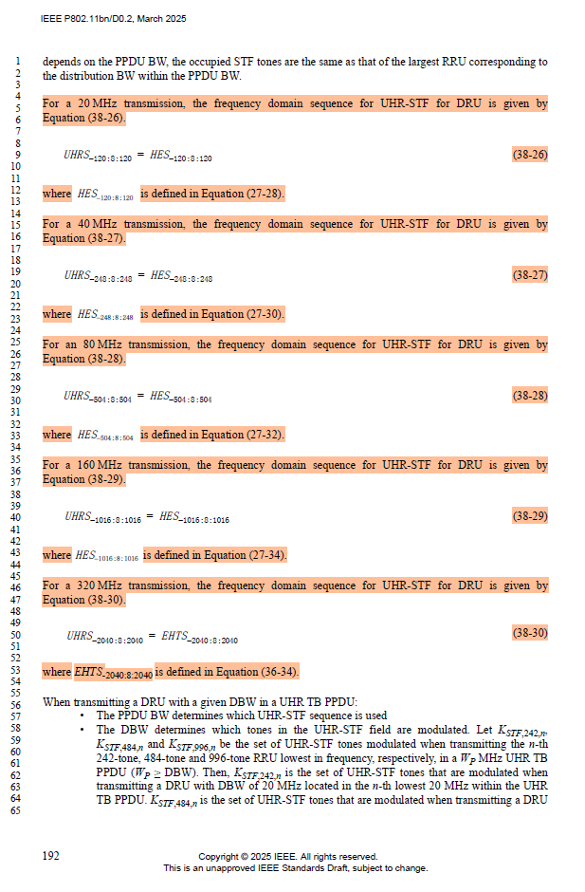

#### *CIDs 593, 2301, 2302*

|  |  |  |  |  |  |
| --- | --- | --- | --- | --- | --- |
| **CID** | **Clause** | **PP.LL** | **Comment** | **Proposed Change** | **Resolution** |
| 593 | 38.3.15.10.2 | 192.59 | Add a description for DBW60 using K_STF,484+242,n. | See the comment. | Revised.  Agree in principle with the commenter  TGbn editor: Please make the changes shown in 11-25/0547r0. |
| 2301 | 38.3.15.10.2 | 192.56 | There is no need to use subbullets for last paragraph in spec text on page 182. Rephrase to "When transmitting a DRU with a given DBW in a UHR TB PPDU, the PPDU BW determines which UHR-STF sequence is used and the DBW determines which tones in the UHR-STF field are modulated. | As in comment | Revised.  Agree in principle with the commenter.  TGbn editor: Please make the changes shown in 11-25/0547r0. |
| 2302 | 38.3.15.10.2 | 192.56 | Separate "Let KSTF,242,n, ... UHR TB PPDU" from the previous sentence. Start with a new paragraph. Move "lowest" after "n-th". | As in comment | Revised.  Agree in principle with the commenter.  TGbn editor: Please make the changes shown in 11-25/0547r0. |

*TGbn Editor: Please make the following changes in Section 38.3.15.10.2 of D0.2:*

**38.3.15.10.2 UHR-STF for DRUs**

…..

When transmitting a DRU with a given DBW in a UHR TB PPDU, the PPDU bandwidth determines which UHR-STF sequence is used and the DBW determines which tones in the UHR-STF field are modulated.(#2301)

Let *KSTF*,242,*n*, *KSTF*,484,*n*and *KSTF*,996,*n* be the set of UHR-STF tones modulated when transmitting the *n*-th lowest 242-tone, 484-tone and 996-tone RRU in frequency, respectively, in a *WP* MHz UHR TB PPDU (*WP* ≥ DBW). Also, let *KSTF*,484+242,*n* be the set of UHR-STF tones modulated when transmitting 484+242-tone MRU in the *n*-th lowest 80 MHz frequency subblock where the highest 20 MHz subchannel is unallocated in a *WP* MHz UHR TB PPDU (*WP* ≥ DBW). Then, *KSTF*,242,*n* is the set of UHR-STF tones that are modulated when transmitting a DRU with DBW of 20 MHz located in the *n*-th lowest 20 MHz within the UHR TB PPDU. *KSTF*,484,*n* is the set of UHR-STF tones that are modulated when transmitting a DRU with DBW of 40 MHz located in the *n*-th lowest 40 MHz within the UHR TB PPDU. *KSTF*,484+242,*n* is the set of UHR-STF tones that are modulated when transmitting a DRU with DBW of 60 MHz located in the *n*-th lowest 80 MHz within the UHR TB PPDU. *KSTF*,996,*n* is the set of UHR-STF tones that are modulated when transmitting a DRU with DBW of 80 MHz located in the *n*-th lowest 80 MHz within the UHR TB PPDU.(#593)(#2302)

#### *CIDs 2306, 3523, 338*

|  |  |  |  |  |  |
| --- | --- | --- | --- | --- | --- |
| **CID** | **Clause** | **PP.LL** | **Comment** | **Proposed Change** | **Resolution** |
| 2306 | 38.3.15.10.2 | 193.08 | Need a paragraph to add the time domain representation of the signal for UHR-STF for DRUs. It can use the same equation as RRU (38-25). But need to give the explanations of Kr range for different DBWs, and incorporate CSD index for the r-th DRU. | As in comment | Revised.  Agree in principle with the commenter. Suggest to add the time domain representation of the signal for UHR-STF with a DRU transmission.  TGbn editor: Please add the text shown in 11-25/0547r0. |
| 3523 | 38.3.15.10.2 | 192.56 | Add equation or refer to equation (38,25) for UHR-STF for DRUs to support the description in line 56 onward. |  | Revised.  Agree in principle with the commenter. Suggest to add the time domain representation of the signal for UHR-STF with a DRU transmission.  TGbn editor: Resolution is the same as CID 2306 in 11-25/0547r0. |
| 338 | 38.3.15.10.2 | 192.56 | It would be helpful and clearer if this paragraph were moved to the beginning of the subclause since it describes some basic rules for DRUs. | See comment | Revised.  The parameters in the paragraph can be used for a time domain representation of the signal for UHR-STF with a DRU transmission. Suggest to keep the location of the paragraph mentioned in the comment and add the time domain representation of the signal for UHR-STF with a DRU transmission.  TGbn editor: Resolution is the same as CID 2306 in 11-25/0547r0. |

*TGbn Editor: Please add the following texts at the end of Section 38.3.15.10.2 of D0.2:*

(#2306)(#3523)(#338)The time domain representation of the signal for a UHR TB PPDU transmitted by user *u* in the *r*-th DRU on *iTX* transmit chain shall be as specified in Equation (38-xx).

$$r_{\text{UHR-STF},r,u}^{\left(i_{TX}\right)}\left(t\right)=\frac{1}{\sqrt{\left|K_{r}^{UHR\text{-STF}}\right|N_{SS,r,u}}}w_{T_{UHR\text{-STF-T}}}\left(t\right) \text{(38-xx)}$$

$$\sum_{k∈K_{r}}{\sum_{m=1}^{N_{SS,r,u}}{\left({\left[Q_{k,u}\right]}_{i_{TX},m}UHRS_{k}∙\text{exp}\left(j2π∆_{F,UHR}\left(t-T_{CS, \text{UHR}}\left(mod\left(j_{r}+m-2,8\right)+1\right)\right)\right)\right)}}$$

where

$K_{r}^{UHR\text{-STF}}$ is the set of subcarriers that have nonzero values within $K_{r}$ in the UHR-STF field.

$\left|K_{r}^{UHR\text{-STF}}\right|$ is the cardinality of the set of subcarriers $K_{r}^{UHR\text{-STF}}$.

$K_{r}$ is *KSTF*,242,*n*, *KSTF*,484,*n*, *KSTF*,484+242,*n* or *KSTF*,996,*n* depending on the DBW and the location of the *r*-th DRU (see 38.3.15.10.2 (UHR-STF for DRUs)).

$j_{r}$ is the CSD starting index of the *r*-th DRU (see 38.3.15.10.4 (CSD index assignment for DRU UHR-STF transmission)).

$mod(a,b)$ is the modulo *b* operation on value *a*.