**IEEE P802.11  
Wireless LANs**

|  |  |  |  |  |
| --- | --- | --- | --- | --- |
| PASN ID for MLO | | | | |
| **Date**: Mar 5, 2025. | | | | |
| **Author(s):** | | | | |
| **Name** | **Affiliation** | **Address** | **Phone** | **email** |
| Yan Li | ZTE |  |  | Li.yan16@zte.com.cn |
| Jay Yang |  |  |  |
| Li Quan |  |  |  |

**Abstract**

This submission proposes that AP MLD may provide non-AP MLD a PASN ID used for identification of the non-AP STA during PASN authentication, when the non-AP MLD becomes a non-AP STA for the purpose of communicating with an AP in the same ESS; otherwise, the non-AP STA and non-AP MLD may be recognized as different devices, which lead to the missing of shared identity state

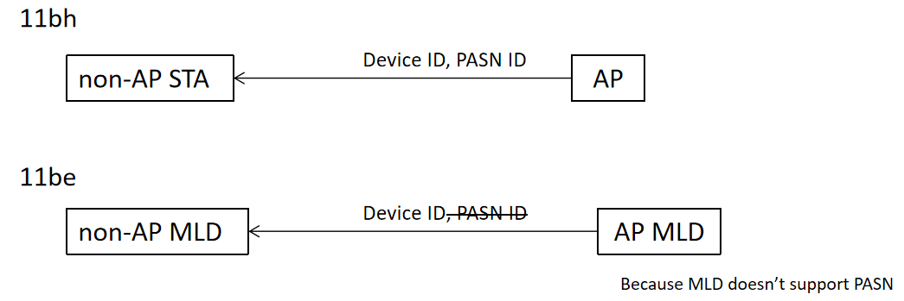

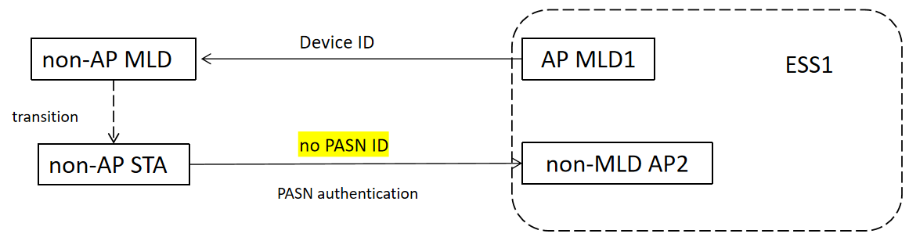

**Revisions:**

Rev 0: Initial version of the document.

Rev 1: Add some illustrations

Rev 2: minor typo

Rev 3: changes based on the comments from Mark and Jose

Rev4: minor typo

***TGm editor: The baseline for this document is P802.11beD7.0 and P802.11bhD6.0***

Interpretation of a Motion to Adopt

A motion to approve this submission means that the editing instructions and any changed or added material are actioned in the TGm Draft. This introduction is not part of the adopted material.

***Editing instructions formatted like this are intended to be copied into the TGbe Draft (i.e., they are instructions to the 802.11 editor on how to merge the text with the baseline documents).***

***TGm Editor: Editing instructions preceded by “TGbm Editor” are instructions to the TGm editor to modify existing material in the TGm draft. As a result of adopting the changes, the TGm editor will execute the instructions rather than copy them to the TGbm Draft.***

**12.2.12.1 Device ID mechanism**

P419L15

***Change the now-shifted 11th paragraph as follows:***

If an AP or an AP affiliated with an AP MLD with dot11DeviceIDActivated equal to true receives an Association Request frame that includes an Extended RSN Capabilities field with the Device ID Support field equal to 1 from a non-AP STA or a non-AP STA affiliated with a non-AP MLD, respectively, the AP or the AP MLD may provide both a device ID and, if dot11PASNActivated is true for the AP or the affiliated AP receiving the Association Request frame, a PASN ID using the procedure described below:

1) When using FILS authentication and the non-AP STA or the non-AP MLD did not provide a device ID in the Device ID element in the Association Request frame, the AP or the AP MLD may provide a device ID in the Device ID element setting the Device ID Status field to 2 to indicate Not Applicable and, if dot11PASNActivated is true, a PASN ID in the PASN ID element setting the PASN ID Status field to 2 to indicate Not Applicable in the Association Response frame.

2) When not using PASN or FILS authentication and the non-AP STA or the non-AP MLD did not provide a device ID in the Device ID KDE in message 2 of the 4-way handshake, the AP or the AP MLD may provide a device ID in the Device ID KDE setting the Device ID Status field to 2 to indicate Not Applicable and, if dot11PASNActivated is true, a PASN ID in the PASN ID KDE setting the PASN ID Status field to 2 to indicate Not Applicable in message 3 of the 4-way handshake.

P419L44

***Insert the following new paragraph as the now-shifted 14th paragraph:***

For MLO, if a non-AP MLD has been provided a PASN ID from an AP MLD in an ESS, the PASN ID may be used for identification of the non-AP STA during PASN authentication, when the non-AP MLD becomes a non-AP STA for the purpose of communicating with an AP in the same ESS, following the procedures defined in this subclause for the non-AP STA.

P420L9

***Change the now-shifted 19th and 20th paragraphs as follows:***

A STA or an MLD may delete either or both of a stored device ID and a stored PASN ID at any point in time for implementation specific reasons.

For non-MLO, when a non-AP STA sends a device ID or a PASN ID to an AP, it shall use the device ID or the PASN ID most recently received from any AP belonging to the same ESS.

***Insert the following new paragraph after the now-shifted 20th paragraph:***

For MLO, when a non-AP MLD sends a device ID to an AP MLD, it shall use the device ID most recently received from any AP or AP MLD belonging to the same ESS.

***Change the now-shifted 22th paragraph as follows:***

When an AP or an AP MLD with dot11DeviceIDActivated equal to true receives an Association Request frame or message 2 of the 4-way handshake, containing a device ID from a non-AP STA or a non-AP MLD and the AP or the AP MLD recognizes the received device ID, the AP or the AP MLD shall...

***Change the now-shifted 24th paragraph, including to split it to two paragraphs, as follows:***

For non-MLO, when a non-AP STA receives a frame that contains a Device ID Status field in the Device ID KDE or Device ID element equal to 0, or a PASN ID Status field in the Robust PASN ID element equal to 0, indicating Recognized, it proceeds with the assumption that...

***Change the now-shifted 26th paragraph as follows:***

If an AP or an AP MLD has a Robust Device ID element or Device ID KDE with the Device ID Status field set to 1, indicating Not Recognized, then the AP or the AP MLD may also provide in that same Robust Device ID element or Device ID KDE a new device ID and, in a Robust PASN ID element or PASN ID KDE, a new PASN ID, thus establishing a new shared identity state, respectively. An AP or an AP MLD shall set a Device ID Status field to 1 indicating Not Recognized if the AP or the AP MLD cannot unequivocally identify the non-AP STA or the non-AP MLD shared identity state, respectively.

***Change the now-shifted 29st paragraph as follows:***

For non-MLO, when a non-AP STA receives a frame that contains a Device ID Status field in a Device ID KDE or Robust Device ID element equal to 1, or a PASN ID status field in a PASN Status field in a Robust PASN ID element equal to 1, indicating Not Recognized, it shall assume that no shared identity state exists with the AP or the ESS (as per the concepts of 12.2.13 (Identifying a non-AP STA or a non-AP MLD with changing MAC address).

***Insert the following paragraph after the now-shifted 29st paragraph:***

For MLO, when a non-AP MLD receives a frame that contains a Device ID Status field in a Device ID KDE or Robust Device ID element equal to 1, indicating Not Recognized, it shall assume that...