### **IEEE P802.11 Wireless LANs**

|  |  |  |  |  |
| --- | --- | --- | --- | --- |
| clarification of the EDCAF operation for the case of no CS busy event | | | | |
| Date: 2025-02-20 | | | | |
| Author(s): | | | | |
| Name | Affiliation | Address | Phone | Email |
| Yanchao Xu | Amlogic |  |  | Yanchao.xu@amlogic.com |
| Henry Yu | Amlogic |  |  | Henry.yu@amlogic.com |
|  |  |  |  |  |

**Abstract**

(No CID associated with this submission)

In 802.11me D7.0, the EDCAF operations are all be performed at slot boundaries and each available slot boundary is defined in the 10.23.2.4. But the current defined available slot boundaries can only be triggered after a “cs busy event” (e.g. Rx end, Tx end, Other CS busy event…). In this contribution, we are trying to deal with the case when there is no CS busy event and how to define a slot boundary to perform the EDCA operation.

**Revisions:**

* Rev 0: Initial version of the document.

***Comment and discussion:***

***EDCAF operations defined in 802.11me***

According to 802.11me D7.0 (10.23.2.4), all the EDCAF operations shall be performed at slot boundaries. The EDCAF operations include the following,

(Page 2015, 10.23.2.4)

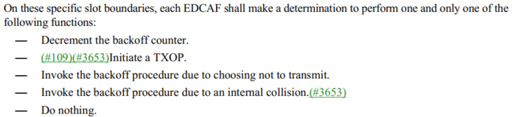

And there are 6 different slot boundaries defined in 10.23.2.4 (Page 2014, 10.23.2.4)),

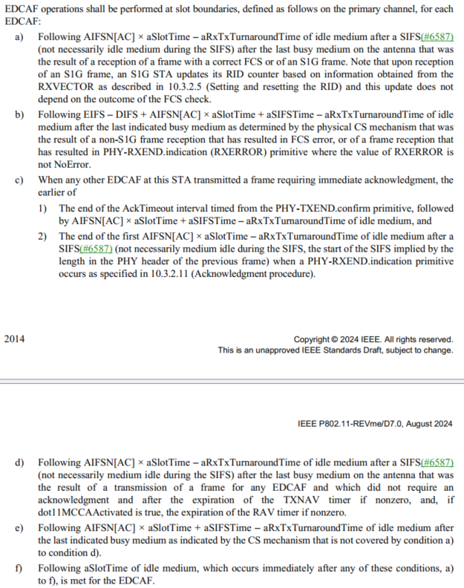

Here we can further provide some simple illustrations for all the above slot boundaries for a specific EDCAF:

1. The case a) above is for the Reception Correct case, which will trigger a slot boundary after AIFS idle time following the PHY Rx end event.

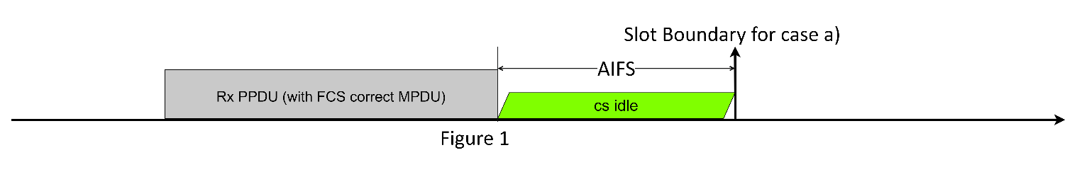

1. The case b) above is for the Reception Error case, which will trigger a slot boundary after EIFS idle time following the PHY Rx end event.

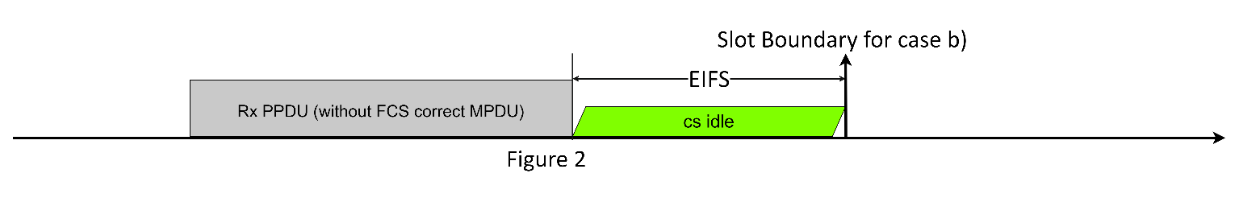

1. The case c) above is for the Transmission case (caused by other EDCAF), which includes Tx success and Tx failure cases,
   1. For the Tx failure case, it will trigger a slot boundary after AIFS idle time after the AckTimeout following the PHY Tx end event

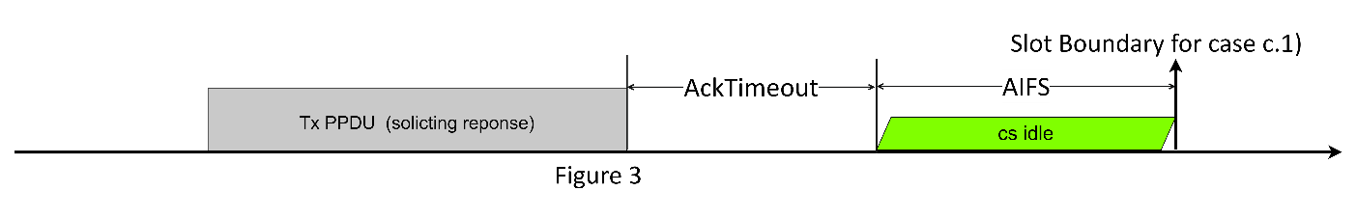

* 1. For the Tx success case, it will trigger a slot boundary after AIFS idle time after the AIFS idle time following the PHY Rx end event

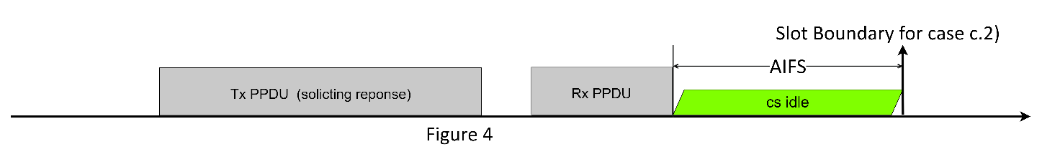

1. The case d) above is for the Transmission case that does not need response, which will trigger a slot boundary after AIFS idle time following the PHY Tx end event

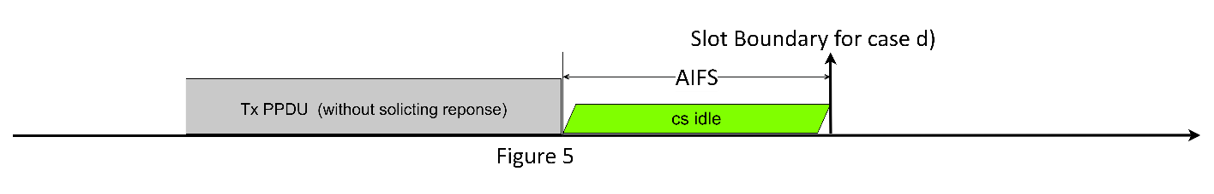

1. The case e) above is for the CS busy case that is not caused by the above a) to d) (i.e. not caused by the 802.11 Tx/Rx event). And this will trigger a slot boundary after the AIFS idle time following the last busy event.

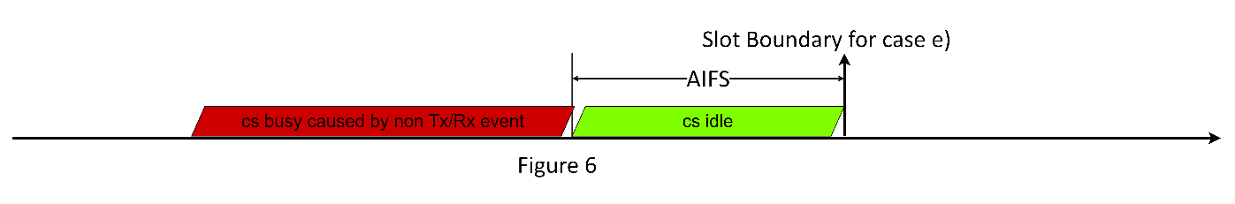

1. The case f) is a little different from a) to e). According to f) condition “*Following aSlotTime of idle medium, which occurs immediately after any of these conditions, a) to f), is met for the EDCAF*”, it can be inferred a slot boundary for f) can be triggered for one of the following conditions,
   1. After aSlotTime idle time following any one slot boundary caused by the a) to e);
   2. Or, after aSlotTime idle time following the previous slot boundary caused by f) itself.

Therefore, it’s obvious that the condition f) is applied to when in the backoff procedure.

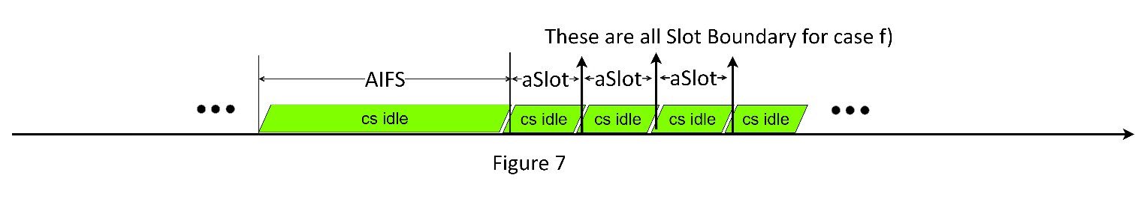

All above are the total allowable slot boundaries defined in 802.11me D7.0. Except the slot boundary of f), all other slot boundaries are triggered after AIFS/EIFS time following a CS busy event. Therefore, there is no slot boundary defined for the “no CS busy event” case.

For example, when a device firstly switches to a channel or powers up from the doze state, and there is not any event that can cause CS busy. If the device wants to transmit (or to initiate a TxOP), but there is no available slot boundary, the device cannot initiate a TxOP, as “initiate a TxOP” is an EDCAF operation that needs be performed at a slot boundary.

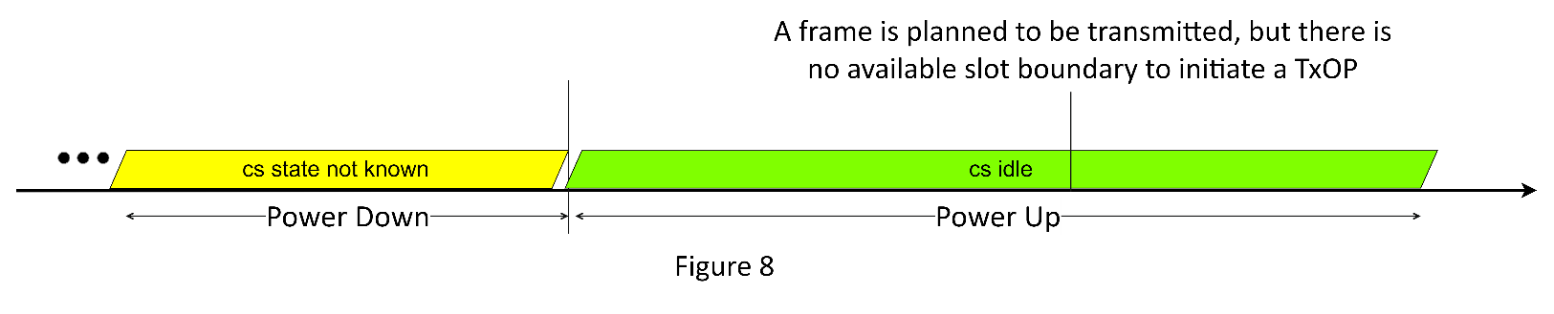

***DCF operations defined in 802.11me***

Different from EDCA, the DCF can handle all the cases above, including the case with no cs busy event.

The following is from the Basic Access section for DCF (10.3.4.2, p1930) in 802.11me D7.0,

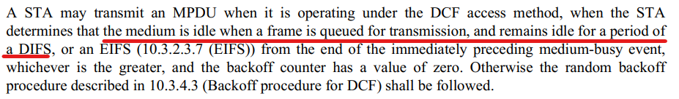

Based on the statement in red, for the case of no CS busy event (shown in Figure 8), under DCF, the device can transmit the frame after DIFS idle time following the time the frame is queued for transmission, as shown below,

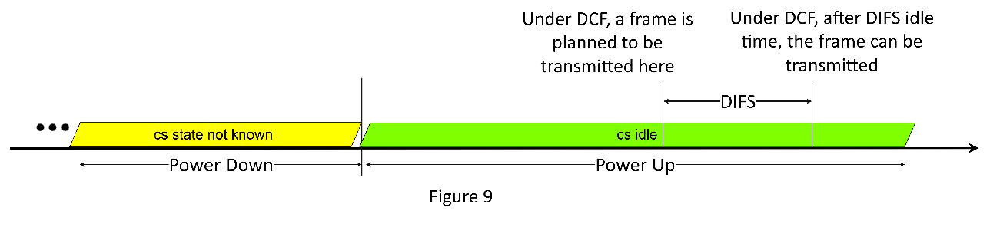

***EDCAF operations defined in 802.11-2012***

And furthermore, we checked the spec of 802.11-2012 version, its EDCAF slot boundaries are different from 802.11me (or different since 802.11-2016). The difference is for the condition e). We try to list both definitions for comparison.

|  |
| --- |
| * For the 802.11me D7.0, the condition of e),   *Following AIFSN[AC] × aSlotTime + aSIFSTime – aRxTxTurnaroundTime of idle medium after*  *the last indicated* ***busy*** *medium as indicated by the CS mechanism that is not covered by condition a)*  *to condition d)*   * For the 802.11-2012 (p876), the condition of e),   *Following AIFSN[AC] × aSlotTime + aSIFSTime – aRxTxTurnaroundTime of idle medium after*  *the last indicated* ***idle*** *medium as indicated by the CS mechanism that is not covered by a) to d)* |

The difference is shown in red. The original condition e) in 802.11-2012 version spec may be able to cover both the case for the cs busy event and the case for no cs busy event. But it may vary based on how to understand the “last indicated IDLE medium” in 802.11-2012, especially whether it can cover the case illustrated by the condition e) in 802.11me (i.e. the case shown in figure 6).

We found the document (doc 16/228, reference [2]) that firstly introduced this change (from “idle” to “busy”). But the doc just said the “last indicated IDLE medium” might be incorrect and should be changed to “busy”. There may be other documents that may have exact explanation for this change of the condition e), but we haven’t found one.

***Possible proposed change:***

If the condition e) cannot be reverted to the original statement in 802.11-2012, here another condition g) is proposed to cover the case of no cs busy event.

|  |
| --- |
| 1. Following AIFSN[AC] × aSlotTime – aRxTxTurnaroundTime of idle medium after a SIFS(#6587)   (not necessarily idle medium during the SIFS) after the last busy medium on the antenna that was  the result of a reception of a frame with a correct FCS or of an S1G frame. Note that upon reception  of an S1G frame, an S1G STA updates its RID counter based on information obtained from the  RXVECTOR as described in 10.3.2.5 (Setting and resetting the RID) and this update does not  depend on the outcome of the FCS check.   1. Following EIFS – DIFS + AIFSN[AC] × aSlotTime + aSIFSTime – aRxTxTurnaroundTime of idle   medium after the last indicated busy medium as determined by the physical CS mechanism that was  the result of a non-S1G frame reception that has resulted in FCS error, or of a frame reception that  has resulted in PHY-RXEND.indication (RXERROR) primitive where the value of RXERROR is  not NoError.   1. When any other EDCAF at this STA transmitted a frame requiring immediate acknowledgment, the   earlier of   * 1. The end of the AckTimeout interval timed from the PHY-TXEND.confirm primitive, followed   by AIFSN[AC] × aSlotTime + aSIFSTime – aRxTxTurnaroundTime of idle medium, and   * 1. The end of the first AIFSN[AC] × aSlotTime – aRxTxTurnaroundTime of idle medium after a   SIFS(#6587) (not necessarily medium idle during the SIFS, the start of the SIFS implied by the  length in the PHY header of the previous frame) when a PHY-RXEND.indication primitive  occurs as specified in 10.3.2.11 (Acknowledgment procedure).   1. Following AIFSN[AC] × aSlotTime – aRxTxTurnaroundTime of idle medium after a SIFS(#6587)   (not necessarily medium idle during the SIFS) after the last busy medium on the antenna that was  the result of a transmission of a frame for any EDCAF and which did not require an  acknowledgment and after the expiration of the TXNAV timer if nonzero, and, if  dot11MCCAActivated is true, the expiration of the RAV timer if nonzero.   1. Following AIFSN[AC] × aSlotTime + aSIFSTime – aRxTxTurnaroundTime of idle medium after   the last indicated busy medium as indicated by the CS mechanism that is not covered by condition a)  to condition d).   1. Following aSlotTime of idle medium, which occurs immediately after any of these conditions, a)   to f), is met for the EDCAF   1. If none of the above a) to f) conditions is met for the EDCAF, following aSlotTime of idle medium after last indicated **IDLE** medium as indicated by the CS mechanism |

***Reference:***

[1] 802.11me D7.0

[2] [11-16-0228-13-000m-resolution-for-cids-7087-7088-edca.doc](https://mentor.ieee.org/802.11/dcn/16/11-16-0228-13-000m-resolution-for-cids-7087-7088-edca.docx)