IEEE P802.11  
Wireless LANs

|  |  |  |  |  |
| --- | --- | --- | --- | --- |
| Minutes 802.11bn PHY ad hoc – Jan to March conference calls | | | | |
| Date: 2025-02-20 | | | | |
| Author(s): | | | | |
| Name | Affiliation | Address | Phone | email |
| Tianyu Wu | Apple |  |  | tianyu@apple.com |

Abstract

This document contains the PHY ad hoc meeting minutes for TGbn teleconferences held between January and March 2025:

* February 20, 2025

**Thursday February 20th, 2025 10:00 – 12:00 ET**

**Introduction**

1. The Chair (Dongguk Lim, LGE) calls the meeting to order at 10:00 ET.
2. The Chair follows the agenda in 11-25/207r4.
3. The Chair goes through the IPR policy and asks if anyone is aware of any potentially essential patents. **Nobody speaks up.**
4. The Chair goes through the Copyright policy.
5. The Chair reminds everyone to report their attendance by using IMAT system and by sending an e-mail to the Co-chair, Tianyu Wu (Apple), Sigurd Schelstraete (MaxLinear) or the Chair himself if unable to record attendance via IMAT system.
6. Agenda

PDT Submissions:

* + [24/2008r1](https://mentor.ieee.org/802.11/dcn/24/11-24-2008-01-00bn-pdt-phy-interference-mitigation.docx) PDT-PHY-Interference-Mitigation Shimi Shilo

Technical Submissions – CBF + Miscellaneous:

* + [25/0154](https://mentor.ieee.org/802.11/dcn/25/11-25-0154-00-00bn-alternative-dru-tone-plan-design-for-60mhz-dbw.pptx) Alternative DRU Tone Plan Design for 60MHz DBW Chenchen Liu
  + 25/0083 CFO correction and related simplifications for COBF Sameer Vermani
  + 25/0103 Simplified carrier synch. for CoBF transmissions Shuling Feng
  + 25/0098 Receiver specification Fang, Juan
  + 25/0101 On Mandatory and Optional 11bn Feature Jianhan Liu
  + 25/0109 UHR Receive Procedure Lin Yang

**Attendance**

The following people registered their attendance through IMAT:

Timestamp                Name                                        Affiliation  
Breakout                                                                                       
TGbn (PHY)  02/20/2025          Yan, Aiguo                                SAMSUNG ELECTRONICS  
TGbn (PHY)  02/20/2025           Zhong, Ke                           Ruijie Networks Co.,Ltd.  
TGbn (PHY)  02/20/2025         Zhao, Xuwen                                                TCL  
TGbn (PHY)  02/20/2025           Zhou, Lei                      H3C Technologies Co., Limited  
TGbn (PHY)  02/20/2025          Wu, Tianyu                                         Apple Inc.  
TGbn (PHY)  02/20/2025           Wei, Dong  Guangdong OPPO Mobile Telecommunications Corp....  
TGbn (PHY)  02/20/2025        Asai, Yusuke                                                NTT  
TGbn (PHY)  02/20/2025  KERGOURLAY, Gerald                       Canon Research Centre France  
TGbn (PHY)  02/20/2025         Li, Jialing                         Qualcomm Technologies, Inc  
TGbn (PHY)  02/20/2025        LIU, QINGLAI                     Panasonic Holdings Corporation  
TGbn (PHY)  02/20/2025         Pan, Ju Yan                       Huawei Technologies Co., Ltd  
TGbn (PHY)  02/20/2025       Jeon, Eunsung                                SAMSUNG ELECTRONICS  
TGbn (PHY)  02/20/2025            Li, Yapu  Guangdong OPPO Mobile Telecommunications Corp....  
TGbn (PHY)  02/20/2025     Strobel, Rainer                                          Maxlinear  
TGbn (PHY)  02/20/2025         Luo, Sixian                                  SHARP CORPORATION  
TGbn (PHY)  02/20/2025          Jee, Anand                                SAMSUNG ELECTRONICS  
TGbn (PHY)  02/20/2025       LIU, CHENCHEN                       Huawei Technologies Co., Ltd  
TGbn (PHY)  02/20/2025       feng, Shuling                                      MediaTek Inc.  
TGbn (PHY)  02/20/2025       Norouzi, Sara  Huawei Technologies Canada; Huawei Technologie...  
TGbn (PHY)  02/20/2025       Chen, You-Wei                                      MediaTek Inc.  
TGbn (PHY)  02/20/2025       Lim, Dong Guk                                     LG ELECTRONICS  
TGbn (PHY)  02/20/2025       Bansal, Ankur                                SAMSUNG ELECTRONICS

**PDT Submissions**

1. **24/2008r1 PDT-PHY-Interference-Mitigation – Shimi Shilo (Huawei)**

Discussions:

C: “Shall” in first paragraph means mandatory to use?

A: If you enable IM, then additional pilot shall be used.

C: Change “shall” to “can”. Remove one sentence.

C: Remove “used by a STA with multiple antennas”.

A: Updated to r2.

**SP1**: Do you agree to incorporate the text in 11-24/2008r2 to next revision of 11bn draft?

No Objection.

**Technical Submissions**

1. **25/0154r0 Alternative DRU Tone Plan Design for 60MHz DBW – Chenchen Liu (Huawei)**

Discussions:

No Discussions.

SP1: **Do you agree to include the following text to the 11bn SFD?**

* Data and pilot subcarrier indices for DRUs in an 60 MHz DBW are defined in following table:

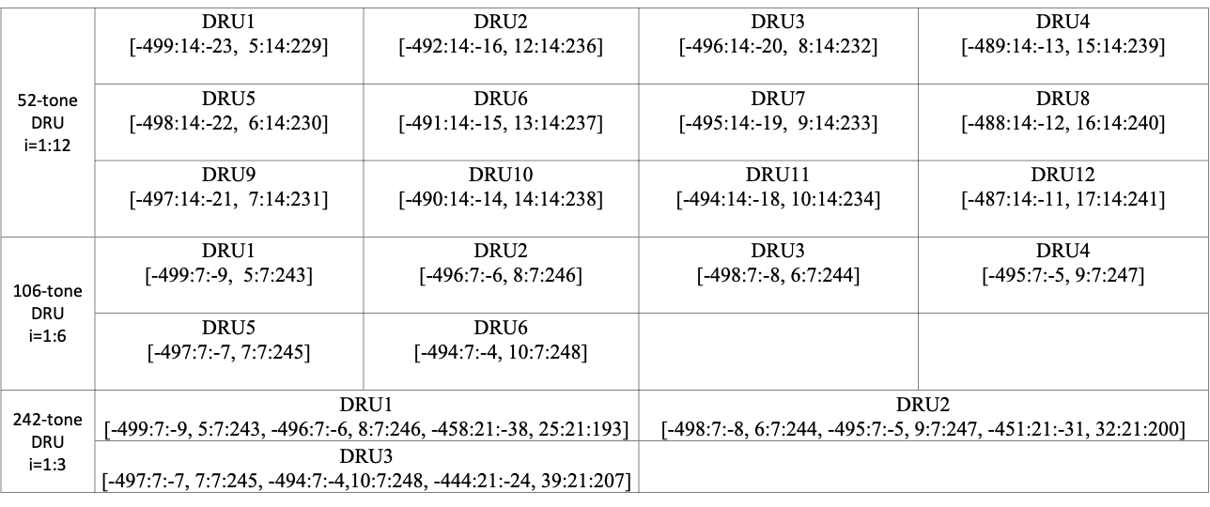

No Objection.

SP2: **Do you agree to include the following text to the 11bn SFD?**

* Pilot subcarrier indices for DRUs in an 60 MHz DBW are defined in following table:

|  |  |
| --- | --- |
| **DRU size** | **Pilot indices** |
| 52-tone DRU i=1:12 | {-373 -219 -65 159}, {-450 -296 -142 82}, {-412 -258 -104 120}, {-335 -181 -27 197},  {-386 -232 -78 146}, {-463 -309 -155 69}, {-425 -271 -117 107}, {-348 -194 -40 184},  {-399 -245 -91 133}, {-476 -322 -168 56}, {-438 -284 -130 94}, {-361 -207 -53 171}, |
| 106-tone DRU i=1:6 | {-450 -296 -142 82}, {-335 -181 -27 197}, {-463 -309 -155 69}, {-348 -194 -40 184},  {-476 -322 -168 56}, {-361 -207 -53 171}, |
| 242-tone DRU i=1:3 | {-450 -335 -296 -181 -142 -27 82 197}, {-463 -348 -309 -194 -155 -40 69 184},  {-476 -361 -322 -207 -168 -53 56 171}, |

No Objection.

**Adjourn**

The meeting is adjourned at 10:33 ET.