IEEE P802.11  
Wireless LANs

|  |  |  |  |  |
| --- | --- | --- | --- | --- |
| Referred Subclause Correction | | | | |
| Date: 2025-03-11 | | | | |
| Author(s): | | | | |
| Name | Affiliation | Address | Phone | email |
| Haorui Yang | China Mobile |  |  | yanghaorui0217@163.com |
|  |  |  |  |  |

Abstract

This document corrects the wrongly referred subclause.

**Reason for change:**

In the Subclause 9.4.2.118 (Quality-of-Service Management Frame Policy element) of Draft P802.11REVme_D7.0, the referred subclause for the Action frame category is wrongly mentioned to 9.4.1.1 which is not related to the Action frame.

Since the Action Frame Category subfield is used to indicate which Action frame to use the ACI in the same element, the correct subclause number is 9.4.1.11 (Action field). Also "of Action Frame" appears twice so one should be removed.

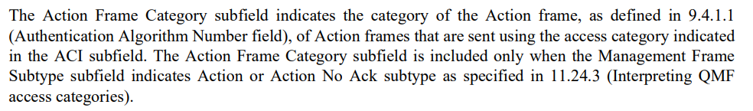

The same issue happens in the next paragraph for the Action Value Bitmap subfield which is referred to 9.5.7 wrongly.

For each Action frame, the action values are different and defined in each subclause of the Action frame in subclause 9.6, such as subclause 9.6.31 and 9.6.32, so it is not possible to referred to a single subclause. It is proposed to use the general subclause 9.6 (Action frame format details).

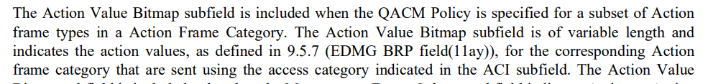

**Proposed changes:**

**9.4.2.118 Quality-of-Service Management Frame Policy element**

*Update the following paragraph:*

The Action Frame Category subfield indicates the category of the Action frames, as defined in 9.4.1.11 (Action field), that are sent using the access category indicated in the ACI subfield. The Action Frame Category subfield is included only when the Management Frame Subtype subfield indicates Action or Action No Ack subtype as specified in 11.24.3 (Interpreting QMF access categories).

The Action Value Bitmap subfield is included when the QACM Policy is specified for a subset of Action frame types in a Action Frame Category. The Action Value Bitmap subfield is of variable length and indicates the action values, as defined in 9.6 (Action frame format details), for the corresponding Action frame category that are sent using the access category indicated in the ACI subfield. The Action Value Bitmap subfield is included only when the Management Frame Subtype subfield indicates Action or Action No Ack subtype and the QACM Field Length subfield is greater than or equal to 2. Each bit in the Action Value Bitmap subfield is mapped to the corresponding action value. The Action Value Bitmap subfield is zero padded to complete any incomplete octet. When included, the size in octets of the Action Value Bitmap field is found by subtracting 1 from the value of the QACM Field Length subfield.

**References:**