IEEE P802.11  
Wireless LANs

|  |  |  |  |  |
| --- | --- | --- | --- | --- |
| Initial thoughts on ARC misc 802 topics | | | | |
| Date: 2025-03-10 | | | | |
| Author(s): | | | | |
| Name | Affiliation | Address | Phone | email |
| Mark Hamilton | Ruckus/CommScope | **350 W Java Dr.**  Sunnyvale, CA 94089 | +1-303-818-8472 | mark.hamilton2152@gmail.com |
|  |  |  |  |  |

Abstract

This document presents some thoughts and discussion items related to the topics on the ARC agenda deck (<https://mentor.ieee.org/802.11/dcn/24/11-24-2095-02-0arc-arc-sc-agenda-january-2025.pptx>) slide 19.

**Background:**

As follow-on work, as IEEE Std 802 revision is reaching completion, the following topics have been identified as areas where maintenance work within 802.11 is possibly/likely needed (this is from the ARC agenda deck, being tracked for many months leading up to this week’s (January 2025) session:

* EPD and LPD terms are going away – we need to update 802.11 to align
* Review MAC address ordering discussion, and 802.11 assumptions
  + <https://mentor.ieee.org/802.1/dcn/24/1-24-0034-00-Mntg-proposal-to-revise-bit-ordering-material-in-p802revc-d2-0.docx>
* Review 802.1AC mapping from ISS to 802.11 MAC SAP interface
* Consider any changes to remove 802.2/LLC terms?
* 802.11’s “Portal”, and mapping to/usage of IEEE Std 802 terminology
* Access Domains: “802 Access Domains”?
  + Interconnection of Access Domains?
  + In 802.11, Access Domain is BSS. Is that still the view, for 802.11be/MLD?
  + Other 802s? 802.3 Multi-carrier fiber – 1 Access Domain, or many? We think it’s 1. But, there are multiple transmitters, in parallel.
  + [Per discussion in November session] How does beamforming relate to the Access Domain concept? (Is there discussion needed about the relationship between “BSS” and beamforming?)
* What if we make the DS a bridge (small ‘b’)?
* Consider adding something about VLANs (just informational?) into 802.11? Relationship (if we talk about it) to security domains (e.g. Authenticator relationship)? VLAN-aware STAs? What about GLK/non-GLK STAs? (cf 11-08/0114r0)

FYI: The latest IEEE Std 802 draft can be found here: <https://www.ieee802.org/1/files/private/802-REVc-drafts/d2/>

(This is a members’ area, you’ll need the password to log in – if you are least an aspirant member, you can log in using your 802.11 members credentials.)

**Discussion:**

Taking the above topics, one at a time:

**EPD and LPD terms are going away – we need to update 802.11 to align**

In IEEE Std 802 REVc, the definitions of the protocol identifers has been changed to a much more rich structure, where the prior concepts of LPD and EPD are now more specifically described as multiple types/methods for identification. This new structure is in a new clause, clause 9 of the draft.

The main discussion of the MSDU format in 802.11 is in subclause 5.1.4 (REVme D7.0 numbering).

That subclause declares that the “default” MSDU format is LPD, which is specified as “LLC Protocol Discrimination (LPD)”, quoting (the older) IEEE Std 802 and ISO/IEC 8802-2:1998. In the updated IEEE Std 802, this is known as “Type 2 PIF encoding of an E-Type protocol identifier” per 9.5.1.2 (of IEEE Std 802REVc D2.2). Thus, it seems that wherever 802.11 uses the term “LPD” it needs to be replaced with “Type 2 PIF encoding of an E-Type protocol identifier” (or “Type 2 PIF encoding of an O-Type protocol identifier, per discussion just below) (and we many want to create an acronym to say this more easily).

Text from IEEE Std 802 REVc D2.2, 9.5.1.2, for reference:

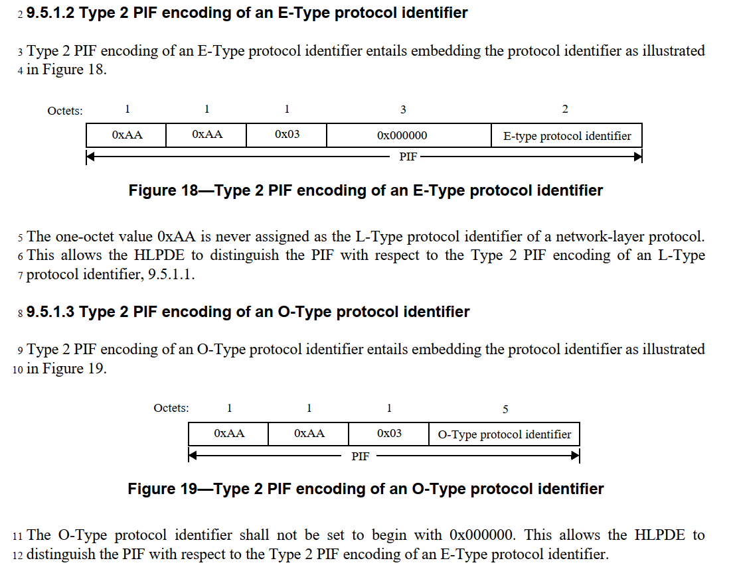

Note that 9.5.1.3 of 802 REVc has similar structure, but with flexibility to use a locally defined protol identifier preceeded by an OUI or CID. I don’t see any evidence that 802.11 supports (or intends to support) this format. Off-line discussion is that while no one knows of common use of this construct, it has been seen in the field, and it seems there is no reason to disallow it – so it should be supported.

Also, note that there are a few references in 802.11 to “SNAP” as well, which is effectively assuming this same LPD concept, and those locations need to be evaluated to see if they should be changed similarly to “LPD”, of it they are okay as implicit references to IEEE Std 802 subclause 9.5.1.4.

The other option, per 802.11 subclause 5.1.4, is to use EPD for MSDU format in some certain situations. EPD is specified in 802.11 as being “EtherType Protocol Discrimination (EPD)” per IEEE Std 802.3-2022. However, this is messy, as 802.3-2022 defines “EPD” to mean “End_of_Packet Delimiter” (a completely irrelvent, different concept). The “EtherType Protocol Discrimination” concept turns out to be a rather implied rather than explicit (and therefore hard to find) reference to 802.3-2022 subclause 3.2.6, as copied here:

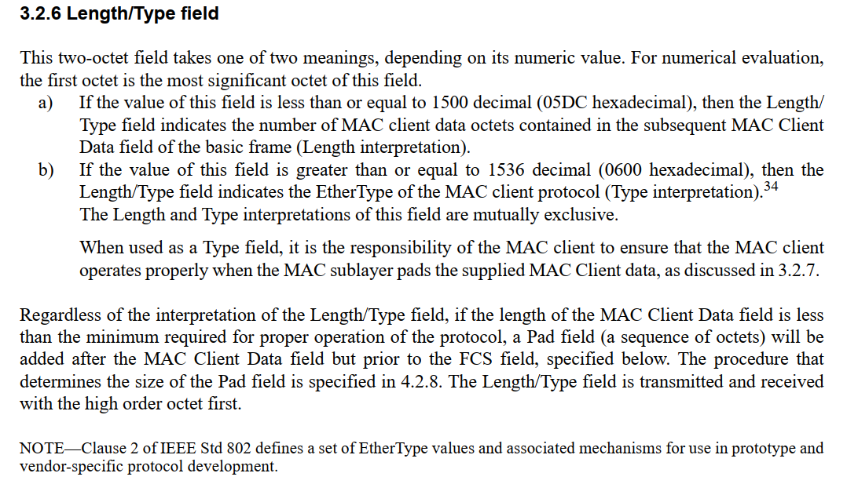

Note that 802.3 describes this field as a Length/Type – and it can contain either an EtherType or a Length.

IEEE Std 802 REVc D2.2 brings this concept into that Standard, and makes this explicit, as “Type 3 PIF encoding of an E-Type protocol identifier”, per subclause 9.5.2.1, or “Type 3 PIF encoding of an L-Type protocol identifier” as shown here:

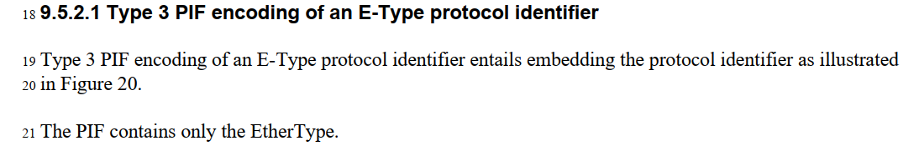

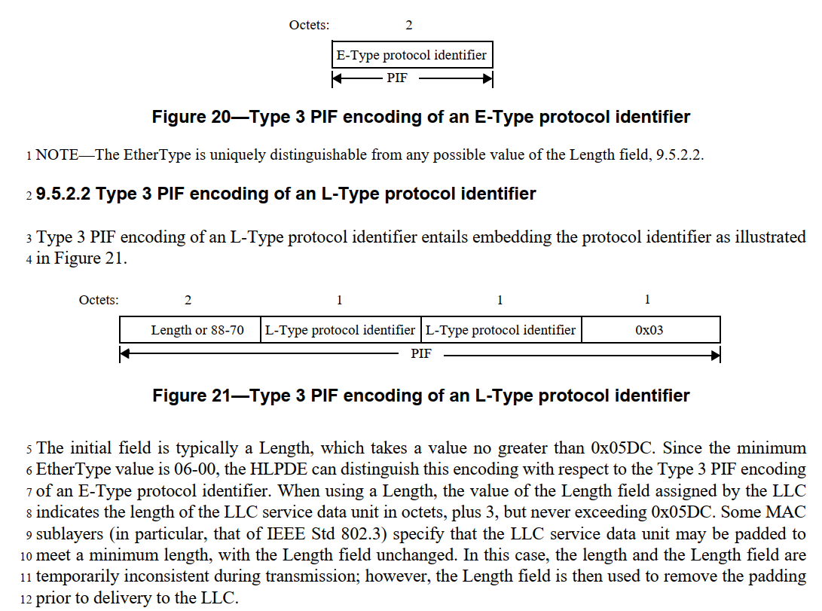

Thus, similarly to the LPD replacement discussed above, it seems that the term “EPD” in 802.11 needs to be replaced with “Type 3 PIF encoding of an E-Type protocol identifier (which, again, we probably want to create an acronym to say more easily). Note that for 802.11’s usage, this _does not_ support the “Type 3 PIF encoding of an L-Type protocol identifier”. This also implies that the normative reference to 802.3 in 5.1.4 can be removed, which leaves only (I believe) non-normative references to 802.3, so that can also be simplified/cleaned-up.

Again, like 9.5.1.3 in 802 REVc, there is also 9.5.2.3 with “Type 3 PIF encoding of an O-Type protocol identifier” with flexibility to use a locally defined protol identifier preceeded by an OUI or CID. I don’t see any evidence that 802.11 supports (or intends to support) this format. This should be discussed/confirmed with experts.

As a practical matter, there are 45 instances of “LPD” and 100 instances of “EPD” in REVme D7.0.

Propose: Define the terms “T2EO” as (only) Type 2 PIF encoding of an E-Type protocol or Type 2 PIF encoding of an O-Type protocol. Define “T3E” as (only) Type 3 PIF encoding of an E-Type protocol. (That implies: only Type 2 support for the O-Type, and no support for L-Types.) Check all occurrences of LPD and EPD, but presume we can just replace them with T2EO and T3E. For completeness, note that this includes **Replacing names in protocol fields, which is usually discouraged.** Also need to do the validation with experts, per highlighted items above.

A detailed submission would be appreciated.

**Review MAC address ordering discussion, and 802.11 assumptions**

* <https://mentor.ieee.org/802.1/dcn/24/1-24-0034-00-Mntg-proposal-to-revise-bit-ordering-material-in-p802revc-d2-0.docx>

The referenced document has discussion about the use and bit-ordering of MAC address written representation. In particular, it sets a convention for 802 standards that the:

* “Hexadecimal representation” is a sequence of octet values in which the values of the individual octets are displayed in order from left to right, with each octet value represented as a 2-digit hexadecimal numeral and with the resulting pairs of hexadecimal digits separated by hyphens. And,
* “Bit-reversed representation” is a sequence of octet values in which the values of the individual octets are displayed in order from left to right, with each octet value represented as a 2-digit hexadecimal numeral and with the resulting pairs of hexadecimal digits separated by colons.

Annex J.6.3 (CCMP test vectors) lists many test vector values with colon notation. Per our conventions (quoted above) this implies that these are “bit-reversed” values. It is for future study to confirm if these values are in fact bit-reversed in these test vectors. Similarly, for J.10. J.11 has addresses with hyphen notation, and similarly, these should be confirmed that they are not bit-reversed.

These appear to be the only use of colon notation. I assume that all the hyphen notation occurrences are correct, as is.

This has been confirmed (we think) off-line. It would be good to check 802.11 for use of the term/concept “bit reversed” as well, and remove/correct that, if appropriate. (for example footnote at the bottom of page 2001 of REVme D7.0)

Propose: Replace the colon notation in Annex J with the hyphen notation (no other change to the values). Remove the footnote on P2001.

**Consider any changes to remove 802.2/LLC terms?**

and

**Review 802.1AC mapping from ISS to 802.11 MAC SAP interface**

Note, 802.11 REVme D7.0 does not actually contain any occurrences of “802.2”. However, there are occurrences of “ISO/IEC 8802-2” which is roughly equivalent.

The term “LLC” is still valid and used, in IEEE Std 802 (REVc). However, the meaning has been softened to not refer explicitly to the LLC protocol (i.e. ISO/IEC 8802-2, or the (no longer valid) IEEE 802.2). There are 97 occurences of “LLC” in REVme D7.0. These will need to be checked, to ensure they reference the general concept as used in IEEE Std 802 REVc, and if any refer to specific details (such as protocol) from IEEE 802.2, those need to be fixed. This is for further study.

One of the occurrences of 8802-2 is in 5.1.4, which can be changed to reference IEEE Std 802 (REVc), like the change to remove the use of “EPD” and the normative reference to 802.3 in that subclause (described in the EPD/LPD section of this document).

Another occurrence of ISO/IEC 8802-2 is in 5.2, where 802.11 REVme D7.0 says, “The IEEE 802.11 MAC supports the following service primitives as defined in ISO/IEC 8802-2:1998”, and then lists MA-UNITDATA primitives. There is a very subtle (probably too subtle) spelling here – IEEE 802.11 discusses the MA-UNITDATA primitives (with a hyphen). 802.1AC-2016 defines the MAC Service as the set of MA_UNITDATA primtives (with an underscore). 802.1AC goes on to define a set of M_UNITDATA primtives as the Service offered by the ISS (only used within a bridge, as defined in 802.1Q). 802.1AC, in clause 13, further specifies a “convergence function” for 802.11 that maps between the ISS’s M_UNITDATA and 802.11’s MA-UNITDATA interfaces, which makes sense for a bridge, using an ISS.

However, 802.1AC also specifies an 802.11 convergence function in Annex B.1.3 that maps between M_UNITDATA and MA-UNITDATA for an end station. But, end stations don’t have a M_UNITDATA service interface, as they don’t have an ISS (or such use of an ISS is not defined, anyway). B.1.3 should probably define a convergence function between MA-UNITDATA and MA_UNITDATA, although that sublte difference of hyphen versus underscore that would appear in such a subclause would surely be confusing and subject to spec rot. This is for further study.

There is a direct reference to ISO/IEC 8802-2 XID null frame in subclause 7.2.3.2.4 (part of how the DS gets updated when client devices do a BSS transition). This needs to be investigated, and probably replaced with something more modern.

Subclause 9.4.2.152 has a NOTE, trying to direct the reader to where the LLC header and SNAP header formats are defined, which is currently pointing to ISO/IEC 8802-2 (for both). With the IEEE Std 802 updates, we can (and probably should) now refer to a combination of IEEE Std 802 and a general pointer to 802.1 standards for the definition of the LLC sublayer protocol(s). Suggested change:

NOTE—The structure of the LLC sublayer header(s) is defined in IEEE Std 802-2024 LLC sublayer protocols are defined in various IEEE 802.1 standards. The SNAP encoding is described in IEEE Std 802-2024.

Consider – if we add (IEEE Std 802-2024) to the acronyms for LLC and SNAP, can we do without the NOTE entirely?

Annex H (which describes 802.11’s Usage of EtherType 89-0d for some MSDU signaling between 802.11-defined components) has a statement that “LLC is defined in ISO/IEC 8802-2-1988”. This can be changed to say “LLC is defined in IEEE Std 802-2024. (Note that in this context, “LLC” is specified to be a simple 3 octet LLC header, as can be found in IEEE Std 802.) This needs to be expanded to specify that in this context, the expected usage is (currently) to use a SNAP format, per IEEE 802 subclause 9.5.1.4. Whether this is a hard requirement for EtherType 89-0d frames is for further study. Whether this supports/allows the use of any other 802.1 services (or needs to) is for further study.

The above removes all occurrences of 8802-2 in 802.11, so the normative reference in clause 2 can be deleted.

* Propose: NOTE change, per above.
* … (other “To be done” items)

**NEW MATERIAL for MARCH 2025 session discussion, below (track changes disabled).**

**802.11’s “Portal”, and mapping to/usage of IEEE Std 802 terminology**

Some 802.11 (REVme D7.0) quotes, on “portal”:

**portal:** The logical point at which the integration service is provided.

NOTE—For the purposes of this Standard, there is at most one portal in a given extended service set’s (ESS’s) infrastructure. In an implementation, a single logical portal function might(M118) be provided by multiple devices that provide integration services for the ESS. How such multiple devices coordinate to appear as a single logical portal is implementation dependent.

**integration service:** The service that enables delivery of medium access control (MAC) service data units (MSDUs) between the distribution system (DS) and a local area network (LAN) (via a portal).

*Per 4.3.7:*

A portal is the logical point at which the integration service is provided. All data from or to non-IEEE- 802.11 LANs enter or leave the IEEE 802.11 architecture via a portal. The integration service is responsible for any addressing changes or other logical mappings that might be required when MSDUs pass between the DS and the integrated LAN. It is possible for one device to offer both the functions of an AP and a portal.

(SSPN unique needs? *See 4.3.23, etc.*)

From 4.5.2.1 (Figure 4-18, on the DS architecture): 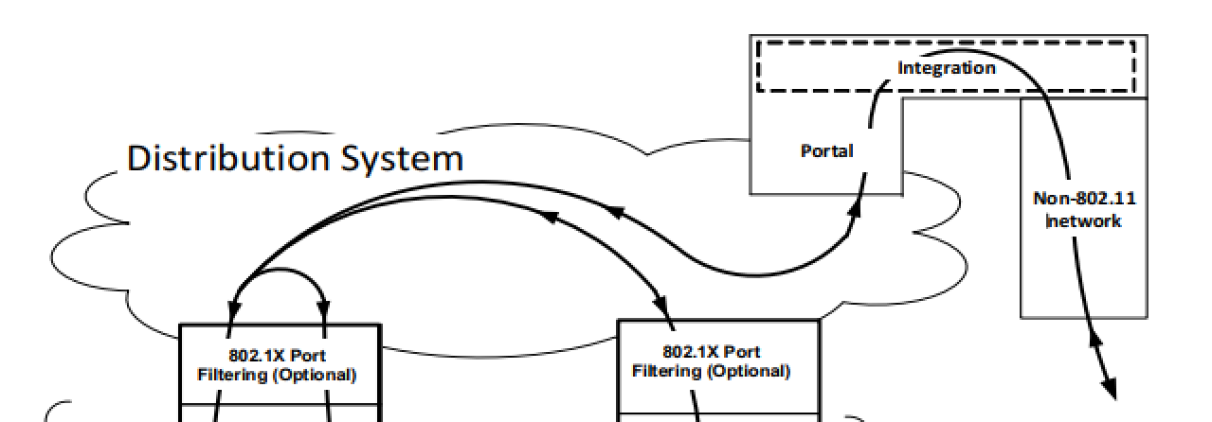

**4.5.2.2 Integration**

When the distribution system service determines that the intended recipient of an MSDU is a member of an integrated LAN, the “output” point of the DS is a portal instead of an AP.

MAC service tuples that are distributed to a portal cause the DS to invoke the Integration function (conceptually after the distribution system service). The Integration function is responsible for accomplishing whatever is needed to deliver a MAC service tuple from the DSM to the integrated LAN media (including any required media or address space translations).

MSDUs received from an integrated LAN invoke the Integration function before the MAC service tuple is distributed by the distribution system.

The details of an Integration function are dependent on a specific portal implementation and are outside the scope of this standard.

A reminder, clause 3 defines:

**medium access control (MAC) service tuple:** [MAC service tuple] The collection of a MAC service data unit (MSDU) along with the associated source address, destination address, priority, drop eligibility, service class, station vector, and MSDU format, which are all passed as parameters across the MAC service access point (SAP) and are all except the station vector delivered across the distribution system between access points (APs), mesh gates, and the portal of an extended service set (ESS)

Another reminder (*5.1.5.3*):

NOTE—This behavior block [non-GLK AP role] indicates that there is no access through the (#1909)Controlled Port to or from the local upper-layers (the LLC sublayer) at an AP. Any such access is logically achieved in the architecture via transition of the DS and Portal to an integrated LAN. In actual implementations, this is likely to be optimized, and Data frames appear to be delivered directly to one or more local LLC sublayer entities on the same physical device as the AP. Such optimization is effectively distributing the functions of the DS and Portal, and it is the responsibility of the implementation to ensure the logical behavior of these entities is maintained.

(*Per 7.1*, the portal uses the DS SAP interface (the left side in the Figure quoted above), which passes MSDUs in/out of the DS, as part of MAC service tuples.)

*Per M.2:*

Table M-1 (EPD and LPD MSDU headers) illustrates EPD and LPD protocol header encodings. The encoding used within the DS is unspecified. If the DS has a portal, that portal provides the integration function. The integration function converts between the encoding used within the DS and that used in the non-IEEE-802.11 network with which the portal is connecting the DS. If the DS uses LPD and the portal connects to a network that uses EPD, for example (#6014)IEEE Std 802.3-2022, the integration function converts MSDUs exiting the DS from LPD to EPD format and those entering the DS from EPD to LPD.

*Per M.4:*

There are a number of differences between the IEEE 802.11 integration service and the service provided by an IEEE 802.1 bridge. In the IEEE 802.11 non-GLK architecture a portal provides the minimum connectivity between an IEEE 802.11 WLAN and a non-IEEE-802.11 LAN. Requiring an (#74)IEEE 802.1Q bridge in order to be compliant with IEEE Std 802.11 would unnecessarily render some implementations noncompliant.

The most important distinction is that a portal has only one “port” (in the sense of IEEE Std 802.1Q(#75), for example) through which it accesses the DS. This renders it unnecessary to update bridging tables inside a portal each time a STA changes its association status. In other words, the details of distributing MSDUs inside the non-GLK IEEE 802.11 WLAN need not be exposed to the portal.

…

Finally, it is an explicit intent of this standard to permit transparent integration of an IEEE 802.11 WLAN into another non-IEEE-802.11 LAN, including passing bridge PDUs through a portal.

Potential IEEE 802 terminology that might apply:

**bridge:** In the general sense, a functional unit that interconnects two or more access domains. In the context of IEEE Std 802, this is narrowed to interconnecting two or more bridgeable IEEE 802® networks that use the same data link layer (DLL) protocols above the medium access control (MAC) sublayer, but can use different MAC protocols. Forwarding and filtering decisions are made on the basis of Layer 2 information.

**access domain:** A set of stations in an IEEE 802® network together with interconnecting data transmission media and functional units (e.g., repeaters), in which the stations use the same medium access control (MAC) protocol to communicate over a common physical medium.

**bridgeable network:** A communication resource that provides the medium access control (MAC) service specified in IEEE Std 802.1AC, between two or more MAC service access points (MSAPs), supporting the MAC Internal Sublayer Service.

Discussion:

Is a portal some sort of bridge?

An 802.1Q bridge contains explicit mechanisms for learning the topology of the bridge ports and their connected networks. A portal has no such purpose. But, a general “bridge” (lower case ‘b’) in IEEE 802 could arguably have a degenerate case, such as an 802.11 portal, where there are only two ports, and all traffic that enters one port is automatically forwarded out the other port.

Bridges also , per the definitions of bridge and bridgeable network (per IEEE 802, and at least in the context of IEEE 802), generally assume the 802.1AC-defined ISS interface at their ports. And, per 802.1AC’s definition of the convergence function for an 802.11 portal (see subclause 13.2.1), the service provided to the integration service of a portal is also the ISS service.

Aside, it is noted that the DS SAP primitives communicate with a “MAC service tuple”, and not a set of parameters matching the components of the MAC service tuple. However, these is no discussion of this “packing”/“unpacking” of the MAC service tuple, in 802.1AC’s IEEE 802.11 portal convergence function definition. This should probably be added (along with a confirmation of whether this is truly a trvial change of structure, or if there are also any semantic changes made during this process).

However, there is no similar requirement or assumption indicated any of these documents that the “top of stack” of the Non-802.11 network in 802.11’s Figure 4-18 is assumed to be the ISS.

So, in summary, the portal appears to be a combination of an integration service, and the portal convergence function. The use/inclusion of the portal convergence function (as defined, but in 802.1AC) would be beneficial to add explicitly to the 802.11 description of the portal.

The integration service is very similar to a bridge, but has both limitations and extensions:

* The integration service has no understanding of topology for controlling the forwarding. Thus, is it “less than a typical 802 bridge”.
* The integration servce does not require an ISS interface on the non-802.11 network interface. Thus, it is “broader than a typical 802 bridge”

As such, it does not seem helpful to try to define the integration service (or, by extension, the portal) through use of the “bridge” concept. However, a NOTE could perhaps be added in 802.11 that briefly outlines that the integration function is both narrower and broader than an 802 bridge, capturing the above bullets.

**What if we make the DS a bridge (small ‘b’)?**

The similar question can be asked about 802.11’s Distribution Service – is it somehow related to the generic concept of “bridge”, from IEEE 802?

The Distribution Service in 802.11 has a few important properties in this regard:

* The DS offers the DS SAP service on its “ports”. While similar to the ISS, this service is not exactly the same. (Note, also, that similar to the discussion above, the DS SAP also processes MAC service tuples, not the set of parameters expected by a bridge, at the ISS.)
* The DS does not learn the topology for forwarding decisions, rather it is told explicitly (through the DS-STA-NOTIFY service) how to deliver MAC service tuples across the “ports”.

Thus, it seems that the DS is not simply a bridge (in the IEEE 802 sense), but is very similar. Like the above question for the portal, it does not seem that it would be helpful to define the DS as a distorted sort of bridge (and having to formally define all the differences). But, it would be useful to mention the similarities in the material that introduces the DS concept (802.11 subclause 4.3.5) along with some more informal discussion about the subtle but important differences.

**Access Domains: “802 Access Domains”?**

* **Interconnection of Access Domains?**
* **In 802.11, Access Domain is BSS. Is that still the view, for 802.11be/MLD?**
* **Other 802s? 802.3 Multi-carrier fiber – 1 Access Domain, or many? We think it’s 1. But, there are multiple transmitters, in parallel.**
* **How does beamforming relate to the Access Domain concept? (Is there discussion needed about the relationship between “BSS” and beamforming?)**

<Still TBD>

**References:**