IEEE P802.11
Wireless LANs
TX Capablities of Robust Beamforming
Date: 2025-01-10
Author(s):
Name | Affiliation | Address | Phone | email
Jarkko Kneckt | Apple Inc | Cupertino, CA |  | jkneckt@apple.com
Yanjun Sun | Apple Inc
Abstract
802.11bi defines robust beamforming report frames.

The robust non-trigger based (non-TB) beamforming report frames have strict non-AP STA real time requirements. The TB robust beamforing reports have less strict non-AP STA real time requirements and they are easier to implement.

This submission proposes a modification to the robust beamforming frame TX capability. The capability is divided to two separate capabilities for the Trigger based (TB) and non-TB encrypted beamforming reports.

Discussion

Currently RSNXE includes only a single capability field for the EDP Robust Individually Addressed Beamforming/CSI/CQI Frame TX Support.

This capability allows transmission of both TB and non-TB Robust Beamforming reports. The non-AP STAs may not be able to transmit non-TB Robust Beamforming reports, because of real time requirements. The robust non-TB beamforming reports are transmitted only a SIFS after an NDP. The TB Beamforming report has a BFRP Trigger frame and two SIFSs duration to create, encrypt and transmit the encrypted beamforming report. The longer preparation time makes the robust TB based beamforming reports easier to implement.

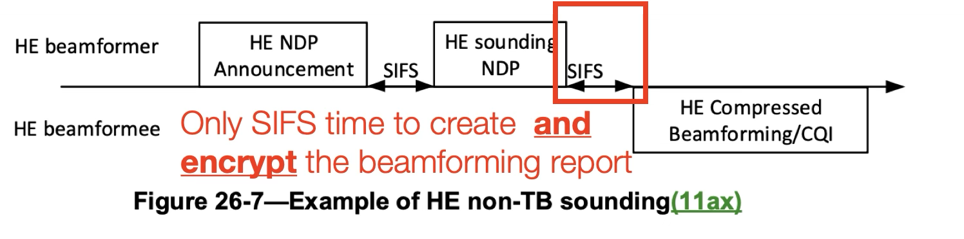

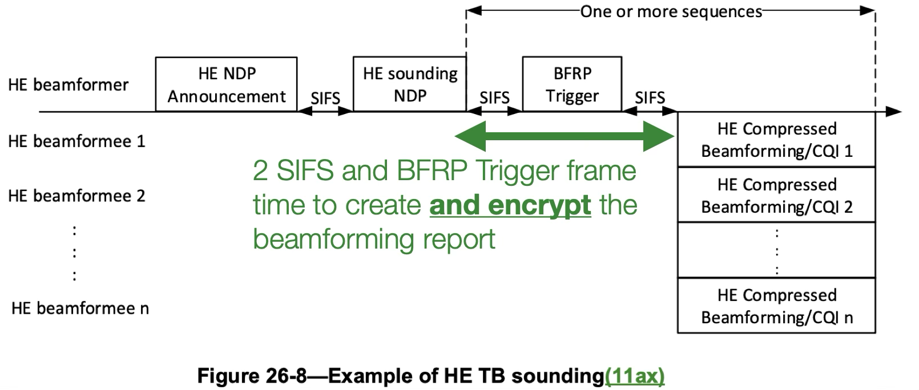

Proposed normative text

9.4.2.240 RSNXE
Instructions to the Editor: Modify the table 9-373 as shown.

Bit | Information | Notes
…
<ANA> | EDP Robust Individually Addressed  Beamforming/CSI/CQI Frame TB Tx Support | An EDP STA sets the EDP Robust Individually Addressed Beamforming/CSI/CQI Frame TB Tx Support field to 1 if dot11EDPRobustIndividuallyAddressedBeamformingCSICQIFrameTBTxActivated is true. Otherwise, this subfield is set to 0. See 12.14.2 (EDP Robust Individually Addressed Management Frame and Robust Individually Addressed Beamforming/CSI/CQI Frame).
<ANA> | EDP Robust Individually Addressed  Beamforming/CSI/CQI Frame Non-TB Tx Support | An EDP STA sets the EDP Robust Individually Addressed Beamforming/CSI/CQI Frame Non-TB Tx Support field to 1 if dot11EDPRobustIndividuallyAddressedBeamformingCSICQIFrameNonTBTxActivated is true. Otherwise, this subfield is set to 0. See 12.14.2 (EDP Robust Individually Addressed Management Frame and Robust Individually Addressed Beamforming/CSI/CQI Frame).

12.14.2 EDP Robust Individually Addressed Management Frame and Robust Individually
Addressed Beamforming/CSI/CQI Frame

Instructions to the Editor: Modify the last paragraphs of the clause as shown.

When performing operations that need to use any individually addressed Beamforming/CSI/CQI frame that is not robust(#1412) described in Table 12-11b (EDP robust individually addressed Beamforming/CSI/CQI frame and its corresponding individually addressed Beamforming/CSI/CQI frame that is not robust(#1412)), if management frame protection is negotiated, the transmitting STA sets the EDP Robust Individually Addressed Beamforming/CSI/CQI TB Frame Tx Support field or EDP Robust IndividuallyAddressed Beamforming/CSI/CQI Non-TB Frame Tx Support field in the RSNXE that it transmits to 1, and the receiving STA sets the EDP Robust Individually Addressed Beamforming/CSI/CQI Frame Rx Support field in the RSNXE that it transmits to 1, then

— the transmitting STA shall use the corresponding robust individually addressed Management frame described in Table 12-11b (EDP robust individually addressed Beamforming/CSI/CQI frame and its corresponding individually addressed Beamforming/CSI/CQI frame that is not robust(#1412))instead of the individually addressed Management frame that is not robust(#1412) and

— the receiving STA shall discard any individually addressed Management frame that is not robust(#1412) described in Table 12-11b (EDP robust individually addressed Beamforming/CSI/CQI frame and its corresponding individually addressed Beamforming/CSI/CQI frame that is not robust(#1412)) from the peer STA, with which management frame protection is negotiated.

The RSNXE capabilities signal the beamforming allowed to a STA as shown in the Table 12-XX.

Table 12-XX RSNXE beamforming TX capability fields settings and allowed beamforming.
EDP Robust IndividuallyAddressed Beamforming/CSI/CQI Frame TB Tx Support field | EDP Robust IndividuallyAddressed Beamforming/CSI/CQI Frame Non-TB Tx Support field | Beamforming allowed to the STA
0 | 0 | Non protected beamforming only
0 | 1 | Protected non-TB beamforming only
1 | 0 | Protected TB beamforming only
1 | 1 | Protected non-TB and TB beamforming only

NOTE – The AP might trigger only a one STA, if only one STA uses the protected TB beamforming.

If management frame protection is not negotiated or the transmitting STA does not indicate support for the transmission of the EDP robust individually addressed Beamforming/CSI/CQI frame, or the receiving STA does not indicate support for the reception of the EDP robust individually addressed Beamforming/CSI/CQI. frame(#1415), the transmitting STA shall not transmit any robust individually addressed Management(#1411) frame described in Table 12-11b (EDP robust individually addressed Beamforming/CSI/CQI frame and its corresponding individually addressed Beamforming/CSI/CQI frame that is not robust(#1412)) to the receiving STA.

ASN.1 encoding of the MAC and PHY MIB
C.3 MIB detail(#1499)

Instructions to the 11bi Editor: Add the new entries to the table as shown below
add new entry to "Dot11StationConfigEntry" as follows (not all lines shown):
Dot11StationConfigEntry ::= SEQUENCE
{
…
dot11EDPRobustIndividuallyAddressedBeamformingCSICQIFrameTBTxActivated TruthValue,
dot11EDPRobustIndividuallyAddressedBeamformingCSICQIFrameNonTBTxActivated TruthValue,

dot11EDPRobustIndividuallyAddressedBeamformingCSICQIFrameTBTxActivated OBJECT-TYPE
SYNTAX TruthValue
MAX-ACCESS read-write
STATUS current
DESCRIPTION
"This is a control variable. It is written by an external management entity or the SME. Changes take effect as soon as practical in the implementation. This attribute, when true, indicates the capability to support EDP robust individually addressed trigger-based beamforming Management frame transmsion is enabled. The capability is disabled otherwise."
DEFVAL { false }
::= { dot11StationConfigEntry <ANA> }

dot11EDPRobustIndividuallyAddressedBeamformingCSICQIFrameNonTBTxActivated OBJECT-TYPE
SYNTAX TruthValue
MAX-ACCESS read-write
STATUS current
DESCRIPTION
"This is a control variable. It is written by an external management entity or the SME. Changes take effect as soon as practical in the implementation. This attribute, when true, indicates the capability to support EDP robust individually addressed non-trigger-based beamforming Management frame transmsion is enabled. The capability is disabled otherwise."
DEFVAL { false }
::= { dot11StationConfigEntry <ANA> }

References:

