IEEE P802.11
Wireless LANs
PDT Joint MLME SAP
Date: 2025-01-14
Author(s):
Name | Affiliation | Address | Phone | email
Brian Hart | Cisco Systems |  |  | brianh@cisco.com
Yan Li | ZTE
Arik Klein | Huawei
XXXX TTT members

Abstract
This document contains Proposed Draft Text (PDT) for the MLME interface for the Multi-AP Coordination (MAPC) feature of TGbn amendment to the 802.11 standard.

Revisions:
- Rev 0: Initial version of the document.
- Rev 1: Incorporating offline feedback related to MLME interface
- Rev 2: Converted UHR action frames to (Protected Dual of) Public Action frames

Relevant passing motion (with green tags added for context):

Motion 185 (MAC)
Move to add to the TGbn SFD the following:
- Define a mechanism in 11bn that defines:
  - (#M185.1)AP-to-AP frame formats to enable interoperable MAPC across APs and including MLME primitive(s) so that a pair of AP’s SMEs can orchestrate the over-the-air transmission and reception of these frames
  - (#M185.2)MLME primitive(s) so that a pair of AP’s SMEs may send the content of the non-real-time instances of such AP-to-AP frames over-the-DS between peer AP-MLMEs (rather than over-the-air via peer AP MACs)
Result: Approved with unanimous consent.

Background
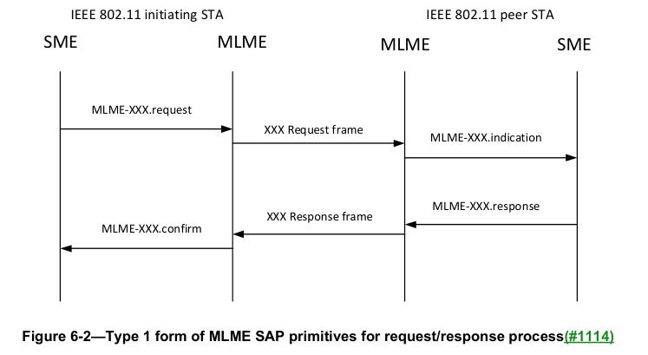

TGbn editor: please make the following changes, identified by Word track changes.

6.3.7 Type 6
Figure 6-7 (Type 6 form of MLME SAP primitives for SME requesting MLME to perform a process not requiring a confirmation(#1114)) depicts Type 6. The Type 6 general form is used when the SME requests a process to be initiated by the MLME and the SME does not require a confirmation.
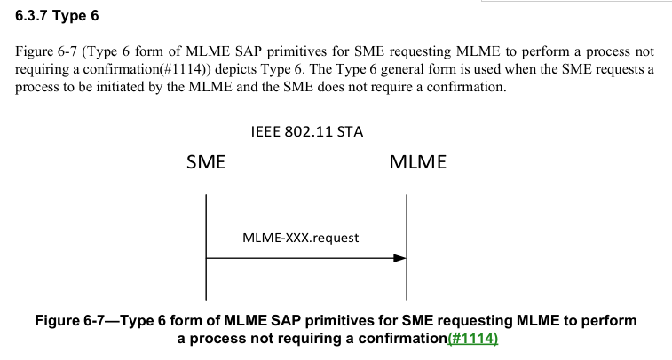
NOTE: One usage of the Type 6 form is shown in Figure 6-7a (Example usage of the Type 6 form of MLME SAP primitives, to notify the MLMEs, of an initiating STA and peer STA, of communications between the SMEs of the STAs)
Figure 6-7a – Example usage of the Type 6 form of MLME SAP primitives, to notify the MLMEs, of an initiating STA and peer STA, of communications between the SMEs of the STAs

Table 6-1— MLME SAP interface(#1114)(#7082)
Service Name | MLME-XXX | Type | References | Comments
(#M185.1)Multi-AP Coordination Over-the-Air | MULTIAPCOORD-OVERTHEAIR | 1 | 9.6.5.55a MAPC (MAPC Request frame format [Name and semantics are TBD]), 9.6.5.55b (MAPC Response frame format [Name and semantics are TBD]) and 9.6.10 (Protected Dual of Public Action frame details) | See 37.7 (Multi-AP Coordination framework)
(#M185.2)Multi-AP Coordination Over-the-DS | MULTIAPCOORD-OVERTHEDS | 6 | 9.6.5.55a MAPC (MAPC Request frame format [Name and semantics are TBD]), 9.6.5.55b (MAPC Response frame format [Name and semantics are TBD]) and 9.6.10 (Protected Dual of Public Action frame details) | See 37.7 (Multi-AP Coordination framework). After SMEs at initiating and peer APs establish an agreement, each SME uses the MLME interface of Type 6 to report the agreement (expressed as the union of the contents of the request and response frames) to its respective MLME.

TGbn editor: please insert two new sections (here labeled 9.6.5.55a and 9.6.5.55b) after 9.6.5.55:
9.6.5.55a (#M185.1)MAPC Request frame format [Name and semantics are TBD]
TBD

9.6.5.55b (#M185.1)MAPC Response frame format [Name and semantics are TBD]
TBD

9.6.10 Protected Dual of Public Action frame details
Table 9-516—Public Action field values defined for Protected Dual of Public Action frames
Public Action field value | Description | Defined in
(#M185.1)<ANA> | MAPC Request | 9.6.5.55a (MAPC Request frame format [Name and semantics are TBD])
(#M185.1)<ANA> | MAPC Response | 9.6.5.55b (MAPC Response frame format [Name and semantics are TBD])
TGbn editor: please remove the ANA-assigned values from this list of reserved values:  35-255 | Reserved

