IEEE P802.11  
Wireless LANs

|  |  |  |  |  |
| --- | --- | --- | --- | --- |
| Correcting The Figure Location | | | | |
| Date: 2025-01-02 | | | | |
| Author(s): | | | | |
| Name | Affiliation | Address | Phone | email |
| Haorui Yang | China Mobile |  |  | yanghaorui0217@163.com |
|  |  |  |  |  |

Abstract

This document corrects the location of the figures in the wrong place.

**Reason for change:**

1. In the Subclause 6.5.14.1.1 of Draft P802.11REVme_D7.0, the Figure 6-10, 6-11, 6-12 and 6-13 are in the wrong place since the figures are not related to the MLME-SETKEYS.request.

Meanwhile, in Subclause 6.5.13, there is the following text which can prove that the figures belong to this subclause.

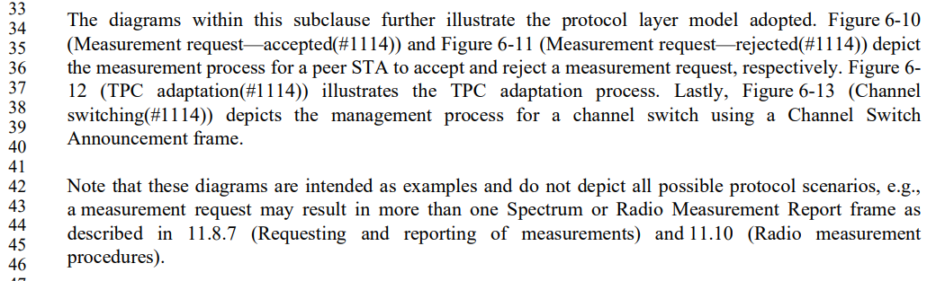

1. In the subclause 9.4.2.137, the Figure 9-664 is interrupted wrongly by the text, as below. The text should be moved below the figure name.

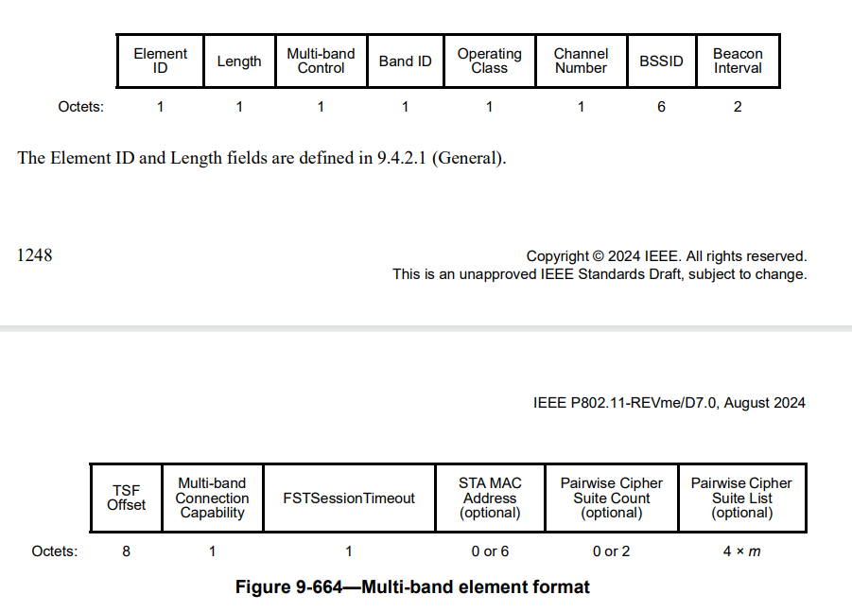

**Proposed changes:**

1. Move the Figure 6-10, 6-11, 6-12 and 6-13 to the end of the Subclause 6.5.13.
2. Move the "The Element ID and Length fields are defined in 9.4.2.1 (General)." just after the Figure 9-664.

**References:**